Appendix 1 Parallel trends
We collected six datasets from the National Bureau of Statistics of China (NBSC) containing indicators which are closed related to the students’ decisions to study abroad. Fig. 3(A) demonstrates that the GDP statistics for groups with high and low exposure are almost parallel. GDP data assesses the monetary worth of final goods and services and provides information about an economy's size and performance across two measure categories. In general, students from higher GDP provinces are more willing to study abroad. Fig. 3(B) and (C) demonstrate that the number of graduates and institutions in our treatment and control groups appeared to be parallel from 2010 to 2017. As the number of graduates and institutions represent the size of the population pool of students studying abroad, there is a positive relationship between them and the number of students studying abroad. Fig 3(D) and (F) illustrate the changes of education expenditure and education income for both groups. Both graphs depict parallel relationships between the low exposure group and high exposure group. Education expenditure and education income are two essential metrics for assessing the financial capabilities of universities, allowing them to offer more foreign language courses, recruit foreign instructors, and initiate study abroad and exchange programs. These encounters will increase student interest in studying abroad. Unfortunately, we did not find the data of education income (Fig 1(F)) of 2013 in the NBSC’s database, but the parallel relationship of education income remains evident. Fig. 1(E), which depicts the per capita disposable income in both groups, also appears to be parallel. Studying abroad is an expensive decision the majority of Chinese students. Therefore, having more disposable income makes studying abroad more affordable. It is important to note that disposable income data (Fig 1(E)) are only accessible from 2013. Overall, all six data reveal parallel trends between treatment group and control group, which are strong evidence of the underlying growth trends are irrelevant factors.
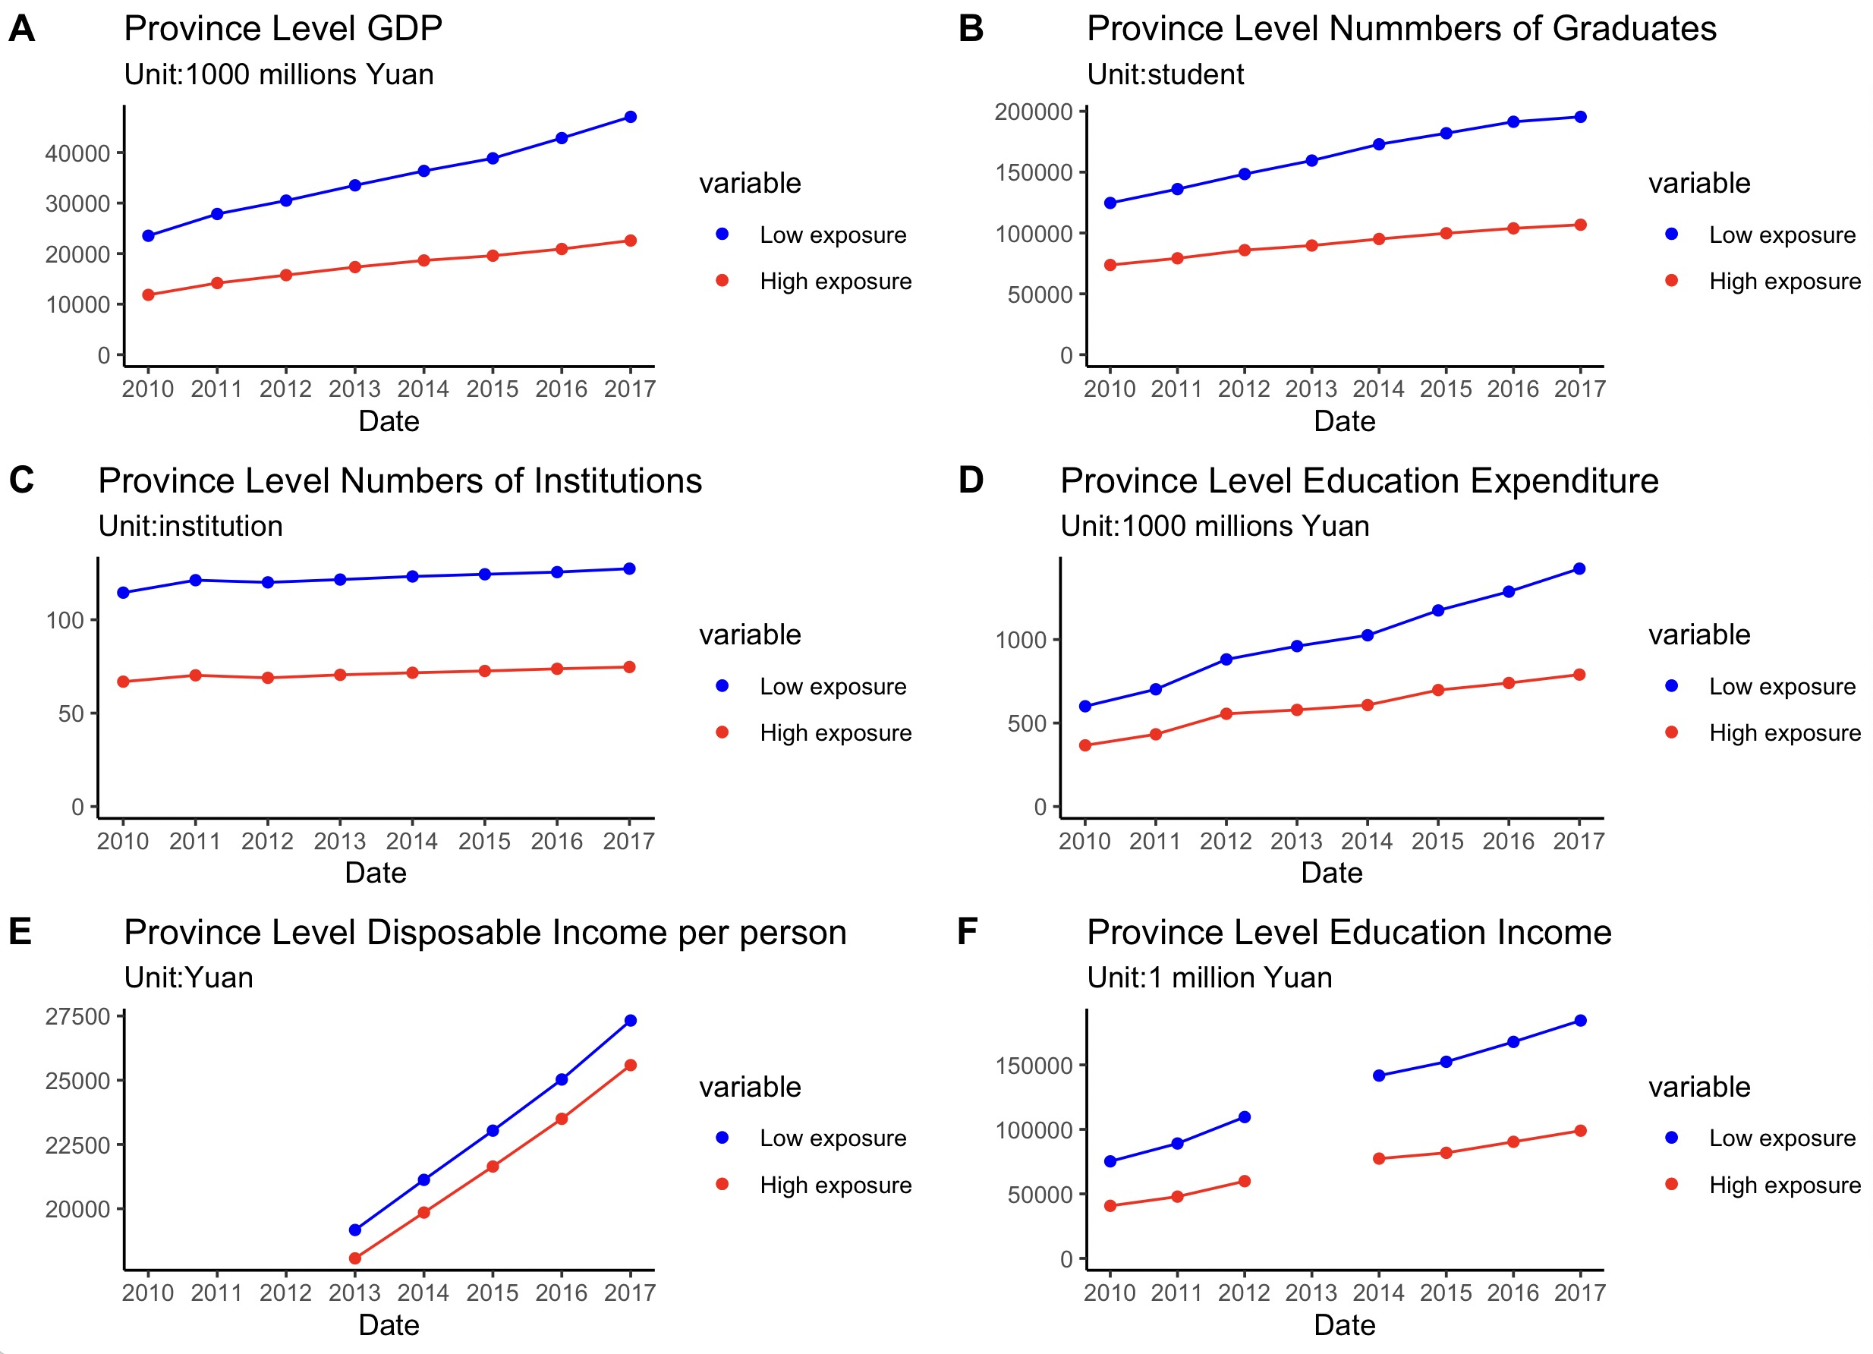
Figure 1. Parallel trends graph

Appendix 2 Figures of Added-up estimates in DID analysis with interaction terms
Fig. 2 depicts the aggregated estimates derived from the DID analysis with interaction terms, offering a visual summary of the relationships among the variables in our study. Fig.1 demonstrates a positive correlation between SES and students’ intention to study abroad before to the COVID-19 pandemic. After the COVID-19 pandemic, the intention has decreased dramatically across all SES categories. In addition, the figure reveals that COVID-19 exposure has had a greater impact on students from SES3 (from 0.42 to 0.12), with a 77% decrease in their intention to study abroad, and a 65% decrease for students from SES4 (drop from 0.51 to 0.20).

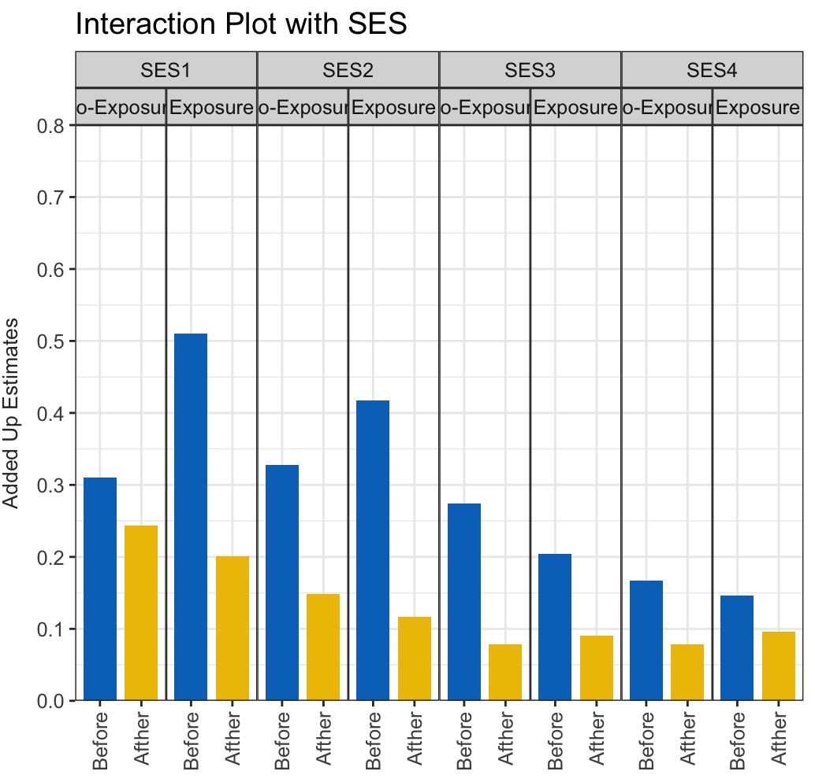

Figure 2. Added-up estimates for the interaction between the variables Time, Treated and SES
Considering the interaction with the academic performance of students. Fig. 3 reveals a significant reduction in students’ intention to study abroad across all academic ranks before and after the COVID-19 pandemic. In addition, the figure clearly shows that before the pandemic, students from treated provinces were less inclined to study abroad than students from untreated provinces, while students from the Ranking1 group were more inclined to study abroad than students from other groups. After the COVID-19 pandemic, the relationship between treated and untreated students from the Ranking1 group changed adversely. Overall, students in the Ranking1 group without high COVID-19 pandemic exposure demonstrate the greatest decline in intention to study abroad (drop from 0.21 to -0.00), while the students from Ranking1 group in Treated provinces have remained same pattern, indicating that students with the highest academic performance remained the most intention to study abroad.
Figure 3. Added-up estimates for the interaction between the variables Time, Treated and Academic Ranking

Appendix 3 Robustness check for DID-analysis of SES
Table 7 presents the robustness check results of the DID-analysis of the SES. In addition to family annual income, we create a composite SES variable that combines family income, parents’ education, and parents’ career. Parents’ career is measured by the survey question “What is your parents’ occupation?” We coded parents’ careers as 1 if one of the parents has a higher status occupation such as professor, doctor, governor, and business owner, and 0 otherwise. Parents’ education level is coded as 1 if at least one parent or guardian of the student holds a bachelor’s or above degree (non-first-generation college students), and 0 otherwise. We assigned a weighted sum to these components: family annual income was given a weight of two, and both parents' education and career status were assigned a weight of one each. The resulting composite scores, which ranged from 2 to 10, were then categorized into four categories to indicate distinct SES level. Specifically, students with scores exceed 8 are classified as having the highest SES, denoted by the value 1. Students with scores of 6 to 8 received value 2. Students get value 3 if their scores ranged from 4 to 5 and value 4 if the scores ranged from 2 to 3. The results of the robustness check align with our initial findings and statistically significant. This indicates that students from the six provinces with high COVID-19 exposure, despite initially being less inclined, showed a smaller decline in their intention to study abroad from 2018 to 2021 compared to students from low COVID-19 exposure provinces.
Table 7. Difference-in-differences on high exposure to COVID-19
Treatment Group  Control Group | Students from 6 provinces  Students from other provinces
Treatment Effects | High Exposure to Virus
Independent Variable | SES (Income + Parents’ education + Parents’ career)
COVID-19 Exposure (Treated) | -0.021***
Time | -0.144***
Treated*Time | 0.020**
Control Variables: SES, gender, academic achievement, prior overseas education experience, intention to pursue doctoral degree, STEM major, foreign language proficiency, university selectivity
Observations |  |  | 28770
*p < 0.5; **p < 0.01; ***p < 0.001.

Considering the inclusion of triple interaction terms of Treated*Time*SES as a robustness check for the DID analysis. The results of our study, as shown in Table 8, indicate that the coefficients for the interaction terms Treated*Time*SES-1, Treated*Time*SES-2, and Treated*Time*SES-3 remained consistent in both direction and significance compared to the initial analysis. This consistency across the interaction terms reinforces our initial findings that the COVID-19 pandemic has diminished the intention of students from high-SES families to study abroad, while simultaneously increasing the intention of low-SES students to study abroad.
Furthermore, it is noteworthy that the coefficient for COVID-19 Exposure (Treated) in the robustness check lacks statistical significance, indicating a less distinct direct effect of high exposure to the COVID-19 when a broader set of SES variables is considered. This underscores the intricacy of interpreting the impact of the COVID-19 pandemic on different SES levels and emphasizes the need for a meticulous examination of the many aspects of SES in future research.

Table 8. Difference-in-differences interaction with SES
Treatment Group  Control Group | Students from 6 provinces (n=6136)  Students from other provinces (n=8249)
Treatment Effects | High Exposure to Virus
Interaction with SES | Estimate SES (Income + Parents’ education + Parents’ career) |  | SE
COVID-19 Exposure (Treated) | -0.009 |  | 0.005
Time | -0.063 *** |  | 0.012
SES-1 | 0.243 *** |  | 0.052
SES-2 | 0.197 *** |  | 0.010
SES-3 | 0.102 *** |  | 0.006
Treated*Time | 0.019 |  | 0.017
Treated*SES-1 | 0.401 *** |  | 0.086
Treated*SES-2 | 0.011 |  | 0.020
Treated*SES-3 | -0.038 *** |  | 0.011
Time*SES-1 | -0.042 |  | 0.053
Time*SES-2 | -0.137 *** |  | 0.016
Time*SES-3 | -0.105*** |  | 0.014
Treated*Time*SES-1 | -0.401*** |  | 0.088
Treated*Time*SES-2 | -0.046 * |  | 0.027
Treated*Time*SES-3 | 0.040 * |  | 0.020
Control Variables: gender, academic achievement, prior overseas education experience, intention to pursue doctoral degree, STEM major, foreign language proficiency, university selectivity
Observations |  | 28770
*p < 0.5; **p < 0.01; ***p < 0.001.
SES-4 serves as the reference category for SES in this DID analysis. The effects associated with SES-1, SES-2, and SES-3 are measured in comparison to SES-4. Thus, the coefficients for these categories indicate the magnitude and direction of their differences from the baseline category (SES-4).”

Appendix 4 Robustness check for Logistic regression model in DID-analysis
Table 9 presents the results of the Logistic regression model in DID-analysis. The odds ratio for “Treated” is less than 1, demonstrates a negative relationship, indicating that in both time periods, students from the six provinces with the higher COVID-19 exposure were generally less inclined to study abroad compared to students from other provinces. Furthermore, the odds ratio for “Time” is 0.867 indicates the odds of students’ inclination to study abroad in 2021 are 0.867 times the odds in 2018. However, the odds ratio of “Treat*Time” is both statistically significant and greater than 1. This finding indicates that between 2018 and 2021, students from the six high COVID-19-exposure provinces exhibited a smaller decline in their intention to study abroad than their counterparts in other provinces, most likely influenced by their experience with the pandemic.

Table 9. Difference-in-differences on high exposure to COVID-19
Treatment Group  Control Group | Students from 6 provinces (n=6136)  Students from other provinces (n=8249)
Treatment Effects | High Exposure to Virus
Independent Variable | Estimate | SE | Odds Ratio
COVID-19 Exposure (Treated) | -0.030*** | 0.005 | 0.971
Time | -0.143*** | 0.006 | 0.867
Treated*Time | 0.027*** | 0.006 | 1.03
Control Variables: SES, gender, academic achievement, prior overseas education experience, intention to pursue doctoral degree, STEM major, foreign language proficiency, university selectivity
Observations |  | 28770
Note: *p < 0.5; **p < 0.01; ***p < 0.001.

Tables 10, 11 and 12 report the results of the Logistic regression model in DID-analysis incorporating the triple interaction terms of Time*Treated*SES, academic achievement, and gender, respectively. This approach enables us to isolate the impact of the pandemic's exposure on students’ intention to study abroad. It’s crucial to interpret these findings within the specific circumstances of the high-COVID-19 exposure context. By conducting this analysis, we could determine the nuanced impacts of COVID-19 pandemic on the intentions of students with different characteristics to study abroad.
The odds ratios for Treated*Time*SES-1 and SES-2 in Table 10 are less than 1 and statistically significant, which implies that the COVID-19 pandemic has diminished the intention of students from high-SES families to study abroad, but at the same time has increased the intention of low-SES students to study abroad.
For academic achievement, Table 11 demonstrates that the triple interaction odds ratios on all levels of students’ achievement groups are less than 1, indicating that students from academic achievement groups other than the top 5% have a decrease in the odds of studying abroad than students from the top 5% academic achievement group, as a result of COIVD-19 exposure although only significant for achievement groups 2 and 4.
Finally, Table 12 indicates that exposure to COVID-19 has no significant effect on the intention of studying abroad among students from different genders.

Table 10. Difference-in-differences interaction with SES
Treatment Group  Control Group | Students from 6 provinces (n=6136)  Students from other provinces (n=8249)
Treatment Effects | High Exposure to Virus
Interaction with SES | Estimate |  | SE | Odds Ratio
COVID-19 Exposure (Treated) | -0.021 *** |  | 0.005 | 0.979
Time | -0.088 *** |  | 0.012 | 0.916
SES-1 | 0.144 ** |  | 0.052 | 1.155
SES-2 | 0.161 *** |  | 0.048 | 1.175
SES-3 | 0.107 *** |  | 0.007 | 1.114
Treated*Time | 0.038 * |  | 0.016 | 1.039
Treated*SES-1 | 0.221 * |  | 0.086 | 1.247
Treated*SES-2 | 0.110 |  | 0.078 | 1.116
Treated*SES-3 | -0.050 *** |  | 0.013 | 0.951
Time*SES-1 | 0.021 |  | 0.053 | 1.021
Time*SES-2 | -0.092 * |  | 0.050 | 0.912
Time*SES-3 | -0.108*** |  | 0.014 | 0.897
Treated*Time*SES-1 | -0.281** |  | 0.089 | 0.755
Treated*Time*SES-2 | -0.159* |  | 0.080 | 0.853
Treated*Time*SES-3 | 0.045* |  | 0.021 | 1.046
Control Variables: gender, academic achievement, prior overseas education experience, intention to pursue doctoral degree, STEM major, foreign language proficiency, university selectivity
Observations |  | 28770
Note: *p < 0.5; **p < 0.01; ***p < 0.001.
SES-4 serves as the reference category for SES in this DID analysis. The effects associated with SES-1, SES-2, and SES-3 are measured in comparison to SES-4. Thus, the coefficients for these categories indicate the magnitude and direction of their differences from the baseline category (SES-4).

Table 11. Difference-in-differences interaction with Academic achievement
Treatment Group  Control Group | Students from 6 provinces (n=6136)  Students from other provinces (n=8249)
Treatment Effects | High Exposure to Virus
Interaction with Academic achievement |  |  | Estimate | SE |  | Odds Ratio
COVID-19 Exposure (Treated) |  |  | -0.046 *** | 0.013 |  | 0.955
Time |  |  | -0.204 *** | 0.013 |  | 0.815
Academic Achievement-2 |  |  | -0.048 *** | 0.012 | 0.953
Academic Achievement-3 |  |  | -0.037 *** | 0.011 | 0.964
Academic Achievement-4 |  |  | -0.043 *** | 0.011 | 0.958
Academic Achievement-5 |  |  | -0.048 *** | 0.011 | 0.953
Treated*Time |  |  | 0.069 *** | 0.017 | 1.072
Treated*Academic Achievement-2 |  |  | 0.024 | 0.017 | 1.024
Treated*Academic Achievement-3 |  |  | 0.009 | 0.016 | 1.009
Treated*Academic Achievement-4 |  |  | 0.020 | 0.015 | 1.020
Treated*Academic Achievement-5 |  |  | 0.019 | 0.016 | 1.019
Time*Academic Achievement-2 |  |  | 0.073 *** | 0.016 | 1.076
Time*Academic Achievement-3 |  |  | 0.061 *** | 0.015 | 1.063
Time*Academic Achievement-4 |  |  | 0.084 *** | 0.014 | 1.087
Time*Academic Achievement-5 |  |  | 0.058 *** | 0.015 | 1.060
Treated*Time* Academic Achievement-2 |  |  | -0.052 * | 0.023 | 0.949
Treated*Time* Academic Achievement-3 |  |  | -0.039 | 0.021 | 0.962
Treated*Time* Academic Achievement-4 |  |  | -0.059 ** | 0.021 | 0.943
Treated*Time* Academic Achievement-5 |  |  | -0.039 | 0.022 | 0.961
Control Variables: SES, gender, prior overseas education experience, intention to pursue doctoral degree, STEM major, foreign language proficiency, university selectivity
Observations |  | 28770
Note: *p < 0.5; **p < 0.01; ***p < 0.001.
Academic Achievement-1 serves as the reference category for Academic Achievement in this DID analysis. The effects associated with Academic Achievement-2, Academic Achievement-3, Academic Achievement-4, and Academic Achievement-5 are measured in comparison to Academic Achievement-1. Thus, the coefficients for these categories indicate the magnitude and direction of their differences from the baseline category (Academic Achievement-1).

Table 12. Difference-in-differences interaction with Gender
Treatment Group  Control Group | Students from 6 provinces (n=6136)  Students from other provinces (n=8249)
Treatment Effects | High Exposure to Virus
Interaction with Gender | Estimate |  | SE | Odds Ratio
COVID-19 Exposure (Treated) | -0.045 *** |  | 0.006 | 0.956
Time | -0.141 *** |  | 0.007 | 0.869
Gender-1 | -0.022 *** |  | 0.006 | 0.979
Treated*Time | 0.035 *** |  | 0.008 | 1.035
Treated*Gender | 0.034 *** |  | 0.009 | 1.035
Time*Gender | -0.004 |  | 0.008 | 0.996
Treated*Time*Gender | -0.017 |  | 0.012 | 0.983
Control Variables: SES, academic achievement, prior overseas education experience, intention to pursue doctoral degree, STEM major, foreign language proficiency, university selectivity
Observations |  | 28770
Note: *p < 0.5; **p < 0.01; ***p < 0.001.
Gender-0(female) serves as the reference category for Gender in this DID analysis. The effects associated with Gender-1(male) are presented relative to Gender-0 (female). Thus, the coefficients for these categories indicate the magnitude and direction of their differences from the baseline category Gender-0 (female).

