ONLINE RESOURCE

Online Resource A: Detailed data description

Dependent variable - participation in tertiary education
Data sources. Tertiary enrolment ratios (TER) include ISCED levels 5 (short-cycle), 6 (bachelor or equivalent), and 7 (master or equivalent). Separate data for each ISCED level are provided by OECD but do not cover the geographic and time scope of the available SFP data to the extent that would enable panel regression analysis. Including ISCED 5 is important, because the diversification of provision has been an important feature of expansion in many countries and often encompassed a rising supply of short-cycle and professional qualifications (Teichler & Bürger, 2008). Furthermore, institutional change in higher education systems, such as upgrading vocational schools or colleges providing education at ISCED-5 level (or tertiary-type B, formerly) to university status (and thus providers of ISCED-6) can create sudden jumps or variations in enrolment ratios. Accounting for ISCED 5 to 7 addresses this potential omitted variable bias. However, what remains overlooked are institutional changes increasing the size of tertiary education through upgrading vocational training outside tertiary education to tertiary-type B, as it was the case in some countries, such as the UK and Spain, in the 1990s (ibid., p. 158). We assume that such big reforms of secondary and tertiary education took generally place in the OECD countries before the period we analyse. Nevertheless, we verified that no outliers in terms of change in TER were affected by such reforms (the analysis available on request). Finally, accounting for all levels rather than just higher education (ISCED 6-7) reduces the bias stemming from the current variation across countries in the definition of higher education, especially in terms of its distinction from other forms of post-secondary schooling.
Comparability problems remain. For instance, in some countries, especially those with developed apprenticeship systems, e.g., Germany), ISCED 4 fulfils a function similar to ISCED 5 in others. Other problems are related to the variation in the incidence and classification of part-time students and the duration of study programmes (cf. Clancy & Goastellec, 2007). We deem the latter as less relevant in the context of our emphasis on the value of each additional person/year of studying. Moreover, a longer study duration can be encouraged by generous SFP, while the differences in formal study length in Europe have become negligible in the course of Bologna process implementation.
The country-level, annual data on the total student population (regardless of age) and inbound internationally mobile students are provided by the Unesco Institute of Statistics (UIS). The population data are taken from the OECD database (https://www.oecd.org/en/data/indicators/population.html). It counts all citizens present in, or temporarily absent from the country, and aliens permanently settled in the country – hence, it includes temporarily settled international students. Information on all countries for which the SFP data are available (see below) is included, except Luxembourg which has a very low proportion of the population studying domestically and thus reported in the UIS data. The TER indicators for the whole United Kingdom are matched with SFP data for England. High mobility across the regions hinders calculations of region-specific TER. The proportion of international students in England roughly follows the national estimations (e.g., 19% in 2016/17; see https://www.hesa.ac.uk/data-and-analysis/students).
The missing data in the student population dataset were filled using the OECD indicator “enrolment rates by age” (2006 and 2011 – Germany, Japan, New Zealand, Portugal), the next year’s value (2006 – Austria, Canada), and other sources (all years – Australia, statistics provided by NCVER for Technical and Further Education and by the Department of Education for the university sector). The missing international student data are filled using averaged adjacent values (2006 – Latvia, New Zealand; 2016 – Portugal) and the OECD database (2006, 2011 – Japan, Germany).
TER differs from the gross enrolment ratio (GER) indicator that is readily provided by Unesco and widely used in comparative research. First, we exclude international students, as they are typically ineligible for domestic student support and often face different pricing of fees than domestic students. This also aligns with the student funding data (see below), which focus exclusively on domestic students. Furthermore, GER is inflated in countries with a higher proportion of international students in the total student population. Since these countries (typically anglophone) tend to have relatively high private expenditures on tertiary education, we are less likely to corroborate their positive effects on enrolment ratios (Yang & McCall, 2014). Second, our denominator considers a wider age group than the five-year age group following the secondary school leaving considered in GER. This better accounts for differences across countries in the average student age (for instance, in 2021, the average age of new first-time entrants varied from 18 in Japan to 25 in Denmark (OECD, 2023, 223)), but comes at the expense of substantive interpretation of TER values (e.g., assessment against the ideal-typical thresholds of mass or universal participation), as the age ranges of the numerator and the denominator are different. However, TER are primarily meant as valid indicators calculated for quantitative comparative analyses. Correlation between TER and GER is high (r=.91), but our indicator yields different regression results due to the correction of values in countries charging high tuition fees (estimations of models using GER are available from the authors on request). Indicators other than GER, for instance entry rates published by the OECD, have been discontinued and had limited country coverage (Clancy & Goastellec, 2007).
Outliers. Greece’s growth of TER from 40% to 76% in the analysed period makes it a noteworthy, outlying case, especially considering that it had meagre SFP and high youth unemployment rates. It illustrates how the supply of study places can adjust to demand (see: https://www.timeshighereducation.com/news/eternal-student-numbers-double-greece). Importantly, this growth seems to only partly result from outbound migration in the age group included in the denominator following the economic collapse, because the long-term demographic decline in this group accelerated between 2011 and 2016. It then slowed down markedly while the enrolment ratios kept rising at a similar rate. Another change with limited impact was a decision to merge Tertiary Education Institutions and universities (https://acei-global.org/greece-shakeup-at-the-higher-education-level/) in 2019.
Data limitation. The growth of enrolment ratios has been related – to a different degree across countries – to the lengthening of typical time in higher education due to the proliferation of master-level courses, and to increasing the availability of short-cycle courses (ISCED5) or upgrading vocational and training institutions to tertiary level (Teichler & Bürger, 2008). The available data do not allow separate analyses for different ISCED levels for a sample of countries including non-European countries. This results in an imperfect match between our SFP indicators, which relate to ISCED-6 only (see sub-section 3.2.). However, we believe that they are still good proxies of country-differences in SFP at other ISCED levels.

Independent variable – student funding policy
Data source. Student Support and Fees Dataset (SSFD) includes the data from winter semesters in four years: 2005, 2010, 2015, and 2020, collected in 33 affluent democracies using model-family techniques typical for comparative social policy research. The entitlements of three hypothetical students (differing only in parental income) to any state-financed financial benefits and the amount of mandatory tuition fees they would have to pay were calculated using information derived from national legislation and other relevant policy documents. Taking average production worker wages (APW) from each country as a referential parental income ensures the cross-national comparability of data. The national-level indicators are averages of values calculated for the three model-typical domestic students, who are assumed to study full-time at the undergraduate level and live away from their parents. For dual-track tuition fee systems or systems with different support rules applying to, for instance, universities at private and public institutions, calculations in SSFD are made separately for the categories of students and then weighted by their respective populations in the single country-level indicator.

The indicators of generosity and decommodification are calculated in the following way:

Decom = (((grant26 + fam26 – fee26)/net52)*100) + (((grant52 + fam52 – fee52)/net52)*100) + (((grant104 + fam104 – fee104)/net52)*100) / 3
Gen = (((grant26 + fam26 + loan26 – fee26)/net52)*100) + (((grant52 + fam52 + loan52 – fee52)/net52)*100) + (((grant104 + fam104 + loan104 – fee104)/net52)*100) / 3

where (variable labels taken from SSFD):

grant26, grant52, grant104 – Total amount of entitlements to non-repayable support (grants) of different model families (national currency)

fam26, fam52, fam104 – Total amount of entitlements to family benefits - paid to parents of a student (tax credits and family allowances) of different model families (national currency)

loan26, loan52, loan104 – Total amount of entitlements to student loans of different model families (national currency)

fee26, fee52, fee104 – Total amount of obligations to pay tuition fees, paid by student's parents or by a student (minus any tuition fee discounts or exemptions) of different model families (national currency)

net26, net52, net104 – Net Average Production Workers Wage (APW) of the three model families (national currency), Source: Social Policy Indicators database (SPIN), https://www.su.se/social-policy-indicators-database/

“26” – model-type family with one earner of 50% of APW
“52” – model-type family with one earner of 100% of APW
“104” – model-type family with dual earners of 100% of APW each

For more information, see the documentation file at https://www.su.se/social-policy-indicators-database/data

These social rights-type of data, in contrast to expenditure or recipiency rate (e.g., the proportion of students receiving aid) data, are not unconditionally determined by the macroeconomic context and the socio-economic composition of the student population, whereby the proportion of low-income students is also affected by the level of enrolment, generating a reverse causality problem (see the discussion in Author).

Other explanatory variables
Table OR.1 Descriptive statistics – explanatory and control variables, pooled data
Variable | Obs | Mean | Std. Dev. | Min | Max
(1) Gross National Income per capita (PPP)  GNI | 128 | 34472 | 12688 | 8600 | 69610
(2) Tertiary education attainment 25-34 y/o (%)  att2534 | 128 | 37.7 | 12.2 | 11.7 | 69.7
(3) Tertiary education attainment 25-64 y/o (%)  att2564 | 128 | 30.6 | 10.6 | 8.1 | 59.4
(4) Youth (15-24 y/o) unemployment (%)  y_unemp | 128 | 17.8 | 9.2 | 3.9 | 53.2
(5) Labour market demand for tertiary education (%)  ter_ed_dem | 104 | 31.6 | 5.1 | 20 | 42.7
(6) Secondary students in vocational education (%)  voc | 128 | 44 | 17.9 | 7.5 | 79.6

(1) Gross national income per capita (PPP) is taken from the World Bank’s World Development Indicators DataBank. The measure is lagged by one year versus the dependent variable.
(2) & (3) Both variables are obtained from the OECD database. Missing data were supplemented using the Barro-Lee Educational Attainment Dataset. Since both variables are highly correlated (r=-.91), they cannot be included in regression models together due to multicollinearity issues. The former is lagged by two years versus the outcome variable, and the latter is the average value in the preceding three years. Quite weak correlations with the outcome (.29 and .34) support our claim that the measures of enrolment and attainment relate to substantially different phenomena, not least because graduation rates vary significantly across countries.
(4) The indicator is taken from the World Development Indicators database of the World Bank, and lagged by two years versus the outcome.
(5) Labour market demand for graduate skills is measured using the skill demand indicator proposed by Tåhlin and Westerman (see Tåhlin, M., & Westerman, J. 2021. Structural consequences of cyclical change for marginal group employment. OSF.) based on the ILO-provided data on the number of jobs requiring tertiary education, defined as jobs in which a substantial portion of skills is largely acquired during tertiary education. The data, not available for Bulgaria, Cyprus, Estonia, Latvia, Malta, and Romania, are lagged by two years, but the enrolment data for 2021 are matched with year 2018 due to data availability.
(6) The proportion of secondary school pupils participating in vocational education is measured using the measure provided by Unesco (UIS): share of upper secondary students in vocational education. The indicator is the average of the values from the second, third, and fourth years preceding the outcome observation year. Missing data (for earlier years in Australia, Canada, Ireland, Japan, and New Zealand) are handled by extrapolating from a linear trend.

Online Resource B: Additional figures and tables
Figure OR.1 Convergence of tertiary enrolment ratios (%) between 2006 and 2021

Figure OR.2a-b Correlation between student funding policy and tertiary enrolment ratios, 2005-2020, scatterplots

a)
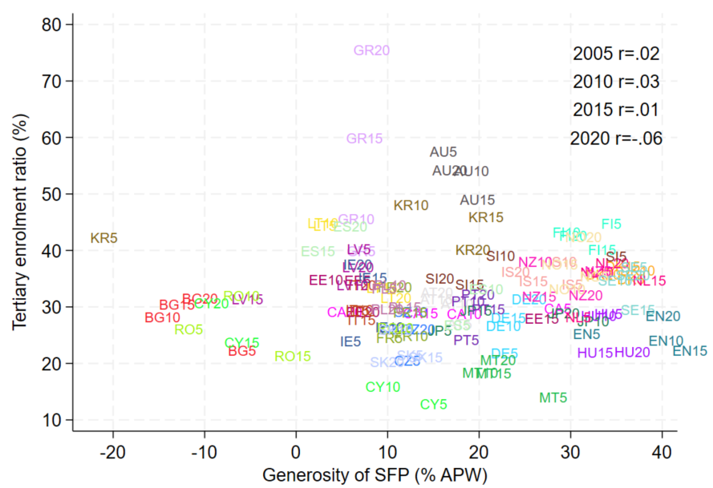

b)

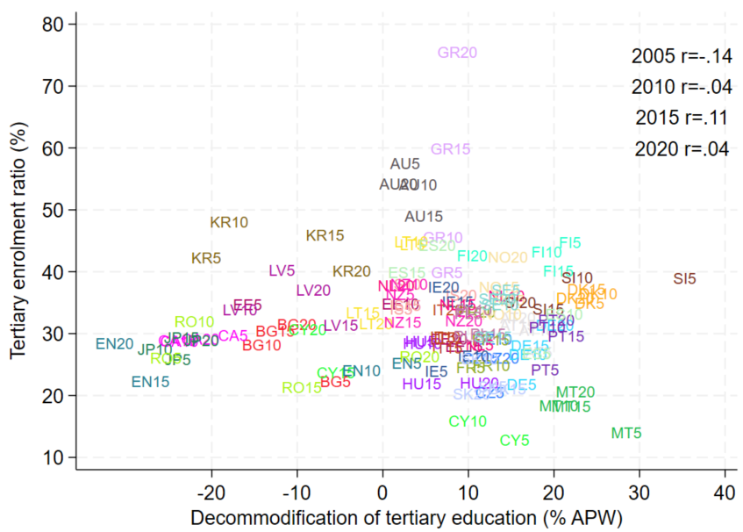

Table OR.2 Tertiary enrolment ratio (%), 2006-2021. Own calculation based on UIS enrolment data and OECD population data
Tertiary enrolment ratio | Obs | Mean | Std. Dev. | Min | Max
2006 | 32 | 30.867 | 9.531 | 12.895 | 57.605
2011 | 32 | 33.004 | 8.242 | 16.001 | 54.156
2016 | 32 | 31.958 | 8.599 | 18.321 | 59.904
2021 | 32 | 34.553 | 10.25 | 20.285 | 75.595
Table OR.3 Tertiary enrolment ratio (%) – changes over time (2005-2020). Own calculation based on UIS enrolment data and OECD population data
Tertiary enrolment ratio | Obs | Mean | Std. Dev. | Min | Max
Δ2006-2021 | 32 | 3.686 | 9.132 | -12.784 | 35.616
Δ2006-2011 | 32 | 2.136 | 3.606 | -6.413 | 8.652
Δ2011-2016 | 32 | -1.046 | 5.508 | -11.49 | 14.3
Δ2016-2021 | 32 | 2.596 | 3.733 | -5.813 | 15.691

Table OR.4 Student funding policy – generosity and decommodification, 2005-2020, % of APW. Own calculation based on SSFD
Variable | Obs | Mean | Std. Dev. | Min | Max
Generosity
2005 | 32 | 15.349 | 14.756 | -23.174 | 34.773
2010 | 32 | 15.262 | 12.882 | -17.237 | 37.815
2015 | 32 | 15.056 | 13.671 | -15.662 | 40.427
2020 | 32 | 14.869 | 12.964 | -13.142 | 37.492
Decommodification
2005 | 32 | 3.814 | 15.085 | -27.999 | 33.146
2010 | 32 | 2.794 | 14.424 | -29.48 | 22.145
2015 | 32 | 2.078 | 13.579 | -30.211 | 20.761
2020 | 32 | 2.402 | 12.969 | -34.409 | 19.45

Table OR.5 Student funding policy – generosity and decommodification, changes over time (2005-2020), % of APW. Own calculation based on SSFD
Variable | Obs | Mean | Std. Dev. | Min | Max
Generosity
Δ2005-2020 | 32 | -.48 | 11.726 | -24.703 | 39.903
Δ2005-2010 | 32 | -.087 | 8.224 | -13.062 | 33.142
Δ2010-2015 | 32 | -.206 | 7.427 | -18.392 | 23.581
Δ2015-2020 | 32 | -.187 | 5.682 | -19.564 | 12.082
Decommodification
Δ2005-2020 | 32 | -1.413 | 12.018 | -34.641 | 29.165
Δ2005-2010 | 32 | -1.021 | 5.124 | -13.062 | 17.383
Δ2010-2015 | 32 | -.716 | 7.558 | -24.675 | 12.549
Δ2015-2020 | 32 | .324 | 4.505 | -10.052 | 13.779

Table OR.6 Matrix of pairwise correlations – variables included in the regression models
Variables | (1) | (2) | (3) | (4) | (5) | (6) | (7) | (8) | (9)
(1) gnr | 1.000
(2) decom | 0.343*** | 1.000
(3) TER | -0.002 | -0.016 | 1.000
(4) GNI | 0.431*** | 0.171* | 0.183** | 1.000
(5) att2534 | 0.167* | -0.335*** | 0.290*** | 0.549*** | 1.000
(6) att2564 | 0.275*** | -0.333*** | 0.341*** | 0.651*** | 0.910*** | 1.000
(7) y_unemp | -0.334*** | 0.056 | 0.149* | -0.405*** | -0.307*** | -0.326*** | 1.000
(8) ter_ed_dem | 0.475*** | 0.034 | 0.058 | 0.676*** | 0.343*** | 0.517*** | -0.393*** | 1.000
(9) voc | 0.042 | 0.418*** | 0.004 | 0.013 | -0.479*** | -0.393*** | 0.018 | 0.099 | 1.000
*** p<0.01, ** p<0.05, * p<0.1

Table OR.7 Robustness check of the interaction effect using random effects models
 | (1) | (2)
 | TER
gnr | 0.087
 | (0.178)
decom |  | -0.255*
 |  | (0.143)
att25-64 | 0.361* | 0.286*
 | (0.196) | (0.170)
gnr*att25-64 | -0.005
 | (0.005)
decom*att25-64 |  | 0.007**
 |  | (0.003)
y_unemp | 0.207** | 0.209**
 | (0.085) | (0.090)
GNI | -0.002 | -0.006
 | (0.087) | (0.095)
Cons. | 19.224*** | 20.790***
 | (4.960) | (3.969)
chi2 | 16.59** | 15.85**
r2_within | 0.16 | 0.14
r2_between | 0.18 | 0.28
r2_overall | 0.17 | 0.24
rho | 0.74 | 0.69
N | 128 | 128
Bootstrapped standard errors in parentheses
* p < 0.10, ** p < 0.05, *** p < 0.01

Online Resource C: Triangulation of findings

(1) We investigated our hypothesis further by looking at extreme cases of increases or decreases in the non-repayable support net of fees (as a liberal test), and assessing (qualitatively) whether they led to a systematic change in TER. Table OR.8 presents our rule of thumb classifications based on Figures 1–2. Neither for generosity nor decommodification, hence irrespective of whether we account for the prominence of loans in student aid packages, was a significant policy change a sufficient condition for a change in TER in the same direction. Cases marked in italics indicate the countries where SFP rose but TER fell or where SFP fell and TER rose. Generosity of student social rights rose in Lithuania and TER fell simultaneously. However, similar policy changes in Japan, Korea, and Romania did not result in TER falling significantly, while in England TER increased (in both England and Japan, the generosity growth was solely driven by the increasing generosity of student loans). For decommodification, Korea, Romania, and Finland saw significant policy changes but no concurrent change in TER, while in Slovenia a strong fall in decommodification (and generosity) levels was associated with decreasing participation in tertiary education. In sum, we do not find evidence of a systematic relationship between significant changes in SFP and concurrent changes in the levels of participation in tertiary education.

Table OR.8 Association between the outlying cases of changes in generosity (GEN) and decommodification (DECOM), and changes in tertiary enrolment ratios (TER), 2006-2021.

 | TER rise | No change | TER fall
Gen rise | EN | JP, KR, RO | LT
Gen fall | ES, CY | CA | SI
Decom rise | - | KR, RO | EE
Decom fall | ES, CY, NL, EN | FI | SI

(2) To further investigate the moderation effects (Figures 3 and 4), we again selected cases extreme on explanatory variable – here att25-64 of at least one SD above the sample mean (41,1%) – as we expect that the association between non-repayable support (net of fees) and participation level should be particularly evident in that group. Figure OR.3 shows the strong correlation (r=.68). Two countries seem to somewhat break out from the pattern due to their relatively low TER given the decommodification levels: Lithuania and Estonia. In both countries, TER has fallen significantly between 2006 and 2021 (see Figure 1). However, this was likely related to the saturation of demand among individuals above the traditional student age, who were often required during the economic transformation in Central-Eastern European countries to improve their qualifications as a condition of career progression (particularly in the public sector). This expansion was financed to a large extent privately, through the provision of self-funded study places (often in part-time mode). The falling demand among the older population has thus contributed to the reduction of supply in tertiary education (cf. argument 3 in Section 2), in the Estonian case much related also to the underfunding of HEIs after the abolition of tuition fees in 2012. Therefore, lower current TER can be observed in those countries parallel to a relatively high tertiary attainment ratio in the labour force and moderate decommodification.
With this qualification in mind, we can conclude that non-repayable student support net of fees higher than –8,5% (hence at least a small effect of student funding on household income), in conjunction with the proliferation of tertiary credentials exceeding 40% of working age population, appear as sufficient conditions for achieving participation levels in tertiary education at minimum 35% of TER (thus, around 70% of Gross Enrolment Ratios published by UIS). However, these conditions are not necessary, as there were 32 country-year cases not fulfilling them that had TER above 35%, whereby Greece, Latvia, and Slovenia managed to exceed that level already in 2005 with tertiary attainment levels even below 25% (the threshold of positive interaction estimated in REWB) and completely different approaches to SFP.

Figure OR.3 Association between decommodification and tertiary education enrolment (TER) among country-year cases of high tertiary attainment in the population aged 25-64

