Supplementary Information
The geographical diversity of the scientific elite in STEMM fields is decreasing, even as the overall scientific workforce has diversified

This PDF includes:
Supporting text
Figures S1 to S13

Supporting Information Text

Decomposition
The threefold Kitagawa-Oaxaca-Blinder decomposition that we use can be represented in the form below, as adapted from Jann⁶⁸ and Fairlie⁶⁹. Given two non-linear models that predict membership in the elite, one among scholars in the Global North, and another among Scholars in the Global South, where F is a non-linear function:
- $Y_{i}^{No}=F\left(X_{i}^{No}{\hat{β}}^{No}\right)+ e_{i}$
- $Y_{i}^{So}=F\left(X_{i}^{So}{\hat{β}}^{So}\right)+ e_{i}$
We can decompose the gap between the Global North and the Global South into three components:
- ${Gap}^{North-South}={\overline{Y}}^{No}- {\overline{Y}}^{So}= E+C+I$
- $E=\left[\sum_{i=1}^{N^{No}}{\frac{F\left(X_{i}^{No}{\hat{β}}^{No}\right)}{N^{No}}}- \sum_{i=1}^{N^{So}}{\frac{F\left(X_{i}^{So}{\hat{β}}^{No}\right)}{N^{So}}}\right]$
- $C=\left[\sum_{i=1}^{N^{So}}{\frac{F\left(X_{i}^{So}{\hat{β}}^{No}\right)}{N^{So}}}- \sum_{i=1}^{N^{So}}{\frac{F\left(X_{i}^{So}{\hat{β}}^{So}\right)}{N^{So}}}\right]$
- $I= \left[\sum_{i=1}^{N^{No}}{\frac{F\left(X_{i}^{No}{\hat{β}}^{No}\right)}{N^{No}}}- \sum_{i=1}^{N^{No}}{\frac{F\left(X_{i}^{No}{\hat{β}}^{So}\right)}{N^{No}}}- \sum_{i=1}^{N^{So}}{\frac{F\left(X_{i}^{So}{\hat{β}}^{No}\right)}{N^{So}}}+ \sum_{i=1}^{N^{So}}{\frac{F\left(X_{i}^{So}{\hat{β}}^{So}\right)}{N^{So}}}\right]$
Here the first component E represents the part of the gap attributed to differences in the average group values on the explanatory variables. The second component C represents the part that owes to differences in the estimated coefficients between the two groups. Meanwhile, the third component I accounts for interactions between the group-level differences in endowments and coefficients. This interaction component is typically treated as the unexplained part of the gap in a threefold decomposition.
We additionally use the simple subtraction method^{43,70} to estimate the amount of change in the gap over time that is attributable to each decomposition component.
- $∆{Gap}_{t_{1}→t_{2}}^{North-South}= ∆E_{t_{1}→t_{2}}+ ∆C_{t_{1}→t_{2}}+ ∆I_{t_{1}→t_{2}}$
- ${Gap}_{t_{2}}^{North-South}- {Gap}_{t_{1}}^{North-South}= \left(E_{t_{2}}- E_{t_{1}}\right)+ \left(C_{t_{2}}- C_{t_{1}}\right)+ \left(I_{t_{2}}- I_{t_{1}}\right)$
Our analysis takes the change from 2005 to 2014 as its comparison. The temporal frame of reference is of course arbitrary, but it has two motivating features. The first is that it represents a tidy 10-year period of change. More important is the second feature, which is that using 2005 as the start point provides a conservative estimate for how much of the growing gap is attributable to endowments, relative to other years, as the proportion of the gap that could be explainable by endowments is at or near a local peak in 2005 for both models.

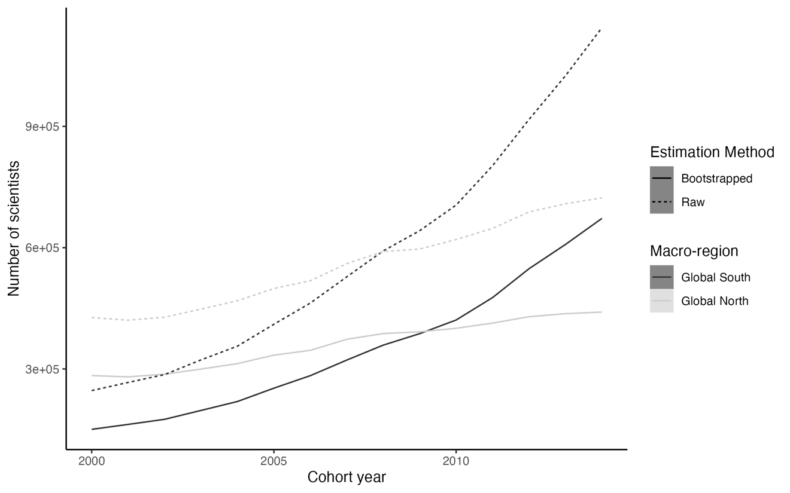
Supplementary Figure 1. Growth of scientists over time (over successive cohorts) in the Global North and the Global South. The figure shows both the trends in the raw data as well as the trends that result from the bootstrapped estimates that are used in the main text.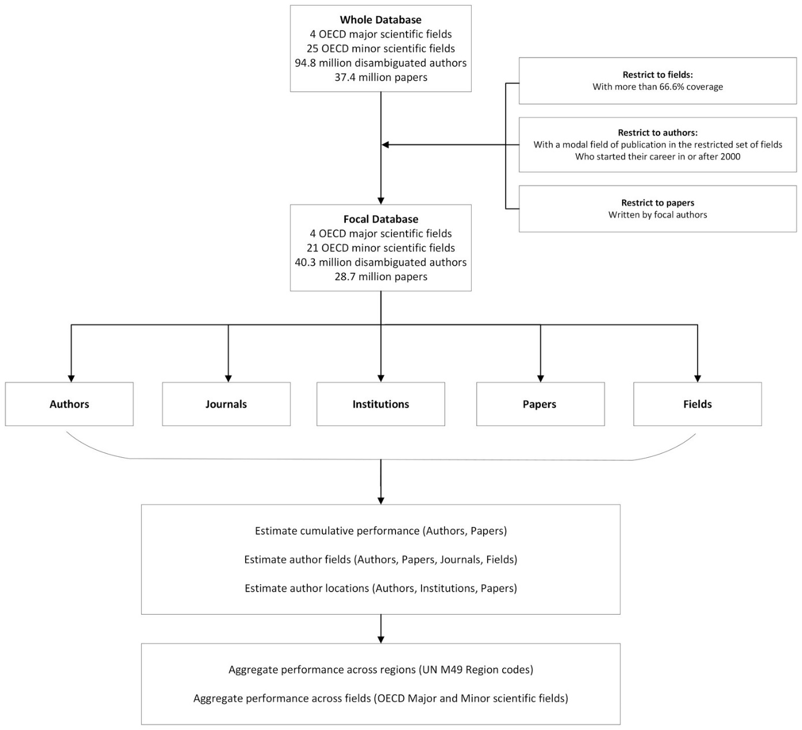
Supplementary Figure 2. Flowchart of data inclusion and exclusion.

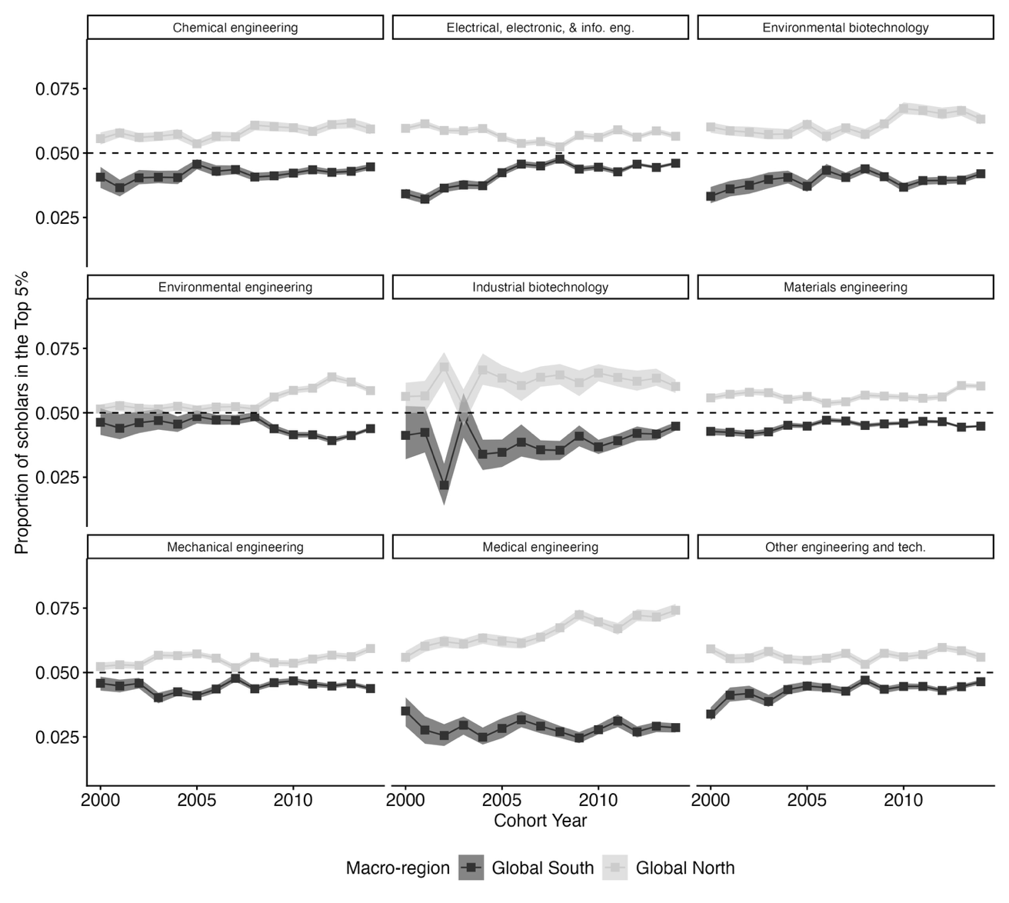
Supplementary Figure 3. Proportion of scientists in the Top 5% by global region, and scientific field within Engineering.

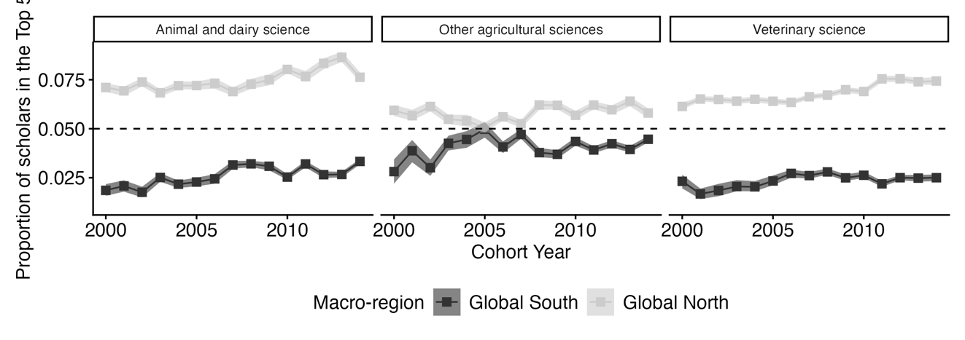
Supplementary Figure 4. Proportion of scientists in the Top 5% by global region, and scientific field within Agricultural and Veterinary Sciences.

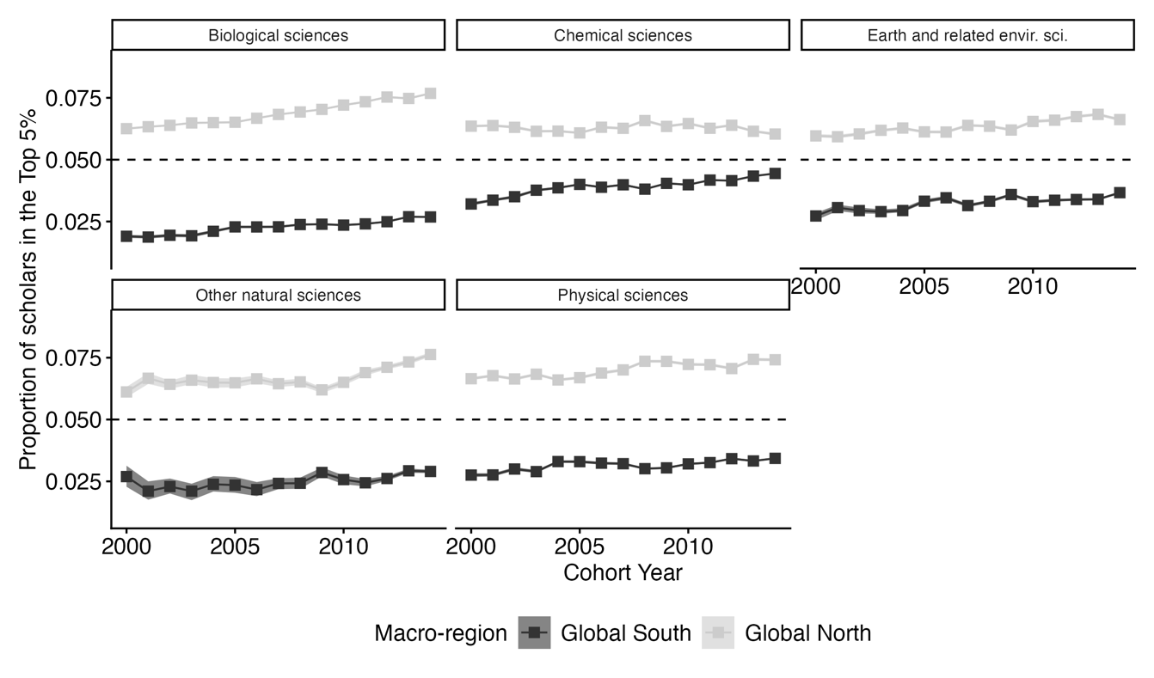
Supplementary Figure 5. Proportion of scientists in the Top 5% by global region, and scientific field within the Natural Sciences.

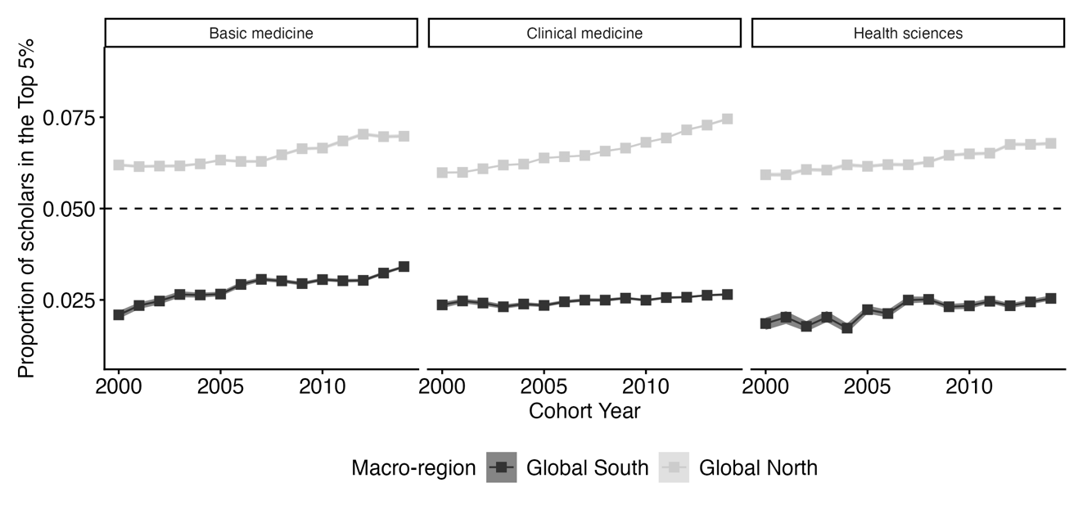
Supplementary Figure 6. Proportion of scientists in the Top 5% by global region, and scientific field within the Medical and Health Sciences.

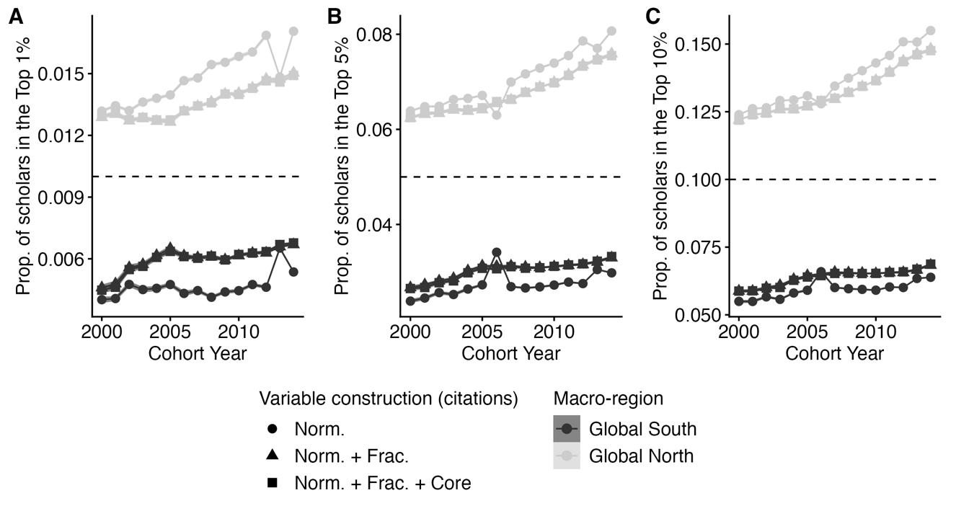
Supplementary Figure 7. The proportion of a region’s scientists that are members of the top 1% (Panel A), top 5% (Panel B) or top 10% (Panel C) of scientists at the end of the 5th year of their careers. Each panel shows the results for different definitions of elite, from the most restrictive on the left (top 1%) to the most inclusive on the right (top 10%). Shapes represent three different variations in how to measure cumulative citations. Note that confidence intervals are included in this plot, but they are narrower than the width of the plotted line.

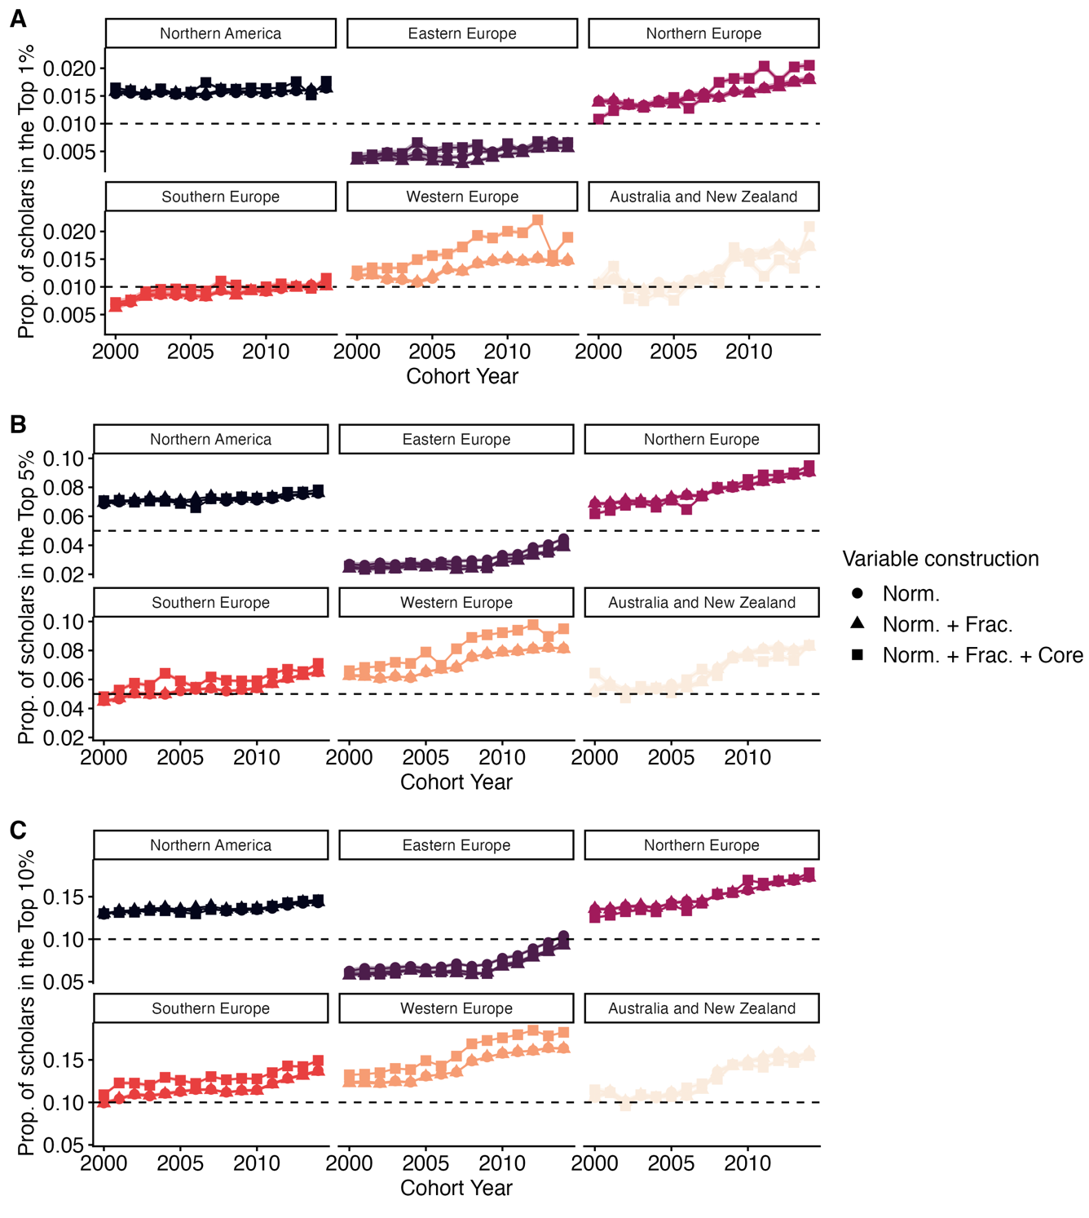
Supplementary Figure 8. Same as Supplementary Figure 7 but showing results according to UN M49 Subregions within the Global North.

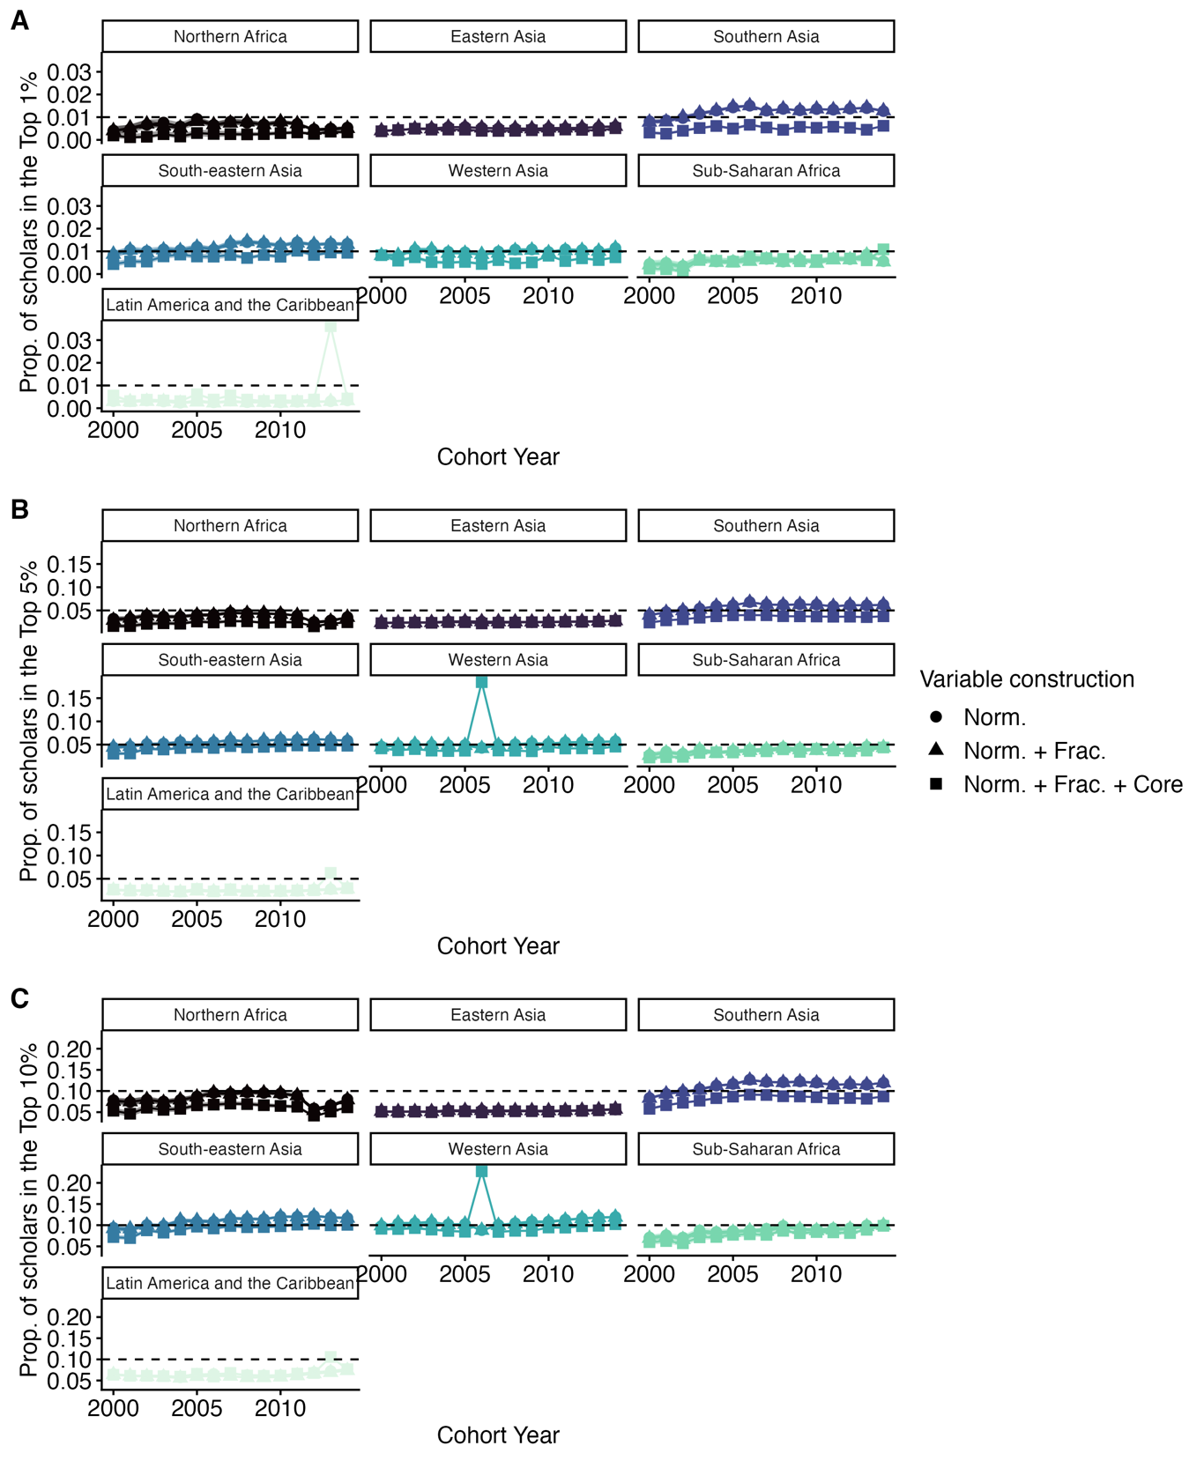
Supplementary Figure 9. Same as Supplementary Figure 7 but showing results according to UN M49 Subregions within the Global South.

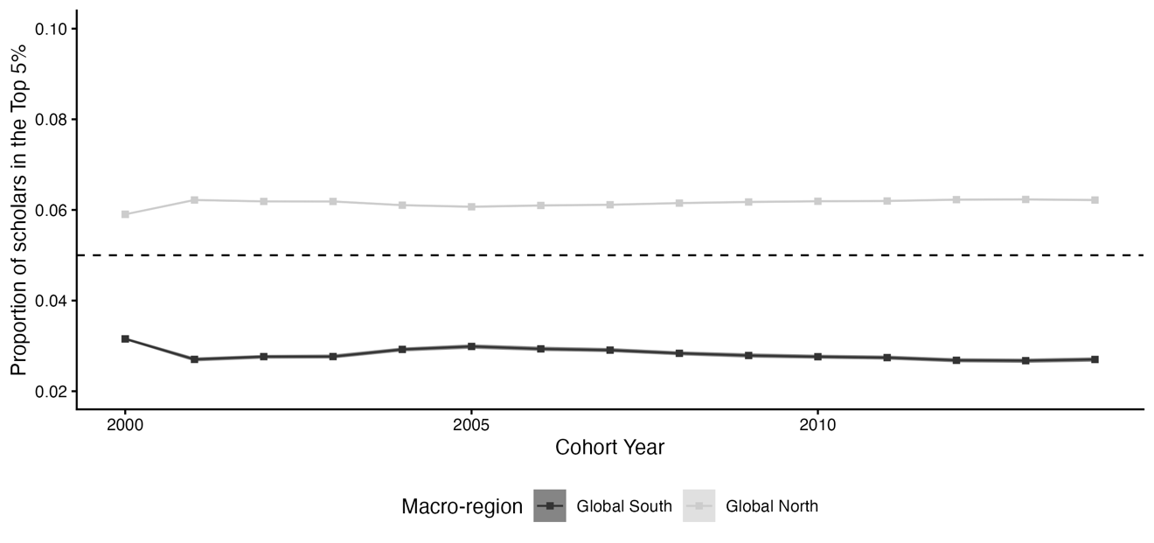Supplementary Figure 10. The proportion of scientists in the top 5% by cohort, aggregated for the Global North and South, under a simulation where the Global South does not expand faster than the Global North.

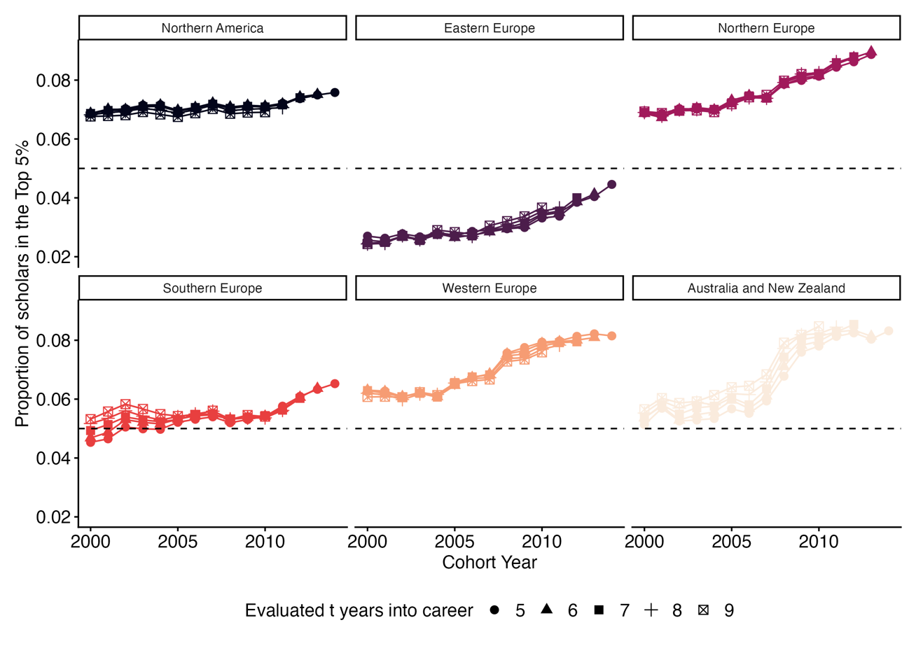
Supplementary Figure 11. Same as Figure 3B but now separated by subregion within the Global North. We have removed the confidence intervals to improve visibility of the lines.

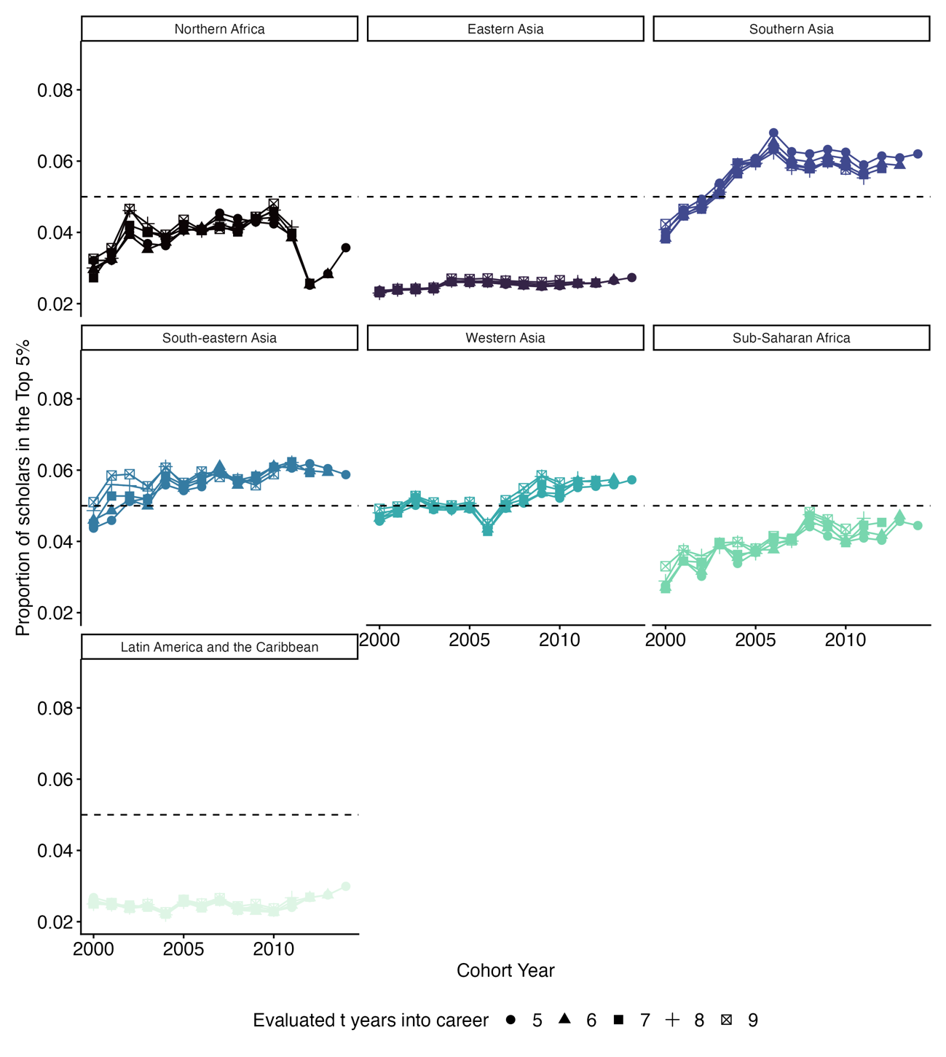
Supplementary Figure 12. Same as Figure 3B but now separated by subregion within the Global South. We have removed the confidence intervals to improve visibility of the lines.

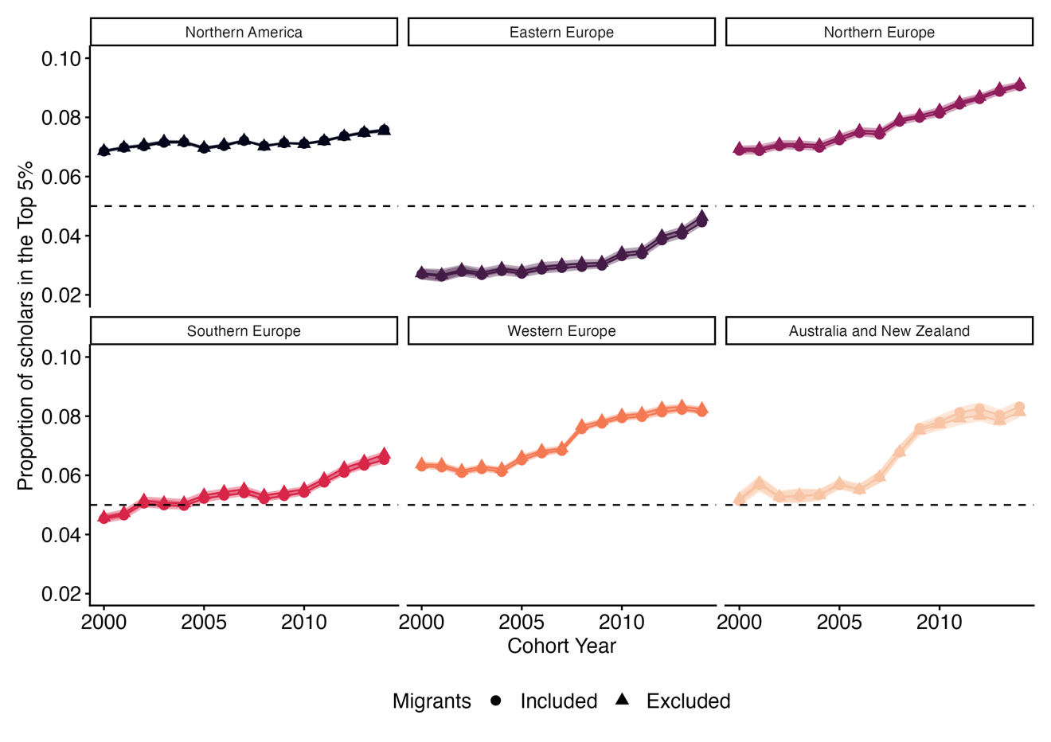
Supplementary Figure 13. Same as Figure 3C but now separated by subregion within the Global North.

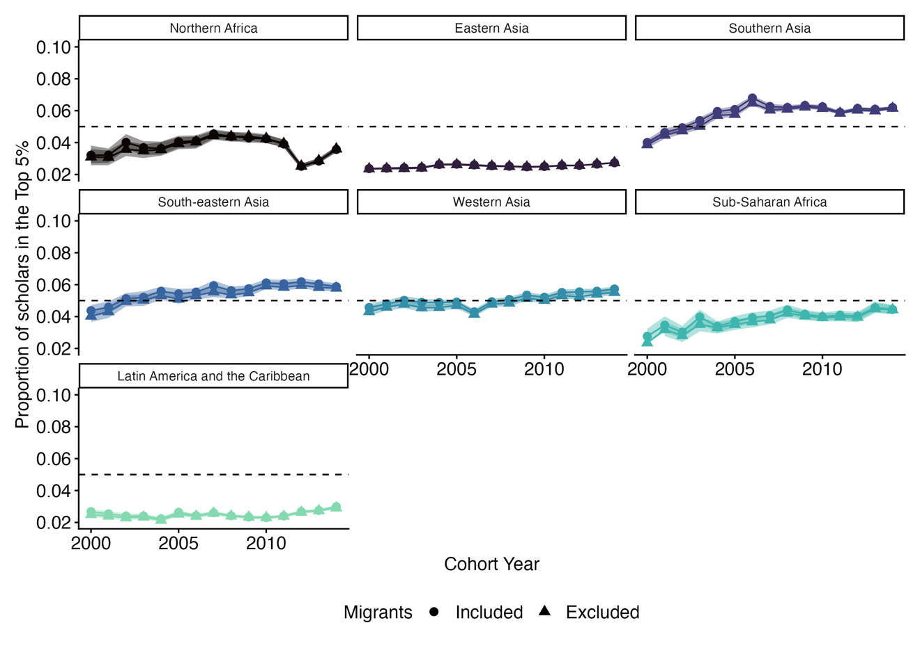
Supplementary Figure 14. Same as Figure 3C but now separated by subregion within the Global South.

