Supplementary Material S1 to Integration or Stratification? Cumulative Advantage and Prestige Homophily in the CEEPUS Inter-university Network
Figure S1: Indegree goodness of fit plot.
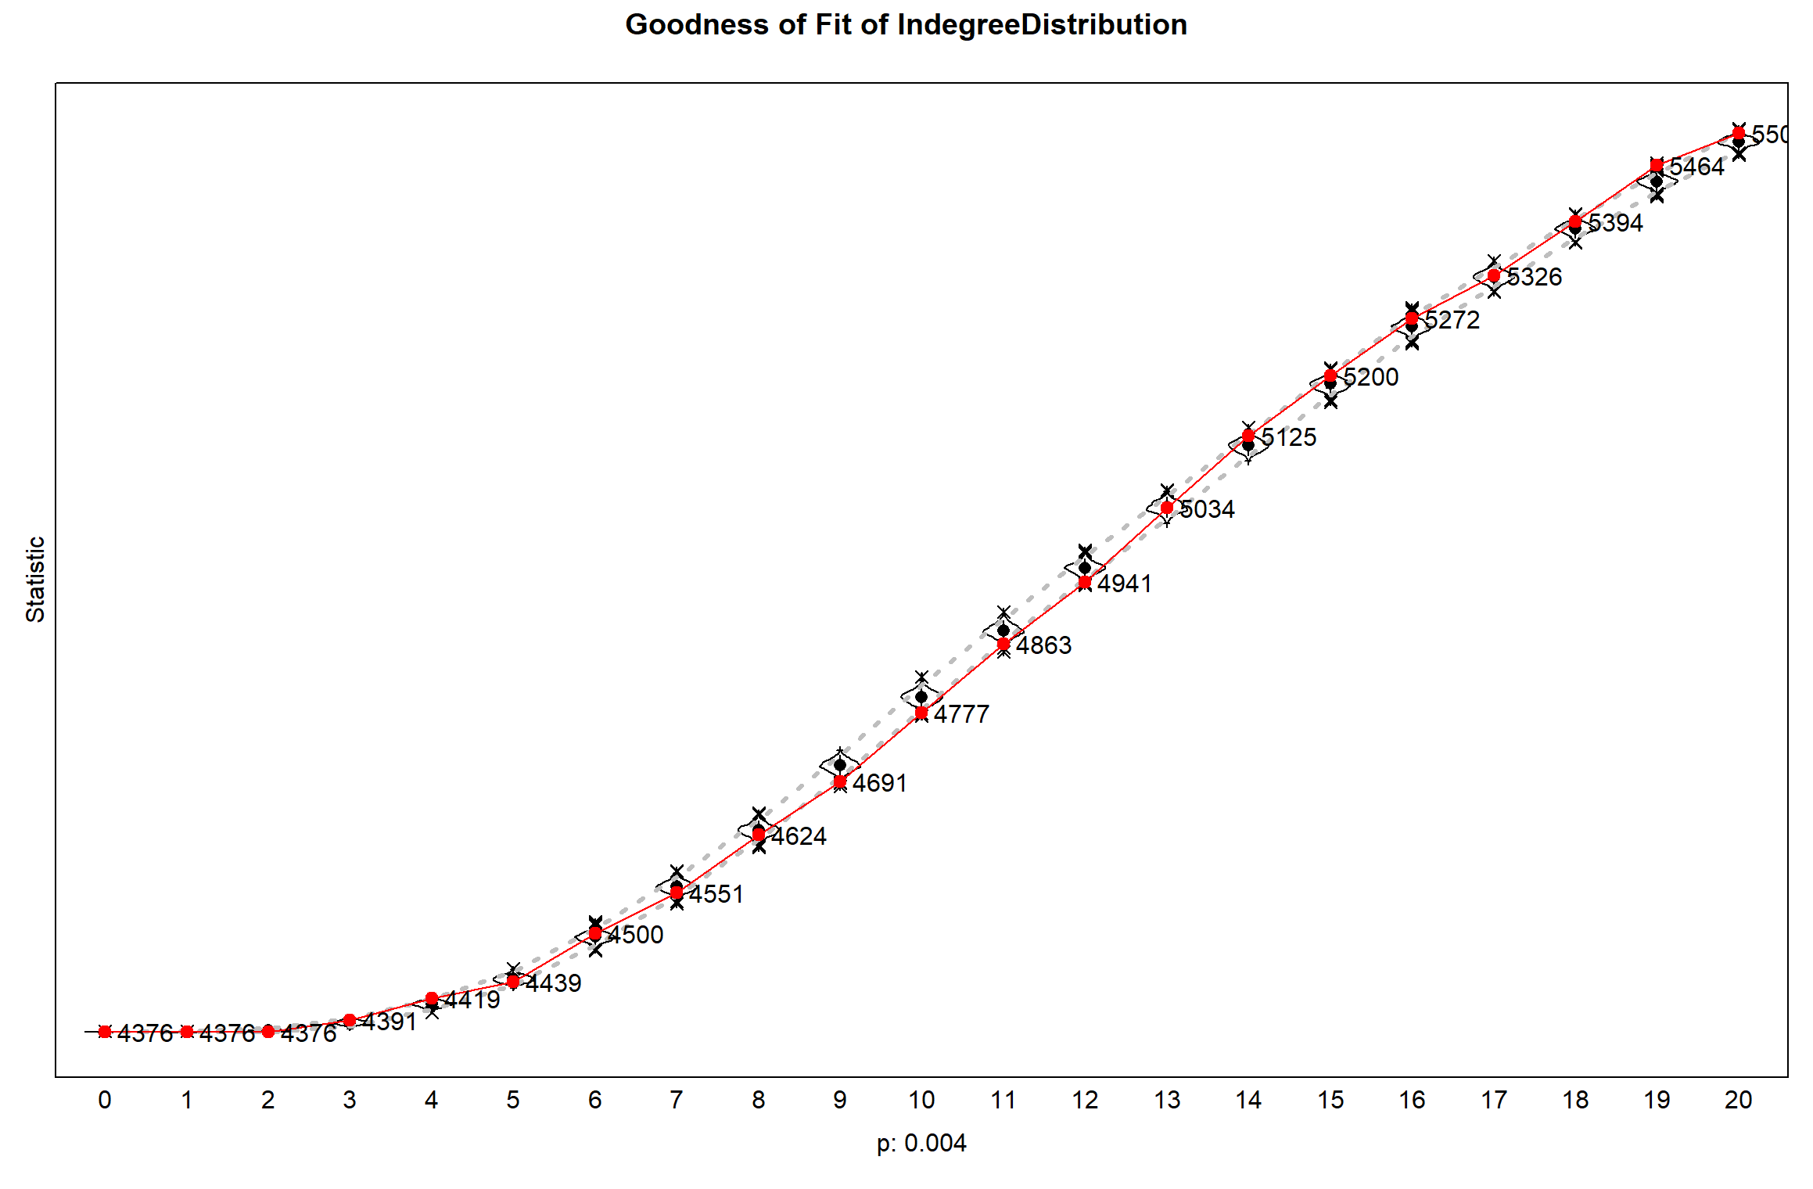
Figure S2. Outdegree goodness of fit plot.
