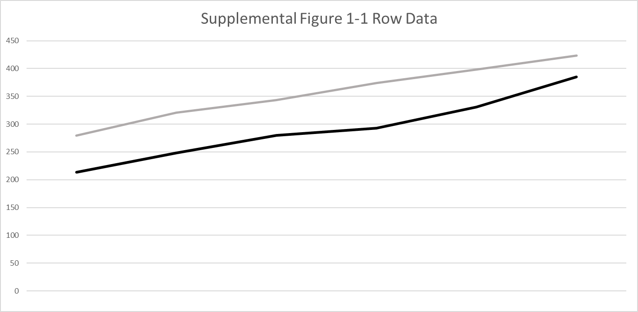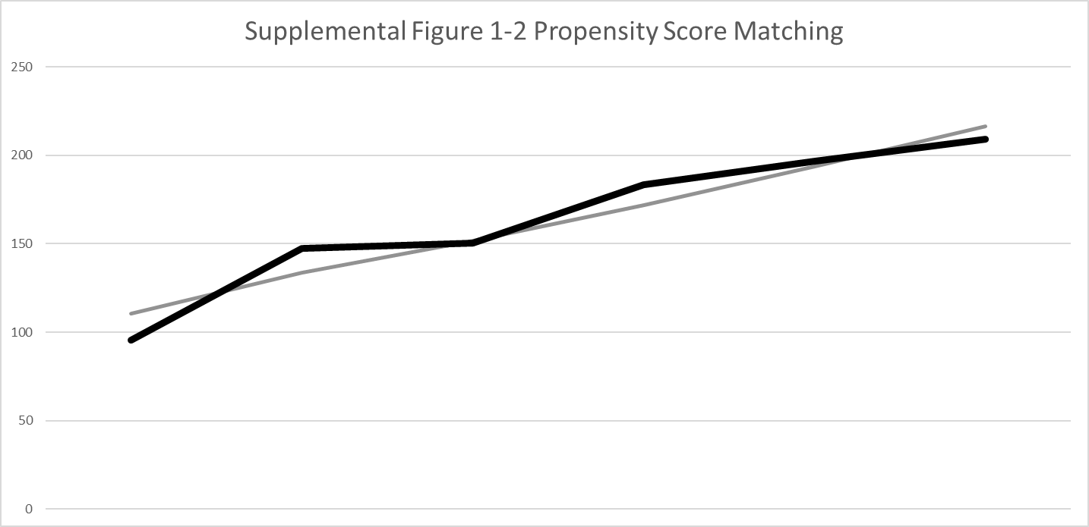
Vertical axis; medical expenses per person per month (USD)
Horizontal axis; time
Thin line: not provided
Dark line: provided
USD/JPY was 150 (October 21, 2022).

