A checklist for causal study design using real-world data.
1. Research question: | Click or tap here to enter text.
2. Effect in whom? | ☐ Average treatment effect (ATE)  ☐ Average effect in the treated (ATT)  ☐ Other (specify): Enter text here.
3. What kind of effect(s)? | ☐ Intention to treat (ITT)  ☐ Per-protocol  ☐ As-treated  ☐ Other (specify): Enter text here.
4. Measure(s) of effect? | ☐ Risk ratio  ☐ Risk difference  ☐ Number needed to treat  ☐ Rate ratio  ☐ Rate difference  ☐ Hazard ratio  ☐ Odds ratio  ☐ Other (specify): Enter text here.
5. Draw a directed acyclic graph (DAG) | Draw by hand in the space below, or by using tools such as DAGitty.  Example:  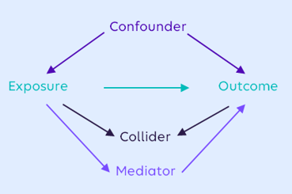
6. Biases  (check all that apply and list relevant variables) | ☐ Measured confounding: Enter text here.  ☐ Unmeasured confounding: Enter text here.  ☐ Collider bias: Enter text here.  ☐ Selection bias: Enter text here.  ☐ Immortal time bias: Enter text here.  ☐ Protopathic bias (reverse causality): Enter text here.  ☐ Healthy adherer effect: Enter text here.  ☐ Prevalent user bias: Enter text here.  ☐ Dependent/informed censoring: Enter text here.  ☐ Exposure misclassification bias: Enter text here.  ☐ Outcome misclassification bias: Enter text here.  ☐ Generalizability or transportability challenges: Enter text here.  ☐ Other (specify): Enter text here.
7. Solutions  (check all that apply) | ☐ Target trial framework used to aid in study design  ☐ New user design  ☐ Active comparator  ☐ Choice and rationale of estimator (e.g., logistic regression model): Enter text here.  ☐ Missing data rules: Enter text here.  ☐ Matching on the following variables: List variables here.  ☐ Propensity score based  ☐ Other: Enter text here.  ☐ Weighting on the following variables: List variables here.  ☐ Propensity score based  ☐ Other: Enter text here.  ☐ Marginal structural model  ☐ Survival analysis  ☐ Censoring weights: List variables here.  ☐ Other: Enter text here.
8. Describe quality checks and sensitivity analyses | ☐ Validation study planned or referenced for the following variables: Enter text here.  ☐ Quantitative bias analysis planned for the following issues: Enter text here.  ☐ Sensitivity analyses planned varying the following parameters or definitions: Enter text here.  ☐ List ways to check assumptions of the statistical techniques or other methods used: Enter text here.

