Annex
Table 1. Main information of the Resguardos where indigenous researchers live. Source: Ministerio del Interior (2020), ONI (2024) and coauthors indigenous studies of this study
Community | Resguardo & Location | Area (ha) | Coordinates | Population | Environment | Main Livelihoods
Arhuaco | Sierra Sabana Crespo, Valledupar, Cesar (Sierra Nevada de Santa Marta) | 25,255 | 10.6833° N, 73.2500° W | ~18,000 | Mountainous cloud forest | Agriculture, small livestock farming, crafts
Tikuna | San Martín de Amacayacu, Puerto Nariño, Amazonas | 183,000 | 3.791° S, 70.267° W | ~700 | Amazonian rainforest | Traditional agriculture (chagra), fishing, crafts, tourism
Uitoto | Los Kilómetros, Leticia, Amazonas | 7,540 | 4.1106° N, 69.9426° W | ~1,080 | Amazonian rainforest | Traditional agriculture (chagra), hunting, fishing, crafts, tourism
Pijao | Totarco Tamarindo, Coyaima, Tolima | 197 | 3.7117° N, 75.1933° W | ~800 | Tropical dry forest | Agriculture, livestock, crafts
Emberá-Chamí | Nuestra Señora Candelaria de la Montaña, Riosucio, Caldas | 20,300 | 5.4200° N, 75.7000° W | ~17,723 | Andean forest | Agriculture, crafts

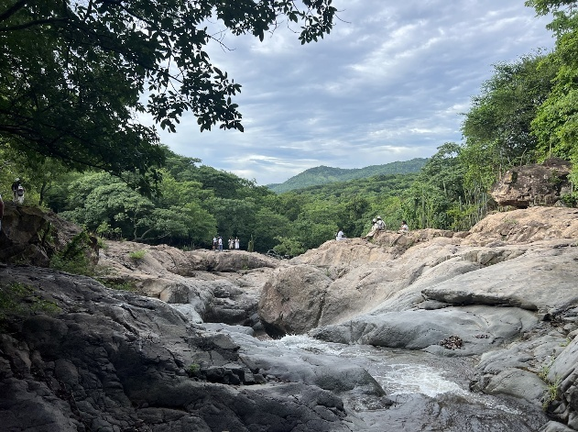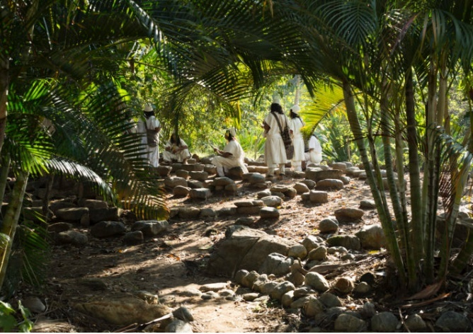
Fig. 4. Arhuaco territory in the Sierra Nevada de Santa Marta, Gun Aruwun Resguardo, and protected landscapes. Source: Left - Authors; Right - Confederación Indígena Tayrona (2020).

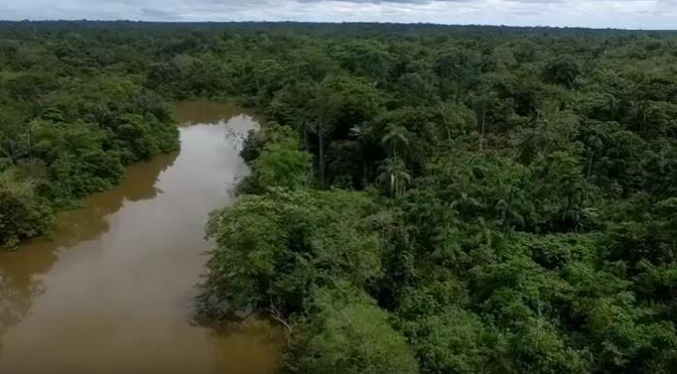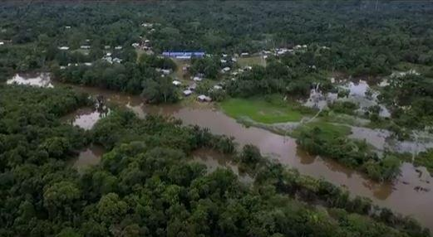
Fig. 5. Tikuna territory along the Amacayacu River and in the village of San Martín de Amacayacu. Source: the authors.
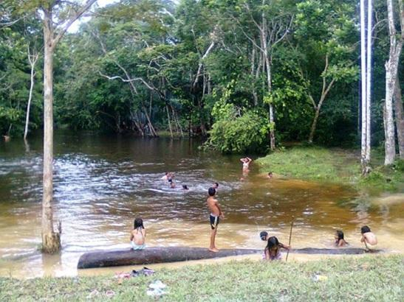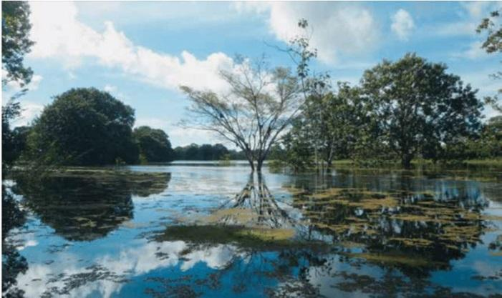
Fig. 6. Uitoto territory in the Department of Amazonas. Left – Tacana River (Source: Agudelo, 2014); Right – Yahuarcaca Lake (Source: Cassú Camps, 2015).

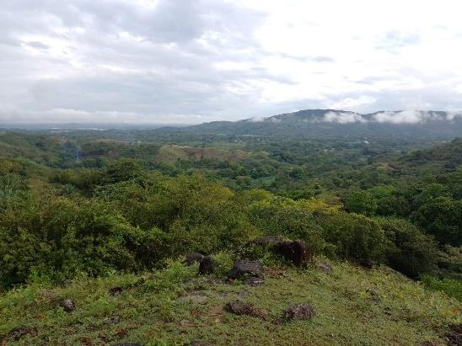
Fig. 7. Pijao territory in the Department of Tolima, municipality of Coyaima. Source: Authors.
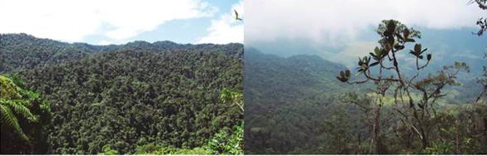
Fig. 8. Embera Chamí territory in Nuestra Señora Candelaria de La Montaña, Resguardo in Riosucio, Caldas.
Left - Forests of La Soledad Right - Forests of Palermo (Source: Duque-Castrillón, C. A., & Sierra-Giraldo, J. A, 2022)

