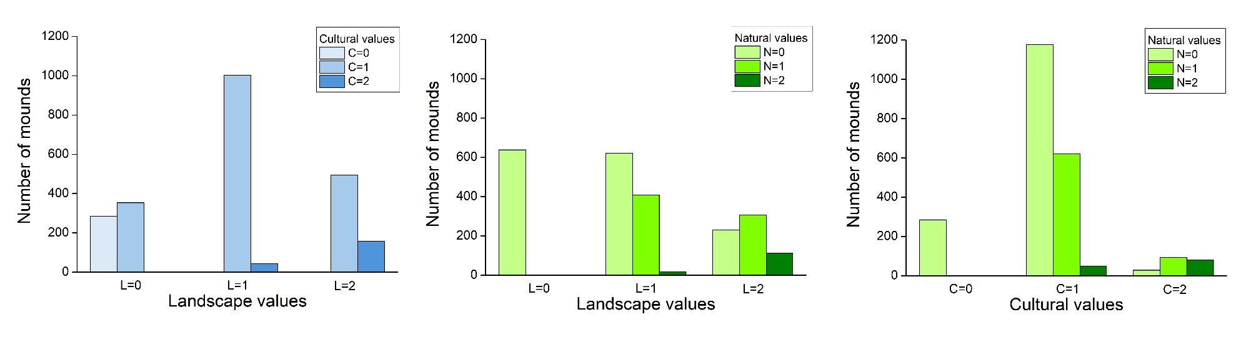
Appendix 3. Diagrams of crosstabulation analysis in each category of the value coupling. A: landscape vs. cultural values; B: landscape vs. natural values; C: cultural vs. natural values (N = 2,335).

