Supplementary Table 1. Summary for the concatenation of mitochondrial genes and microsatellite data in B. plicatilis per sampling point. Number of B. plicatilis s. s.diapausing eggs genetically characterized (N; between parentheses, number of eggs found from other species of the B. plicatilis complex), number of haplotypes/alleles (Na), effective number of haplotypes/alleles (eNa), Shannon-Weaver index (I), observed heterozygosity (Ho), unbiased genetic diversity (h for mitochondrial, and He for microsatellites), and fixation index (F). For microsatellites, values are average across loci, with its standard error between parentheses.

 |  | Mitochondrial |  |  |  |  | Microsatellites
Lake | Point | N | Na | eNa | I | h | N | Na | eNa | I | Ho | He | F
ATA | Center | 29 (9) | 2 | 1.08 | 0.16 | 0.07 | 18 | 2.17 (0.40) | 1.53 (0.23) | 0.46 (0.15) | 0.32 (0.12) | 0.29 (0.09) | -0.04 (0.16)
ATA | Shore | 18 (0) | 1 | 1 | 0 | 0 | 18 | 2.33 (0.33) | 1.42 (0.21) | 0.42 (0.14) | 0.25 (0.11) | 0.24 (0.09) | 0.00 (0.09)
CAM | Center | 10 (3) | 2 | 1.22 | 0.33 | 0.2 | 9 | 2.50 (0.43) | 1.76 (0.19) | 0.65 (0.15) | 0.28 (0.06) | 0.41 (0.09) | 0.25 (0.13)
CAM | Shore | 0 (0) | -- | -- | -- | -- | 0 | -- | -- | -- | -- | -- | --
HTU | Center | 0 (0) | -- | -- | -- | -- | 0 | -- | -- | -- | -- | -- | --
HTU | Shore | 40 (0) | 1 | 1 | 0 | 0 | 22 | 2.17 (0.65) | 1.53 (0.26) | 0.42 (0.19) | 0.29 (0.14) | 0.26 (0.12) | -0.14 (0.11)
HYB | Center | 44 (0) | 2 | 1.1 | 0.19 | 0.09 | 24 | 3.17 (0.48) | 1.93 (0.33) | 0.73 (0.18) | 0.42 (0.10) | 0.41 (0.10) | -0.07 (0.07)
HYB | Shore | 48 (0) | 1 | 1 | 0 | 0 | 23 | 2.83 (0.48) | 1.95 (0.36) | 0.71 (0.19) | 0.37 (0.09) | 0.41 (0.11) | 0.06 (0.06)
HYC | Center | 1 (0) | 1 | 1 | 0 | 0 | 0 | -- | -- | -- | -- | -- | --
HYC | Shore | 0 (0) | -- | -- | -- | -- | 0 | -- | -- | -- | -- | -- | --
HYE | Center | 3 (0) | 1 | 1 | 0 | 0 | 3 | 1.83 (0.54) | 1.70 (0.46) | 0.39 (0.25) | 0.22 (0.17) | 0.27 (0.17) | 0.04 (0.24)
HYE | Shore | 1 (0) | 1 | 1 | 0 | 0 | 1 | 1.33 (0.21) | 1.33 (0.21) | 0.23 (0.15) | 0.33 (0.21) | 0.33 (0.21) | -1.00 (0.00)
HYM | N Shore | 47 (0) | 2 | 1.72 | 0.61 | 0.43 | 23 | 2.50 (0.43) | 1.95 (0.31) | 0.65 (0.20) | 0.39 (0.12) | 0.40 (0.12) | 0.00 (0.05)
HYM | S Shore | 48 (0) | 2 | 2 | 0.69 | 0.51 | 24 | 2.50 (0.56) | 2.03 (0.40) | 0.66 (0.23) | 0.33 (0.11) | 0.39 (0.13) | 0.16 (0.03)
HYR | Center | 46 (1) | 2 | 1.95 | 0.68 | 0.5 | 23 | 2.67 (0.42) | 1.73 (0.23) | 0.61 (0.15) | 0.33 (0.11) | 0.37 (0.09) | 0.16 (0.14)
HYR | Shore | 48 (0) | 2 | 1.98 | 0.69 | 0.51 | 24 | 2.50 (0.43) | 1.78 (0.25) | 0.61 (0.16) | 0.39 (0.10) | 0.38 (0.1) | -0.04 (0.07)
MJB | Center | 4 (0) | 3 | 2.67 | 1.04 | 0.83 | 5 | 2.50 (0.56) | 1.75 (0.35) | 0.58 (0.21) | 0.40 (0.16) | 0.36 (0.13) | -0.17 (0.16)
MJB | Shore | 0 (0) | -- | -- | -- | -- | 0 | -- | -- | -- | -- | -- | --
MSA | Center | 2 (5) | 1 | 1 | 0 | 0 | 2 | 1.33 (0.21) | 1.20 (0.13) | 0.19 (0.12) | 0.17 (0.11) | 0.17 (0.11) | -0.33 (0.00)
MSA | Shore | 0 (0) | -- | -- | -- | -- | 0 | -- | -- | -- | -- | -- | --
ONT | Center | 26 (14) | 1 | 1 | 0 | 0 | 25 | 3.17 (0.48) | 2.06 (0.26) | 0.79 (0.15) | 0.39 (0.07) | 0.48 (0.08) | 0.13 (0.07)
ONT | Shore | 0 (3) | -- | -- | -- | -- | 0 | -- | -- | -- | -- | -- | --
PET | N Shore | 45 (134) | 5 | 2.98 | 1.23 | 0.68 | 5 | 2.33 (0.42) | 1.93 (0.32) | 0.66 (0.17) | 0.43 (0.12) | 0.46 (0.11) | -0.10 (0.20)
PET | S Shore | 64 (104) | 5 | 2.21 | 1.12 | 0.58 | 26 | 3.00 (0.73) | 2.27 (0.51) | 0.77 (0.24) | 0.37 (0.12) | 0.44 (0.13) | 0.13 (0.10)
SAL | Center | 38 (48) | 2 | 1.6 | 0.56 | 0.39 | 18 | 2.50 (0.76) | 1.54 (0.25) | 0.48 (0.19) | 0.26 (0.10) | 0.28 (0.10) | 0.07 (0.07)
SAL | Shore | 61 (22) | 2 | 1.63 | 0.58 | 0.4 | 22 | 2.17 (0.60) | 1.44 (0.23) | 0.39 (0.18) | 0.21 (0.10) | 0.23 (0.10) | 0.07 (0.06)
SLD | E Shore | 40 (0) | 2 | 1.76 | 0.62 | 0.44 | 23 | 2.67 (0.76) | 2.17 (0.59) | 0.65 (0.28) | 0.36 (0.16) | 0.36 (0.15) | 0.07 (0.11)
SLD | N Shore | 6 (0) | 2 | 1.32 | 0.41 | 0.29 | 7 | 2.50 (0.67) | 1.75 (0.41) | 0.54 (0.24) | 0.33 (0.15) | 0.31 (0.14) | -0.15 (0.03)

Supplementary Table 2. Private alleles found in the microsatellite and mitochondrial loci analysed. Locus, microsatellite allele or mitochondrial haplotype and lake’s allelic frequency are shown.

Lake | Locus type | Locus | Allele/haplotype | Freq
HTU | Microsatellite | Bp2 | 174 | 0.02
HYM | Microsatellite | Bp5 | 248 | 0.17
HYM | Mitochondrial | COI | H16 | 0.41
ONT | Microsatellite | Bp1 | 243 | 0.02
ONT | Microsatellite | Bp2 | 199 | 0.08
ONT | Microsatellite | Bp4a | 216 | 0.06
PET | Microsatellite | Bp2 | 146 | 0.02
PET | Microsatellite | Bp3c | 196 | 0.07
PET | Mitochondrial | COI | H23 | 0.02
SAL | Microsatellite | Bp2 | 155 | 0.01
SAL | Mitochondrial | 16S | H4 | 0.73

Supplementary Table 4. Linear determination coefficients between mitochondrial (h) and microsatellite genetic diversity (He), on the one hand, and untransformed or log-transformed population size proxies (lake area and size of B. plicatilis s. s. diapausing egg bank), on the other hand.

Genetic diversity | Population size proxy | R² | df | p-value
Mitochondrial (h) | Lake area | 0.345 | 8 | 0.074
Mitochondrial (h) | Log lake area | 0.345 | 8 | 0.074
Mitochondrial (h) | Size of B. plicatilis s. s. egg bank | 0.380 | 8 | 0.058
Mitochondrial (h) | Log size of B. plicatilis s. s. egg bank | 0.089 | 8 | 0.401
Microsatellites (He) | Lake area | 0.128 | 8 | 0.311
Microsatellites (He) | Log lake area | 0.146 | 8 | 0.275
Microsatellites (He) | Size of B. plicatilis s. s. egg bank | 0.080 | 8 | 0.429
Microsatellites (He) | Log size of B. plicatilis s. s. egg bank | 0.002 | 8 | 0.914

Supplementary Figure 1. Google Earth’s satellite images used to estimate maximum lake area. Lines delimit the maximum area considered.

Supplementary Figure 2. Comparison of frequency of B. plicatilis s. s. diapausing eggs between center and shore for the lakes were more than one species of the B. plicatilis species complex is present.

Supplementary Figure 3. Genetic diversity for microsatellites (left panel) and mitochondrial genes (right panel) for each sampling point. Bars are the 95% confidence interval.

Supplementary Figure 4. Scatterplot showing the relationships between genetic and geographical distances. Genetic distance is based on haplotypes for mitochondrial genes COI and 16S (Φ_{st}) (a) and microsatellite data for six loci (F_{st}) (b). Solid lines represent linear correlations and dashed lines 95% confidence intervals.

Supplementary Figure 5. Relationship between the number of alleles/haplotypes corrected by rarefaction and B. plicatilis s. s. egg bank size (two superior panels) and lake size (two inferior panels) for microsatellites (left panels) and mitochondrial concatenate (right panels) after excluding Pétrola, the largest lake. Lines were fitted using least squares linear regression using untransformed (dashed line) or log-transformed (solid line) population size proxies.

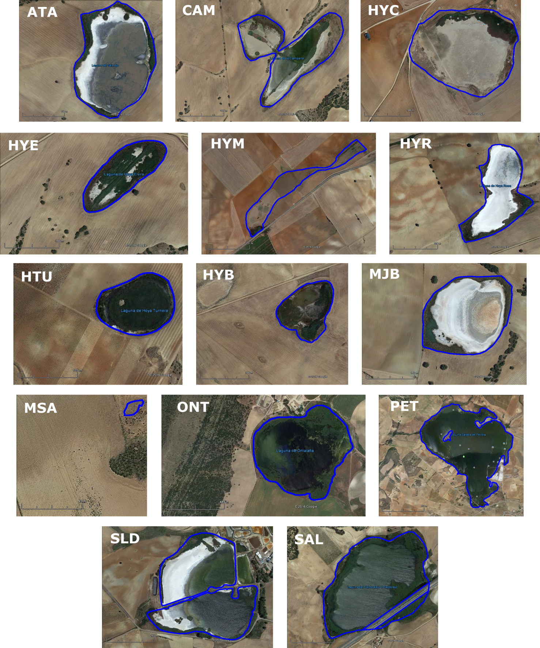

Suppl. Fig. 1

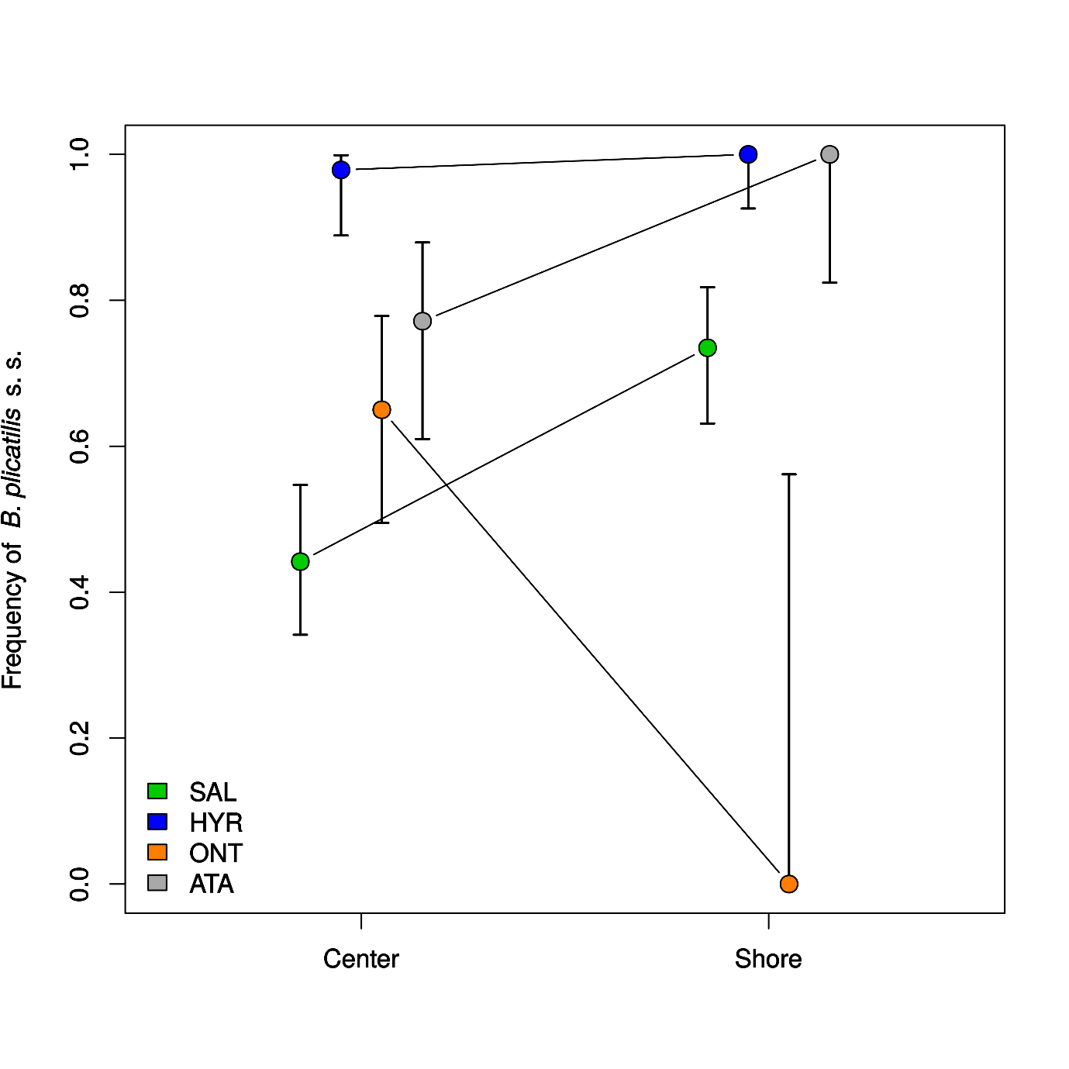
Suppl. Fig. 2

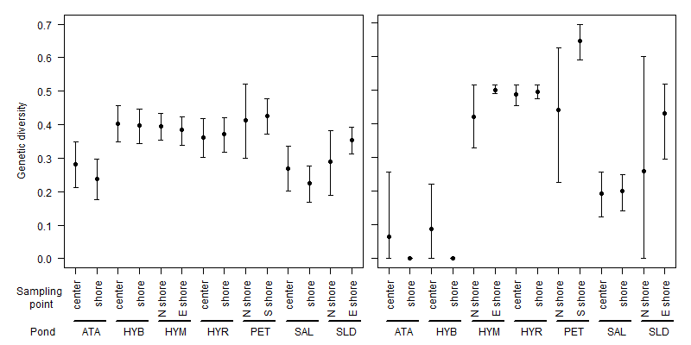

Suppl. Fig 3

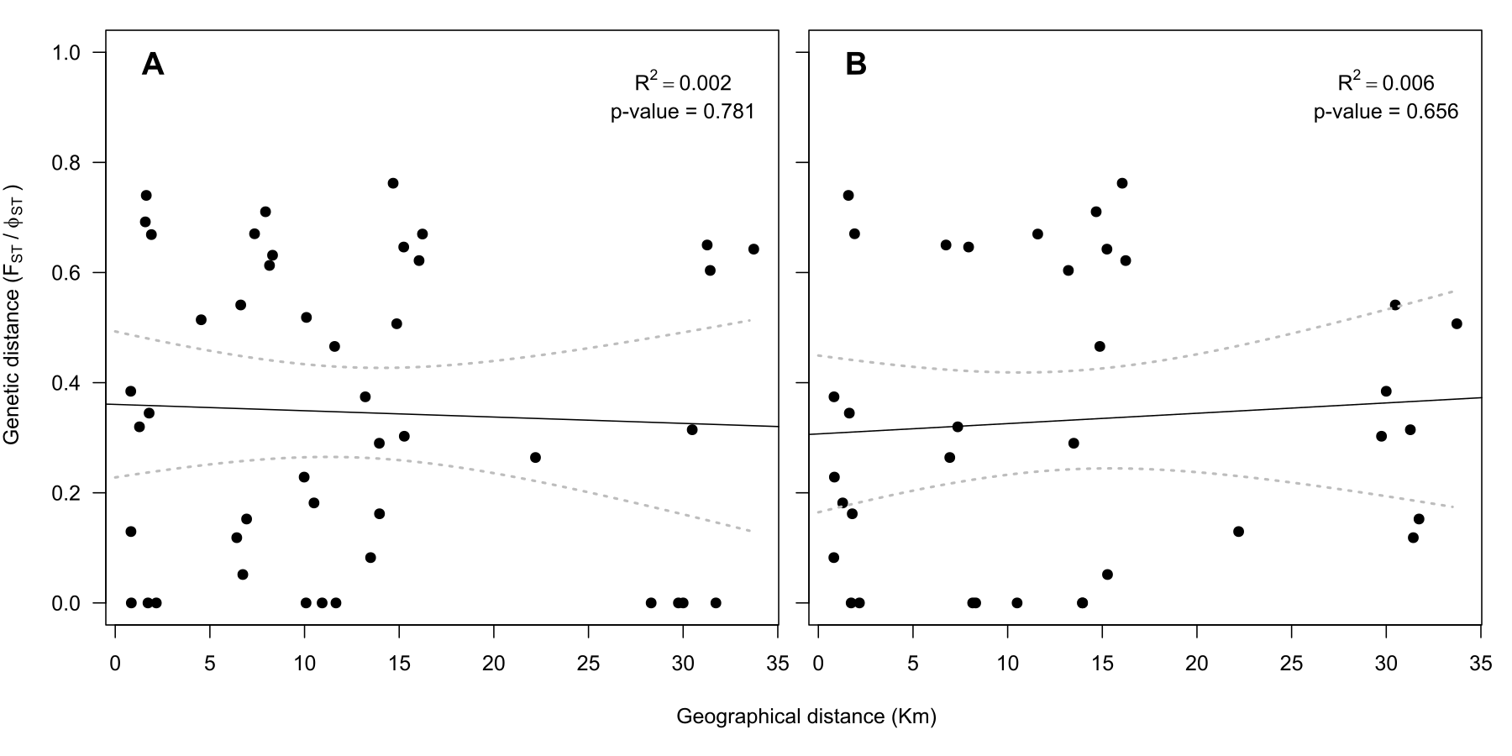

Suppl. Fig. 4

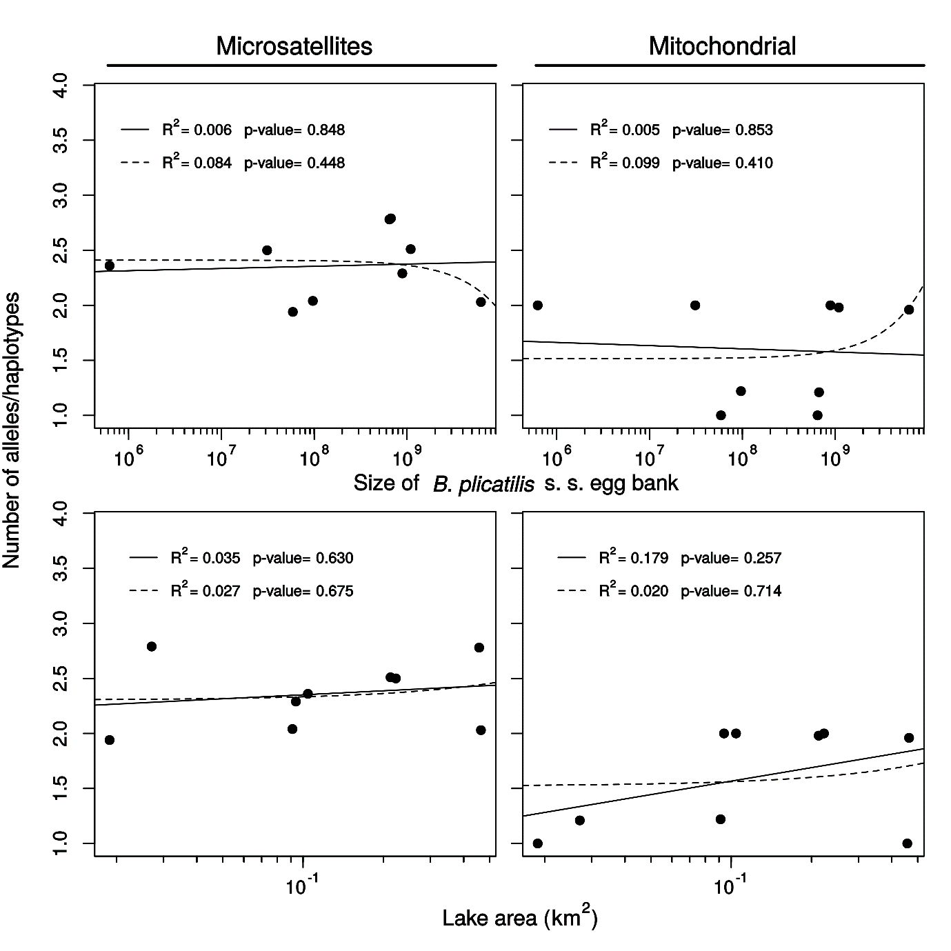
Suppl. Fig. 5

