Appendix
Macroinvertebrates taxa retrieved in the samples and relative code.
Baetis sp. | BAE
Blephariceridae | BLE
Chironomidae | CHI
Capniidae | CAP
Chloroperlidae | CHL
Dixidae | DIX
Limnius sp. (Elmidae) | ELM
Empididae | EMP
Heptageniidae | HEP
Leuctra sp. | LEU
Limnephilidae | LIN
Limoniidae | LIM
Lumbricidae | LUM
Mermithidae | MER
Naididae | NAI
Nemoura sp. | NEM
Perlodidae | PER
Crenobia alpina (Planariidae) | PLA
Polycentropodidae | POL
Protonemura sp. | PRO
Psychodidae | PSY
Rhabdiopteryx sp. | RHA
Rhyacophila sp. | RHY
Simuliidae | SIM
Staphylinidae | STA
Sericostoma sp. | SER
Tipulidae | TIP

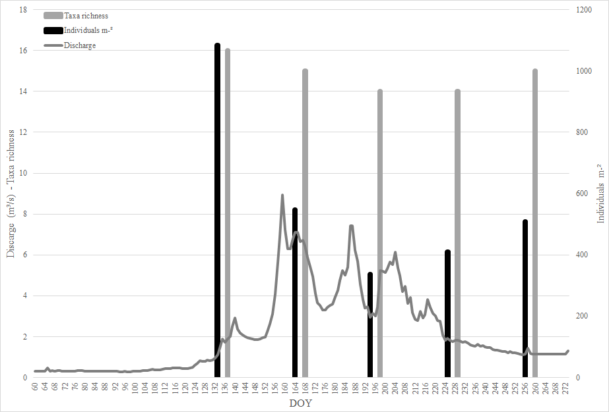
Fig. 1 APPENDIX Relationship between taxa richness, macroinvertebrate abundance and discharge across the sampling season of the study.

