Supporting information
Organic matter resources fuelling food webs in a human-modified lowland river: Importance of habitat and season
Mario Brauns, Marian Brabender, Matthias Gehre, Karsten Rinke & Markus Weitere

Figure S1. Aerial photograph and bathymetric maps of the studied off-bankline revetment and wing dike. The rip rap was not bathymetrically mapped and a picture is given instead. The shares of the mesohabitats are exemplarily shown for an average water level. Stones for the mesohabitat “stones” were collected from the stone bars of the engineering structures.
Off-bankline revetment
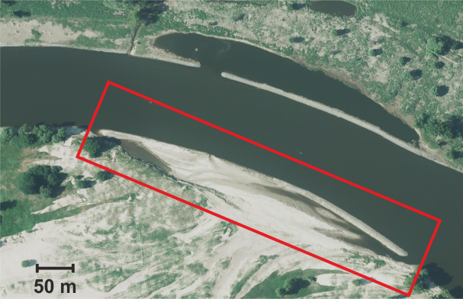 | 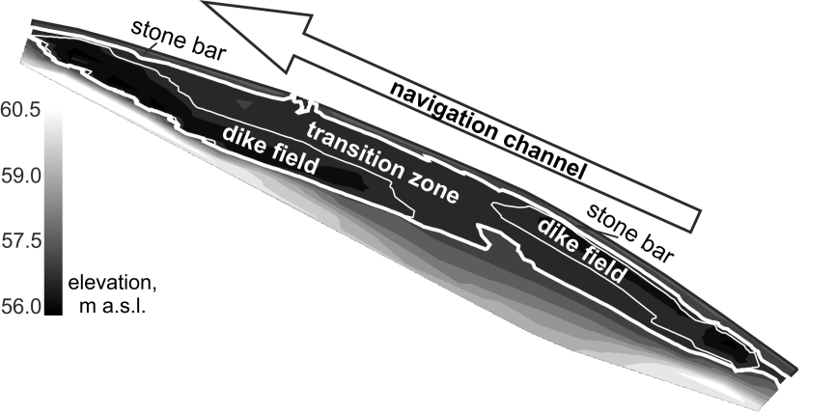
Rip rap
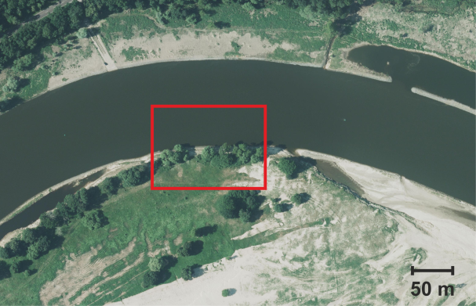 | 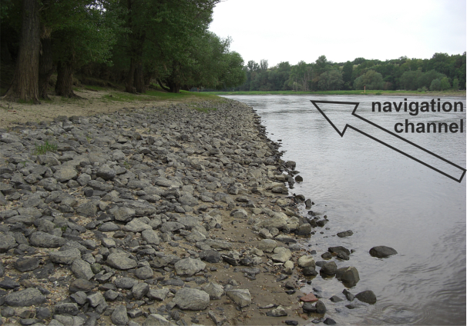
Wing dike
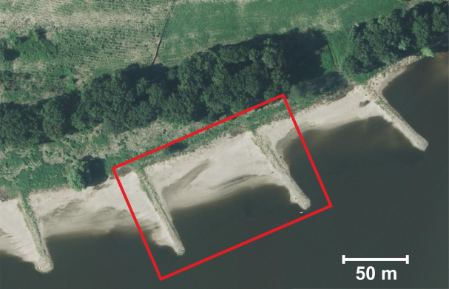 | 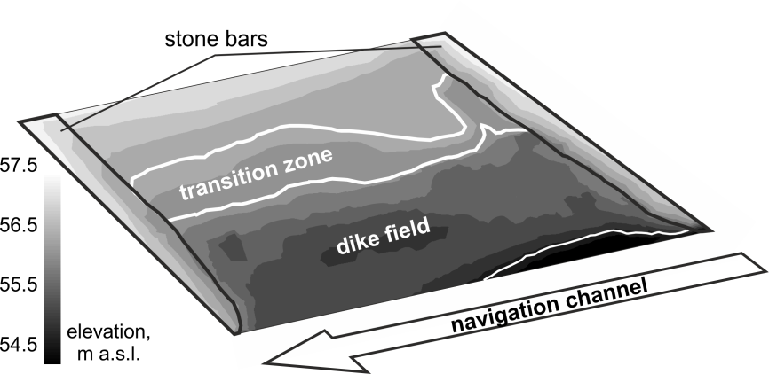

Figure S2. Stable isotope values (δ¹³C and δ¹⁵N) of macroinvertebrates and resources found at the studied engineering structures and seasons in the Elbe River. Stable isotope values of potential resources (mean) are shown as boxes delineated by ±1 SD, values of macroinvertebrates (dots) are given as mean (±1 SD). Resources are: Biofilm (1), Benthic organic matter (2), Phytoplankton (3), t-POM from elm (4), from oak (5), from poplar (6), from herbaceous riparian vegetation (7), and from willow (8). Consumers are: Ametropus fragilis (9), Anabolia nervosa/furcata (10), Ancylus fluviatilis (11), Asellus aquaticus (12), Baetis sp. (13), Brachyptera braueri (14), Chelicorophium curvispinum (15), Chironominae (16), Cloeon dipterum (17), Corbicula fluminea (17), Dikerogammarus villosus (18), Dreissena polymorpha (19), Eiseniella tetraeda (20), Gammarus roeselii (21), Heptagenia sulphurea (22), Hydropsyche bulgaromanorum (23), Hydropsyche contubernalis (24), Jaera sarsi (25), Kageronia fuscogrisea (26), Leptophlebia marginata (27), Limnephilus sp. (28), Limoniidae (29), Oligochaeta (30), Orthocladiinae (31), Physidae (32), Potamanthus luteus (33), Potamopyrgus antipodarum (34), Radix balthica (35), Simuliidae (36), Siphlonurus lacustris (37), and Sphaerium corneum (38).
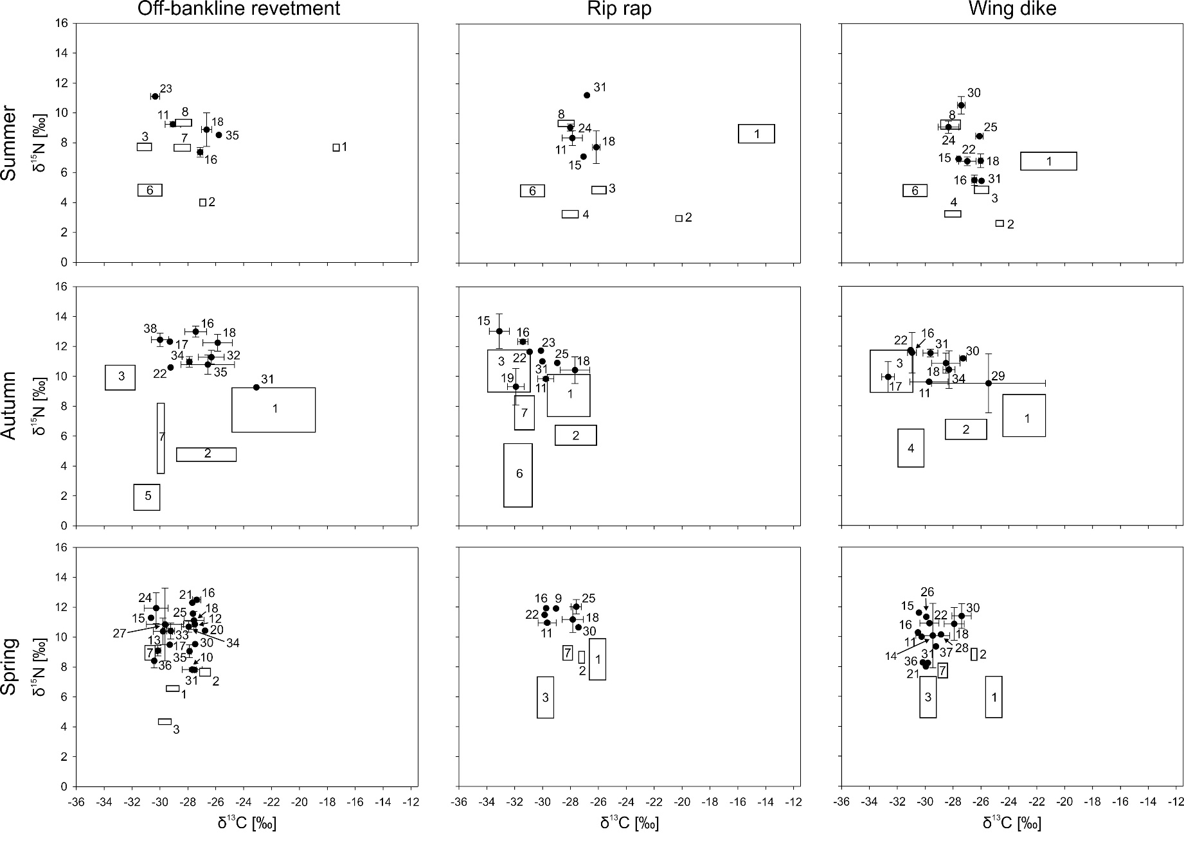

Table S1. Mixing model estimates of the contribution of different resources to the diet of macroinvertebrate primary consumers from the Elbe River. Shown are means and 95% credible intervals. The number in brackets following the species names refer to the number of replicates used for stable isotope analysis.
Engineering |  |  | Resources
structure | Season | Taxon | Biofilm |  | FPOM |  | Phytoplankton |  | t-POM
Off-bankline  revetment | Summer | Ancylus fluviatilis (3) | 0.05 (0.00-0.23) |  | 0.22 (0.00-0.64) |  | 0.18 (0.00-0.55) |  | 0.53 (0.01-0.99)
Off-bankline  revetment | Summer | Chironominae (3) | 0.03 (0.00-0.18) |  | 0.87 (0.45-0.99) |  | 0.02 (0.00-0.09) |  | 0.07 (0.00-0.26)
Off-bankline  revetment | Summer | Dikerogammarus villosus (3) | 0.21 (0.00-0.58) |  | 0.53 (0.00-0.98) |  | 0.05 (0.00-0.20) |  | 0.20 (0.00-0.5)
Off-bankline  revetment | Summer | Hydropsyche bulgaromanorum (2) | 0.02 (0.00-0.09) |  | 0.05 (0.00-0.24) |  | 0.72 (0.00-0.99) |  | 0.19 (0.00-0.95)
Off-bankline  revetment | Summer | Radix balthica (1) | 0.21 (0.00-0.62) |  | 0.56 (0.00-0.99) |  | 0.04 (0.00-0.22) |  | 0.17 (0.00-0.62)
Off-bankline  revetment | Autumn | Chironominae (3) | 0.63 (0.35-0.84) |  | 0.05 (0.00-0.18) |  | 0.25 (0.00-0.48) |  | 0.05 (0.00-0.16)
Off-bankline  revetment | Autumn | Cloeon dipterum (1) | 0.44 (0.06-0.73) |  | 0.10 (0.00-0.32) |  | 0.34 (0.00-0.64) |  | 0.10 (0.00-0.37)
Off-bankline  revetment | Autumn | Dikerogammarus villosus (3) | 0.71 (0.49-0.86) |  | 0.08 (0.00-0.26) |  | 0.15 (0.01-0.28) |  | 0.05 (0.00-0.15)
Off-bankline  revetment | Autumn | Heptagenia sulphurea (1) | 0.47 (0.09-0.76) |  | 0.15 (0.00-0.51) |  | 0.21 (0.00-0.43) |  | 0.15 (0.00-0.46)
Off-bankline  revetment | Autumn | Orthocladiinae (1) | 0.76 (0.20-0.99) |  | 0.14 (0.00-0.72) |  | 0.05 (0.00-0.13) |  | 0.03 (0.00-0.09)
Off-bankline  revetment | Autumn | Physidae (3) | 0.70 (0.45-0.88) |  | 0.11 (0.00-0.37) |  | 0.12 (0.00-0.24) |  | 0.06 (0.00-0.15)
Off-bankline  revetment | Autumn | Potamopyrgus antipodarum (3) | 0.58 (0.28-0.78) |  | 0.14 (0.00-0.43) |  | 0.17 (0.00-0.31) |  | 0.10 (0.00-0.27)
Off-bankline  revetment | Autumn | Radix balthica (4) | 0.67 (0.32-0.88) |  | 0.14 (0.00-0.51) |  | 0.10 (0.00-0.22) |  | 0.06 (0.00-0.16)
Off-bankline  revetment | Autumn | Sphaerium corneum (3) | 0.36 (0.08-0.60) |  | 0.09 (0.00-0.27) |  | 0.44 (0.14-0.72) |  | 0.09 (0.00-0.33)
Off-bankline  revetment | Spring | Anabolia furcata/nervosa (2) | 0.22 (0.00-0.97) |  | 0.63 (0.00-0.97) |  | 0.12 (0.00-0.45) |  | 0.01 (0.00-0.05)
Off-bankline  revetment | Spring | Asellus aquaticus (1) | 0.13 (0.00-0.70) |  | 0.80 (0.22-0.99) |  | 0.03 (0.00-0.12) |  | 0.03 (0.00-0.09)
Off-bankline  revetment | Spring | Baetis sp. (3) | 0.22 (0.00-0.75) |  | 0.18 (0.00-0.45) |  | 0.35 (0.00-0.66) |  | 0.24 (0.00-0.47)
Off-bankline  revetment | Spring | Chelicorophium curvispinum (1) | 0.16 (0.00-0.67) |  | 0.22 (0.00-0.62) |  | 0.07 (0.00-0.28) |  | 0.54 (0.11-0.99)
Off-bankline  revetment | Spring | Chironominae (2) | 0.04 (0.00-0.19) |  | 0.91 (0.76-0.99) |  | 0.01 (0.00-0.06) |  | 0.02 (0.00-0.07)
Off-bankline  revetment | Spring | Cloeon dipterum (1) | 0.31 (0.00-0.95) |  | 0.38 (0.00-0.85) |  | 0.16 (0.00-0.62) |  | 0.13 (0.00-0.42)
Off-bankline  revetment | Spring | Dikerogammarus villosus (3) | 0.15 (0.00-0.55) |  | 0.78 (0.40-0.99) |  | 0.03 (0.00-0.11) |  | 0.03 (0.00-0.09)
Off-bankline  revetment | Spring | Eiseniella tetraeda (1) | 0.08 (0.00-0.40) |  | 0.87 (0.55-0.99) |  | 0.02 (0.00-0.10) |  | 0.01 (0.00-0.05)
Off-bankline  revetment | Spring | Gammarus roeselii (1) | 0.11 (0.00-0.76) |  | 0.82 (0.11-0.99) |  | 0.02 (0.00-0.09) |  | 0.04 (0.00-0.12)
Off-bankline  revetment | Spring | Heptagenia sulphurea (4) | 0.26 (0.00-0.80) |  | 0.36 (0.00-0.71) |  | 0.08 (0.00-0.29) |  | 0.29 (0.00-0.57)
Off-bankline  revetment | Spring | Hydropsyche contubernalis (3) | 0.10 (0.00-0.46) |  | 0.20 (0.00-0.58) |  | 0.03 (0.00-0.12) |  | 0.65 (0.28-0.99)
Off-bankline  revetment | Spring | Jaera istri (3) | 0.13 (0.00-0.79) |  | 0.80 (0.10-0.99) |  | 0.03 (0.00-0.12) |  | 0.03 (0.00-0.11)
Off-bankline  revetment | Spring | Leptophlebia marginata (2) | 0.25 (0.00-0.94) |  | 0.36 (0.00-0.82) |  | 0.04 (0.00-0.15) |  | 0.34 (0.00-0.97)
Off-bankline  revetment | Spring | Oligochaeta (1) | 0.17 (0.00-0.86) |  | 0.75 (0.08-0.99) |  | 0.04 (0.00-0.19) |  | 0.02 (0.00-0.08)
Off-bankline  revetment | Spring | Orthocladiinae (2) | 0.20 (0.00-0.97) |  | 0.67 (0.00-0.98) |  | 0.10 (0.00-0.41) |  | 0.01 (0.00-0.05)
Off-bankline  revetment | Spring | Potamanthus luteus (2) | 0.28 (0.00-0.90) |  | 0.46 (0.00-0.81) |  | 0.07 (0.00-0.28) |  | 0.17 (0.00-0.43)
Off-bankline  revetment | Spring | Potamopyrgus antipodarum (5) | 0.17 (0.00-0.74) |  | 0.74 (0.20-0.99) |  | 0.04 (0.00-0.15) |  | 0.03 (0.00-0.11)
Off-bankline  revetment | Spring | Radix balthica (2) | 0.23 (0.00-0.90) |  | 0.65 (0.04-0.99) |  | 0.08 (0.00-0.28) |  | 0.02 (0.00-0.07)
Off-bankline  revetment | Spring | Simuliidae (4) | 0.14 (0.00-0.55) |  | 0.10 (0.00-0.30) |  | 0.53 (0.09-0.86) |  | 0.20 (0.00-0.39)
Rip rap | Summer | Ancylus fluviatilis (5) | 0.07 (0.00-0.29) |  | 0.10 (0.00-0.39) |  | 0.17 (0.00-0.61) |  | 0.63 (0.30-0.99)
Rip rap | Summer | Chelicorophium curvispinum (1) | 0.06 (0.00-0.23) |  | 0.17 (0.00-0.57) |  | 0.27 (0.00-0.86) |  | 0.48 (0.00-0.91)
Rip rap | Summer | Dikerogammarus villosus (10) | 0.12 (0.00-0.32) |  | 0.26 (0.00-0.62) |  | 0.31 (0.00-0.91) |  | 0.29 (0.00-0.56)
Rip rap | Summer | Hydropsyche contubernalis (2) | 0.07 (0.00-0.25) |  | 0.11 (0.00-0.37) |  | 0.15 (0.00-0.48) |  | 0.65 (0.38-0.99)
Rip rap | Summer | Orthocladiinae (1) | 0.12 (0.00-0.36) |  | 0.14 (0.00-0.51) |  | 0.09 (0.00-0.35) |  | 0.63 (0.33-0.99)
Rip rap | Autumn | Ancylus fluviatilis (5) | 0.26 (0.00-0.75) |  | 0.47 (0.00-0.83) |  | 0.03 (0.00-0.11) |  | 0.22 (0.00-0.58)
Rip rap | Autumn | Chelicorophium curvispinum (3) | 0.03 (0.00-0.13) |  | 0.03 (0.00-0.13) |  | 0.91 (0.72-0.99) |  | 0.03 (0.00-0.12)
Rip rap | Autumn | Chironominae (2) | 0.16 (0.00-0.55) |  | 0.11 (0.00-0.45) |  | 0.54 (0.17-0.99) |  | 0.17 (0.00-0.62)
Rip rap | Autumn | Dikerogammarus villosus (15) | 0.48 (0.01-0.99) |  | 0.49 (0.00-0.90) |  | 0.01 (0.00-0.06) |  | 0.01 (0.00-0.03)
Rip rap | Autumn | Dreissena polymorpha (2) | 0.09 (0.00-0.47) |  | 0.08 (0.00-0.41) |  | 0.09 (0.00-0.33) |  | 0.72 (0.28-0.99)
Rip rap | Autumn | Heptagenia sulphurea (1) | 0.22 (0.00-0.81) |  | 0.14 (0.00-0.58) |  | 0.31 (0.00-0.83) |  | 0.31 (0.00-0.99)
Rip rap | Autumn | Hydropsyche bulgaromanorum (1) | 0.35 (0.00-0.95) |  | 0.15 (0.00-0.62) |  | 0.23 (0.00-0.76) |  | 0.26 (0.00-0.99)
Rip rap | Autumn | Jaera istri (1) | 0.56 (0.00-0.99) |  | 0.21 (0.00-0.81) |  | 0.06 (0.00-0.22) |  | 0.15 (0.00-0.94)
Rip rap | Autumn | Orthocladiinae (1) | 0.35 (0.00-0.96) |  | 0.20 (0.00-0.73) |  | 0.12 (0.00-0.38) |  | 0.32 (0.00-0.99)
Rip rap | Spring | Ametropus fragilis (1) | 0.11 (0.00-0.35) |  | 0.21 (0.00-0.62) |  | 0.22 (0.00-0.64) |  | 0.44 (0.00-0.92)
Rip rap | Spring | Ancylus fluviatilis (3) | 0.09 (0.00-0.26) |  | 0.19 (0.00-0.52) |  | 0.35 (0.00-0.92) |  | 0.36 (0.00-0.79)
Rip rap | Spring | Chironominae (1) | 0.10 (0.00-0.32) |  | 0.20 (0.00-0.59) |  | 0.27 (0.00-0.88) |  | 0.42 (0.00-0.92)
Rip rap | Spring | Dikerogammarus villosus (11) | 0.13 (0.00-0.38) |  | 0.24 (0.00-0.60) |  | 0.24 (0.00-0.43) |  | 0.37 (0.00-0.71)
Rip rap | Spring | Heptagenia sulphurea (2) | 0.09 (0.00-0.28) |  | 0.18 (0.00-0.54) |  | 0.31 (0.00-0.94) |  | 0.41 (0.00-0.87)
Rip rap | Spring | Jaera istri (2) | 0.14 (0.00-0.50) |  | 0.26 (0.00-0.81) |  | 0.14 (0.00-0.35) |  | 0.44 (0.00-0.91)
Rip rap | Spring | Oligochaeta (1) | 0.16 (0.00-0.57) |  | 0.26 (0.00-0.80) |  | 0.19 (0.00-0.47) |  | 0.38 (0.00-0.83)
Wing dike | Summer | Chelicorophium curvispinum (2) | 0.05 (0.00-0.21) |  | 0.21 (0.00-0.69) |  | 0.17 (0.00-0.62) |  | 0.55 (0.16-0.99)
Wing dike | Summer | Chironominae (5) | 0.01 (0.00-0.04) |  | 0.74 (0.11-0.96) |  | 0.02 (0.00-0.07) |  | 0.23 (0.02-0.82)
Wing dike | Summer | Dikerogammarus villosus (3) | 0.06 (0.00-0.32) |  | 0.46 (0.00-0.90) |  | 0.32 (0.00-0.98) |  | 0.14 (0.00-0.52)
Wing dike | Summer | Heptagenia sulphurea (3) | 0.07 (0.00-0.30) |  | 0.27 (0.00-0.81) |  | 0.21 (0.00-0.75) |  | 0.44 (0.05-0.95)
Wing dike | Summer | Hydropsyche contubernalis (3) | 0.10 (0.00-0.52) |  | 0.12 (0.00-0.53) |  | 0.08 (0.00-0.41) |  | 0.68 (0.35-0.99)
Wing dike | Summer | Jaera istri (2) | 0.24 (0.00-0.65) |  | 0.24 (0.00-0.81) |  | 0.33 (0.00-0.96) |  | 0.18 (0.00-0.41)
Wing dike | Summer | Oligochaeta (4) | 0.10 (0.00-0.38) |  | 0.20 (0.00-0.58) |  | 0.09 (0.00-0.34) |  | 0.60 (0.33-0.94)
Wing dike | Summer | Orthocladiinae (1) | 0.01 (0.00-0.07) |  | 0.70 (0.00-0.98) |  | 0.06 (0.00-0.30) |  | 0.21 (0.00-0.97)
Wing dike | Autumn | Ancylus fluviatilis (2) | 0.31 (0.00-0.65) |  | 0.33 (0.00-0.86) |  | 0.11 (0.00-0.31) |  | 0.23 (0.00-0.58)
Wing dike | Autumn | Chironominae (6) | 0.19 (0.00-0.41) |  | 0.19 (0.00-0.57) |  | 0.47 (0.19-0.76) |  | 0.13 (0.00-0.38)
Wing dike | Autumn | Corbicula fluminea (5) | 0.07 (0.00-0.21) |  | 0.11 (0.00-0.40) |  | 0.32 (0.00-0.87) |  | 0.49 (0.00-0.86)
Wing dike | Autumn | Dikerogammarus villosus (10) | 0.40 (0.08-0.67) |  | 0.34 (0.00-0.71) |  | 0.16 (0.02-0.28) |  | 0.09 (0.00-0.21)
Wing dike | Autumn | Heptagenia sulphurea (1) | 0.20 (0.00-0.50) |  | 0.21 (0.00-0.64) |  | 0.43 (0.00-0.84) |  | 0.14 (0.00-0.45)
Wing dike | Autumn | Limoniidae (2) | 0.68 (0.00-0.96) |  | 0.24 (0.00-0.97) |  | 0.04 (0.00-0.11) |  | 0.03 (0.00-0.09)
Wing dike | Autumn | Oligochaeta (2) | 0.53 (0.00-0.81) |  | 0.26 (0.00-0.83) |  | 0.14 (0.00-0.29) |  | 0.04 (0.00-0.13)
Wing dike | Autumn | Orthocladiinae (2) | 0.32 (0.00-0.61) |  | 0.25 (0.00-0.71) |  | 0.32 (0.05-0.62) |  | 0.09 (0.00-0.27)
Wing dike | Autumn | Potamopyrgus antipodarum (3) | 0.46 (0.00-0.76) |  | 0.32 (0.00-0.87) |  | 0.13 (0.00-0.30) |  | 0.08 (0.00-0.21)
Wing dike | Spring | Ancylus fluviatilis(1) | 0.08 (0.00-0.25) |  | 0.18 (0.00-0.48) |  | 0.38 (0.00-0.81) |  | 0.35 (0.00-0.80)
Wing dike | Spring | Brachyptera braueri (2) | 0.08 (0.00-0.25) |  | 0.17 (0.00-0.48) |  | 0.37 (0.00-0.79) |  | 0.36 (0.00-0.81)
Wing dike | Spring | Chelicorophium curvispinum (1) | 0.07 (0.00-0.22) |  | 0.18 (0.00-0.53) |  | 0.35 (0.00-0.79) |  | 0.38 (0.00-0.86)
Wing dike | Spring | Chironominae (1) | 0.08 (0.00-0.24) |  | 0.18 (0.00-0.51) |  | 0.37 (0.00-0.8) |  | 0.35 (0.00-0.80)
Wing dike | Spring | Dikerogammarus villosus (5) | 0.12 (0.00-0.38) |  | 0.21 (0.00-0.57) |  | 0.29 (0.00-0.59) |  | 0.37 (0.00-0.78)
Wing dike | Spring | Gammarus roeselii (1) | 0.08 (0.00-0.25) |  | 0.16 (0.00-0.45) |  | 0.43 (0.00-0.88) |  | 0.32 (0.00-0.77)
Wing dike | Spring | Heptagenia sulphurea (2) | 0.08 (0.00-0.25) |  | 0.20 (0.00-0.54) |  | 0.34 (0.00-0.72) |  | 0.37 (0.00-0.81)
Wing dike | Spring | Kageronia fuscogrisea (1) | 0.08 (0.00-0.24) |  | 0.19 (0.00-0.54) |  | 0.35 (0.00-0.77) |  | 0.37 (0.00-0.82)
Wing dike | Spring | Limnephilus sp. (1) | 0.09 (0.00-0.30) |  | 0.20 (0.00-0.53) |  | 0.34 (0.00-0.71) |  | 0.36 (0.00-0.76)
Wing dike | Spring | Oligochaeta (2) | 0.09 (0.00-0.32) |  | 0.27 (0.00-0.79) |  | 0.26 (0.00-0.61) |  | 0.36 (0.00-0.83)
Wing dike | Spring | Orthocladiinae (1) | 0.08 (0.00-0.26) |  | 0.16 (0.00-0.45) |  | 0.41 (0.00-0.84) |  | 0.32 (0.00-0.76)
Wing dike | Spring | Simuliidae (1) | 0.08 (0.00-0.25) |  | 0.16 (0.00-0.47) |  | 0.42 (0.00-0.87) |  | 0.32 (0.00-0.76)
Wing dike | Spring | Siphlonurus lacustris (1) | 0.09 (0.00-0.29) |  | 0.19 (0.00-0.52) |  | 0.36 (0.00-0.75) |  | 0.35 (0.00-0.78)

Table S2. Standing stocks of organic matter resources present at the studied engineering structures. Terrestrial particulate organic matter was sampled only qualitatively. AFDM = ash-free dry mass, Chl a = chlorophyll a, SPOM = suspended particulate organic matter
 |  |  |  | SPOM
 |  | Biofilm  [g AFDM m⁻²] | BOM  [g AFDM m⁻²] | Chl a  [µg L⁻¹] | AFDM  [mg L⁻¹]
Off bankline revetment | Summer | 0.92 | 255.17 | 27.4 | 3.3
Off bankline revetment | Autumn | 15.19 | 252.9 | 7.2 | 3.0
Off bankline revetment | Spring | 0.82 | 85.03 | 42.7 | 10.0
Rip rap | Summer | 2.31 | 53.65 | 77.0 | 27.3
Rip rap | Autumn | 11.76 | 58.64 | 6.6 | 6.3
Rip rap | Spring | 3.51 | 72.92 | 41.3 | 9.4
Wing dike | Summer | 5.91 | 83.15 | 85.1 | 13.6
Wing dike | Autumn | 16.69 | 27.71 | 6.4 | 5.2
Wing dike | Spring | 2.76 | 112.86 | 43.3 | 10.0

