Supplementary material
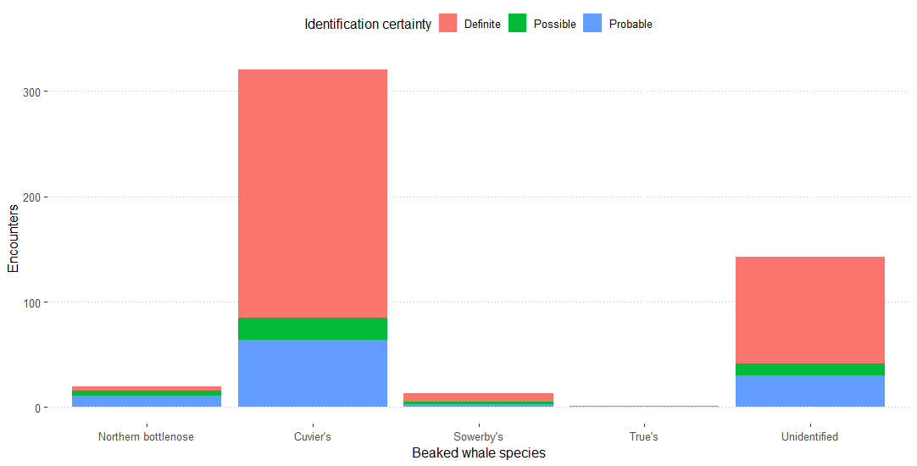
Supplementary Figure 1: Beaked whale encounters broken into categories of certainty. The majority of Cuvier’s beaked whale identifications were ‘definite’, therefore these were used as a subset for further analyses to present a more accurate depiction of their distribution with limited scope for false-positive identification. Cuvier’s beaked whales were further reduced to only include those seen below sea state 3. Analysis of all other species used their entire dataset regardless of certainty or sea state to maximise sample size.

