Online information

Table S1. Mean C/N ratios of animal taxa (SD in brackets, min – max range in italics) collected in Lake Trasimeno in summer and winter. Zooplankton C/N value exceed 3.5 in both seasons; accordingly, its δ¹³C values were corrected using the equation reported in Syväranta & Rautio (2010). Similarly, with the only exception of the decapod Procambarus clarkii all the remaining taxa showed C/N ratios > 3.5 and had their δ¹³C values corrected using the equation reported in Post et al. (2007). See the text for additional details.

Taxon | Summer | Winter
Anodonta anatina | 3.7 (0.2) 3.4 - 3.9 | 7.9 (0.7) 7.1 - 8.3
Dreissena polymorpha | 4.2 (0.1) 4.1 - 4.3 | 4.8 (0.5) 4.3 - 5.7
Zooplankton | 5.4 (0.4) 4.9 - 5.6 | 7.7 (0.3) 7.4 - 8
Procambarus clarkii | 2.4 (0.1) 2.4 - 2.4 | ---
Echinogammarus veneris | 4.7 (0.2) 4.5 - 5 | 6.5 (1.5) 5.1 - 8
Chironomus plumosus | 4.6 (0.2) 4.5 - 4.8 | 6.5 (0.4) 6.1 - 6.9
Branchiura sowerbyi | 5.2 (0.5) 4.7 - 5.8 | 5.5 (0.2) 5.3 - 5.7

Table S2. Trophic enrichment factors (Δ¹³C and Δ¹⁵N, in ‰) obtained from literature sources for marine (M) and freshwater (F) bivalves feeding on phytoplankton species under controlled laboratory conditions. All estimations were performed on whole soft tissues (WST) not subjected to chemical lipid estraction.

Consumer | Environment | Tissue | Food | ∆¹³C | ∆¹⁵N | Source
Mactra veneriformis | M | WST | Chaetoceros gracilis* | 0.9 | 3.6 | Yokoyama et al. 2005
Ruditapes philippinarum | M | WST | Chaetoceros gracilis* | 0.6 | 3.4 | Yokoyama et al. 2005
Crassostrea gigas | M | WST | Skeletonema costatum | 1.9 | 3.8 | Dubois et al. 2007
Mytilus edulis | M | WST | Skeletonema costatum | 2.2 | 3.8 | Dubois et al. 2007
Crassostrea gigas | M | WST | Chaetoceros gracilis | -0.9 | 5.4 | Yokoyama et al. 2008
Corbicula sandai | F | WST | Chlorella homosphaera§ | 0.6 | 3.6 | Kasai et al. 2016
Corbicula sandai | F | WST | Chaetoceros calcitrans | 0.7 | 2.1 | Kasai et al. 2016
Corbicula sandai | F | WST | Chlorella vulgaris | 0.1 | 3.3 | Kasai et al. 2016
Mean |  |  |  | 0.8 | 3.6
Standard deviation |  |  |  | 1 | 0.9

* Currently accepted as Chaetoceros neogracile
§ Currently accepted as Mychonastes homosphaera

Figure S1

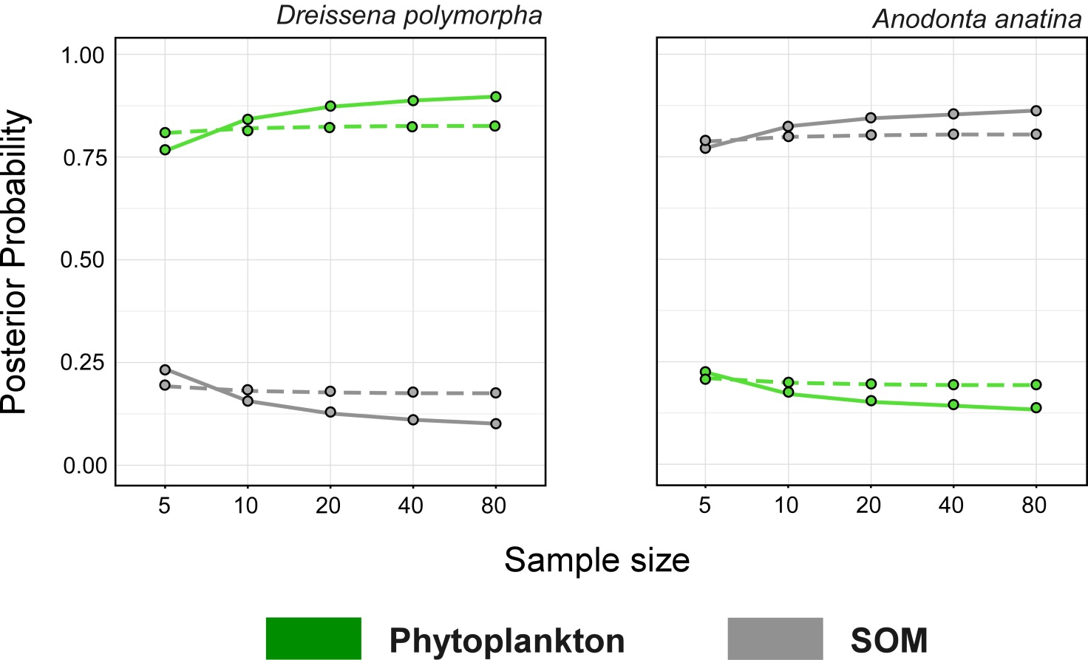

Figure S1. Results of the simulation test verifying the effect of the sample size of Dreissena polymorpha and Anodonta anatina on estimates and precision of stable isotope mixing solutions in August (continuous line) and in February (dashed line). See the text for further technical details on the procedure.
Cited literature
Dubois, D. J., 1980. Fuzzy Sets and Systems: Theory and Applications, vol 144. Academic Press, New York.
Kasai, A., D. Ishizaki & T. Isoda, 2016. Isotopic trophic-step fractionation of the freshwater clam Corbicula sandai. Fisheries Science 82:491-498.
Post, D. M., C. A. Layman, D. A. Arrington, G. Takimoto, J. Quattrochi & C. G. Montana, 2007. Getting to the fat of the matter: models, methods and assumptions for dealing with lipids in stable isotope analyses. Oecologia 152:179-189.
Syväranta, J. & M. Rautio, 2010. Zooplankton, lipids and stable isotopes: importance of seasonal, latitudinal, and taxonomic differences. Canadian Journal of Fisheries and Aquatic Sciences 67:1721-1729.
Yokoyama, H., Y. Ishihi & S. Yamamoto, 2008. Diet–tissue isotopic fractionation of the Pacific oyster Crassostrea gigas. Marine Ecology Progress Series 358:173-179.
Yokoyama, H., A. Tamaki, K. Harada, K. Shimoda, K. Koyama & Y. Ishihi, 2005. Variability of diet-tissue isotopic fractionation in estuarine macrobenthos. Marine Ecology Progress Series 296:115-128.

