Title: Diatom-salinity thresholds in an experimental setting reinforce the need for stricter water quality guidelines in South Australia
Authors: Frost, Charles; University of Adelaide; Geography; Environment and Population; Adelaide, SA; charles.frost@adelaide.edu.au; ORCID 0000-0003-4419-7936
Tibby, John; University of Adelaide; Geography; Environment and Population; Adelaide, SA; john.tibby@adelaide.edu.au; ORCID 0000-0002-5897-2932
Goonan, Peter; Environment Protection Authority, South Australia; Adelaide, SA

Supplementary information 2

Spearmen’s correlations between the five key variables EC, TP, TN, pH, and temperature (°C)
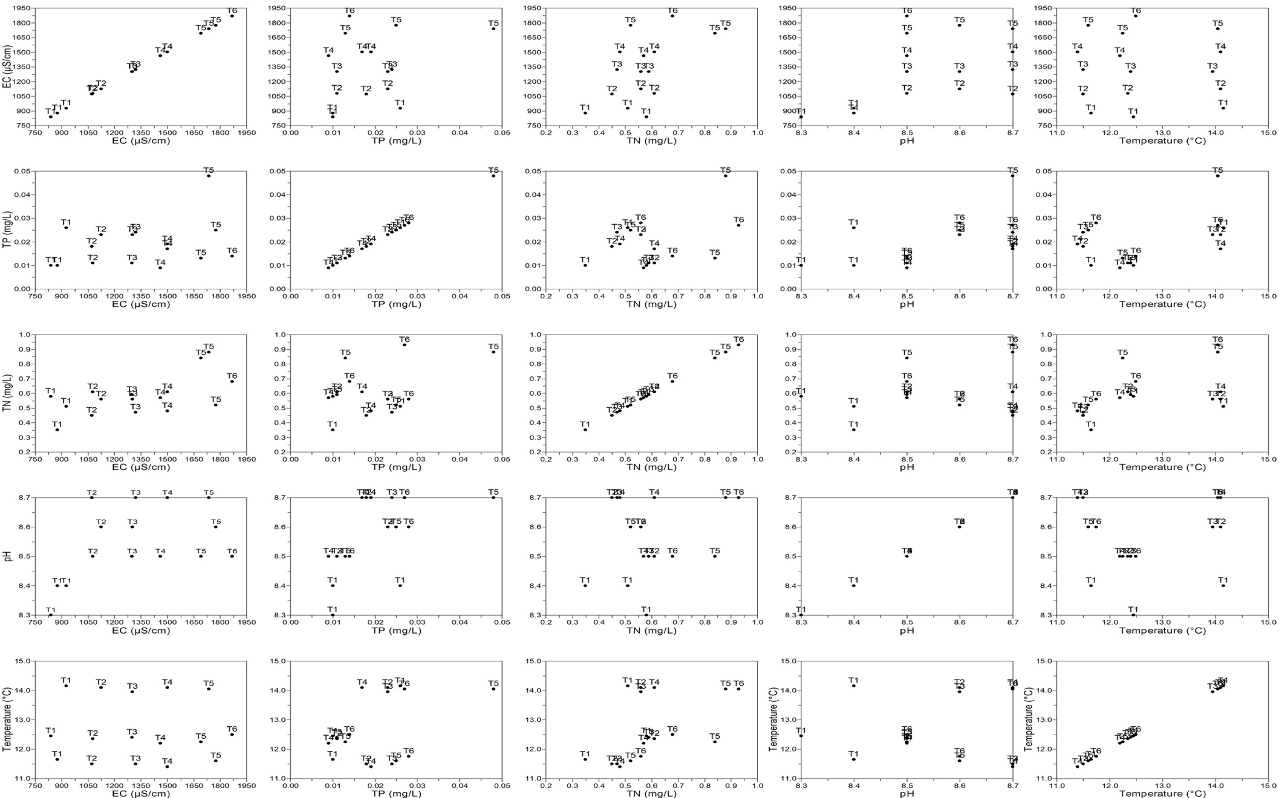

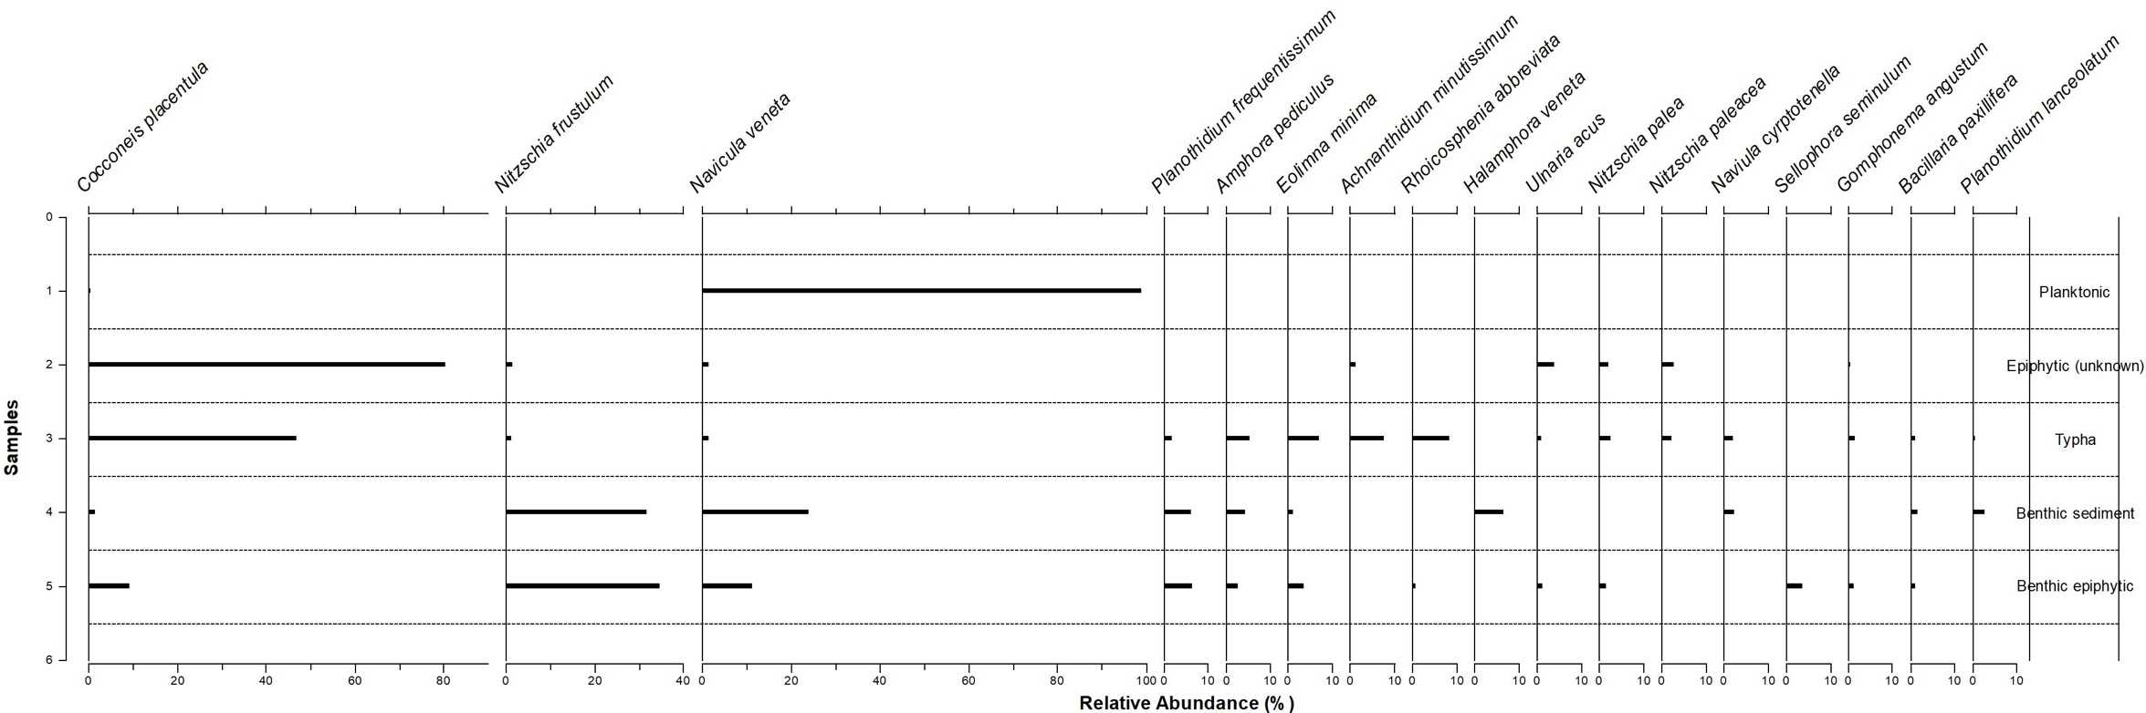
Diatom assemblages from five samples in Railway Dam. Diatoms in the graph have relative abundances ≥1%

Achnanthes subexigua, Hustedt 1934; Achnanthidium minutissimum, (Kützing) Czarnecki 1994; Amphora libyca, Enhrenberg 1841; Amphora pediculus, (Kützing) Grunow 1875; Bacillaria paxillifera, (O.F.Müller) T. Marsson 1901; Caloneis cf. hyaline, Hustedt 1937; Cocconeis placentula, Ehrenberg 1838; Diatom tenuis, C.Agardh 1812; Eolimna minima, (Grunow) Lange-Bertalot 1998; Epithemia adnata, (Kützing) Brébission 1833; Epithemia sorex, Kützing 1844; Eunotia exigua, (Brébission ex Kützing) Rabenhorst 1864; Frustulia vulgaris (Thwaites) De Toni 1891; Gomphonema affine, Kützing 1844; Gomphonema angustatum, (Kützing) Rabenhorst 1864; Gomphonema gracile, Ehrenberg 1838; Halamphora veneta, (Kützing) Levkov 2009; Hippodonta capitata, (Ehrenberg) Lange-Bertalot, Metzeltin & Witkowski 1996; Muelleria gibbula (Cleve) Spaulding & Stoermer 1997; Navicula cryptotenella, Lange-Bertalot 1985; Navicula veneta, Kützing 1844; Nitzschia acicularis (Kützing) W.Smith 1853; Nitzschia agnita, Hustedt 1957; Nitzschia frustulum, (Kützing) Grunow 1880; Nitzschia gracilis, Hantzsch 1860; Nitzschia incognita Legler & Krasske 1941; Nitzschia lacuum Lange-Bertalot 1980; Nitzschia liebetruthii, Rabenhorst 1864; Nitzschia linearis, W.Smith 1853; Nitzschia palea, (Kützing) W.Smith 1856; Nitzschia paleacea, (Grunow) Grunow 1881; Nitzschia recta, Rabenhorst 1862; Nitzschia sigma, (Kützing) Smith 1853; Placoneis elginensis (W. Gregory) E.J. Cox 1988; Planothidium frequentissimum, (Lange-Bertalot) Lange-Bertalot 1999; Planothidium lanceolatum, (Brébisson ex Kützing) Lange-Bertalot 1999; Pseudofallacia tenera, (Hustedt) Y.Liu, Kociolek & Q.Wang 2012; Rhoicosphenia abbreviata, (C.Agardh) Lange-Bertalot 1980; Rhopalodia brebissonii, Krammer 1987; Rhopalodia gibba, c; Sellaphora pupula (Kützing) Mereschkovsky 1902; Sellaphora seminulum, (Grunow) D.G.Mann 1989; Stauroneis smithii Grunow 1860; Staurosirella pinnata (Ehrenberg) D.M.Williams & Round 1988; Surirella angusta Kützing 1844; Tryblionella apiculate W.Gregory 1857; Ulnaria acus, (Kützing) Aboal 2003
PCA results and interpretation
PCA of water quality between all treatments and all study weeks that water samples were collected in (i.e. week 1, 3, and 6).
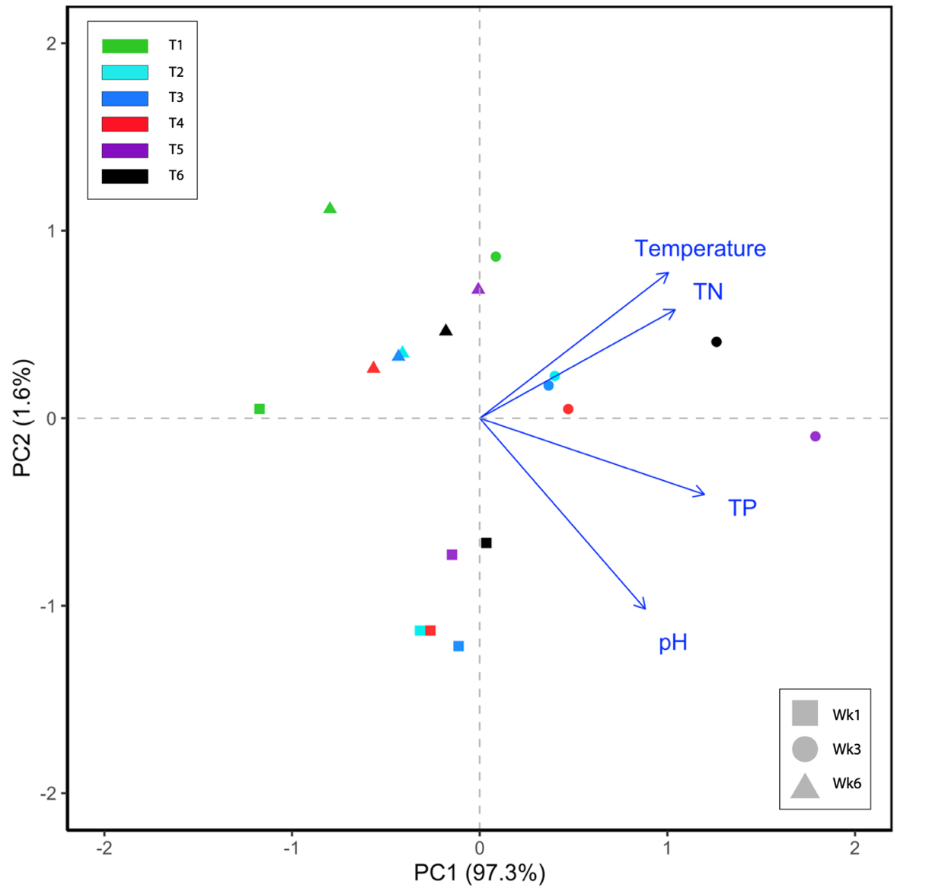

PCA illustrates that most treatments and sampling weeks are plotted closely along PC1 (which explains 97.3% of variation). There is a distinct trend of sampling weeks clustering together, however, that variation is based mostly along PC2 (1.6% variance explained), and treatments are plotted randomly and inconsistently within those weekly groups. There are two expectations to these trends; 1) the water quality for treatment 1 in week 1 was plotted differently compared to other treatments; and 2) there were substantial distances along PC1 between the data points of treatments 5 and 6 from week 3 and all other treatments from any sampling week. Raw water quality data (supplementary 2) show that pH in treatment 1 was lower than other treatments, and treatments 5 and 6 had significantly higher values in TP and TN, indicating potential sources for dissimilarity in this PCA. Significance testings of these variables, however, show no variation between all treatments.

Schematic of the mesocosm design. Recirculating pumps were submerged in the return tanks. Note the random placing of treatment channels (three per treatment).

