Supplementary Information

Top-down and bottom-up controls of plankton structure and dynamics in hypertrophic fishponds

Jaroslav Vrba^{1,2}, Michal Šorf^{1,3}, Jiří Nedoma², Zdenka Benedová⁴, Lenka Kröpfelová⁴, Jana Šulcová⁴, Blanka Tesařová^{4,5}, Martin Musil^{4,5}, Libor Pechar^{4,5}, Jan Potužák⁶, Ján Regenda⁶, Karel Šimek^{1,2}, Klára Řeháková²

¹Faculty of Science, University of South Bohemia, České Budějovice, Czech Republic
²Institute of Hydrobiology, Biology Centre CAS, České Budějovice, Czech Republic
³Faculty of AgriSciences, Mendel University, Brno, Czech Republic
⁴ENKI, o.p.s., Třeboň, Czech Republic
⁵Faculty of Agriculture, University of South Bohemia, České Budějovice, Czech Republic
⁶Faculty of Fishery and Water Protection, University of South Bohemia, České Budějovice, Czech Republic

Table S1 Main characteristics of the studied fishponds.

Fishpond  code / name |  | GPS coordinates | Area (ha) | Mean depth (m) | Dominant fish stock | Fish farming management
DH | Dehtář | 49.006N, 14.294E | 228 | 5.0 | two-year old to market carp | main pond,  two–year
KL | Klec | 49.090N, 14.767E | 64 | 2.0 | market carp | main pond,  one–year
KV | Kvítkovický | 48.963N, 14.337E | 24 | 3.0 | market carp | main pond,  one–year ^{*)}
RD | Rod | 49.121N, 14.745E | 22 | 1.3 | market carp (2017),  pikeperch and tench (2018) | nature reserve,  one–year
PM | Posměch | 48.996N, 14.295E | 37 | 3.2 | two-year old carp | main pond,  two–year ^{*)}
PT | Potěšil | 49.079N, 14.766E | 64 | 2.6 | market carp | main pond,  one–year
BR | Beranov | 48.980N, 14.321E | 13 | 2.5 | common carp fry | nursery pond,  two–year
RK | Roubíček | 48.981N, 14.261E | 4 | 1.4 | common carp fry | nursery pond,  two–year
ZB | Zběhov | 48.992N, 14.305E | 2 | 1.1 | undesirable fish (roach) | nursery pond,  one–year
^{*)} additional breeding of semiwild mallards with auxiliary feeding of cereals at a shore
Details to the section Methods

Fish density (ind. ha⁻¹) and biomass (kg ha⁻¹), both from stocking and harvest provided by commercial fisheries, were used as the primary data to calculate mean weight of individual fish, either stocked or harvested. Fishponds were typically stocked in March or April and harvested in October or November. The fish stock estimate was determined for the dominant fish species, common carp, which represented 82–98% of harvested fish biomass in most fishponds. The exceptions were RD in 2018 with tench being the dominant fish and ZB where only pike was stocked in 2017. We calculated specific growth rate (SGR) of a dominant fish species for each fishpond in the given year:
$SGR= \frac{(ln {fish weight}_{harvest day} - ln{{fish weight}_{stocking day})}}{(harvest day - stocking day)}×100$ (1),
where fish weight represents an average biomass of one fish (in kg) and harvest day and stocking day represent the respective days, when fish were stocked and harvested. SGR refers to a percentage increase in weight per day. We further modelled non-linear fish growth with a declining growth rate during the growing season as follows. SGR value was multiplied by a specific factor for each sampled month resulting in proportional SGR (SGR_{P}): 2 in April, 1.75 in May, 1.25 in June, 1.0 in July, 0.5 in August, and 0.25 in September. Such a proportional development of individual fish weight allowed us to get reasonable estimate of non-linear fish growth in time. The total biomass of dominant stocked fish (fish biomass in 10² kg ha⁻¹) at each sampling day was estimated based on the proportional SGR_{P} summing up biomass at the previous sampling day plus a biomass increment based on the above-described SGR_{P} for the number of days between samplings:
${fish biomass}_{t2}= {fish biomass}_{t1}+(\frac{{SGR}_{P}}{100}×{fish biomass}_{t1} ×\left(t_{2}-t_{1}\right))$ (2),
where t₂ and t₁ represent two subsequent sampling days.
Fish density was also modelled in monthly step. Data obtained from commercial fisheries often reflected either partial harvest in summer or mortality in fish stock (difference between number of stocked and harvested fish). A partial harvest was simply subtracted in the corresponding month. Mortality was assigned to spring months. Finally, a fish stock index (FSI) was determined from modelled seasonal development of fish biomass and fish density according to equation:
$FSI=(fish biomass)×\sqrt{fish density}$ (3),
denoted FSI_{S} for stocked fishes. In addition, the FSI was also determined for undesirable (not intentionally stocked planktivorous) fish in June–September 2018 (denoted FSI_{U}). Undesirable fish density and biomass were based on regular sampling of the littoral zones by a throwing net with a height of 1 m (area 1.33 m²) and mesh size of 4 mm. Fish estimates were based on the catch per used effort (CPUE) method: 20 hauls (area 26.6 m²) at KV, KL and RD, and 30 hauls (area 39.9 m²) at larger DH. The caught fish were fixed in the field with 4% formaldehyde and subsequently measured in the laboratory. All fish caught were determined to a species, individually measured with a digital ruler (accuracy to 0.01 mm) to a standard length (SL in mm) and weighed on an analytical balance (Ohaus Explore EX224, accuracy to 0.0001 g). Both total number and total weight of the fish sampled this way in a fishpond were converted to density (ind. ha⁻¹) and biomass (kg ha⁻¹), respectively. Undesirable fish density and biomass data were expanded to May being 65% of values in June. Comparison of FSI, density and biomass of both dominant stocked fish and undesirable fish is given in Table S3.
Table S2 Fish Stock Index, density, and biomass of common carp (or tench, in RD; FSI_{S}) and undesirable fish (FSI_{U}) in four fishponds sampled in 2018.

Fishpond | Month | Market carp (tench) |  |  |  | Undesirable fish
code |  | FSI_{S} | Density (ind. ha⁻¹) | Biomass (kg ha⁻¹) |  | FSI_{U} | Density (ind. ha⁻¹) | Biomass (kg ha⁻¹)
DH | Apr | 168 | 580 | 700
DH | May | 198 | 580 | 803 |  | 29.1 | 7820 | 33
DH | Jun | 239 | 580 | 969 |  | 55.6 | 12000 | 51
DH | Jul | 270 | 580 | 1097 |  | 68.1 | 13500 | 59
DH | Aug | 288 | 580 | 1170 |  | 37.1 | 6020 | 48
DH | Sep | 297 | 580 | 1208 |  | 30.5 | 3260 | 54
KL | Apr | 65.7 | 435 | 300
KL | May | 85.3 | 435 | 376 |  | 0.23 | 490 | 1
KL | Jun | 116 | 435 | 510 |  | 0.53 | 750 | 2
KL | Jul | 124 | 332 | 626 |  | 2.69 | 750 | 10
KL | Aug | 138 | 332 | 697 |  | 25.5 | 6020 | 33
KL | Sep | 149 | 332 | 736 |  | 39.2 | 5260 | 54
KV | Apr | 70.0 | 667 | 271
KV | May | 90.3 | 667 | 350 |  | 15.8 | 21700 | 11
KV | Jun | 121 | 667 | 470 |  | 30.2 | 33500 | 17
KV | Jul | 148 | 667 | 574 |  | 154 | 55300 | 66
KV | Aug | 116 | 333 | 637 |  | 315 | 80800 | 111
KV | Sep | 123 | 333 | 672 |  | 310 | 123000 | 88
RD | Apr | 10.7 | 450 | 51
RD | May | 10.2 | 270 | 62 |  | 33.1 | 45500 | 16
RD | Jun | 12.6 | 257 | 79 |  | 63.1 | 70000 | 24
RD | Jul | 14.4 | 244 | 93 |  | 119 | 48100 | 54
RD | Aug | 15.3 | 232 | 101 |  | 188 | 30800 | 107
RD | Sep | 15.6 | 220 | 105 |  | 292 | 51500 | 129

Table S3 Correlation matrix based on Spearman rank correlation coefficient. Significant relations are in bold, explanatory variables included in statistical analyses (Fig. 2, Table 4) in italics; Cond. – conductivity; C:P, N:P, C:N – seston molar ratios; DIN:DP – fishpond water molar ratio; Chla – concentration of chlorophyll a.

 | Secchi | Cond. | TN | TP | DOC | DIN | DRP | DIN:DP | C:P | N:P | C:N | FSI_{S} | Chla
Secchi | 1.00
Cond. | 0.00 | 1.00
TN | –0.69 | –0.19 | 1.00
TP | –0.57 | –0.06 | 0.44 | 1.00
DOC | –0.19 | –0.02 | 0.28 | 0.34 | 1.00
DIN | 0.00 | 0.21 | 0.11 | –0.08 | –0.04 | 1.00
DRP | –0.27 | 0.23 | 0.18 | 0.51 | 0.28 | 0.13 | 1.00
DIN:DP | –0.01 | 0.20 | 0.17 | –0.25 | –0.01 | 0.92 | 0.02 | 1.00
C:P | 0.01 | –0.39 | 0.04 | –0.41 | –0.05 | 0.02 | –0.30 | 0.12 | 1.00
N:P | –0.24 | –0.37 | 0.44 | –0.22 | –0.01 | –0.13 | –0.27 | –0.02 | 0.80 | 1.00
C:N | 0.39 | 0.28 | –0.66 | –0.28 | –0.21 | 0.24 | –0.08 | 0.19 | 0.06 | –0.46 | 1.00
FSI_{S} | –0.15 | 0.30 | 0.15 | 0.11 | –0.01 | 0.10 | 0.25 | 0.03 | 0.08 | 0.08 | –0.10 | 1.00
Chla | –0.78 | –0.16 | 0.77 | 0.58 | 0.21 | –0.10 | 0.30 | –0.12 | 0.13 | 0.47 | –0.59 | 0.32 | 1.00

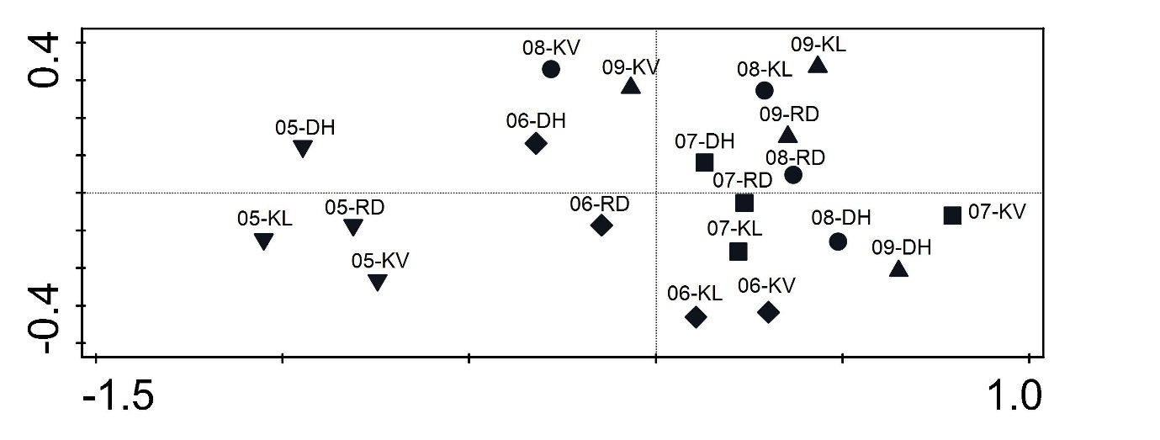
Fig. S1 Seasonal patterns of fishponds sampled in 2018 revealed by redundancy analysis. Scatterplot of samples shows seasonal development from left to right with more variable pattern during the summer months (distinguished with different symbols and labelled with ‘month-fishpond code’ format).

