Comparing methods and indices for biodiversity and status assessment in a hydropower-regulated river
Hydrobiologia
Markus Majaneva*, Line Elisabeth Sundt-Hansen, Hege Brandsegg, Rolf Sivertsgård, Terje Bongard, Frode Fossøy
*Corresponding author: markus.majaneva@nina.no, Norwegian Institute for Nature Research – NINA, Trondheim, Norway

Supplementary tables
Supplementary table S1. Bioinformatic quality filtering parameters in DADA2. Parameters included maximum expected errors for forward and reverse reads (maxEEf and maxEEr, respectively), maximum number of ambiguous bases (maxN), minimum length (minLen), minimum quality score for truncation (truncQ), truncation length for forward and reverse reads (tLenf and tLenr, respectively), minimum overlap in merging (minov), minimum quality score (minQ) and chimera detection method (chim).
 | maxEEf | maxEEr | maxN | minLen | truncQ | tLenf | tLenr | minov | minQ | chim
Lib 1 | 2 | 4 | 0 | 50 | 15 | - | - | 30 | 5 | consensus
Lib 2 | 2 | 2 | 0 | 50 | 15 | 275 | 210 | 30 | 10 | consensus

Supplementary table S2. Taxonomic level reached in morphological identifications.
Taxon | Taxonomic level
Gordius sp. | Genus
Radix balthica (Linnaeus, 1758) | Species
Gyraulus acronicus (Férussac, 1807) | Species
Gammarus lacustris G.O.Sars, 1863 | Species
Oligochaeta | Order
Acari | Order
Ephemera danica Müller, 1764 | Species
Caenis horaria (Linnaeus, 1758) | Species
Siphlonurus spp. | Genus
Siphlonurus lacustris Eaton, 1870 | Species
Cloeon spp. | Genus
Centroptilum luteolum (Müller, 1776) | Species
Ameletus inopinatus Eaton, 1887 | Species
Baetis muticus (Linnaeus, 1758) | Species
Baetis niger (Linnaeus, 1761) | Species
Baetis rhodani (Pictet, 1843) | Species
Heptagenia dalecarlica Bengtsson, 1912 | Species
Heptagenia fuscogrisea (Retzius, 1783) | Species
Arthroplea congener Bengtsson, 1908 | Species
Ephemerella aroni Eaton, 1908 | Species
Ephemerella mucronata (Bengtsson, 1909) | Species
Leptophlebiidae | Family
Paraleptophlebia submarginata (Stephens, 1835) | Species
Leptophlebia marginata (Linnaeus, 1767) | Species
Leptophlebia vespertina (Linnaeus, 1758) | Species
Diura nanseni (Kempny, 1900) | Species
Isoperla obscura (Zetterstedt, 1840) | Species
Isoperla grammatica (Poda, 1761) | Species
Xanthoperla apicalis (Newman, 1836) | Species
Siphonoperla burmeisteri (Pictet, 1841) | Species
Taeniopteryx nebulosa (Linnaeus, 1758) | Species
Brachyptera risi (Morton, 1896) | Species
Amphinemura borealis (Morton, 1894) | Species
Amphinemura sulcicollis (Stephens, 1836) | Species
Nemouridae | Family
Nemurella pictetii (Klapálek, 1900) | Species
Nemoura cinerea (Retzius, 1783) | Species
Nemoura avicularis Morton, 1894 | Species
Capnia sp. | Genus
Capnopsis schilleri (Rostock, 1892) | Species
Leuctra fusca/digitata | Species
Leuctra hippopus Kempny, 1899 | Species
Coenagrion hastulatum (Charpentier, 1825) | Species
Aeshna cyanea (Müller, 1764) | Species
Corixidae | Family
Callicorixa producta (Reuter, 1880) | Species
Dytiscidae | Family
Hydraenidae | Family
Haliplidae | Family
Elmis aenea (Müller, 1806) | Species
Limnius volckmari (Panzer, 1793) | Species
Sialis spp. | Genus
Sialis fuliginosa Pictet, 1836 | Species
Rhyacophila nubila (Zetterstedt, 1840) | Species
Oxyethira spp. | Genus
Hydroptila spp. | Genus
Wormaldia subnigra McLachlan, 1865 | Species
Plectrocnemia conspersa (Curtis, 1834) | Species
Polycentropus flavomaculatus (Pictet, 1834) | Species
Hydropsyche nevae Kolenati, 1858 | Species
Hydropsyche silfvenii (Ulmer, 1906) | Species
Arctopsyche ladogensis (Kolenati, 1859) | Species
Lepidostoma hirtum (Fabricius, 1775) | Species
Sericostoma personatum (Spence, 1826) | Species
Limnephilidae | Family
Aprypnia obsoleta (Hagen, 1864) | Species
Apatania spp. | Genus
Apatania stigmatella (Zetterstedt, 1840) | Species
Halesus radiatus (Curtis, 1834) | Species
Halesus digitatus (Schrank, 1781) | Species
Potamophylax spp. | Genus
Potamophylax latipennis (Curtis, 1834) | Species
Limnephilus spp. | Genus
Silo pallipes (Fabricius, 1781) | Species
Molannodes tinctus (Zetterstedt, 1840) | Species
Leptoceridae | Family
Athripsodes sp. | Genus
Athripsodes cinereus (Curtis, 1834) | Species
Athripsodes aterrimus (Stephens 1836) | Species
Mystacides sp. | Genus
Mystacides azurea (Linnaeus, 1761) | Species
Ceraclea spp. | Genus
Diptera | Order
Ceratopogonidae | Family
Tipulidae | Family
Simuliidae | Family
Chironomidae | Family

Supplementary table S3. The list of expected EPT taxa in Central Norway to be used in calculation of the IBIBI index, adapted from Bongard et al. (2018).
Taxa | Order
Baetis muticus (Linnaeus, 1758) | Ephemeroptera
Baetis rhodani (Pictet, 1843) | Ephemeroptera
Baetis scambus Eaton, 1870 | Ephemeroptera
Heptagenia spp. | Ephemeroptera
Ameletus inopinatus Eaton, 1887 | Ephemeroptera
Ephemerella aurivilli (Bengtsson, 1908) | Ephemeroptera
Ephemerella mucronate (Bengtsson, 1909) | Ephemeroptera
Diura nanseni (Kempny, 1900) | Plecoptera
Amphinemura spp. | Plecoptera
Nemoura cinerea (Retzius, 1783) | Plecoptera
Leuctra spp. | Plecoptera
Taeniopteryx nebulosa (Linnaeus, 1758) | Plecoptera
Isoperla obscura (Zetterstedt, 1840) | Plecoptera
Isoperla grammatica (Poda, 1761) | Plecoptera
Capnia spp. | Plecoptera
Siphonoperla burmeisteri (Pictet, 1841) | Plecoptera
Brachyptera risi (Morton, 1896) | Plecoptera
Protonemura meyeri (Pictet, 1841) | Plecoptera
Rhyacophila nubila (Zetterstedt, 1840) | Trichoptera
Hydroptila spp. | Trichoptera
Polycentropus flavomaculatus (Pictet, 1834) | Trichoptera
Apatania spp. | Trichoptera
Potamophylax spp. | Trichoptera
Arctopsyche ladogensis (Kolenati, 1859) | Trichoptera
Sericostoma personatum (Spence, 1826) | Trichoptera
Lepidostoma hirtum (Fabricius, 1775) | Trichoptera
Hydropsyche spp. | Trichoptera

Supplementary Figures
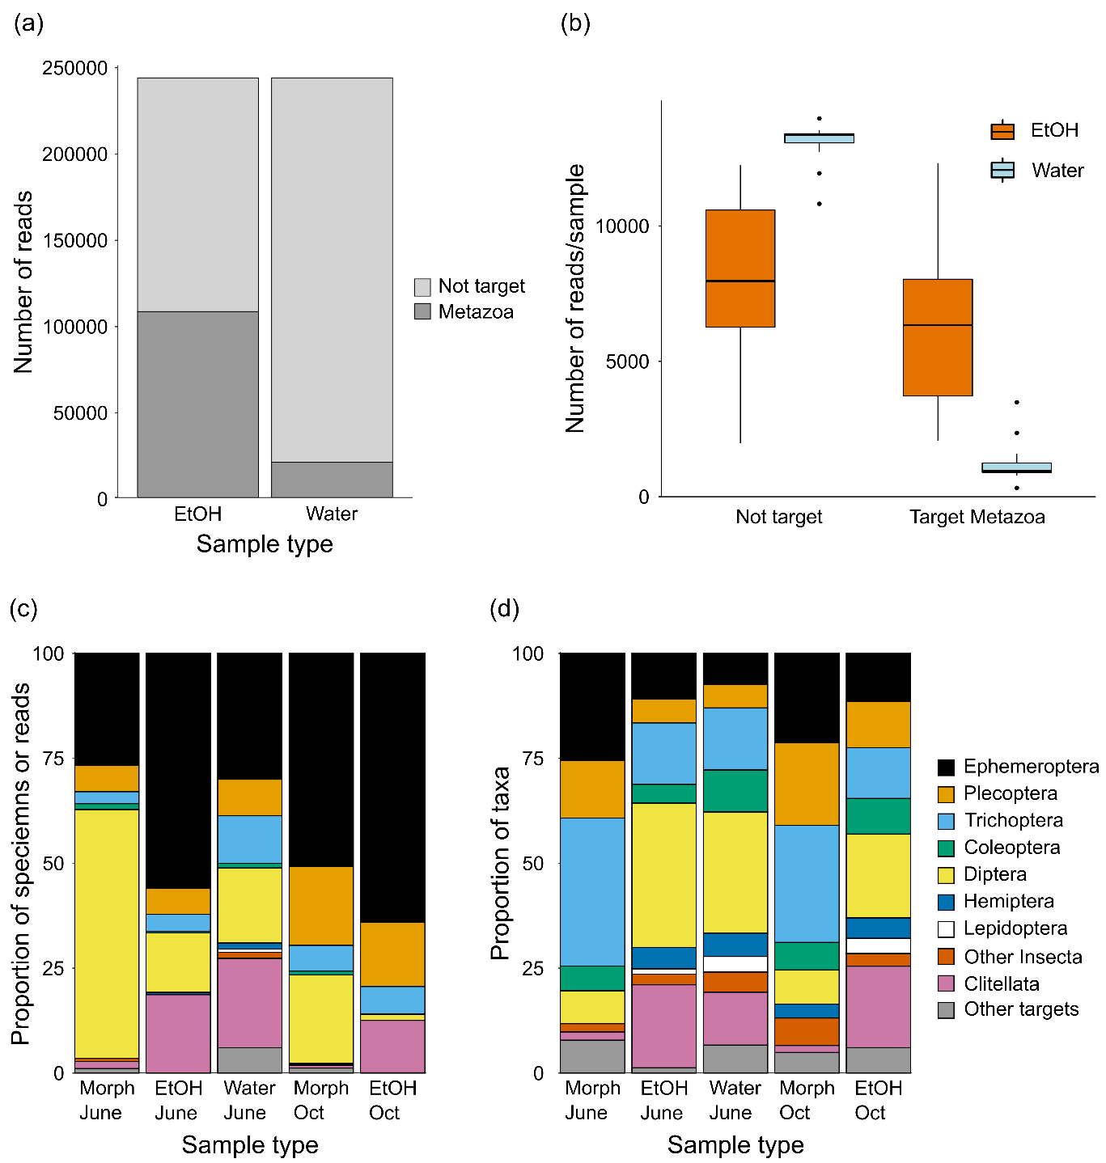
Supplementary figure S1. Proportions of recovered taxa. (a) Number of non-target and target reads in EtOH and water samples. (b) Number of reads/sample. The number of non-target and target Metazoa reads differ between EtOH and water samples in June 2019 (Wilcoxon signed rank test, p < 0.001) (b). (c) Relative abundance estimates of taxa detected in the morphology, EtOH and water samples in June and October 2019. (d) Proportion of taxa detected in the morphology, EtOH and water samples in June and October 2019. EtOH and water samples were normalized to the lowest read number.
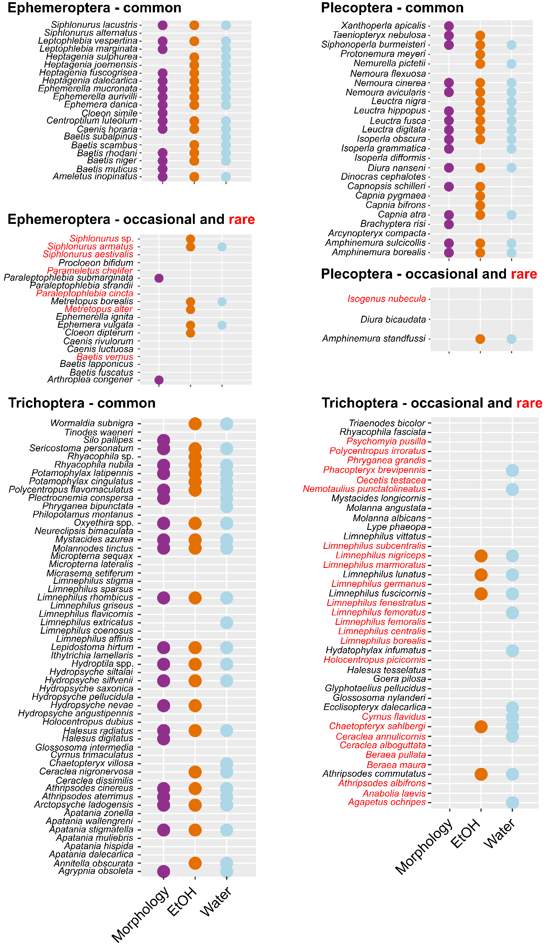
Supplementary figure S2. The list of expected EPT taxa found in samples identified using morphology, using ethanol from kick samples (EtOH) or water samples. Taxa are classified as common (black text), occasional (black text) or rare (red text) according to Aagaard & Dolmen (1996).

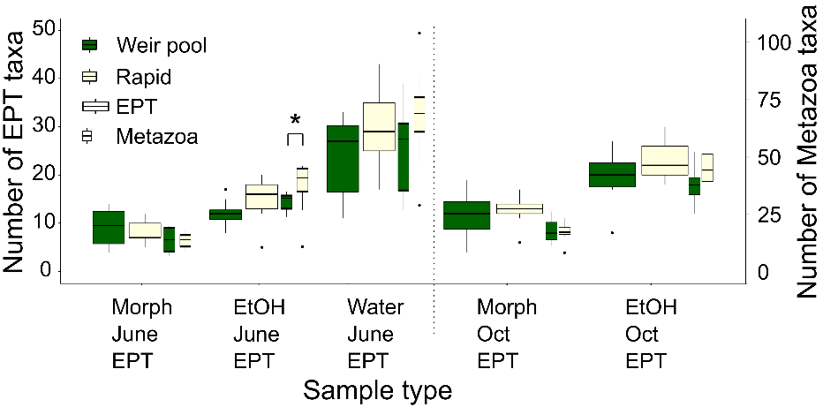
Supplementary figure S3. The total number of Ephemeroptera, Plecoptera and Trichoptera (EPT) and Metazoa taxa in rapids and weir pools. The dashed line separates June and October. The number of EPT and Metazoa taxa was similar in the weir pools and rapids considering the data collected in June and October (Wilcoxon rank sum test, p > 0.05), except Metazoa in EtOH samples collected in June (Wilcoxon rank sum test, p = 0.043). Asterix (*) denotes the significant difference. Note the different scales for EPT and Metazoa taxa.

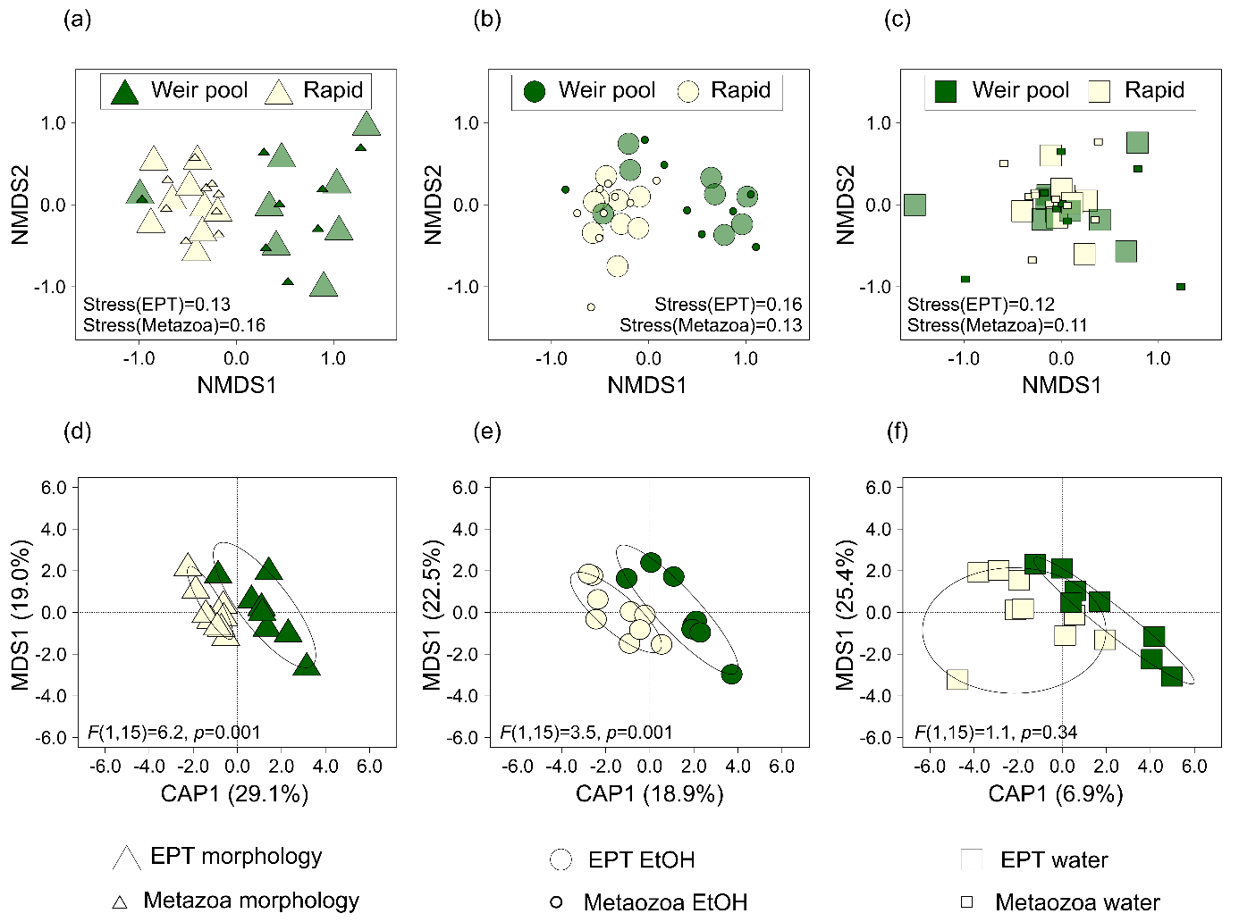
Supplementary figure S4. EPT community composition differences in weir pools and rapids using morphologically identified kick samples (Morphology) (a and d), kick-sample ethanol DNA (EtOH) (b and e) and water eDNA (Water) samples (c and f). The panels (a–c) present nonmetric multidimensional scaling (NMDS) plots based on relative read abundance and Bray-Curtis dissimilarity. The panels (d–f) present generalized discriminant analysis plots (CAP) based on a binomial (presence-absence) dissimilarity matrix. The significance of CAP analyses was tested with permutation tests (999 permutations). NMDS plots present both EPT and Metazoa taxa, while CAP plots present EPT taxa only. CAP analyses based on Metazoa taxa showed the same pattern as based on EPT taxa (permutation test on the results of the generalized discriminant analysis results, p = 0.001 in the case of morphology and EtOH samples and p = 0.47 in the case of water samples). The EPT species that were observed mainly in the rapids included Ephemeroptera Alainites muticus (Linnaeus, 1758) and Ephemerella aurivilli (Bengtsson, 1908), Plecoptera Amphinemura borealis (Morton, 1894), Diura nanseni (Kempny, 1900) and Taeniopteryx nebulosa (Linnaeus, 1758), and Trichoptera Rhyacophila nubila (Zetterstedt, 1840) and Arctopsyche ladogensis (Kolenati, 1859). The characteristic weir-pool EPT taxa included Ephemeroptera Centroptilum luteolum (Müller, 1776), Ephemera danica Müller, 1764, Leptophlebia vespertina (Linnaeus, 1758), Metretopus borealis (Eaton, 1871) and Siphlonurus lacustris Eaton, 1870, and Trichoptera Limnephilus spp., Mystacides azurea (Linnaeus, 1761) and Potamophylax latipennis (Curtis, 1834). One weir pool sample (st 6) grouped within rapid samples in morphology and EtOH NMDS plots, because it included typical rapid-sample species Alainites muticus, Ephemerella aurivilli, Diura nanseni, Rhyacophila nubila, and Arctopsyche ladogensis. This sampling station is near the outlet of a large tributary, which may have affected the community composition in the station.

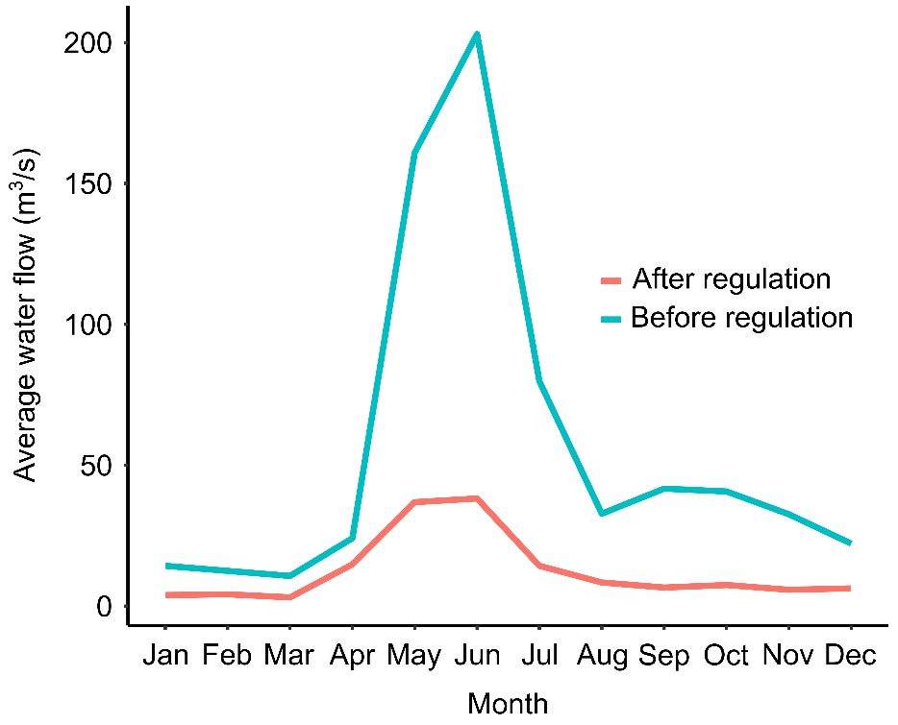
Supplementary figure S5. Average water flow (m³/s) near sampling station 5, downstream from outlet of a large tributary, based on values in Sundt-Hansen et al. (2021) before (1930–1961) and after (1989–2018) regulation of the river Nea.

Supplementary references
Aagaard, K. & D. Dolmen, 1996. Limnofauna Norvegica. Tapir forlag.
Bongard, T., O. H. Diserud, O. T. Sandlund & K. Aagaard, 2011. Detecting Invertebrate Species Change in Running Waters: An Approach Based on the Sufficient Sample Size Principle. Bentham Open Environmental & Biological Monitoring Journal, 4, 72–82. https://doi.org/10.2174/1875040001104010072
Bongard, T., K. Johansen & T. B. Munkeby, 2018. A New Sampling Protocol and Intercalibrated Index for Invertebrates in Running Water. NINA Report 1548. Norwegian Institute for Nature Research, Trondheim, Norway.
Sundt-Hansen, L. E., T. Forseth & A. Harby, 2021. Utvidet miljødesign i demovassdrag Nea. HydroCen rapport 22. Norwegian Research Centre for Hydropower Technology, Trondheim, Norway.

