SUPPLEMENTAL FIGURES
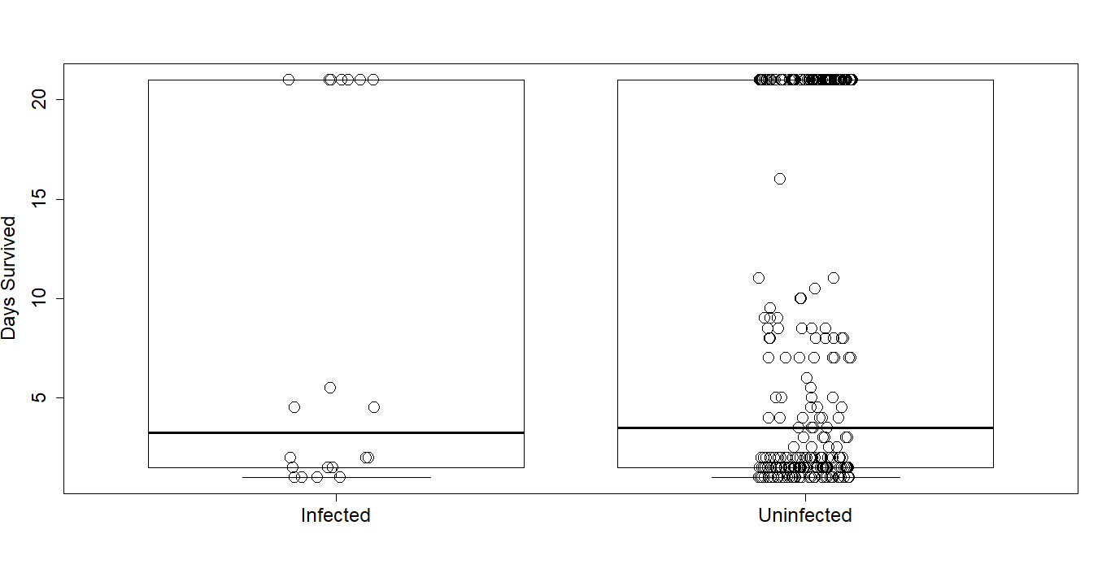
Figure S1 Number of days survived by individual I. obsoleta between infected (n = 20) and uninfected (n = 280) snails (t = -0.06, df = 21.5, p = 0.9552). Error bars = SE, black circle = number of days each snail survived (jittered).

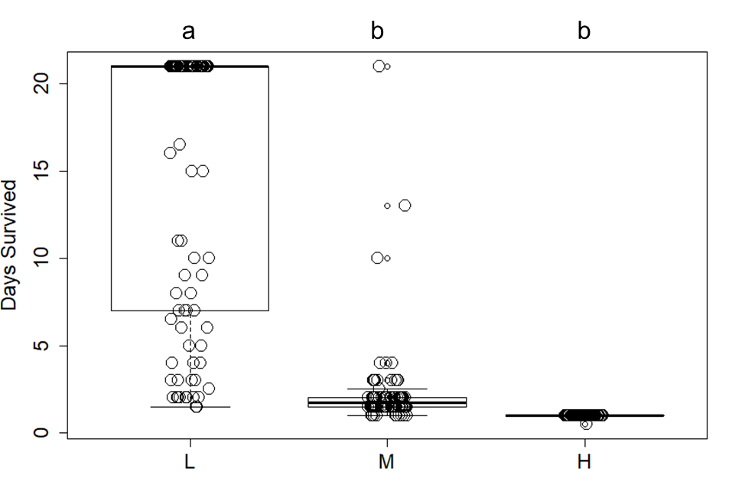
Figure S2 Number of days survived by individual I. obsoleta between three temperature treatments in trial 2. L = “low” temperature (27 ºC), M = “medium” temperature (32 ºC), H = “high” temperature (36 ºC) (df = 2, p < 0.001). Same letters above the graph indicate that those categories are not statistically significant in pairwise comparisons. Error bars = SE, black circle = number of days each snail survived (jittered).
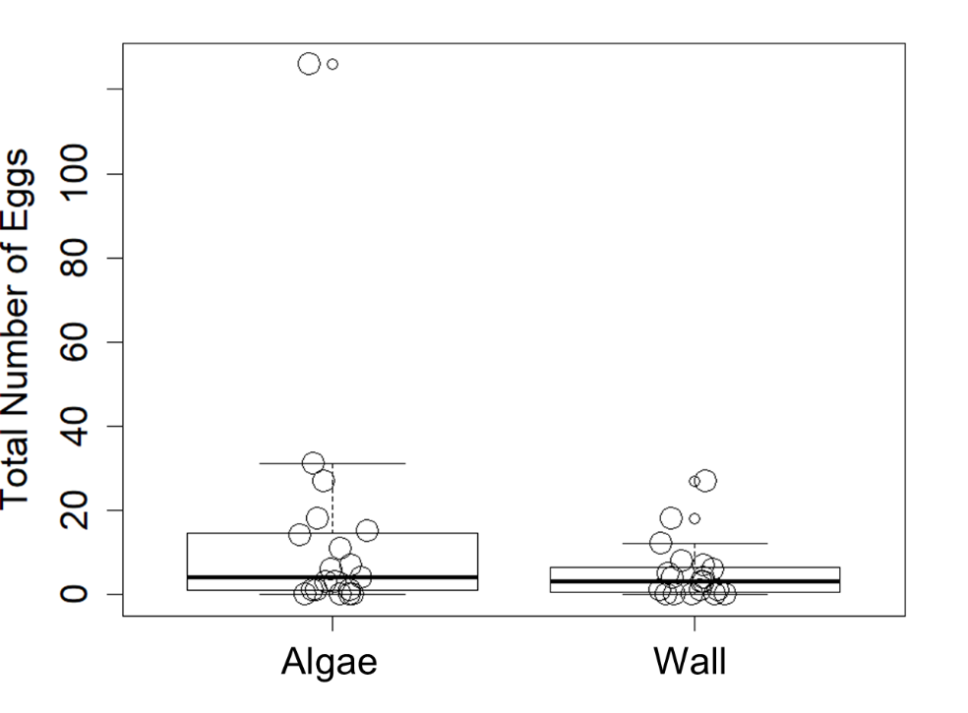
Figure S3 Trial 2 comparison of I. obsoleta egg counts in the low temperature algae habitat: “Algae”, or the total number of eggs on G. vermiculophylla only and “Wall”, or the total number of eggs on the wall surface only (t = 1.54, df = 18, p = 0.14). Error bars = SE, black circle = number of cumulative eggs each snail deposited (jittered).
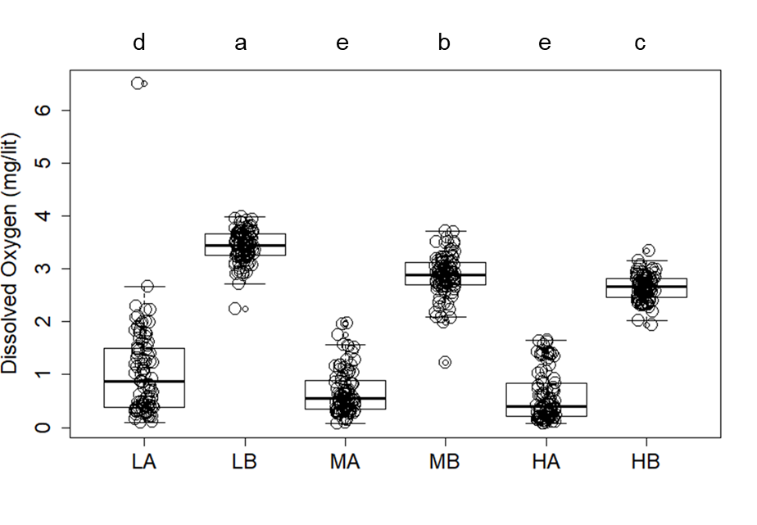
Figure S4 Comparison of dissolved oxygen by habitat and temperature interaction. LA = low temperature (27 ºC), algae; LB = low temperature, bare; MA = medium temperature (32 ºC), algae; MB = medium temperature, bare; HA = high temperature (36 ºC), algae; HB = high temperature, bare (df = 5, p < 0.001). Same letters above the graph indicate that those categories are not statistically significant upon pairwise comparisons. Error bars = SE, black circle = dissolved oxygen level of each replicate (jittered).

SUPPLEMENTAL TABLES

Table S1 ANOVA Summary of Table 1’s CPHM model with greatest AICc weight (temp*habitat + infected). See table 1 for definitions of predictors.
Predictor | Chi-sq | df | p-value
temp | 515.86 | 2 | <0.001
habitat | 63.5 | 1 | <0.001
infected | 2.75 | 1 | 0.097
temp*habitat | 16.03 | 2 | <0.001

Table S2 ANOVA summary of Table 1’s CPHM model with the second greatest AICc weight (temp*habitat). See table 1 for definitions of predictors.
Predictor | Chi-sq | df | p-value
temp | 514.09 | 2 | <0.001
habitat | 66.76 | 1 | <0.001
temp*habitat | 15.05 | 2 | <0.001

Table S3 ANOVA summary of Table 2’s CPHM model with the greatest AICc weight (temp). See table 2 for definitions of predictors.
Predictor | Chi-sq | df | p-value
temp | 455.18 | 2 | <0.001

Table S4 ANOVA summary of Table 2’s CPHM model with the second greatest AICc weight (temp + habitat). See table 2 for definitions of predictors.
Predictor | Chi-sq | df | p-value
temp | 456.43 | 2 | <0.001
habitat | 1.6 | 1 | 0.206

Table S5 ANOVA summary of Table 2’s CPHM model with the third greatest AICc weight (temp + habitat + infected). See table 2 for definitions of predictors.
Predictor | Chi-sq | df | p-value
temp | 458.24 | 2 | <0.001
habitat | 1.56 | 1 | 0.212
infected | 1.9 | 1 | 0.168

Table S6 Comparisons of dissolved oxygen based on Generalized Linear Mixed Model (GLMM) selection using AICc, using day as the random effect (day 1, day 2, day 3, day 4, day 5); temp = temperature (low, medium, high), habitat = habitat type (algae or bare), trial (one or two).
Model | K | AICc | ∆AICc | AICc Wt. | Cumulative Wt.
(1|day) + temp*habitat | 8 | 869.38 | 0.00 | 0.72 | 0.72
(1|day) + temp + habitat | 6 | 871.31 | 1.93 | 0.27 | 0.99
(1|day) + temp + trial + habitat + time | 8 | 878.99 | 9.61 | 0.01 | 1.00
(1|day) + habitat | 4 | 1009.09 | 139.71 | 0.00 | 1.00
(1|day) + temp | 5 | 1953.38 | 1084.00 | 0.00 | 1.00
NULL | 3 | 1971.19 | 1101.81 | 0.00 | 1.00

Table S7 ANOVA summary of Table S6’s GLMM model with the greatest AICc weight; (1|day) + temp*habitat. Parameter estimates with Chi-square and p-values based on Type III Wald Chi-Square Test. Conditional R² = 0.849, marginal R² = 0.847.
Predictor | Chi-sq | df | p-value
temp | 173.689 | 2 | <0.001
habitat | 3166.766 | 1 | <0.001
temp*habitat | 12.075 | 2 | 0.002

