Multi-method potential distributions of an invasive crayfish (Pontastacus leptodactylus) at Eurasian scale

Authors: Hodson J., South J., Cancellario T., Guareschi S.
Hydrobiologia

Corresponding author: simone.guareschi@unito.it

Supplementary Materials

S1. Occurrences of the species with coordinates. List of records used when modelling (n. 649) and list of references are also provided (Excel file).

S2. List and details of the four algorithms used during distribution modelling.

S3. Complete details about variables selection: A) hierarchical clustering (the chosen distance-threshold to form the clusters was set at 0.3, i.e. less than 70% correlation) and B) Variance Inflation Factor (VIF) analysis. Variables included in final models presented a correlation coefficient < 0.7 (in blue, see dendrogram) and VIF <3 (listed below). Codes and definitions available in Table 1.

S4. Values for each variable considered extracted from the intermediate-high suitable areas obtained via binary maps for each temporal scenario and approach (details in the Methods). Mean and standard deviation are displayed. Soil pH values *10.

S5. Variables importance for each algorithm used (see Methods) during species distribution modelling: A) Climatic; B) Environmental. Mean and standard deviation are provided. Variable importance was assessed with the “get_variables_importance” function (biomod2 package) as 1 minus the Pearson's correlation between the reference predictions of the full model and the predictions of the model where the target variable was randomized. The higher the value, the more influential the variable is in the model. Variable codes available in Table 1. Main results from the Ensemble procedure are discussed in the text.

S6. Evaluation boxplots for each algorithm. A) Climatic approach; B) Environmental approach. Both the area under the receiver operating characteristic curve (ROC) and the true skill statistic (TSS) are showed. The higher the output values, the better the model performance. Values from 3 runs are displayed.

S7. Zooms on the most invaded areas (western-central Europe) using climatic (A = current; B= 2-4.5 scenario; C=3-7.0 scenario) and environmental (D=current; E= 2-4.5; F= 3-7.0 scenario) approaches. Suitability ranges from black (low) to light yellow (high).

S2. List and details of the four algorithms used during distribution modelling.

Algorithm | Code | Family of modelling | Methodologic reference | Applied reference (SDM example)
Generalized Linear Models | GLM | Regression | Guisan et al. 2002 | Santini et al. 2021
Generalized Boosted Models | GBM | Decision trees | Elith et al. 2008 | Cancellario et al. 2022
Random Forests | RF | Decision trees | Valavi et al. 2021 | Gallardo et al. 2020
Maximum Entropy Modelling | Maxent | Maximum entropy | Phillips et al. 2006 | Mammola et al. 2018

References cited here:
Cancellario, T., Miranda, R., Baquero, E., Fontaneto, D., Martínez, A. and Mammola, S., (2022). Climate change will redefine taxonomic, functional, and phylogenetic diversity of Odonata in space and time. npj Biodiversity, 1(1), p.1.
Elith, J., Leathwick, J. R. & Hastie, T. A (2018) Working guide to boosted regression trees. J. Animal Ecol. 77, 802–813.
Gallardo, B. and Aldridge, D.C., (2020). Priority setting for invasive species management by the water industry. Water Research, 178, p.115771.
Guisan, A., Edwards Jr, T.C. and Hastie, T., (2002). Generalized linear and generalized additive models in studies of species distributions: setting the scene. Ecological modelling, 157(2-3), 89-100.
Mammola, S., Goodacre, S. L. & Isaia, M. (2018). Climate change may drive cave spiders to extinction. Ecography 41(1), 233–243.
Phillips, S. J., Anderson, R. P. & Schapire, R. E. (2006). Maximum entropy modeling of species geographic distributions. Ecol. Model. 190(3-4), 231–259.
Santini, L., Benítez‐López, A., Maiorano, L., Čengić, M. and Huijbregts, M.A., (2021). Assessing the reliability of species distribution projections in climate change research. Diversity and Distributions, 27(6), 1035-1050.
Valavi, R., Elith, J., Lahoz‐Monfort, J.J. and Guillera‐Arroita, G., (2021). Modelling species presence‐only data with random forests. Ecography, 44(12), 1731-1742.

S3. Complete details about variables selection: A) hierarchical clustering (the chosen distance-threshold to form the clusters was set at 0.3, i.e. less than 70% correlation) and B) Variance Inflation Factor (VIF) analysis. Variables included in final models presented a correlation coefficient < 0.7 (in blue, see dendrogram) and VIF <3 (listed below). Codes and definitions available in Table 1.

A)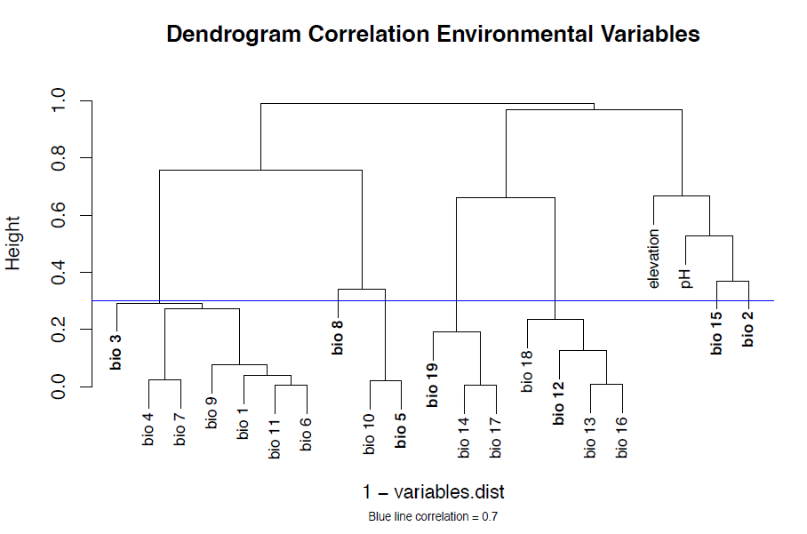

B)
Results for the Variance Inflation Factor (VIF) analysis using the uncorrelated variables (in blue above). Details available in Methods section. Only variables with VIF < 3 were retained:

pH = 1.761256
Elevation = 1.779636
BIO08 = 2.071980
BIO15 = 2.151524
BIO02 = 2.179124
BIO19 = 2.535835
BIO03 = 2.990904

S4. Values for each variable considered extracted from the intermediate-high suitable areas obtained via binary maps for each temporal scenario and approach (details in the Methods). Mean and standard deviation are displayed. Soil pH values *10.
Variables | Climatic current | Climatic ssp 2.45 at 2050 | Climatic ssp 3.70 at 2050 | Environmental current | Environmental ssp 2.45 at 2050 | Environmental ssp 3.70 at 2050
BIO02 | 8.7±1.4 | 8.8±1.5 | 8.8±1.5 | 8.9±1.4 | 9.0±1.8 | 9.1±1.8
BIO03 | 29.7±5.4 | 29.0±5.8 | 28.7±5.5 | 30.2±5.6 | 32.2±4.6 | 30.9±4.9
BIO08 | 13.6±5.4 | 14.7±5.7 | 13.6±6.0 | 13.9±5.3 | 13.0±6.0 | 11.9±6.1
BIO15 | 29.5±10.6 | 29.5±10.4 | 29.4±10.1 | 29.2±11.4 | 28.5±13.2 | 29.2±12.0
BIO19 | 161.4±75.0 | 168.9±73.4 | 173.1±74.7 | 158.2±73.4 | 189.9±75.5 | 187.9±76.0
Elevation | / | / | / | 307±352.2 | 393±417.1 | 377.5±402.0
Soil pH | / | / | / | 62.8±4.9 | 62.4±5.0 | 62.4±5.0

S5. Variables importance for each algorithm used (see Methods) during species distribution modelling: A) Climatic; B) Environmental. Mean and standard deviation are provided.
Variable importance was assessed with the “get_variables_importance” function (biomod2 package) as 1 minus the Pearson's correlation between the reference predictions of the full model and the predictions of the model where the target variable was randomized. The higher the value, the more influential the variable is in the model. Variable codes available in Table 1. Main results from the Ensemble procedure are discussed in the text.

A)

Algorithm | Variable | Mean importance | Standard Deviation
GLM | BIO15 | 0.306389 | 0.025434
GLM | BIO03 | 0.207729 | 0.013523
GLM | BIO19 | 0.182225 | 0.024851
GLM | BIO02 | 0.047902 | 0.01894
GLM | BIO08 | 0.02847 | 0.007089
GBM | BIO19 | 0.378071 | 0.025634
GBM | BIO08 | 0.17753 | 0.014986
GBM | BIO03 | 0.171462 | 0.016965
GBM | BIO15 | 0.133604 | 0.019674
GBM | BIO02 | 0.036754 | 0.011037
RF | BIO15 | 0.306389 | 0.027978
RF | BIO03 | 0.266977 | 0.028599
RF | BIO08 | 0.262222 | 0.019134
RF | BIO19 | 0.252546 | 0.019316
RF | BIO02 | 0.143783 | 0.008987
MAXNET | BIO19 | 0.286359 | 0.035109
MAXNET | BIO03 | 0.272734 | 0.019997
MAXNET | BIO15 | 0.197668 | 0.016184
MAXNET | BIO08 | 0.119534 | 0.009289
MAXNET | BIO02 | 0.106072 | 0.016805

B)

Algorithm | Variable | Mean importance | Standard Deviation
GLM | BIO15 | 0.230727 | 0.016183
GLM | BIO19 | 0.186191 | 0.030259
GLM | BIO03 | 0.140452 | 0.017542
GLM | Soil pH | 0.102298 | 0.009282
GLM | BIO02 | 0.062628 | 0.026562
GLM | BIO08 | 0.059463 | 0.010564
GLM | Elevation | 0.02878 | 0.013796
GBM | BIO19 | 0.445558 | 0.036456
GBM | Soil pH | 0.184511 | 0.025385
GBM | BIO15 | 0.131663 | 0.02341
GBM | BIO08 | 0.097079 | 0.013377
GBM | BIO03 | 0.054848 | 0.014574
GBM | Elevation | 0.025875 | 0.00706
GBM | BIO02 | 0.024667 | 0.005801
RF | BIO15 | 0.19666 | 0.018688
RF | BIO19 | 0.172567 | 0.017243
RF | Soil pH | 0.156768 | 0.01392
RF | BIO08 | 0.12764 | 0.012593
RF | BIO03 | 0.119666 | 0.012644
RF | BIO02 | 0.096435 | 0.009039
RF | Elevation | 0.091669 | 0.006802
MAXNET | BIO19 | 0.303847 | 0.031038
MAXNET | Soil pH | 0.173665 | 0.013227
MAXNET | BIO03 | 0.154217 | 0.016191
MAXNET | BIO15 | 0.135815 | 0.020074
MAXNET | BIO08 | 0.105335 | 0.010085
MAXNET | BIO02 | 0.085124 | 0.014341
MAXNET | Elevation | 0.052507 | 0.010539

S6. Evaluation boxplots for each algorithm. A) climatic approach; B) environmental approach. Both the area under the receiver operating characteristic curve (ROC) and the true skill statistic (TSS) are showed. The higher the output values, the better the model performance. Values from 3 runs are displayed.

A)
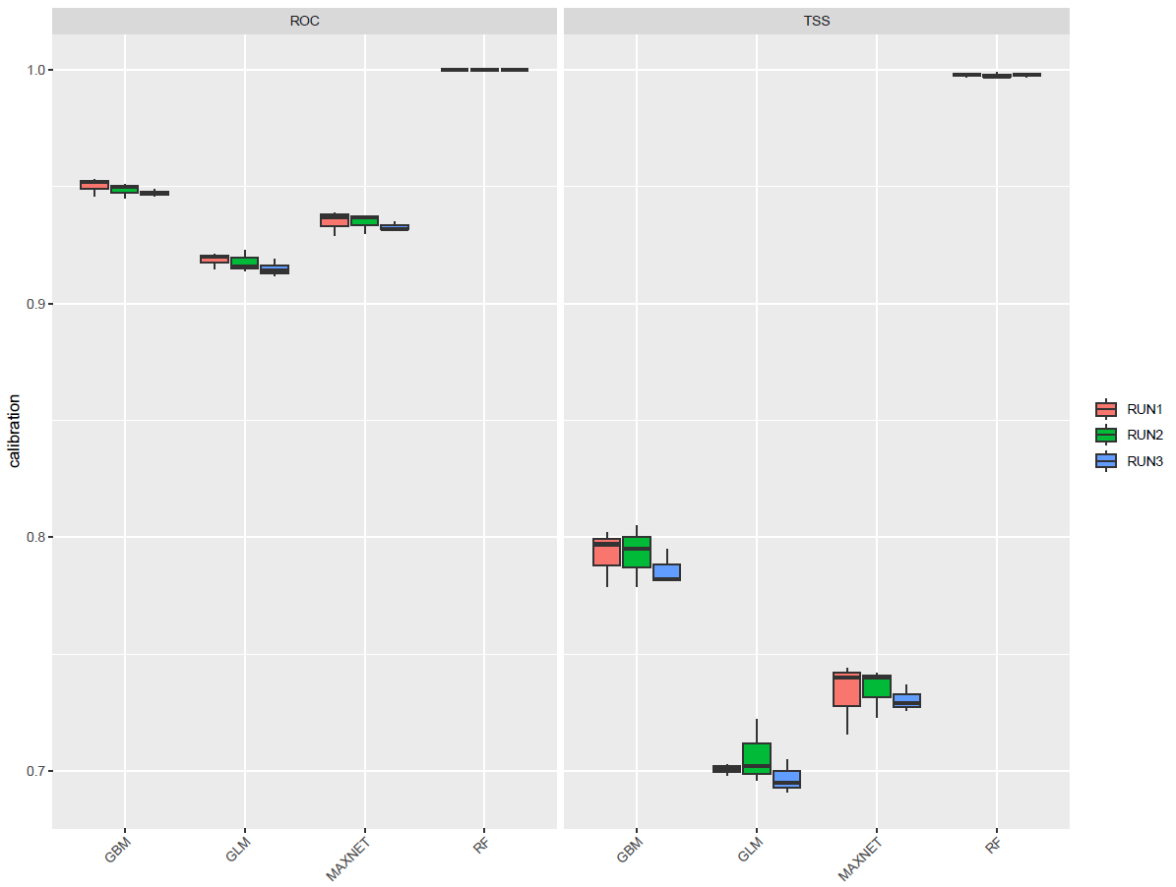

B)
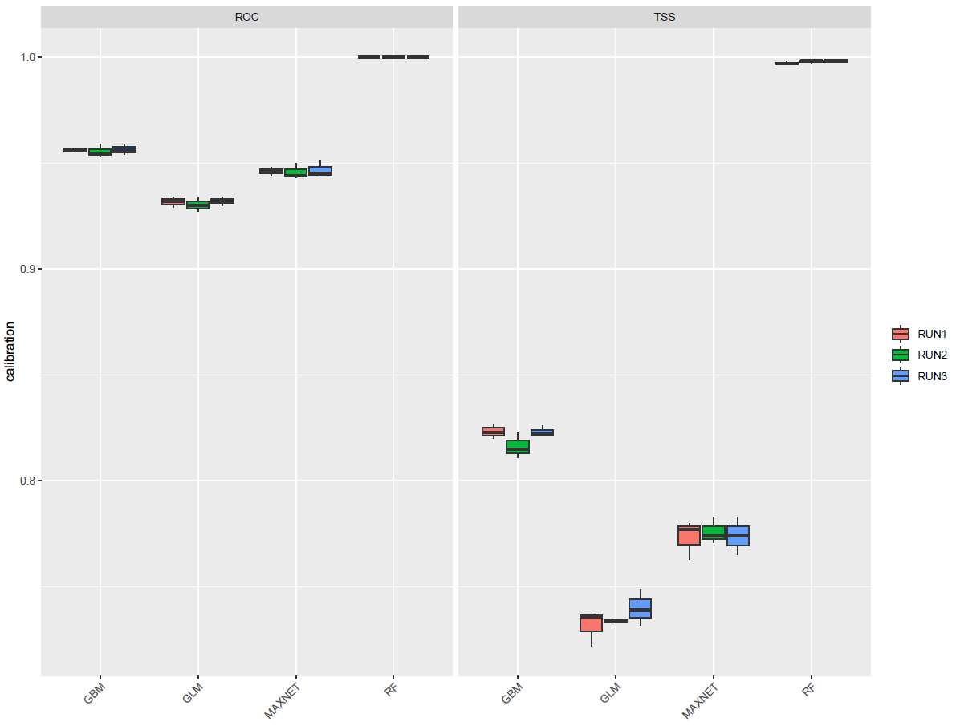

S7. Zooms on the most invaded areas (western-central Europe) using climatic (A = current; B= 2-4.5 scenario; C=3-7.0 scenario) and environmental (D=current; E= 2-4.5; F= 3-7.0 scenario) approaches. Suitability ranges from black (low) to light yellow (high).
