Online Resource 1. Relative dominance (expressed as a percentage representation of the number of particular species in the total fish community) of fish species at sampling sites Capi Horni (borrow pit) and D8 (oxbow).

 | Borrow pit |  | Oxbow
 | N=208 |  | N=137
Non-native fish species
Pseudorasbora parva | 1.9 |  | 3.6
Carassius gibelio | 3.4
Proterorhinus semilunaris |  |  | 11.7
Lepomis gibbosus | 9.6 |  | 54.7
Native fish species
Alburnus alburnus |  | 4.8 | 2.2
Abramis brama |  | 0.5
Blicca bjoerkna |  | 3.7
Rutilus rutilus |  | 25.0
Perca fluviatilis |  | 4.3 | 5.1
Esox lucius |  | 1.0
Cyprinus carpio |  | 1.0
Leucaspius delineatus |  | 8.2
Rhodeus amarus |  | 33.2 | 19.7
Scardinius erythrophthalmus |  | 3.8 | 3.0

Online Resource 2. Benthos assemblage. LIT – lowest identified taxon; GCA taxon – taxon used in gut content analysis; SIA taxon – taxon used in stable isotope analysis
Common taxon | LIT | GCA taxon | SIA taxon | Borrow pit  (Weight) |  | Oxbow  (Weight)
Ephemeroptera | Potamanthus luteus | aquatic larvae | macrozoobenthos | 13 | 0.242 | 65 | 1.209
 | Caenis sp. | aquatic larvae | macrozoobenthos | 5 | 0.03 | 77 | 0.466
 | Baetis sp. | aquatic larvae | macrozoobenthos | 52 | 0.411 | 3 | 0.024
Zygoptera | Coenagrionidae | aquatic larvae | macrozoobenthos | 0 | 0 | 5 | 0.03
 | Pyrrhosoma nymphula | aquatic larvae | macrozoobenthos | 24 | 0.854 | 0 | 0
 | Ischnura pumilio | aquatic larvae | macrozoobenthos | 0 | 0 | 3 | 0.013
 | Ischnura elegans | aquatic larvae | macrozoobenthos | 2 | 0.104 | 2 | 0.104
 | Platycnemis pennipes | aquatic larvae | macrozoobenthos | 12 | 0.163 | 0 | 0
 | Erythromma najas | aquatic larvae | macrozoobenthos | 4 | 0.172 | 0 | 0
Anisoptera | Corduliidae | aquatic larvae | macrozoobenthos | 0 | 0 | 1 | 0.563
 | Anax sp. juv. | aquatic larvae | macrozoobenthos | 1 | 0.188 | 0 | 0
Diptera | Culicidae | Diptera | macrozoobenthos | 3 | 0.012 | 0 | 0
 | Chironomidae | Chironimidae | macrozoobenthos | 165 | 0.743 | 136 | 0.612
Gastropoda | Physella acuta | Mollusca | Mollusca | 23 | 1.002 | 10 | 0.436
 | Lymnaea stagnalis | Mollusca | Mollusca | 1 | 0.102 | 0 | 0
 | Lymnaea palustris | Mollusca | Mollusca | 0 | 0 | 7 | 0.3
 | Radix auricularia | Mollusca | Mollusca | 2 | 0.112 | 0 | 0
Naididae | Tubificidae | Naididae | macrozoobenthos | 24 | 0.141 | 180 | 1.054
 | Bothrioneurum sp. | Naididae | macrozoobenthos | 21 | 0.034 | 0 | 0
 | Limnodrilus sp. | Naididae | macrozoobenthos | 142 | 0.54 | 7 | 0.027
 | Potamothrix sp. | Naididae | macrozoobenthos | 11 | 0.084 | 2 | 0.015
 | Naidinae | Naididae | macrozoobenthos | 14 | 0.015 | 14 | 0.015
 | Dero sp. | Naididae | macrozoobenthos | 2 | 0.001 | 0 | 0
 | Enchytraeidae | Naididae | macrozoobenthos | 2 | 0 | 0 | 0
 | Stylaria lacustris | Naididae | macrozoobenthos | 1 | 0 | 0 | 0
Lumbriculidae | Stylodrilus sp. | other | macrozoobenthos | 10 | 0.048 | 0 | 0
Hirudinea | Helobdella stagnalis | other | macrozoobenthos | 17 | 0.196 | 0 | 0
 | Erpobdella octoculata | other | macrozoobenthos | 2 | 0.023 | 0 | 0
Crustacea | Asellus aquaticus | other | macrozoobenthos | 0 | 0 | 1 | 0.008
Heteroptera | Ilyocoris cimicoides | other | macrozoobenthos | 0 | 0 | 1 | 0.155
 | Ranatra linearis | other | macrozoobenthos | 1 | 0.293 | 0 | 0
 | Corixa sp. | other | macrozoobenthos | 6 | 0.012 | 1 | 0.002
 | Micronecta sp. | other | macrozoobenthos | 0 | 0 | 2 | 0.001
 | Plea sp. | other | macrozoobenthos | 0 | 0 | 1 | 0.002
Coleoptera | Dytiscidae (adult) | other | macrozoobenthos | 2 | 0 | 0 | 0
Lepidoptera | Paraponyx stagnata | other | macrozoobenthos | 1 | 0.013 | 0 | 0
Zooplankton | Cladocera, Copepoda | zooplankton | zooplankton | NC | NC | NW | NW

Online Resource 3
For dietary items present in both benthos sampling and gut content analysis, we calculated Ivlev’s electivity index (E_{i}), which provides an estimation of preference or avoidance toward particular dietary items or classes (Ivlev, 1961). Ivlev’s electivity index was expressed as:
$$E_{i}=\frac{r_{i}-p_{i}}{r_{i}+p_{i}}$$
where Ei is index of electivity for item i, r_{i} is the relative quantity (proportion or percentage; calculated in this study as weight percentage [W%]) of item i and p_{i} is the relative quantity of item i in the environment (Manko, 2016).

Ivlev’s index indicated that dipteran larvae and chironomids were taken preferentially (i.e. positive electivity) at both sites, while other taxa (aquatic larvae, other items, molluscs) appeared to be avoided, i.e. they were consumed less often, despite high abundance (Fig. Online Resource 3). Highest preference was shown for dipteran larvae (borrow pit = 0.86, oxbow =1).

Fig. Online Resource 3. Ivlev’s electivity index of pumpkinseed diet at the two sites.
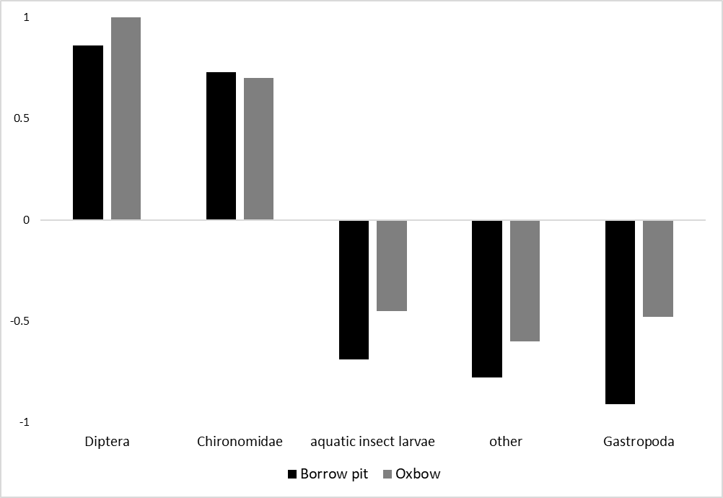

The index of electivity was surprisingly low for gastropods, indicating a level of avoidance; however, as only small parts of shell were found in otherwise empty stomachs, this could mean that gastropods were heavily underestimated in the diet, the low weight of the shell fragments resulting in a low overall weight percentage. In this case, SIA gave more useful data as it is less prone to underestimation of prey items that are digested or destroyed. In comparison, the electivity index of diptera (other than chironomids) was high (showing preferential feeding) due to the low catch of non-chironomid dipteran larvae at both localities (Strauss, 1979), which resulted in a relatively low weight percentage of non-chironomid dipterans in the benthos assemblage. While the non-chironomid dipterans in the benthos assemblage were represented only by Culicidae (representing 0.1 % of the total weight of benthos), GCA revealed Culicidae, Ceratopogonidae and Tabanidae (representing 2.3 % of total diet by weight). In this case, therefore, the electivity indices should be considered with great care.

References:
Ivlev, V. S., 1961. Experimental ecology of the feeding of fishes. Yale University Press, New Haven.
Manko, P., 2016. Stomach content analysis in freshwater fish feeding ecology. Vydavateľstvo Prešovskej univerzity, Prešov.
Strauss, R. E., 1979. Reliability Estimates for Ivlev’s Electivity Index, the Forage Ratio, and a Proposed Linear Index of Food Selection. Transactions of the American Fisheries Society Taylor & Francis 108: 344–352.

Online Resource 4. Food composition of pumpkinseed Lepomis gibbosus collected at the two sampling sites (borrow pit Capi Horni, oxbow D8) in the Dyje River floodplain (Czech Republic) during the two sampling seasons (spring, summer) using visual gut content analysis. Small fish correspond to 1+ fish, large fish are represented by ≥2+ fish. Mean percentage volume (%V) / frequency of occurrence (%F) / index of preponderance (%P). A dash (-) indicates that the dietary item was not found in the respective fish group or site.
Group | Site | Season | Aquatic larvae | Detrit | Diptera | Eggs | Chironomidae | Gastropoda | Other | Plants | Zooplankton
small | Borrow pit | Summer | 60/10/6 | 5/5/0 | — | — | 86/100/86 | 8/10/1 | 15/5/1 | 5/24/1 | 18/29/5
small | Oxbow | Summer | 27/16/4 | 20/26/5 | 15/11/2 | — | 71/95/67 | 6/11/1 | 28/53/15 | 9/21/2 | 27/16/4
large | Borrow pit | Spring | 26/38/10 | — | 33/25/8 | — | 68/94/64 | 35/25/9 | 37/19/7 | 20/13/3 | —
large | Borrow pit | Summer | 35/21/7 | 50/3/2 | 10/3/0 | — | 87/100/87 | 13/14/2 | 10/3/0 | 6/21/1 | 5/3/0
large | Oxbow | Spring | 25/44/11 | — | — | — | 74/89/66 | 16/22/4 | 57/33/18 | 3/22/1 | —
large | Oxbow | Summer | 44/26/11 | 36/29/10 | 10/3/0 | 50/3/2 | 63/90/57 | 22/26/6 | 40/10/4 | 22/42/9 | 4/16/1
Total |  |  | 35/23/8 | 30/13/4 | 23/7/2 | 50/1/0 | 76/95/72 | 19/17/3 | 34/17/6 | 13/26/3 | 14/12/2

Online Resource 5. Pumpkinseed diet mixing models. Mean is the mean proportion of diet; SD is the standard deviation; 5% CI resp. 95% CI are 5% resp. 95% confidence intervals.
Group | Site | Food item | Mean | SD | 5% CI | 95% CI
small  < 60 mm  1+ | borrow pit | eggs | 0.017 | 0.018 | 0.001 | 0.054
small  < 60 mm  1+ | borrow pit | fish | 0.202 | 0.063 | 0.103 | 0.31
small  < 60 mm  1+ | borrow pit | gastropoda | 0.234 | 0.054 | 0.148 | 0.323
small  < 60 mm  1+ | borrow pit | macrozoobenthos | 0.395 | 0.1 | 0.215 | 0.55
small  < 60 mm  1+ | borrow pit | plankton | 0.153 | 0.093 | 0.019 | 0.312
small  < 60 mm  1+ | oxbow | eggs | 0.005 | 0.005 | 0 | 0.016
small  < 60 mm  1+ | oxbow | fish | 0.632 | 0.043 | 0.553 | 0.689
small  < 60 mm  1+ | oxbow | gastropoda | 0.241 | 0.05 | 0.145 | 0.302
small  < 60 mm  1+ | oxbow | macrozoobenthos | 0.104 | 0.083 | 0.022 | 0.267
small  < 60 mm  1+ | oxbow | plankton | 0.018 | 0.013 | 0.003 | 0.044
large  ≥ 60 mm  ≥ 2+ | borrow pit | eggs | 0.018 | 0.023 | 0 | 0.067
large  ≥ 60 mm  ≥ 2+ | borrow pit | fish | 0.115 | 0.043 | 0.052 | 0.191
large  ≥ 60 mm  ≥ 2+ | borrow pit | gastropoda | 0.192 | 0.055 | 0.098 | 0.282
large  ≥ 60 mm  ≥ 2+ | borrow pit | macrozoobenthos | 0.568 | 0.101 | 0.392 | 0.728
large  ≥ 60 mm  ≥ 2+ | borrow pit | plankton | 0.108 | 0.071 | 0.011 | 0.234
large  ≥ 60 mm  ≥ 2+ | oxbow | eggs | 0.009 | 0.013 | 0 | 0.036
large  ≥ 60 mm  ≥ 2+ | oxbow | fish | 0.495 | 0.059 | 0.388 | 0.575
large  ≥ 60 mm  ≥ 2+ | oxbow | gastropoda | 0.274 | 0.069 | 0.144 | 0.364
large  ≥ 60 mm  ≥ 2+ | oxbow | macrozoobenthos | 0.202 | 0.124 | 0.046 | 0.438
large  ≥ 60 mm  ≥ 2+ | oxbow | plankton | 0.02 | 0.017 | 0.002 | 0.054

