Small dams fragment assemblages of diadromous and freshwater decapod species in Hong Kong lowland streams – Supplementary files
Jeffery C.F. Chan^{1,2}, Jia Huan Liew^{2,3} & David Dudgeon^{1*}

¹School of Biological Sciences, The University of Hong Kong, Hong Kong SAR; (J.C.F Chan, ORCID: 0000-0003-0412-9429, email: jefferychan@connect.hku.hk; (*corresponding author, D. Dudgeon, ORCID: 0000-0003-4632-3473, email: ddudgeon@hku.hk)
²Science Unit, Lingnan University, Hong Kong SAR.
³School of Natural Sciences, University of Tasmania, Australia; ORCID: 0000-0002-7649-0398, email: JiaHuan.Liew@utas.edu.au).

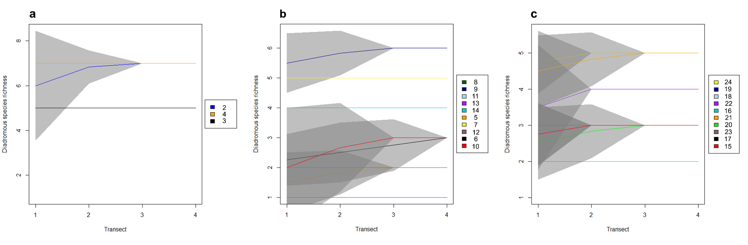
Figure S1. Species-accumulation curves of diadromous decapods in each stream on (a) Hong Kong Island, (b) Lantau Island, and (c) the New Territories during the 2022 wet season using 95% confidence intervals of sample-based rarefaction (Mao Tau estimates)
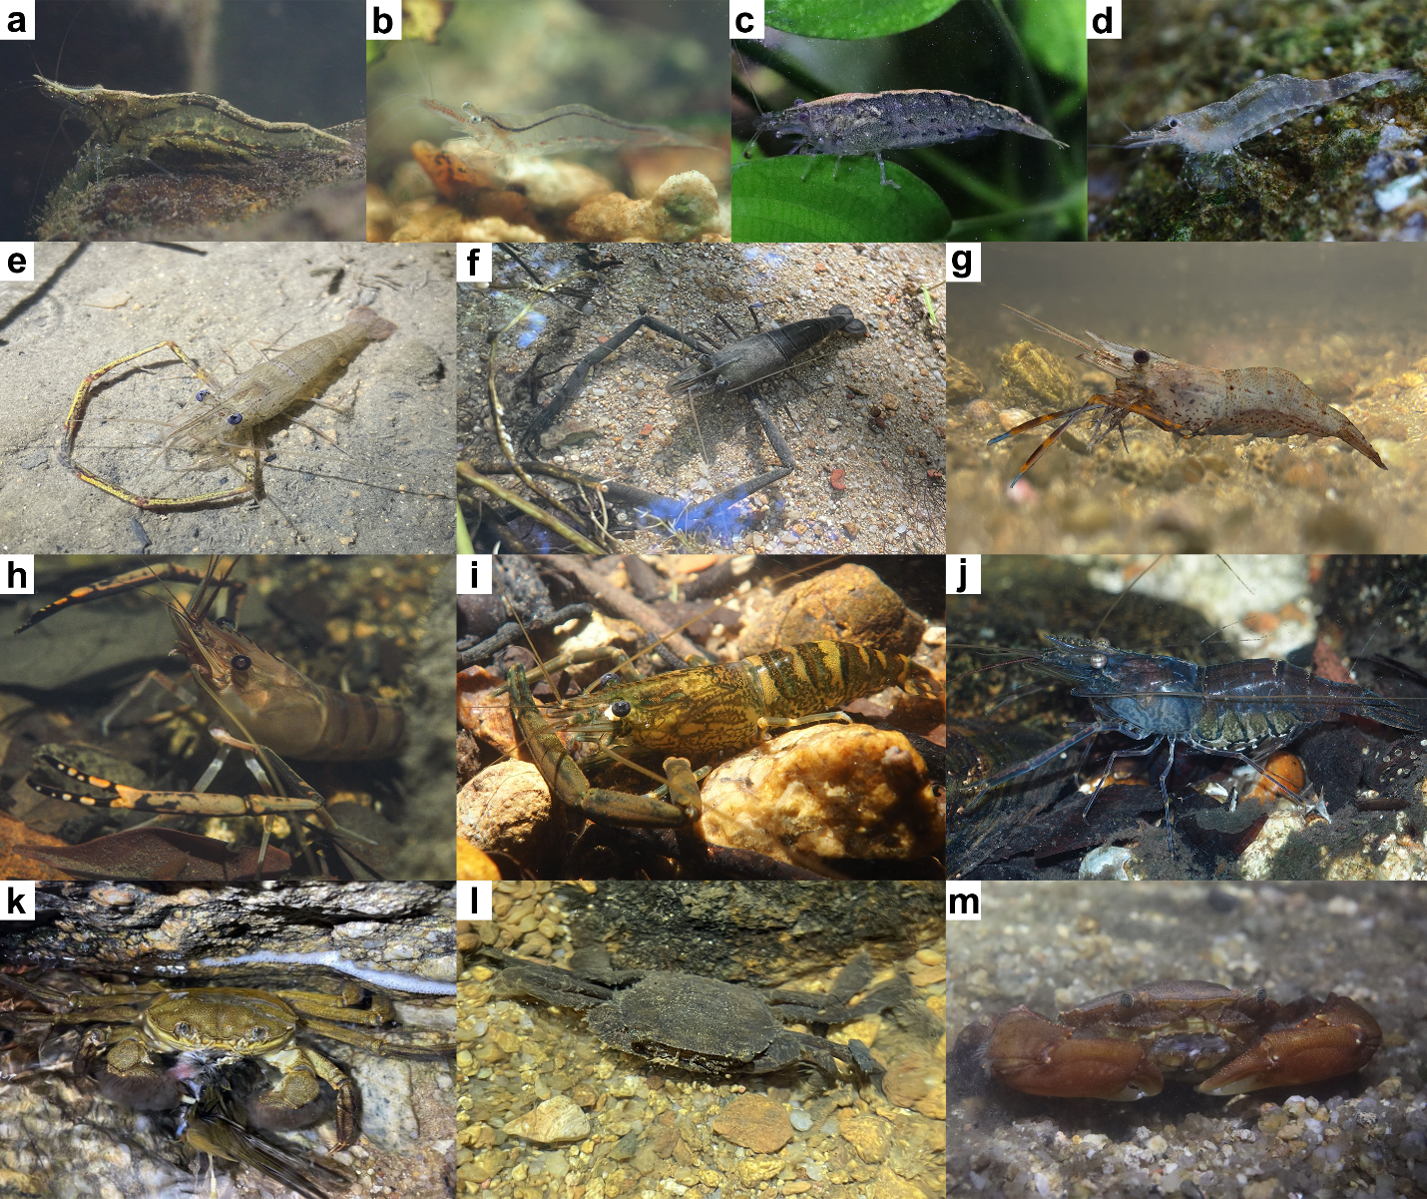
Figure S2. Diadromous decapods collected from Hong Kong streams: (a) Caridina elongapoda; (b) C. gracilipes; (c) C. typus; (d) C. sp.; (e) Macrobrachium equidens; (f) M. formosense; (g) M. lantau; (h) M. lar; (i) M. meridionale; (j); M. nipponense; (k) Eriocheir japonica; (l) Varuna litterata; (m) V. yui. Photographs by J.C.F. Chan.

Table S1. Summary of streams surveyed and site codes. As diadromous decapods are poached in Hong Kong, localities of sampling sites have not been given. Please email the corresponding author if you require to request further locality information.
Site code | 2022 Wet season | 2022-2023 Dry season | Within-Season replication | Barrier type | Height (m)
HONG KONG ISLAND
H1 | Y | - | - | - | -
H2 | Y | Y | Y | - | -
H3 | Y | - | - | Dam | 0.3, 0.9
H4 | Y | - | - | - | -
LANTAU ISLAND
L5 | Y | - | - | Dam | 2.3
L6 | Y | - | - | - | -
L7 | Y | Y | - | Dam | 1.2
L8 | Y | Y | - | Dam | 0.9
L9 | Y | - | - | Dam | 0.6, 1.4, 1.4
L10 | Y | - | - | - | -
L11 | Y | - | - | Dam | 1.5, 1.0
L12 | Y | - | - | Dam | 0.6, 0.8
L13 | Y | Y | Y | Dam | 8.7
L14 | Y | - | - | - | -
NEW TERRITORIES
N15 | Y | - | - | Dam | 2.6
N16 | Y | - | - | Dam | 2.2
N17 | Y | Y | - | - | -
N18 | Y | - | - | Dam | 0.6
N19 | Y | - | - | Waterfall | 11.5
N20 | Y | Y | Y | Dam | 1.4, 5.8, 1.4
N21 | Y | - | - | Dam | 0.3, 0.3
N22 | Y | - | - | - | -
N23 | Y | - | - | Waterfall, dam, dam | 10.2, 1.4, 5.9
N24 | Y | Y | - | Waterfall | 12.3

Table S2. Diadromous species recorded from the seven Hong Kong streams sampled repeatedly during both wet and dry seasons.
Species | Wet season 2022 | Dry season 2022 - 2023
Caridina elongapoda | 1 | 1
C. typus | 1 | 1
C. sp. | 1 | 1
Macobrachium meridionale | 1 | 1
M. formosense | 1 | 1
M. lar | 1 | 0
Eriocheir japonica | 1 | 1
Varuna yui | 1 | 1

