Time series of the auto-classifications versus the manual classifications for the IFCB verification samples
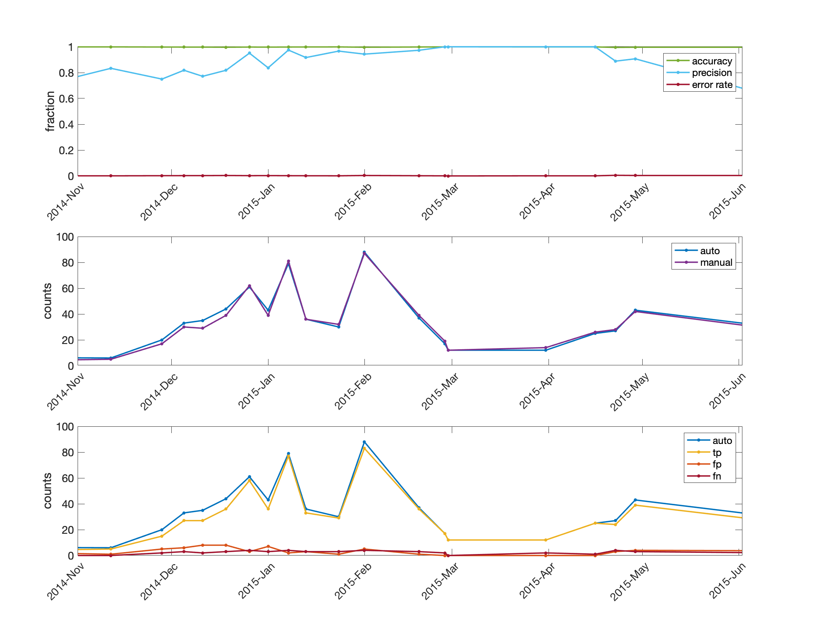

S1.Figure 1.Assessment metrics for autoclassification of Asterionella for winter 2014-2015 and beyond. Top panel: accuracy, error, and precision based on comparison of autoclassified and manual verification samples. Middle panel: Counts of images classified as Asterionella by a human user (manual verification samples) and the autoclassifier (auto). Bottom panel: Counts of autoclassified Asterionella images that were true positives (tp), false positives (fp), and false negatives (fn). True negatives (tn) are the (thousands of) non-Asterionella that were correctly excluded from the Asterionella category, and are not plotted here.
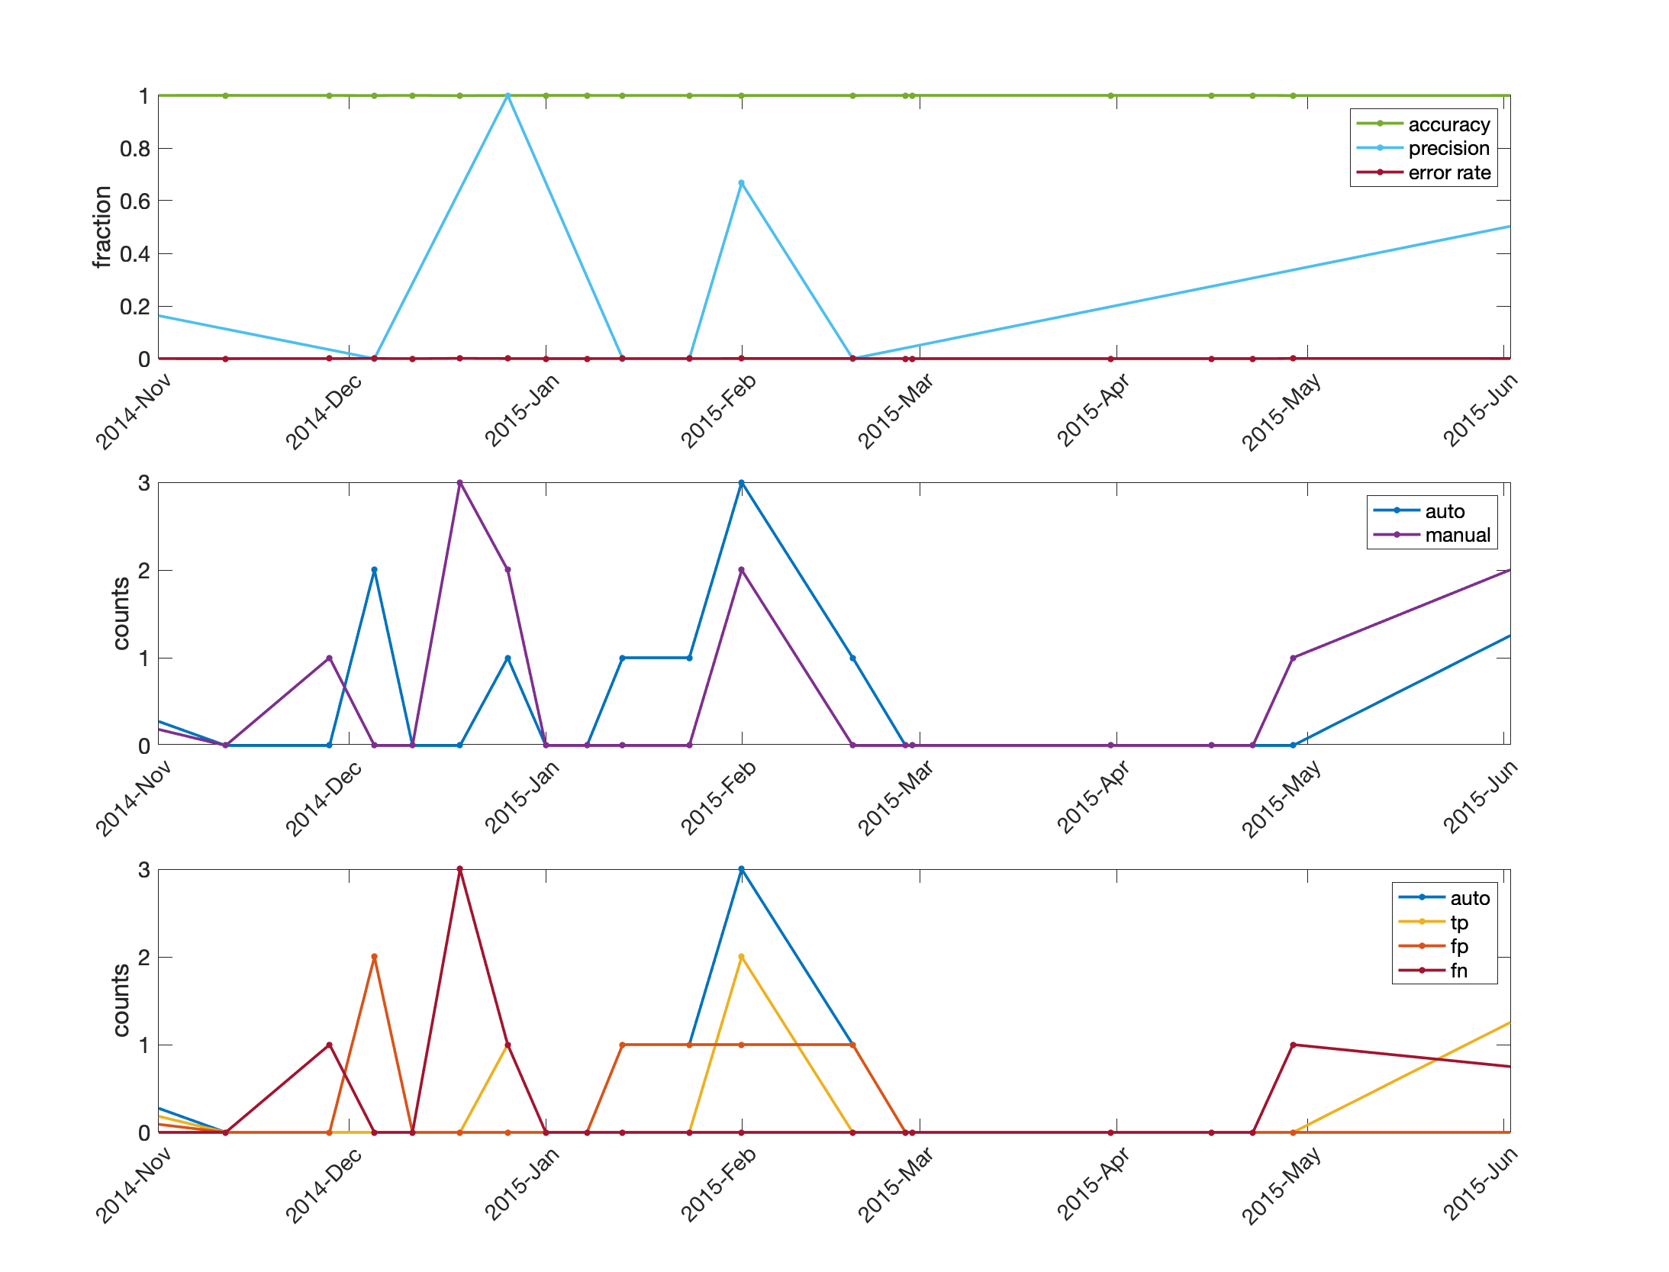
S1.Figure 2.Assessment metrics for autoclassification of Fragilaria for winter 2014-2015 and beyond. Top panel: accuracy, error, and precision based on comparison of autoclassified and verification samples. Middle panel: Counts of images classified as Fragilaria by a human user (manual verification samples) and the autoclassifier (auto). Bottom panel: Counts of autoclassified Fragilaria images that were true positives (tp), false positives (fp), and false negatives (fn). True negatives (tn) are the (thousands of) non- Fragilaria that were correctly excluded from the Fragilaria category, and are not plotted here.

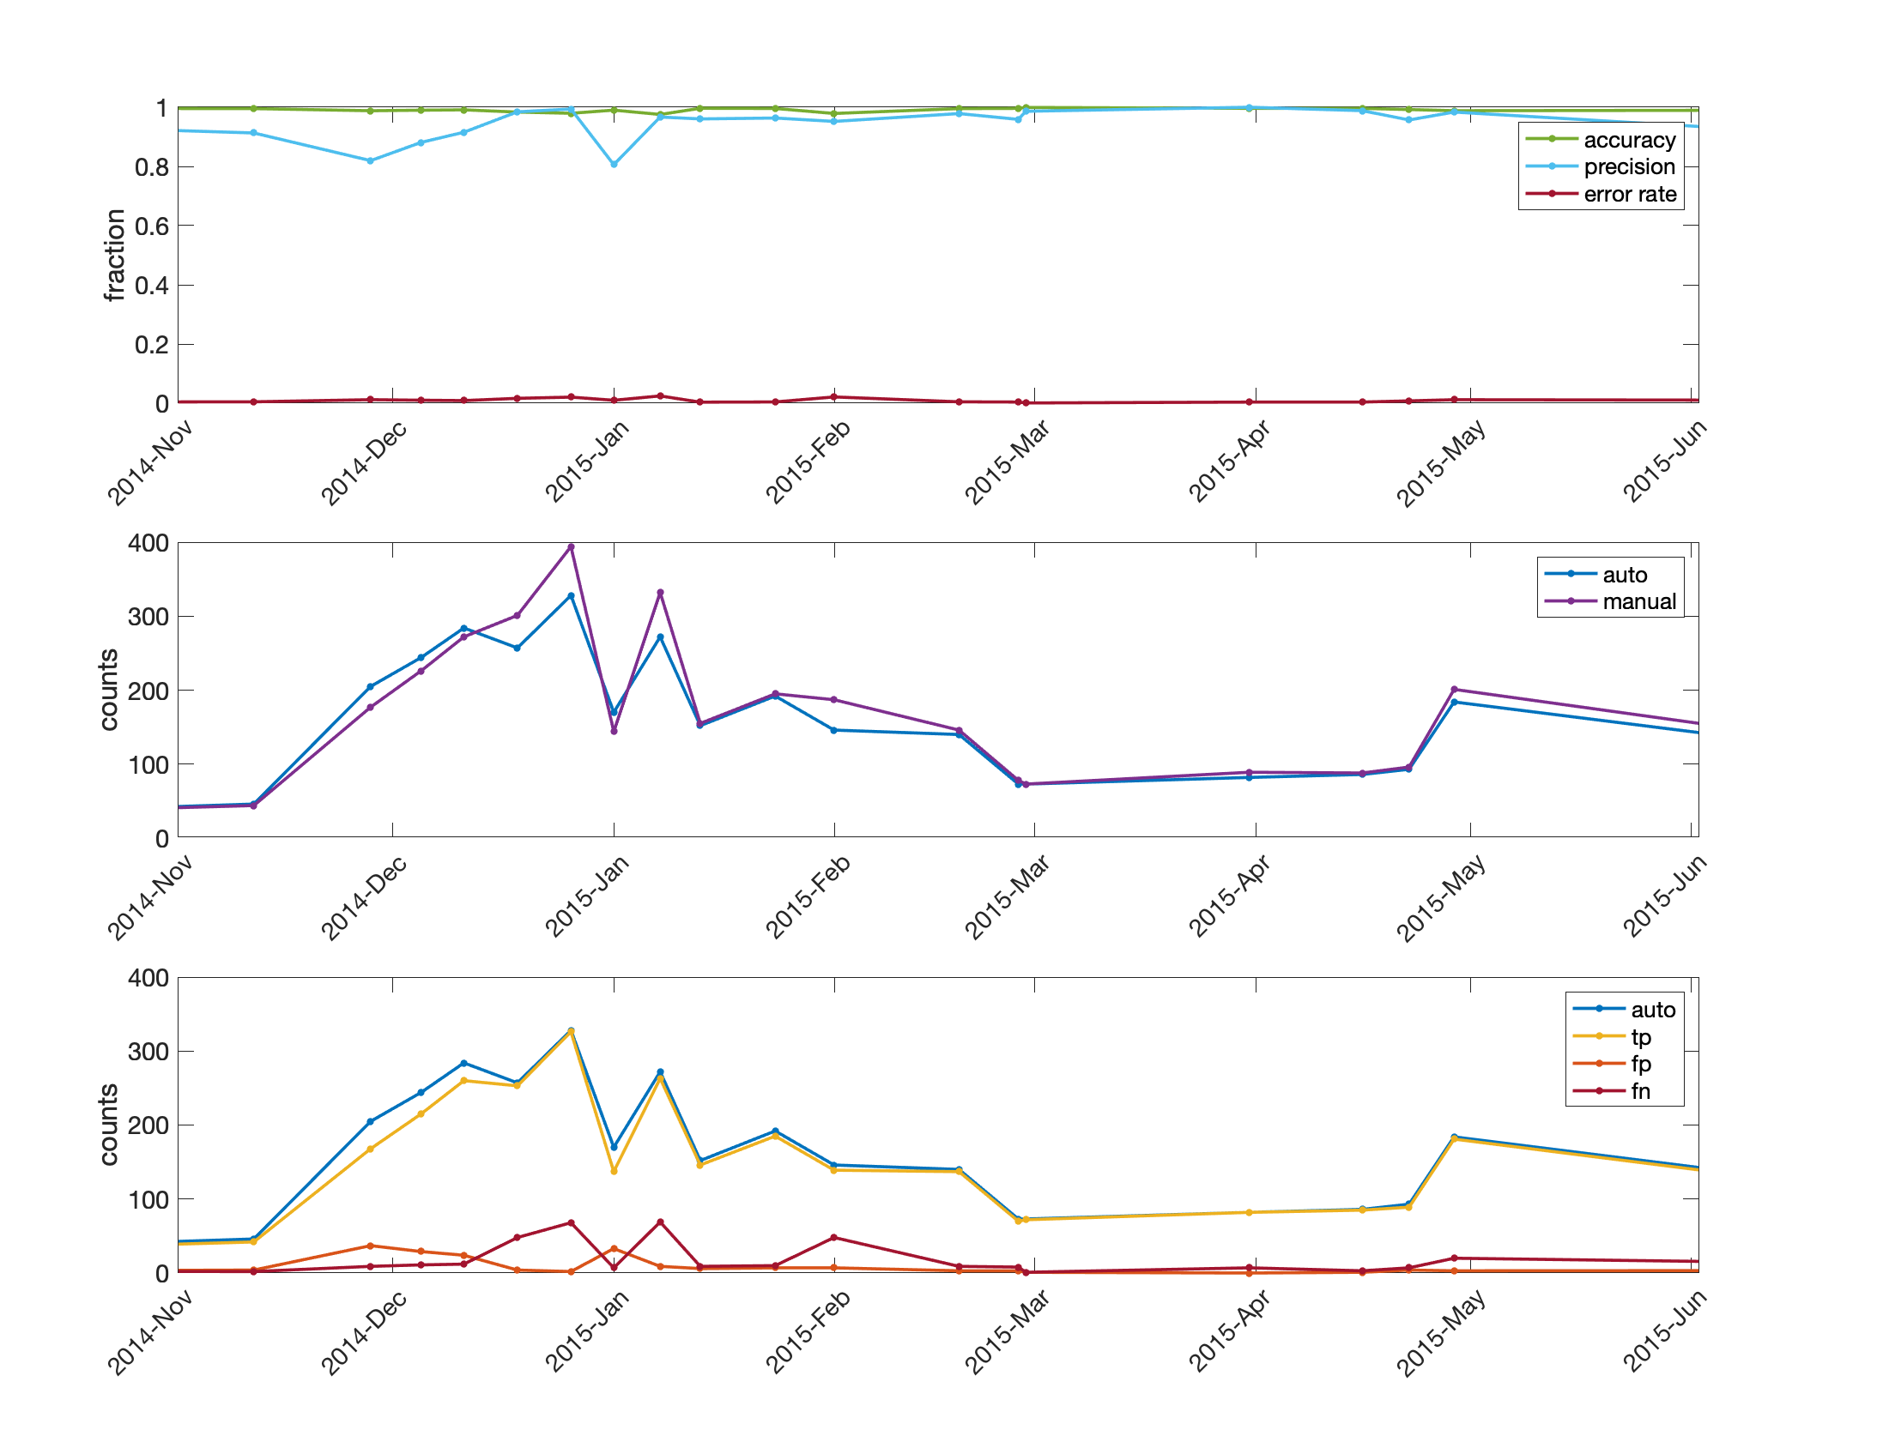
S1.Figure 3.Assessment metrics for autoclassification of cf. Synedra for winter 2014-2015 and beyond. Top panel: accuracy, error, and precision based on comparison of autoclassified and verification samples. Middle panel: Counts of images classified as cf. Synedra by a human user (manual verification samples) and the autoclassifier (auto). Bottom panel: Counts of autoclassified cf. Synedra images that were true positives (tp), false positives (fp), and false negatives (fn). True negatives (tn) are the (thousands of) non- cf. Synedra that were correctly excluded from the cf. Synedra category, and are not plotted here.

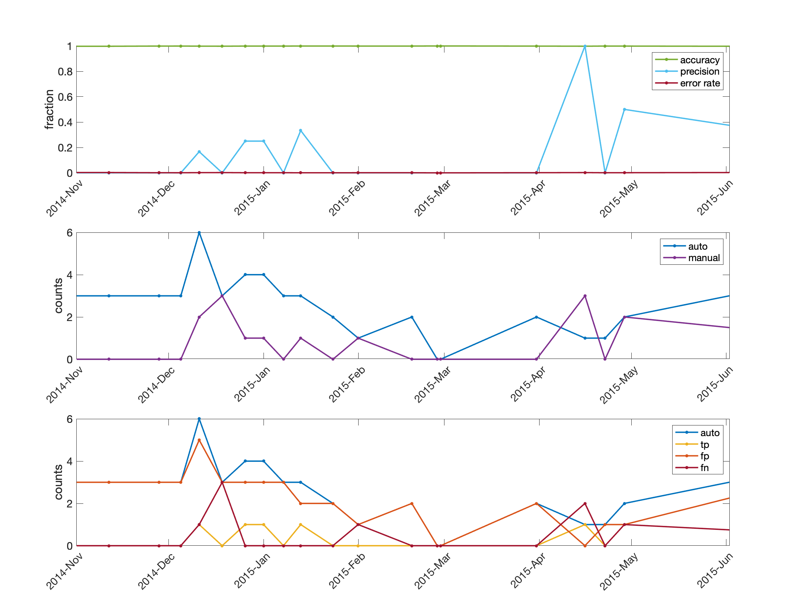
S1.Figure 4.Assessment metrics for autoclassification of Tabellaria for winter 2014-2015 and beyond. Top panel: accuracy, error, and precision based on comparison of autoclassified and verification samples. Middle panel: Counts of images classified as Tabellaria by a human user (manual verification samples) and the autoclassifier (auto). Bottom panel: Counts of autoclassified Tabellaria images that were true positives (tp), false positives (fp), and false negatives (fn). True negatives (tn) are the (thousands of) non-Tabellaria that were correctly excluded from the Tabellaria category, and are not plotted here.

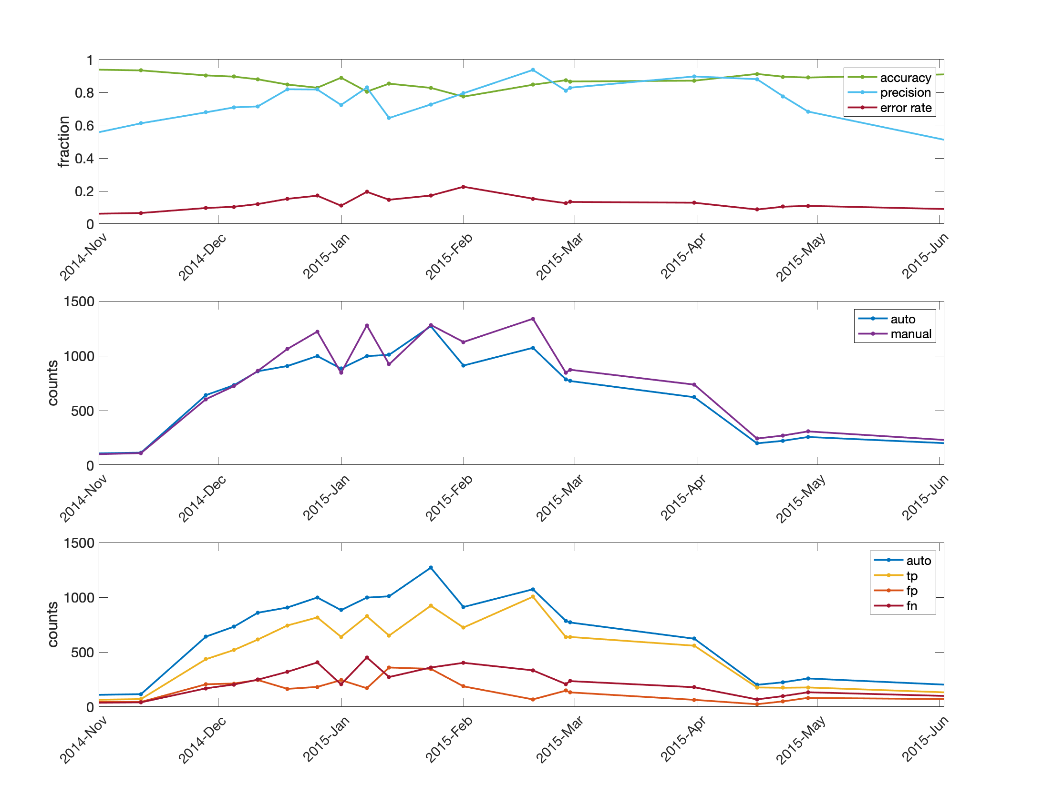
S1.Figure 5.Assessment metrics for autoclassification of Urosolenia for winter 2014-2015 and beyond. Top panel: accuracy, error, and precision based on comparison of autoclassified and verification samples. Middle panel: Counts of images classified as Urosolenia by a human user (manual verification samples) and the autoclassifier (auto). Bottom panel: Counts of autoclassified Urosolenia images that were true positives (tp), false positives (fp), and false negatives (fn). True negatives (tn) are the (thousands of) non-Urosolenia that were correctly excluded from the Urosolenia category, and are not plotted here.

