Connection over creation: hydrological connectivity drives post-restoration community assembly in coastal ponds
Hydrobiologia
¹Anna Equisuany, ¹Dani Boix, ² David Cunillera-Montcusí, ¹Xavier D. Quintana, ¹Jordi Sala and ¹Stéphanie Gascón.
¹GRECO, Institute of Aquatic Ecology, University of Girona (Girona, Spain)
²Institute of Aquatic Ecology, HUN-REN Centre for Ecological Research (Budapest, Hungary)
Corresponding author address: anna.equisuany@udg.edu

SUPPLEMENTARY MATERIALS

Supplementary Material 1. Images of the study site.
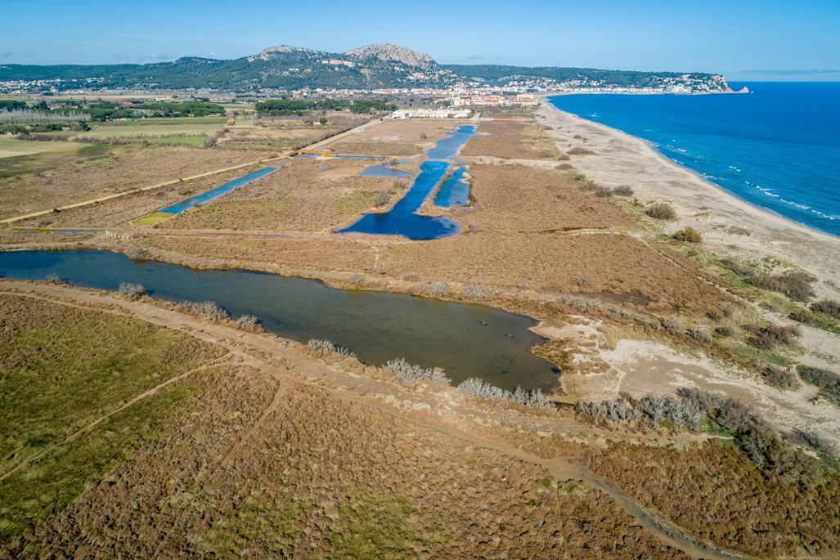
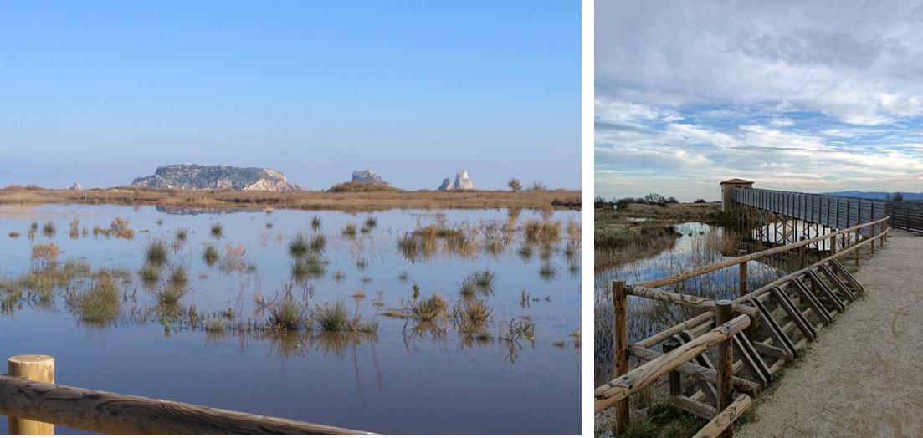

Supplementary Material 2. La Pletera salt marsh with old ponds (red) and new ponds (orange). From left to right (upper figure panels): A) no flooding; B) flooded area at 0.7 m a.s.l; C) flooded area above 1 m a.s.l.
Water level changes at La Pletera salt marsh (D). Blue represents data from La Pletera (2015–2019), while orange represents data from a nearby area (2015–2022). Sampling campaigns are indicated on the graph. High-connected ponds became interconnected at 0.7 m a.s.l. (dashed yellow line), while all ponds (both high-connected and low-connected) connect above 1 m a.s.l. (dashed brown line). A major inundation event between December 2016 and February 2017, during which water levels exceeded 1 m a.s.l is marked (red arrow). Measurement sites are shown with points on the accompanying map (E).
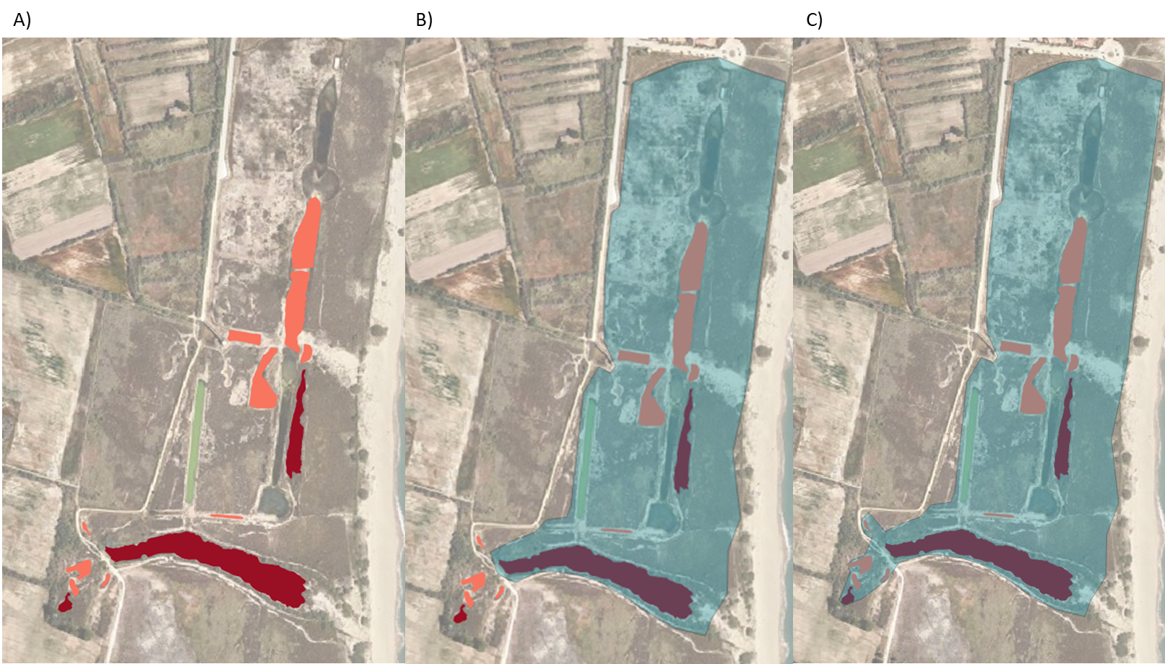
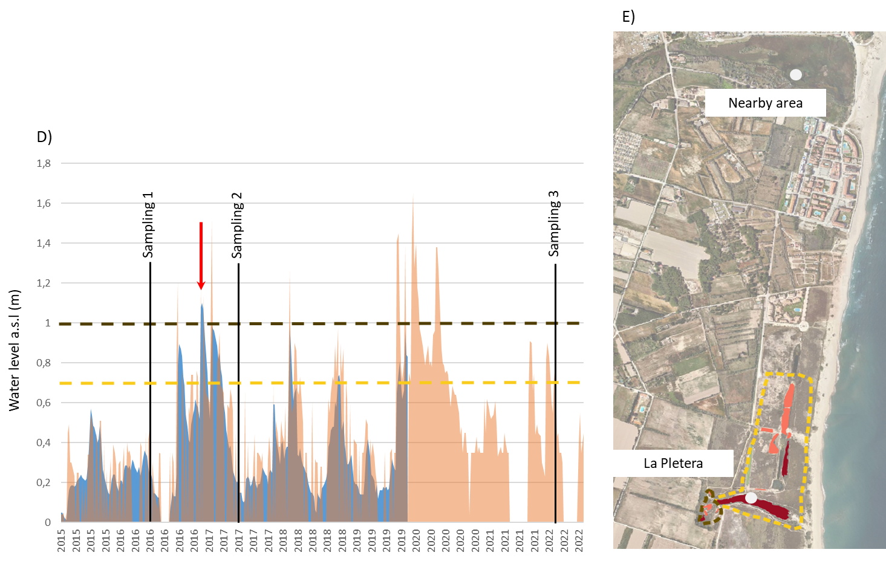
Supplementary Material 3. Mean values ± standard deviation of the environmental variables for pond age (Old/New) and hydrological connectivity (High-connected/ Low-connected) in each year.
 | 2016 |  | 2017 |  | 2022
Pond age | New | Old | New | Old | New | Old
Temperature (°C) | 24.28±1.19 | 18.17±0.21 | 24.11±2.84 | 13.43±1.94 | 14.89±0.43 | 15.56±0.29
Conductivity (mS/cm) | 31.46±8.31 | 62.2±20.54 | 27.31±4.74 | 42.4±13.65 | 24.71±7.45 | 31.2±7.92
Dissolved oxygen (mg/l) | 10.33±2.83 | 5.09±1.18 | 11.15±3.02 | 8.37±1.7 | 6.83±1.5 | 5.04±2.75
pH | 9.17±0.46 | 8.94±0.27 | 8.72±0.24 | 8.68±0.18 | 8.46±0.28 | 8.25±0.47
ECELS index | 59±6.15 | 83.33±10.41 | 63.9±11.41 | 85±8.66 | 79.9±10.35 | 83.33±2.89
Pond size (m²) | 823.03±903.27 | 4048.98±5917.19 | 823.03±903.27 | 4048.98±5917.19 | 823.03±903.27 | 4048.98±5917.19
Hydrology | High-connected | Low-connected | High-connected | Low-connected | High-connected | Low-connected
Temperature (°C) | 22.8±2.98 | 22.98±3.04 | 20.48±5.21 | 23.52±5.58 | 14.93±0.58 | 15.24±0.21
Conductivity (mS/cm) | 35.38±12.84 | 43.64±23.88 | 32.86±9.51 | 27.48±9.72 | 24.66±7.29 | 28.7±8.67
Dissolved oxygen (mg/l) | 8.45±1.98 | 10.19±5.04 | 10.11±2.45 | 11.15±3.88 | 6.43±1.97 | 6.39±1.96
pH | 9.4±0.25 | 8.67±0.19 | 8.71±0.19 | 8.71±0.29 | 8.23±0.19 | 8.69±0.29
ECELS index | 63.13±15.57 | 67±6.71 | 67.38±15.06 | 71±13.42 | 82.75±6.27 | 77.4±12.7
Pond size (m²) | 2393.09±3526.5 | 246.5±196 | 2393.09±3526.5 | 246.5±196 | 2393.09±3526.5 | 246.5±196

Supplementary Material 4. Vectors of community trajectory analyses (CTA) of the two periods studied (i.e. 2016-2017 and 2017-2022) for each pond, grouped by (a) pond age (New/Old) and (b) hydrological connectivity (High-connected/Low-connected).
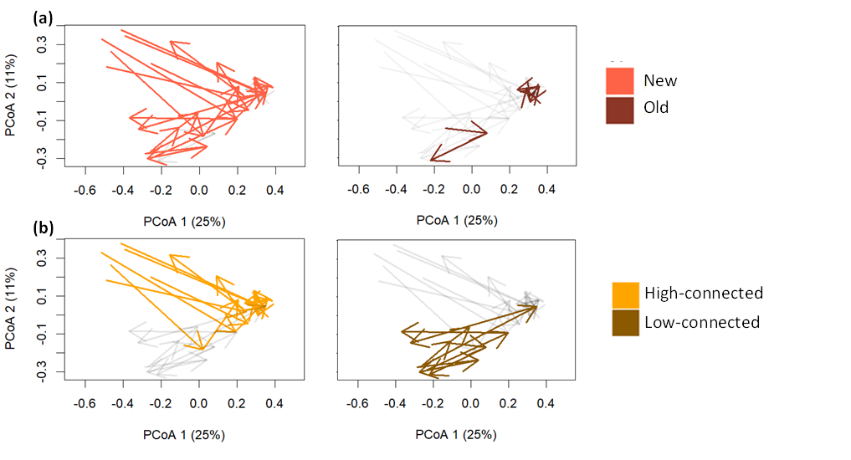

Supplementary Material 5. Linear mixed model results for diversity indices, between old and new ponds, and high-connected (HC) and low-connected (LC). SW diversity, Shannon-Wiener diversity; FRic, functional richness; FDiv, functional divergence; FDis, functional dispersion; and FEve, functional evenness. T-test results for diversity indices, when significant, for each year. P value adjusted by Bonferroni method.
 |  | Results for New/Old |  |  | Results for HC/LC
 |  | DF₁,DF₂ | F value | p value | DF₁,DF₂ | F value | p value
Species richness | Factor | 1,10 | 0.16 | 0.69 | 1,10 | 3.00 | 0.1
Species richness | Year | 2,20 | 0.56 | 0.57 | 2,20 | 0.9 | 0.4
Species richness | Factor:Year | 2,20 | 0.28 | 0.75 | 2,20 | 1.12 | 0.3
SW diversity | Factor | 1,10 | 0.03 | 0.86 | 1,10 | 3.99 | 0.07
SW diversity | Year | 2,20 | 0.31 | 0.73 | 2,20 | 0.01 | 0.9
SW diversity | Factor:Year | 2,20 | 0.68 | 0.51 | 2,20 | 0.77 | 0.7
FRic | Factor | 1,9 | 0.04 | 0.84 | 1,9 | 0.89 | 0.36
 | Year | 2,18 | 1.48 | 0.25 | 2,18 | 2 | 0.15
 | Factor:Year | 2,18 | 0.35 | 0.71 | 2,18 | 0.29 | 0.75
FDis | Factor | 1,10 | 1.00 | 0.34 | 1,10 | 5.3 | 0.05
 | Year | 2,20 | 2.6 | 0.09 | 1.2,12.6 | 9.91 | <0.01
 | Factor:Year | 2,20 | 3.02 | 0.07 | 1.2,12.6 | 2.88 | 0.1
FDiv | Factor | 1,9 | 2.1 | 0.18 | 1,9 | 0.8 | 0.39
 | Year | 2,18 | 1.8 | 0.19 | 2,18 | 0.8 | 0.46
 | Factor:Year | 2,18 | 1.39 | 0.27 | 2,18 | 1.33 | 0.28
FEve | Factor | 1,9 | 0.5 | 0.49 | 1,9 | 0.38 | 0.55
 | Year | 2,18 | 6.35 | <0.01 | 2,18 | 3.6 | 0.04
 | Factor:Year | 2,18 | 0.91 | 0.41 | 2,18 | 0.05 | 0.94

T-test |  | DF₁,DF₂ | F value | p. adj
FDis | 2016 HC/LC | 1,10 | 3.02 | 0.33
 | 2017 HC/LC | 1,10 | 0.75 | 1.00
 | 2022 HC/LC | 1,10 | 8.04 | 0.05

Supplementary Material 6. List of taxa and taxonomic groups. In bold, taxa found in the three surveys.
TAXA | TAXONOMIC GROUPS
Berosus fulvus (Kuwert, 1888) | COLEOPTERA
Berosus hispanicus (Küster, 1847) | COLEOPTERA
Chironominae | DIPTERA
Culicoides sp. | DIPTERA
Discocerina sp. | DIPTERA
Dolichopodidae | DIPTERA
Ecrobia ventrosa (Montagu, 1803) | GASTROPODA
Enchytraeidae | OLIGOCHAETA
Enochrus bicolor (Fabricius, 1792) | COLEOPTERA
Ephydra sp. | DIPTERA
Eretes griseus (Fabricius, 1781) | COLEOPTERA
Ficopomatus enigmaticus (Fauvel, 1923) | POLYCHAETA
Gammarus aequicauda (Martynov, 1931) | AMPHIPODA
Gerris argentatus (Schummel, 1832) | HEMIPTERA
Gerris thoracicus (Schummel, 1832) | HEMIPTERA
Hediste diversicolor (O.F. Müller, 1776) | POLYCHAETA
Helophorus brevipalpis (Bedel, 1881) | COLEOPTERA
Helophorus fulgidicollis (Motschulsky, 1860) | COLEOPTERA
Hydroglyphus geminus (Fabricius, 1792) | COLEOPTERA
Hydroporus pubescens (Gyllenhal, 1808) | COLEOPTERA
Hygrotus sp. | COLEOPTERA
Ischnura sp. | ODONATA
Myosotella myosotis (Draparnaud, 1801) | GASTROPODA
Nebrioporus cerisyi (Aubé, 1838) | COLEOPTERA
Nemotelus sp. | DIPTERA
Ochlerotatus caspius (Pallas, 1771) | DIPTERA
Ochthebius dentifer (Rey, 1885) | COLEOPTERA
Ochthebius dilatatus (Stephens, 1829) | COLEOPTERA
Ochthebius punctatus (Stephens, 1829) | COLEOPTERA
Orthocladiinae | DIPTERA
Paracymus aeneus (Germar, 1823) | COLEOPTERA
Parydra sp. | DIPTERA
Scatella sp. | DIPTERA
Scatopsidae | DIPTERA
Sciomyzidae | DIPTERA
Sigara selecta (Fieber, 1848) | HEMIPTERA
Tanypodinae | DIPTERA
Tubificidae | OLIGOCHAETA

Supplementary Material 7. NMDS of taxonomic and traits composition, grouped by (a) pond age (Old/New) and (b) hydrological connectivity (High-connected/Low-connected). Centroids indicated by triangles.

Taxonomic composition
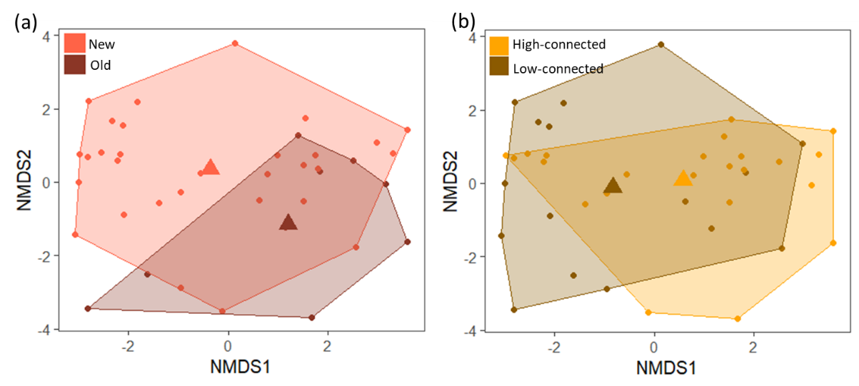

Traits composition
- Maximal potential body length
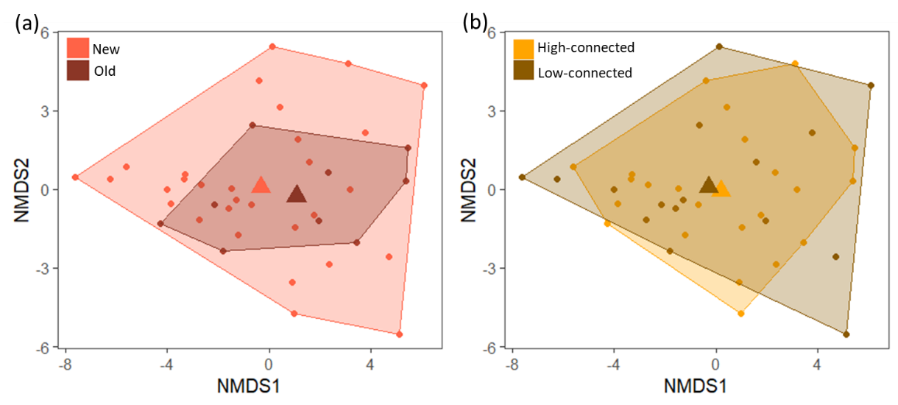

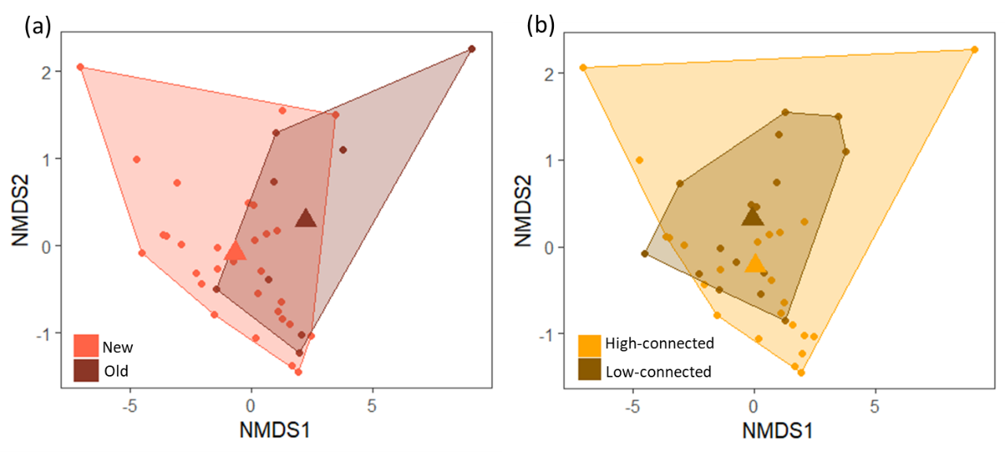
- Aquatic stages
- Dispersal ability

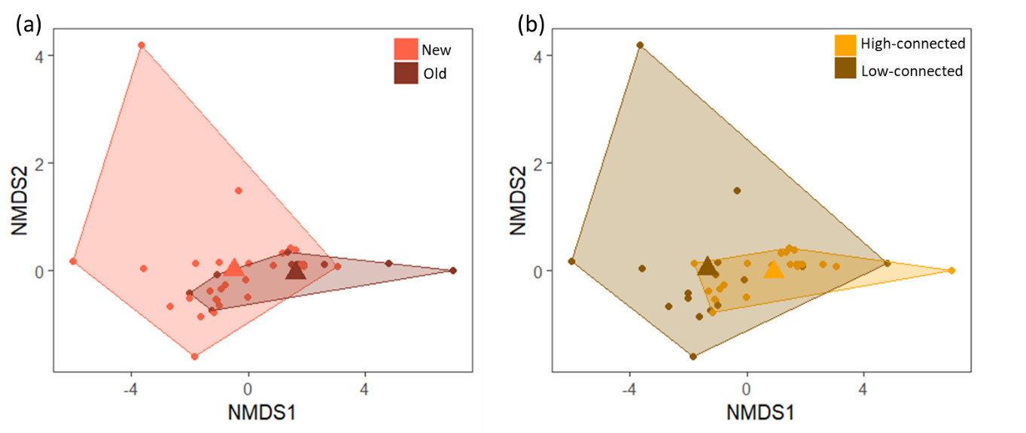
- Respiration
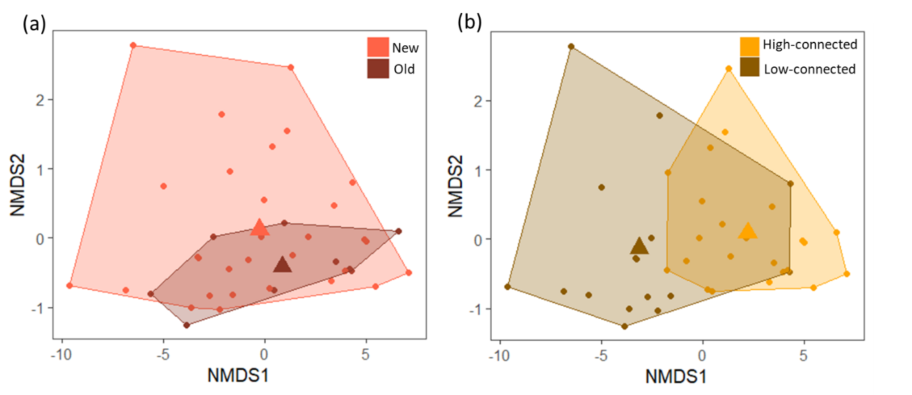

- Locomotion and substrate relation
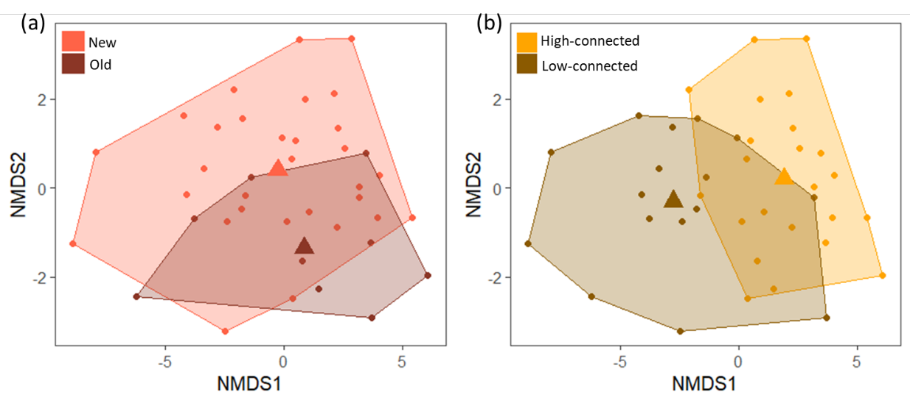
- Food preferences
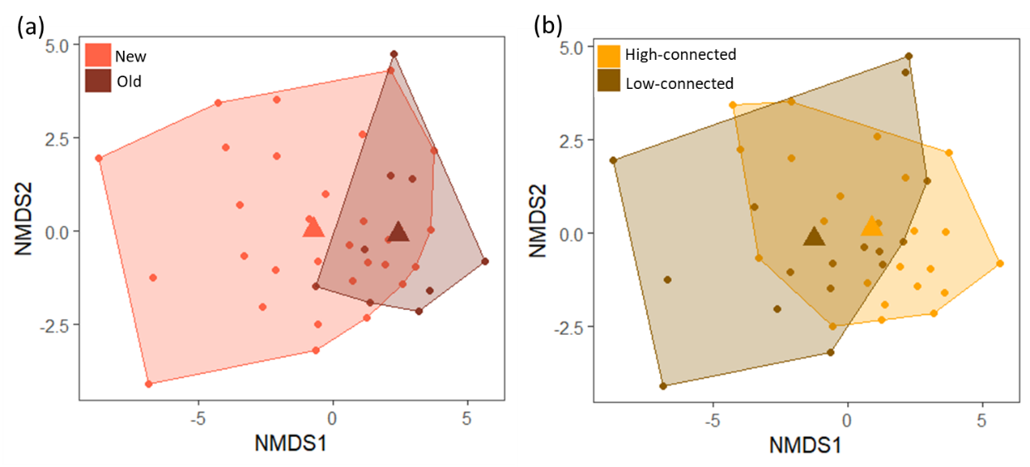
- Feeding habits
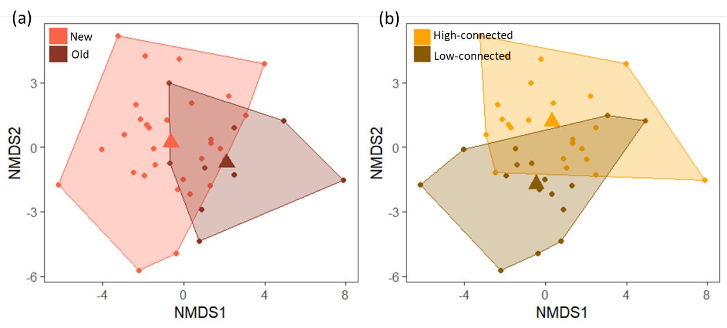

Supplementary Material 8. Relative abundances of taxonomic groups in the three years and per each pond surveyed. High-connected ponds are indicated with yellow squares and low-connected ponds are indicated with a brown square.
