Supplementary Materials - Ecological niche dynamics across continents for aquatic plants native to South America and invasive aliens elsewhere

Vanessa Lozano^{1,2*}, Ileana Herrera^{3,4}, André Große-Stoltenberg^{5,6}, Flavio Marzialetti^{1,2}
¹Department of Agricultural Sciences, University of Sassari, Viale Italia 39/a, 07100 Sassari, Italy. VL email: vlozano@uniss.it; FM email: fmarzialetti@uniss.it.
²National Biodiversity Future Center (NBFC), Piazza marina 61, 90133 Palermo, Italy.
³Escuela de Ciencias Ambientales, Universidad Espíritu Santo (UEES), Samborondón 091650, Ecuador. IH email: ileanaherrera@uees.edu.ec
⁴Instituto Nacional de Biodiversidad (INABIO), Quito 170501, Ecuador.
⁵Institute of Landscape Ecology and Resource Management (ILR), Research Centre for BioSystems, Land Use and Nutrition (iFZ), Justus Liebig University Gießen, Heinrich-Buff-Ring 26-32, 35392 Gießen, Germany. AGS email: Andre.Grosse-Stoltenberg@umwelt.uni-giessen.de.
⁶Center for International Development and Environmental Research (ZEU), Justus Liebig University Gießen, Senckenbergstrasse 3, 35390 Gießen, Germany.
* Corresponding Author: Vanessa Lozano (vlozano@uniss.it)

Table S1 The total number of occurrence records used to assess the niche dynamics downloaded and filtered using “Spocc” R package, focused on the native and invaded ranges (i.e., Africa, Asia, Australia, Europe and North America) of Egeria densa; Myriophyllum aquaticum; Pistia stratiotes; Pontederia crassipes and Salvinia molesta.
Aquatic invasive non-native plants | Filtered occurrences
Egeria densa (Planch.) Casp. | 1,354
Myriophyllum aquaticum (Vell.) Verdc. | 2,193
Pistia stratiotes L. | 3,454
Pontederia crassipes Mart. | 3,313
Salvinia molesta D.Mitch. | 749

Table S2 The multicollinearity values of hydroclimatic and environmental variables according to Variance Inflation Factor (VIF).
Hydroclimatic and environmental variables | Acronym | VIF
Minimum Upstream Temperature of Coldest Month | Hydro 06 | 2.699
Mean Upstream Temperature of Warmest Quarter | Hydro 10 | 3.105
Upstream Precipitation of Warmest Quarter | Hydro 18 | 1.476
Global Lakes and Wetlands cover Database | GLWD | 1.166

The PCA-env analysis (the most accurate method in terms of niche overlap detection) of the pooled hydroclimatic and environmental data revealed two significant axes associated with hydroclimatic variation of water availability and heat energy defining a realized climate space of reduced dimensionality which allows the study of niche conservatism (Broennimann et al., 2012). This ordination technique showed changes in the size of the niches and in the position of the areas (i.e., the highest density of occurrences) (Figs S1-S4).

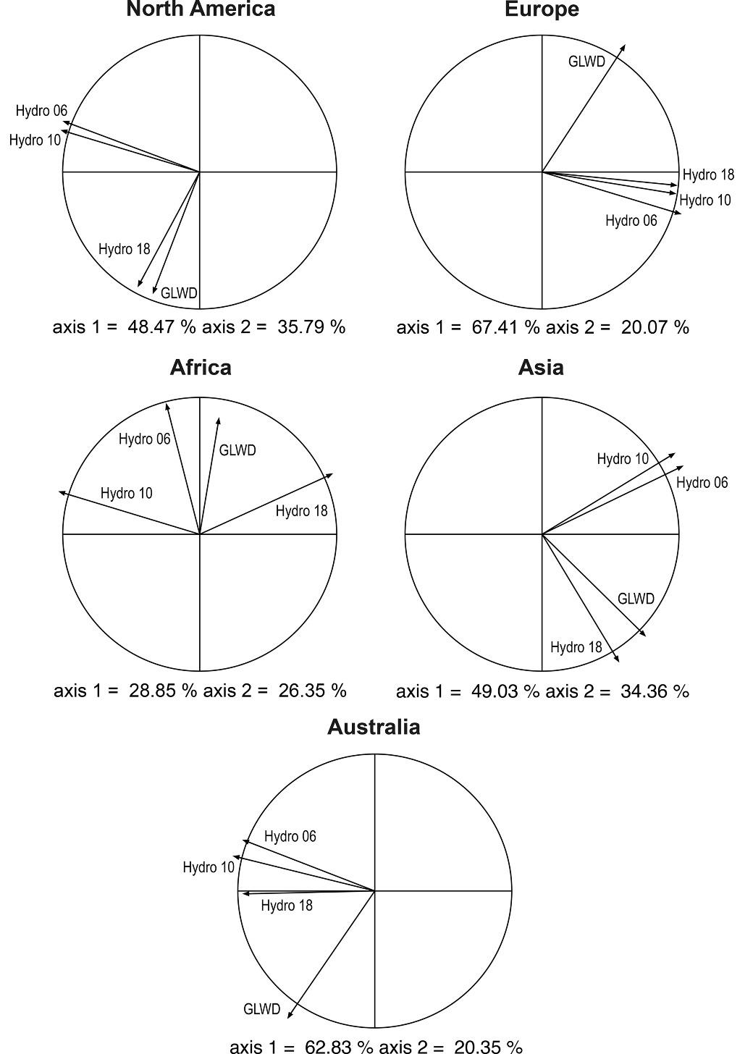
Fig. S1 A loadings plot illustrates how each of the environmental variables relates to the first two axes of the PCA and the weight of each variable for Egeria densa. The predictor climatic variables are Hydro 06 (Minimum Upstream Temperature of Coldest Month), Hydro 10 (Mean Upstream Temperature of Warmest Quarter), Hydro 18 (Upstream Precipitation of Warmest Quarter) and the Global lakes and wetlands cover (GLWD).

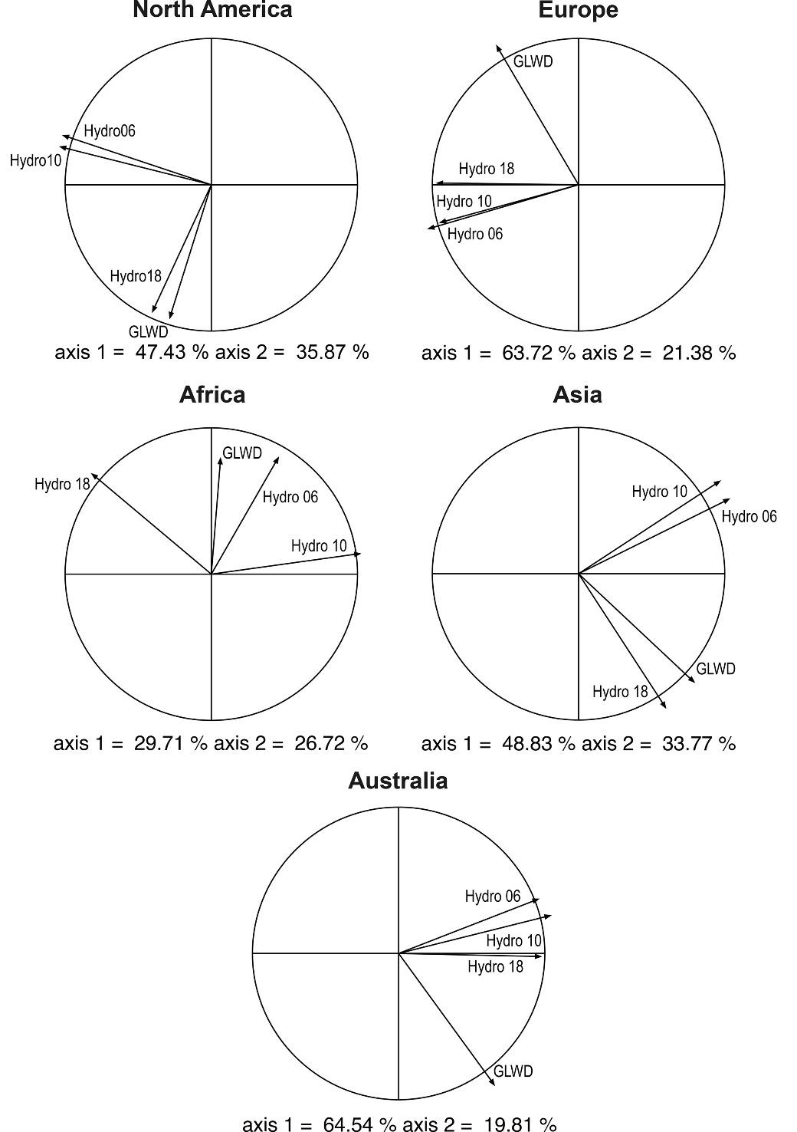
Fig. S2 A loadings plot illustrates how each of the environmental variables relates to the first two axes of the PCA and the weight of each variable for Myriophyllum aquaticum. The predictor climatic variables are Hydro 06 (Minimum Upstream Temperature of Coldest Month), Hydro 10 (Mean Upstream Temperature of Warmest Quarter), Hydro 18 (Upstream Precipitation of Warmest Quarter) and the Global lakes and wetlands cover (GLWD).

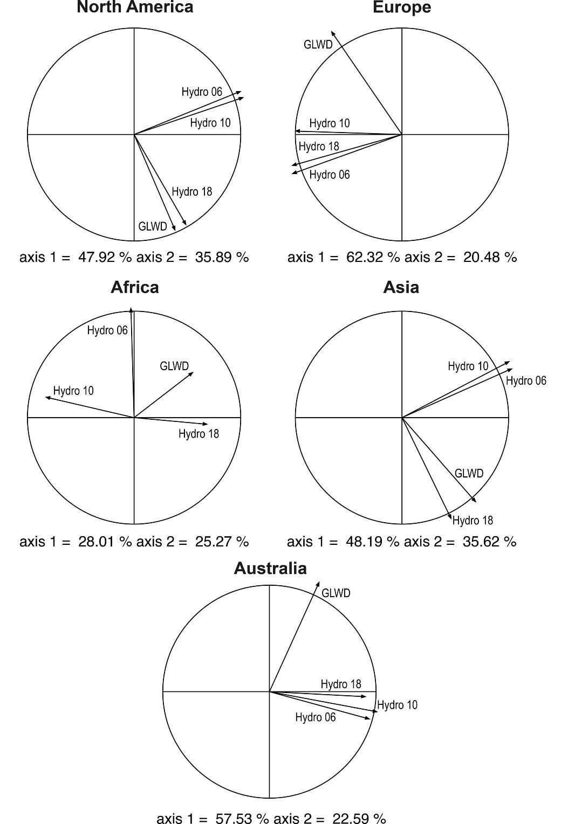
Fig. S3 A loadings plot illustrates how each of the environmental variables relates to the first two axes of the PCA and the weight of each variable for Pistia stratiotes. The predictor climatic variables are Hydro 06 (Minimum Upstream Temperature of Coldest Month), Hydro 10 (Mean Upstream Temperature of Warmest Quarter), Hydro 18 (Upstream Precipitation of Warmest Quarter) and the Global lakes and wetlands cover (GLWD).

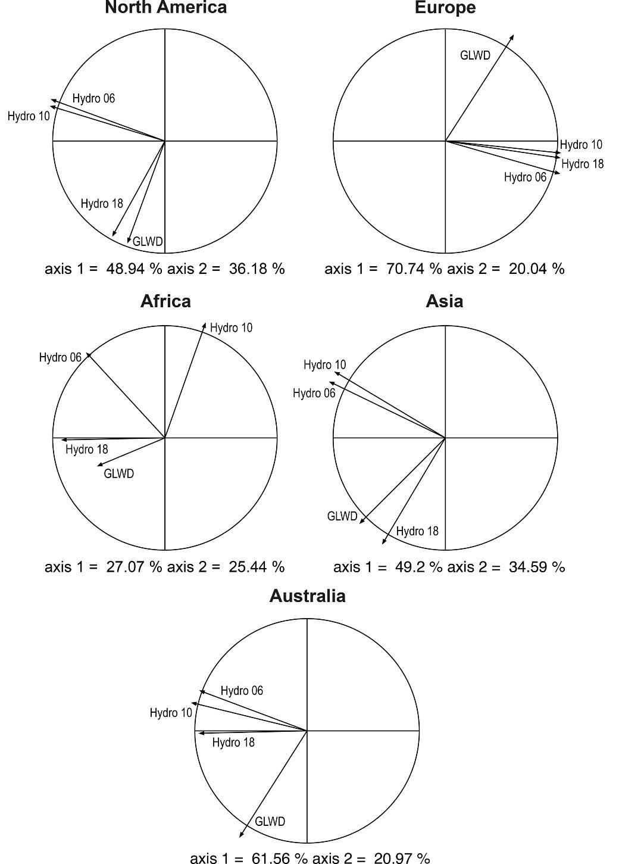
Fig. S4 A loadings plot illustrates how each of the environmental variables relates to the first two axes of the PCA and the weight of each variable for Pontederia crassipes and Salvinia molesta. The predictor climatic variables are Hydro 06 (Minimum Upstream Temperature of Coldest Month), Hydro 10 (Mean Upstream Temperature of Warmest Quarter), Hydro 18 (Upstream Precipitation of Warmest Quarter) and the Global lakes and wetlands cover (GLWD).
Fig. S5 Statistical tests on niche equivalency of Egeria densa (Planch.) Casp. for niche comparisons between native and invaded regions. The vertical red line indicates the observed Schoener’s D value for niche overlap.

Fig. S6 Statistical tests on niche equivalency of Myriophyllum aquaticum (Vell.) Verdc. for niche comparisons between native and invaded regions. The vertical red line indicates the observed Schoener’s D value for niche overlap.

Fig. S7 Statistical tests on niche equivalency of Pistia stratiotes L. for niche comparisons between native and invaded regions. The vertical red line indicates the observed Schoener’s D value for niche overlap.

Fig. S8 Statistical tests on niche equivalency of Pontederia crassipes Mart. for niche comparisons between native and invaded regions. The vertical red line indicates the observed Schoener’s D value for niche overlap.

Fig. S9 Statistical tests on niche equivalency of Salvinia molesta D. Mitch for niche comparisons between native and invaded regions. The vertical red line indicates the observed Schoener’s D value for niche overlap.

Fig. S10 Statistical tests on niche similarity of Egeria densa (Planch.) Casp. for niche comparisons between native and invaded regions. The vertical red line indicates the observed Schoener’s D value for niche overlap.

Fig. S11 Statistical tests on niche similarity of Myriophyllum aquaticum (Vell.) Verdc. for niche comparisons between native and invaded regions. The vertical red line indicates the observed Schoener’s D value for niche overlap.

Fig. S12 Statistical tests on niche similarity of Pistia stratiotes L. for niche comparisons between native and invaded regions. The vertical red line indicates the observed Schoener’s D value for niche overlap.

Fig. S13 Statistical tests on niche similarity of Pontederia crassipes Mart. for niche comparisons between native and invaded regions. The vertical red line indicates the observed Schoener’s D value for niche overlap.

Fig. S14 Statistical tests on niche similarity of Salvinia molesta D. for niche comparisons between native and invaded regions. The vertical red line indicates the observed Schoener’s D value for niche overlap.

