Diversity of diapausing egg ornamentation in rotifer species: standardizing traits

Gerardo Guerrero-Jiménez^{1*}, Julieta Cuevas^{4,5}, Araceli Adabache-Ortiz², Roberto Rico-Martínez³, Gissell Lacerot⁴, María de Lourdes Segura Valdez¹

¹ Universidad Nacional Autónoma de México CU, Facultad de Ciencias, Departamento de Biología Celular, Laboratorio de Nanobiología celular. Avenida Universidad 3000, C.P. 04510, Ciudad de México.
²Universidad Autónoma de Aguascalientes, Centro de Ciencias Básicas, Departamento de Biología. Avenida Universidad 940, C.P. 20131, Aguascalientes, Ags. México.
³Universidad Autónoma de Aguascalientes, Centro de Ciencias Básicas, Departamento de Química. Avenida Universidad 940, C.P. 20131, Aguascalientes, Ags., México.
⁴Universidad de la República, Centro Universitario Regional del Este, Departamento Interdisciplinario de Sistemas Costeros y Marinos. Av. Cachimba del Rey entre Bvar. Artigas y Av. Aparicio Saravia. C.P. 20000, Maldonado, Uruguay.
⁵Universidad de la República, Facultad de Ciencias, Instituto de Ecología y Ciencias Ambientales, Sección de Limnología. Iguá 4225, C.P. 11400, Montevideo, Uruguay.

GGJ = gerardo.guerrero@ciencias.unam.mx; ORCID https://orcid.org/0000-0002-1788-8099
JC= jcuevas@fcien.edu.uy; ORCID https://orcid.org/0000-00024605-6507
AAO = aadaba@correo.uaa.mx; ORCID https://orcid.org/0000-0003-4332-9650
RRM = rebertoricomartinez@gmail.com; ORCID https://orcid.org/0000-0002-7776-9542
GL= glacerot@cure.edu.uy; ORCID https://orcid.org/0000-0002- 9705-5715
MLSV= lourdes_segura@ciencias.unam.mx; ORCID https://orcid.org/0000-0001-6462-7775

Corresponding author: gerardo.guerrero@ciencias.unam.mx *

Supplementary Information for:

Two Appendices:
Appendix 1: Map with coordinates of all locations where samples were collected.
Appendix 2: Data of diapausing eggs collected.
Appendix 3: Data of diapausing

Appendix 1.
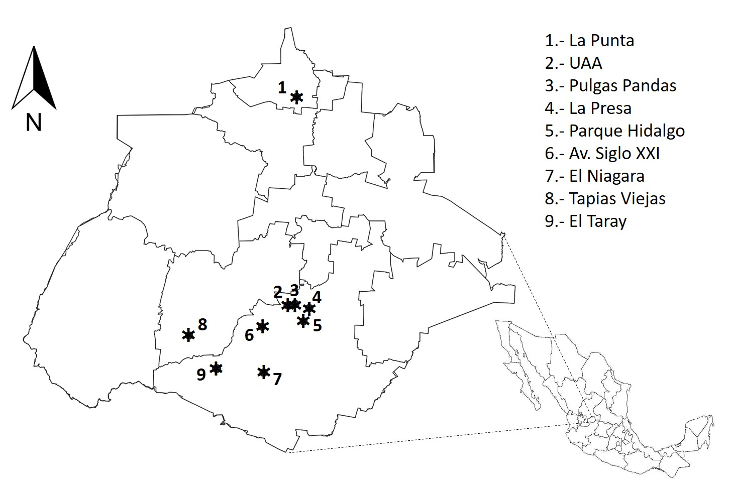

Aguascalientes map with coordinates of the sediment and water samples was obtained. El Niagara: 21°46´47” N, 102°22´10” W; La Punta: 22°19'08” N, 102° 17´16”' W; Parque Hidalgo: 21°52´47” N, 102°17´00” W; UAA: 21°54´42” N, 102°18´59” W; Av. Siglo XXI: 21°52´14” N, 102°22´15” W; La Presa: 21°54´20” N, 102°16´,13” W; Tapias Viejas: 21°51´21” N, 102°31´31” W; Pulgas Pandas: 21°54´51”, 102°18´01” W; El Taray: 21°47´21” N, 102°28´01” W.

Appendix 2
Table with measurements of the diapausing eggs analized
No. | Species | Diapausing eggs analyzed (#) | Lenth  (μm) | Width  (μm) | Diameter  (μm)
1 | Asplanchna intermedia | N= 6 | - | - | 139.8±2.7
2 | Brachionus bidentatus | N=20 | 133.4±8.4 | 83.3±6.7 | -
3 | B. budapestinesis | N=3 | 70.1±1 | 46.5±1.6 | -
4 | B. calyciflorus | N=5 | 132.3±3.7 | 84.2±36 | -
5 | B. caudatus | N=4 | 65.7±5.5 | 45.7±.0.5 | -
6 | B. quadridentatus | N=3 | 84.2±1.1 | 52.7±0.6 | -
7 | B. rubens | N=3 | 92.9±5.4 | 59.8±1.8 | -
8 | Cephalodella forceps | N=5 | 49.5±2.3 | 38.3±0.8 | -
9 | Euchlanis dilatata | N=10 | 118.7±2 | 70.1±1.6 | -
10 | Filinia cornuta | N=3 | - | - | 58.1±2.6
11 | Filinia sp. | N=1 | 83.8 | 63.1 | -
12 | Hexarthra mira | N=3 | 90.4±1.1 | 78.5±0.4 | -
13 | Lecane papuana | N=3 | 85.3±6.7 | 67.5±5 | -
14 | L. quadridentata | N=10 | - | - | 79±3
15 | Plationus patulus | N=5 | 100.7±2.8 | 78.9±0.7 | -
16 | Platyias quadricornis | N=3 | 111.7±1.6 | 72.8±0.7 | -
17 | Polyarthra remata | N=3 | 105.8±2.8 | 80.3±3 | -
18 | Sinantherina socialis | N=1 | 103.2 | 91.8 | -

Appendix 3. Number of resting eggs collected for each rotifer species in all water ponds sampled in situ and from cultures, total of organisms hatched, and place where diapausing eggs were found.
No. | Species | Water pond/propagules per lake |  |  | # of hatched |  | Place where diapausing eggs were found
1 | Asplanchna intermedia | El Niagara  UAA  La Presa | (25)  (10)  (15) | 8  1  3 |  | Sediment  Sediment  Sediment
2 | Brachionus bidentatus | La Punta | (65) | 5 |  | Cultures (deepmost of petri dish)
3 | B. budapestinesis | Parque Hidalgo | (8) | 4 |  | Sediment
4 | B. calyciflorus | UAA | (20) | 5 |  | Culture (deepmost of petri dish)
5 | B. caudatus | UAA | (40) | 3 |  | Cultures (deepmost of petri dish)
6 | B. quadridentatus | Av. Siglo XXI | (30) | 2 |  | Cultures (deepmost of petri dish)
7 | B. rubens | El Niagara  UAA  La Presa | (32)  (22)  (10) | 8  9  1 |  | Sediment  Sediment  Sediment
8 | Cephalodella forceps | Av. Siglo XXI | (55) | 0 |  | Culture (deepmost of petri dish)
9 | Euchanis dilatata | Tapias Viejas  UAA | (19)  (40) | 0  4 |  | Sediment  Cultures (deepmost of petri dish)
10 | Filinia cornuta | Parque Hidalgo | (12) | 4 |  | Sediment
11 | Filinia sp. | El Niagara  UAA  La Presa | (15)  (10)  (20) | 1  0  0 |  | Sediment
12 | Hexarthra mira | Pulgas Pandas | (8) | 2 |  | Sediment
13 | Lecane papuana | Av. Siglo XXI | (65) | 5 |  | Cultures (deepmost of petri dish)
14 | L. quadridentata | UAA | (50) | 1 |  | Cultures (attached to substrate)
15 | Plationus patulus | Tapias Viejas | (3) | 0 |  | Cultures (deepmost of petri dish)
16 | Platyias quadricornis | UAA | (70) | 3 |  | Cultures (deepmost of petri dish)
17 | Polyarthra remata | UAA | (115) | 2 |  | Sediment
18 | Sinantherina socialis | Taray | (5) | 0 |  | Cultures (inside of the female)

