Figure S1. Spearman correlation between variables (conductivity, water level, and dissolved oxygen -DO-) in each coastal pond (FRA, TV, BC and ESC). Only significant correlations (p < 0.05) are shown. The colours indicate the sign of the correlation coefficient, and the size of the circles, the strength of the correlation.
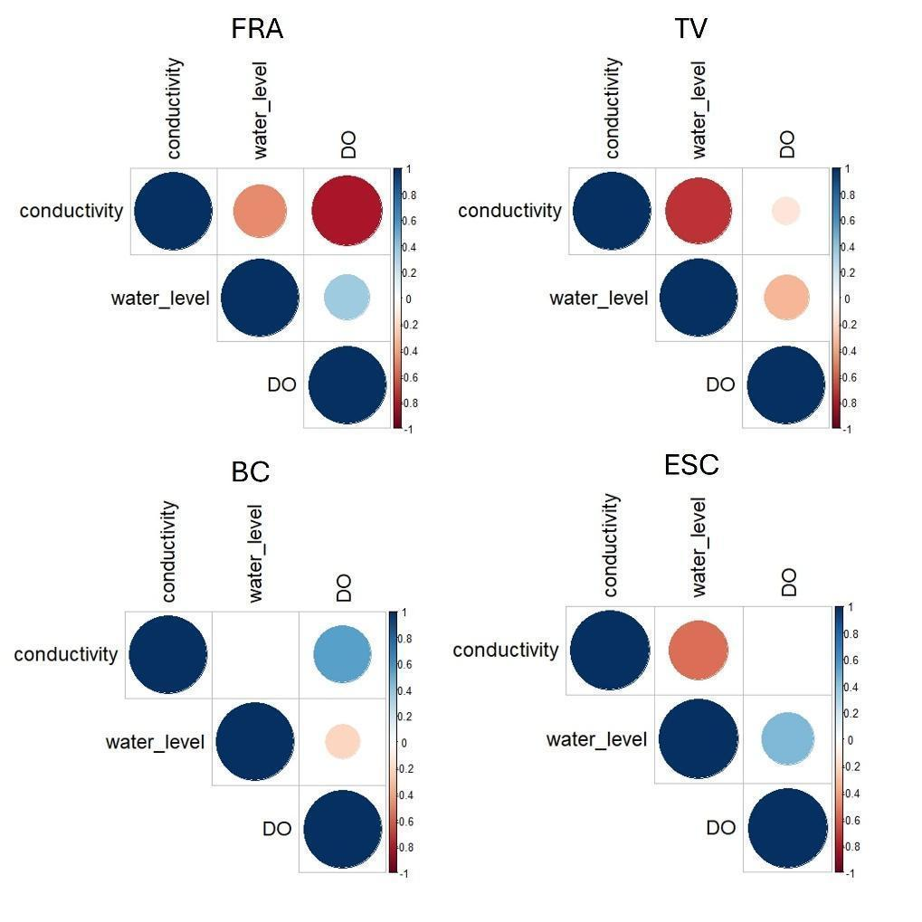
Figure S2. Average daily values -continuous lines- of conductivity, dissolved oxygen and water level, and detected sudden environmental fluctuations -points- in the four studied coastal ponds (FRA, TV, BC and ESC).
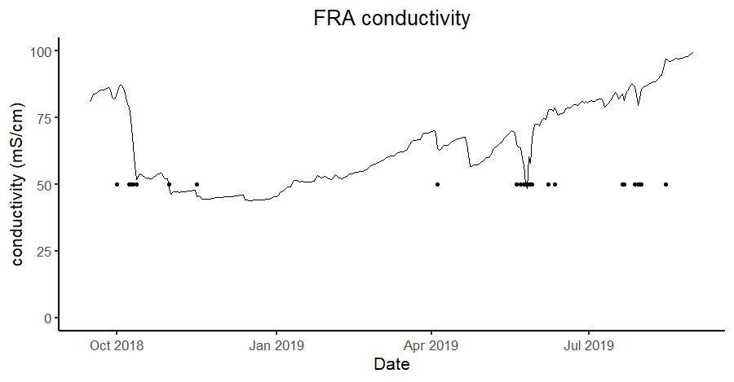
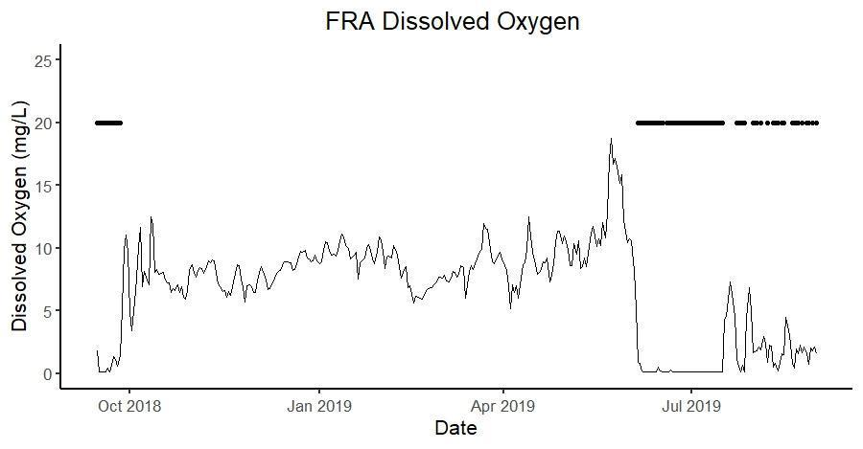

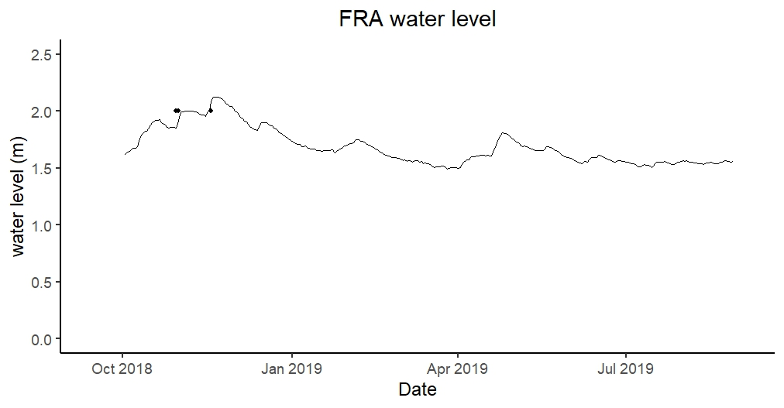
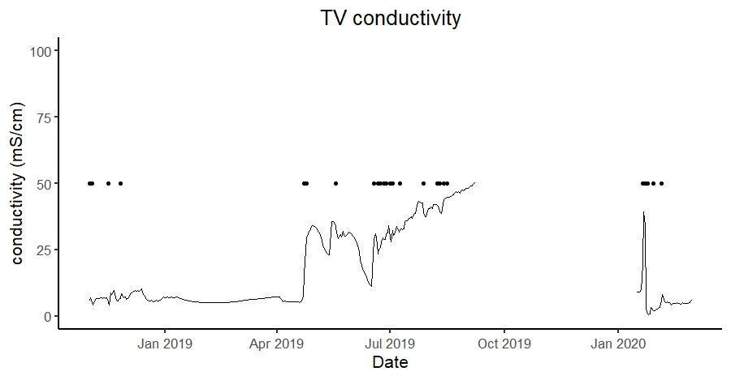
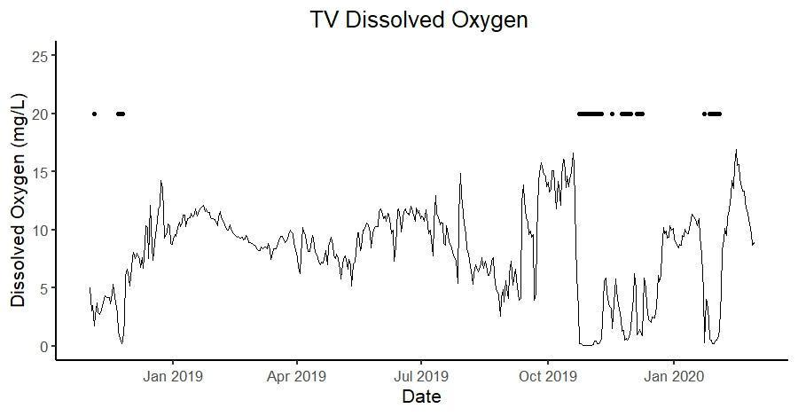
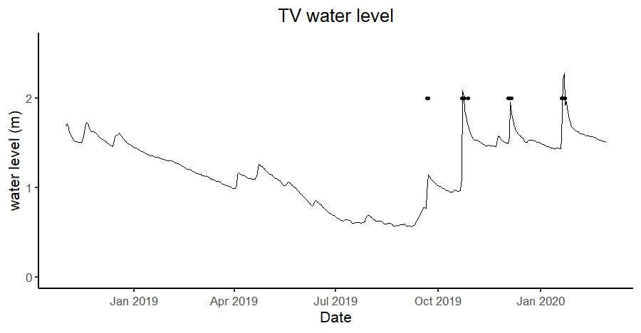

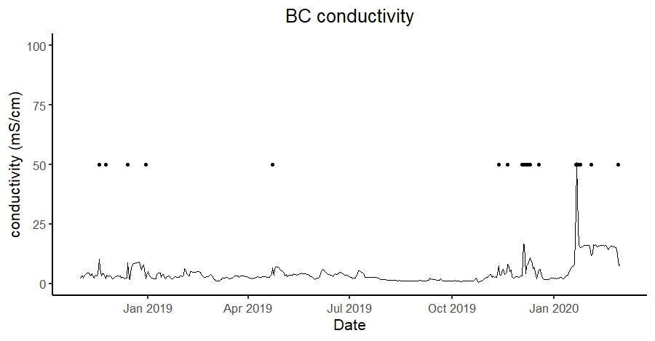
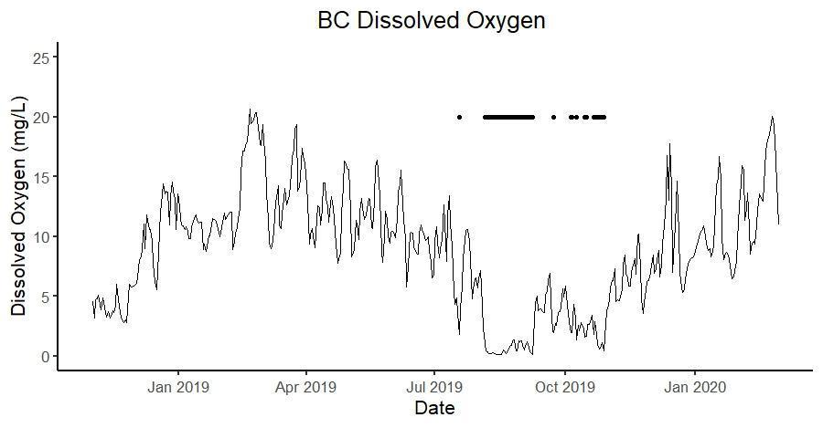
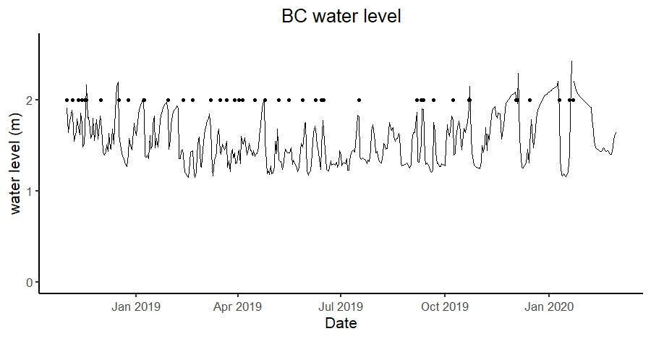
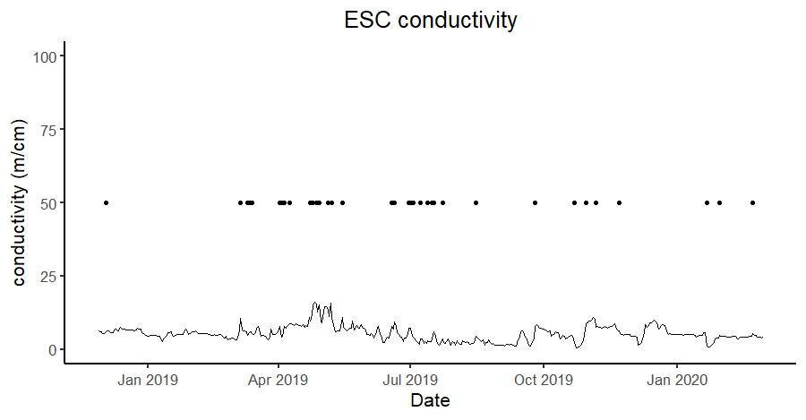

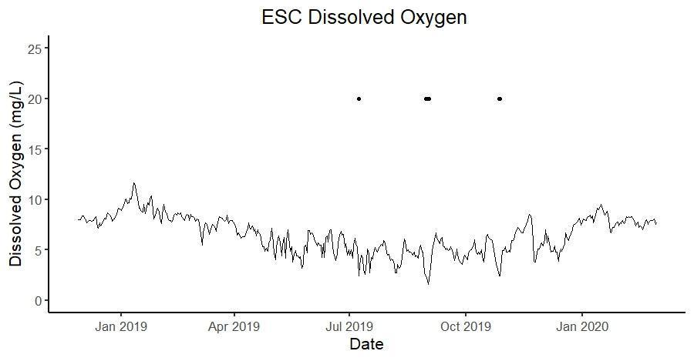
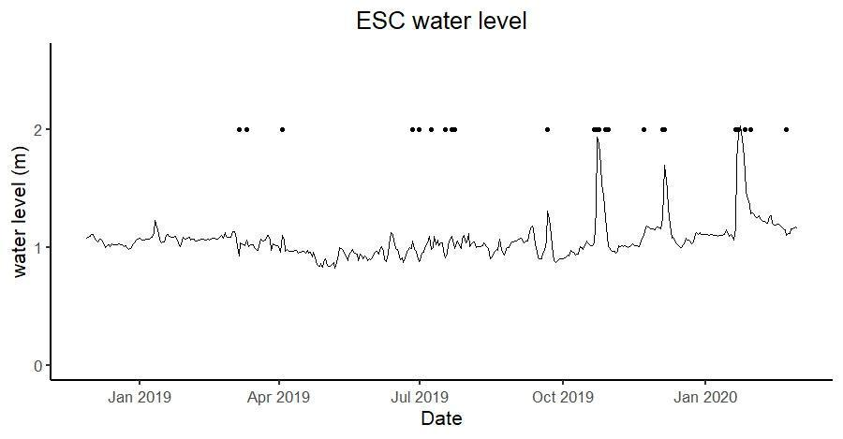
Figure S3. Temporal variations in time of the estimated zooplankton community attributes: zooplankton density, biomass, taxa richness, Shannon-Wiener diversity index, size diversity and size evenness.

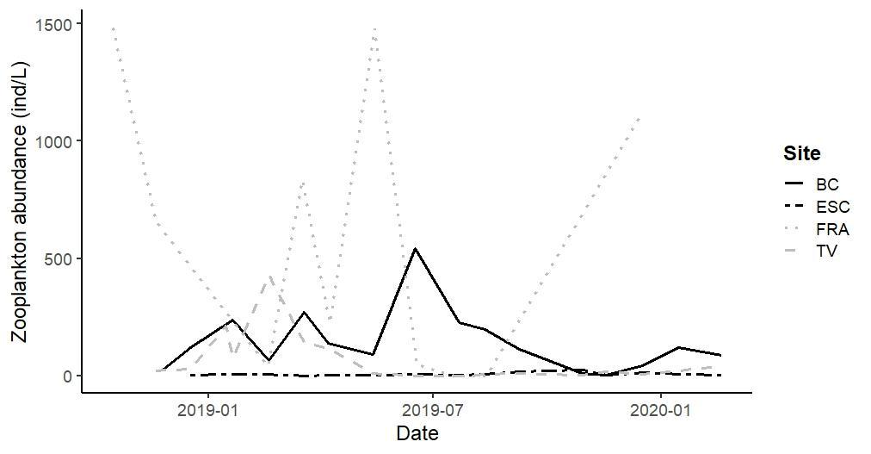
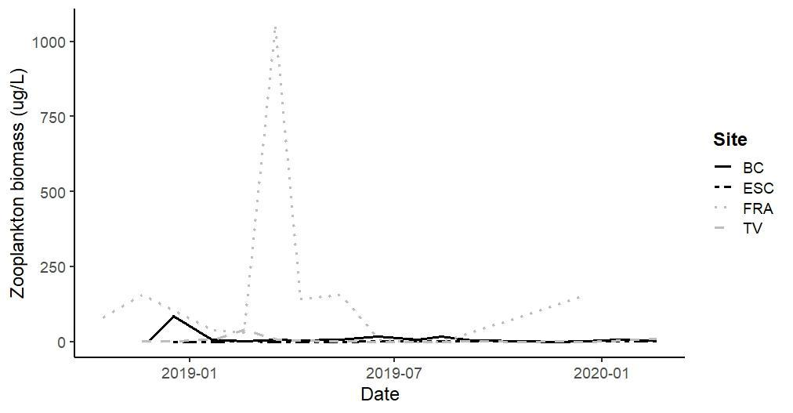

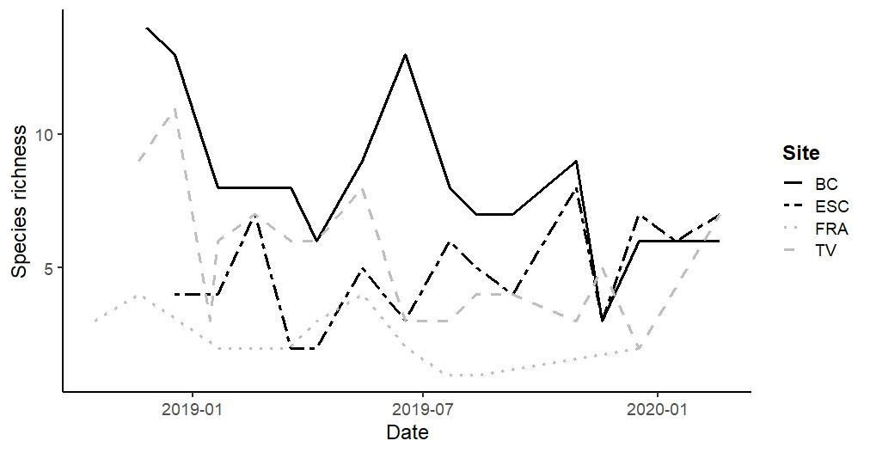

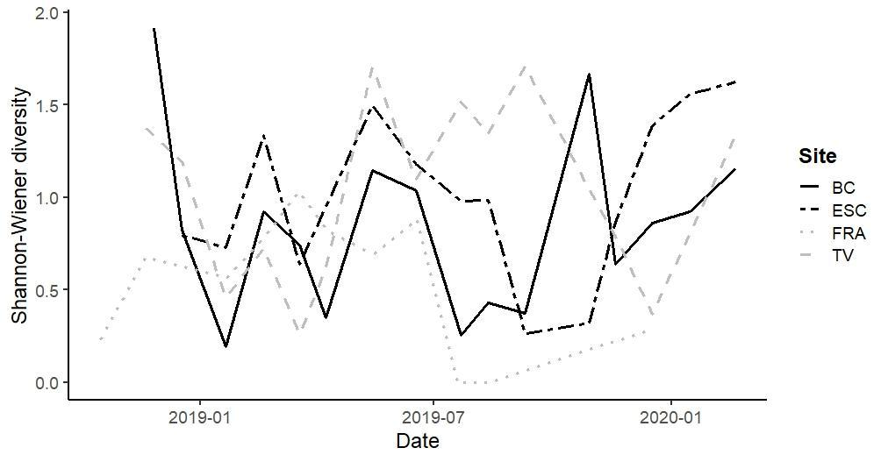

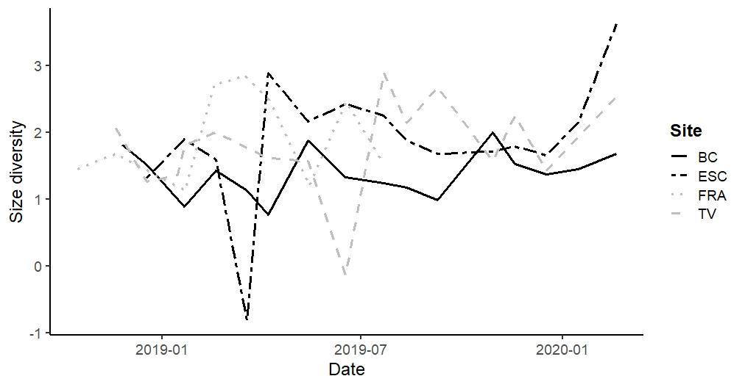
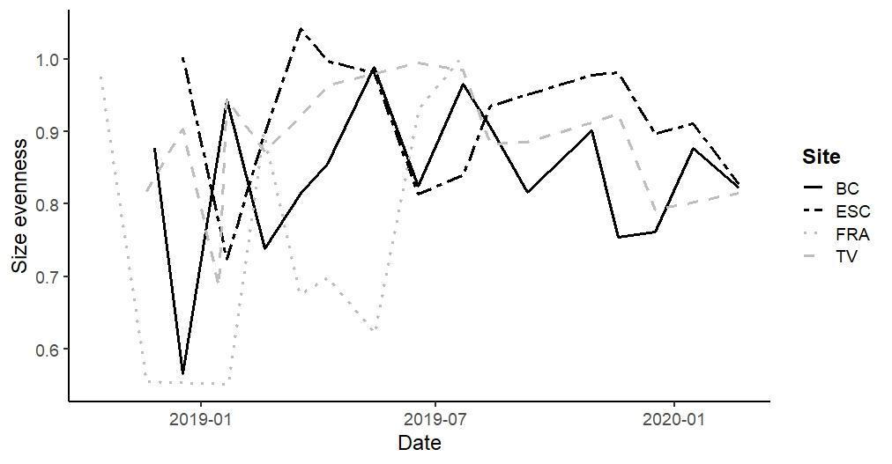

Table S1. Average values of the environmental variables measured in the field (± sd) in each coastal pond (FRA, BC, TV and ESC). Turb: water turbidity (FTU); chla: chlorophyll a concentration (µg L⁻¹); NH₄⁺: ammonium concentration (mg N L⁻¹); TP: total phosphorus (mg L⁻¹); TOC: total organic carbon (mg L⁻¹); DOC: dissolved organic carbon (mg L⁻¹). The values of conductivity (µS cm⁻¹), water level (WL, m) and dissolved oxygen (DO, mg L⁻¹) were calculated with the daily measurements from the sensors installed in each coastal pond.

Site | pH | Turb | chla | NH4 | PT | TOC | DOC | Conductivity | WL | DO
FRA | 8.43 ± 0.22 | 43.04 ± 92.28 | 46.40 ± 58.63 | 0.23 ± 0.07 | 0.21 ± 0.24 | 40.77 ± 22.53 | 30.16 ± 9.66 | 64158.52 ± 15797.50 | 1.69 ± 0.16 | 6.82 ± 3.90
TV | 8.52 ± 0.79 | 6.46 ± 3.74 | 7.71 ± 6.44 | 0.18 ± 0.14 | 0.30 ± 0.35 | 12.58 ± 5.75 | 13.60 ± 5.46 | 16348.56 ± 14451.62 | 1.20 ± 0.37 | 8.19 ± 3.79
BC | 8.08 ± 0.38 | 18.98 ± 9.08 | 39.07 ± 38.75 | 0.14 ± 0.10 | 0.55 ± 0.98 | 8.71 ± 3.15 | 9.67 ± 5.88 | 4392.01 ± 4597.69 | 1.57 ± 0.27 | 8.87 ± 4.82
ESC | 7.92 ± 0.24 | 33.70 ± 25.40 | 2.82 ± 2.11 | 0.33 ± 0.36 | 0.47 ± 0.81 | 4.77 ± 1.45 | 6.15 ± 2.43 | 5347.86 ± 2610.32 | 1.06 ± 0.16 | 6.48 ± 1.84

Table S2. Frequency of occurrence of zooplankton taxa in each of the studied coastal ponds along the period (16 months for BC and TV; 15 months for ESC and 11 months for FRA). Crustacean taxa refer to crustacean species seasonally sampled with a 250 µm-mesh hand net, not quantified, but included here to list the species in each habitat. X: presence of the species in the pond over the studied period.

 |  | FRA | TV | BC | ESC
Rotifers
Asplanchna sp. |  |  | 0.06 | 0.13
Bdelloids |  |  | 0.19 | 0.56 | 0.47
Brachionus spp. |  | 0.36 | 0.38 | 0.81 | 0.07
Cephalodella sp. |  |  | 0.13 | 0.19 | 0.07
Colurella sp. |  |  | 0.44 | 0.56 | 0.20
Euchlanis sp. |  |  | 0.06 |  | 0.40
Hexarthra sp. |  |  |  | 0.06
Keratella sp. |  |  |  | 0.31 | 0.07
Lecane sp. |  |  | 0.44 | 0.69 | 0.40
Lepadella sp. |  |  | 0.19 | 0.25 | 0.33
Lophocaris spp. |  |  | 0.13 | 0.25
Notholca spp. |  |  | 0.56 | 1 | 0.60
Polyarthra sp. |  |  |  | 0.56 | 0.07
Proales sp. |  |  | 0.13 | 0.06 | 0.07
Ptygura spp. |  |  |  | 0.06
Synchaeta sp. |  | 0.18 | 0.44 | 0.69 | 0.13
Testudinella sp. |  | 0.18 | 0.50 | 0.13 | 0.13
Trichotria sp. |  |  |  |  | 0.07
Copepods
Nauplius Cyclopoida |  |  | 0.88 | 1 | 0.93
Copepodit Cyclopida |  |  | 0.69 | 0.63 | 0.07
Adult Cyclopoida |  |  | 0.31 | 0.13 | 0.07
Nauplius Calanoida |  | 0.64 | 0.31 | 0.25 | 0.07
Copepodit Calanoida |  | 0.73 | 0.06 | 0.13 | 0.53
Nauplius Harpacticoida |  | 0.82 | 0.31 | 0.19
Copepodit Harpacticoida |  | 0.45 | 0.19 | 0.13
Adult Harpacticoida |  |  | 0.19 | 0.13
Cladocerans
Chydoridae |  |  | 0.06 | 0.06 | 0.33
Daphnia sp. |  |  | 0.13 | 0.13 | 0.07
Crustacean taxa
Acanthocyclops sp. |  |  | X | X | X
Diacyclops sp. |  |  | X | X
Eucyclops sp. |  |  | X | X | X
Halicyclops sp. |  |  | X
Macrocylops sp. |  |  |  | X | X
Microcylops sp.
Paracyclops sp. |  |  | X |  | X
Calanipeda aquaedulcis Kritchagin, 1873 |  |  | X
Eurytemora velox (Lilljeborg, 1853) |  | X |  | X
Cletocamptus sp. |  |  | X
Nitokra sp. |  |  | X | X
Onychocamptus mohammed (Blanchard & Richard, 1891) |  |  |  | X
Alona sp. |  |  | X
Daphnia spp. |  |  | X | X | X
Macrothrix sp. |  |  |  |  | X
Simocephalus sp. |  |  |  | X

