Table IS1. Abundance by species and digestive tracts extracted (TD) and analyzed by station and sampling (M1, M2) in the Combeima River sub-basin, Tolima, Colombia.
Scientific Name | Author | Sampling 1 |  |  |  |  |  |  |  |  |  | Sampling 2 |  |  |  |  |  |  |  |  |  | Total
Scientific Name | Author | 1 |  | 2 |  | 3 |  | 4 |  | Subtotal |  | 1 |  | 2 |  | 3 |  | 4 |  | Subtotal
Scientific Name | Author | # | TD | # | TD | # | TD | # | TD | # | TD | # | TD | # | TD | # | TD | # | TD | # | TD | # | TD
Creagrutus cf. dulima | Albornoz-Garzón, Conde-Saldaña, García-Melo, Taphorn & Villa-Navarro 2018 |  |  |  |  | 19 | 6 | 128 | 9 | 147 | 15 |  |  |  |  | 32 | 8 | 44 | 9 | 76 | 17 | 223 | 32
Creagrutus cf. magdalenae | Eigenmann 1913 |  |  |  |  |  |  |  |  |  |  |  |  |  |  |  |  | 1 | 1 | 1 | 1 | 1 | 1
Hemibrycon iqueima | García-Melo, Albornoz‐Garzón, García‐Melo, Villa‐Navarro & Maldonado-Ocampo 2018 |  |  |  |  |  |  | 27 | 9 | 27 | 9 |  |  |  |  | 2 | 2 | 39 | 9 | 41 | 11 | 68 | 20
Hemibrycon tolimae | Eigenmann 1913 |  |  |  |  |  |  | 4 | 4 | 4 | 4 |  |  |  |  |  |  | 2 | 2 | 2 | 2 | 6 | 6
Microgenys minuta | Eigenmann 1913 |  |  |  |  |  |  | 1 | 1 | 1 | 1 |  |  |  |  |  |  |  |  |  |  | 1 | 1
Astroblepus cf. chotae | Regan 1904 |  |  | 8 | 3 |  |  |  |  | 8 | 3 |  |  | 6 | 5 |  |  |  |  | 6 | 5 | 14 | 8
Astroblepus grixalvii | Humboldt 1805 |  |  | 1 | 1 |  |  |  |  | 1 | 1 |  |  | 1 | 1 |  |  |  |  | 1 | 1 | 2 | 2
Astroblepus homodon | Regan 1904 |  |  | 9 | 6 | 2 | 2 |  |  | 11 | 8 |  |  | 3 | 3 |  |  |  |  | 3 | 3 | 14 | 11
Astroblepus micrescens | Eigenmann 1918 |  |  |  |  |  |  |  |  |  |  | 1 | 1 |  |  |  |  |  |  | 1 | 1 | 1 | 1
Astroblepus sp | Humboldt 1805 |  |  | 11 | 3 |  |  |  |  | 11 | 3 |  |  |  |  |  |  |  |  |  |  | 11 | 3
Astroblepus sp "unifasciatus" | Humboldt 1805 |  |  | 25 | 6 |  |  |  |  | 25 | 6 |  |  | 21 | 8 |  |  |  |  | 21 | 8 | 46 | 14
Pimelodella floridablancaensis | Ardila Rodríguez 2017 |  |  |  |  |  |  | 7 | 5 | 7 | 5 |  |  |  |  |  |  | 3 | 3 | 3 | 3 | 10 | 8
Rhamdia guatemalensis | Günther 1864 |  |  |  |  |  |  |  |  |  |  |  |  |  |  |  |  | 1 | 1 | 1 | 1 | 1 | 1
Chaetostoma milesi | Fowler 1941 |  |  |  |  |  |  | 2 | 2 | 2 | 2 |  |  |  |  |  |  | 1 | 1 | 1 | 1 | 3 | 3
Chaetostoma thomsoni | Regan 1904 |  |  |  |  | 1 | 1 | 18 | 6 | 19 | 7 |  |  |  |  | 3 | 3 | 4 | 4 | 7 | 7 | 26 | 14
Trichomycterus mogotensis | Ardila Rodríguez, 2017 |  |  |  |  | 12 | 6 | 50 | 9 | 62 | 15 |  |  |  |  | 2 | 2 | 14 | 7 | 16 | 9 | 78 | 24
Trichomycterus banneaui | Eigenmann 1912 |  |  |  |  |  |  | 103 | 9 | 103 | 9 |  |  |  |  | 8 | 4 | 29 | 9 | 37 | 13 | 140 | 22
Trichomycterus transandianus | Steindachner 1915 |  |  | 1 | 1 |  |  |  |  | 1 | 1 |  |  |  |  |  |  |  |  |  |  | 1 | 1
Total |  |  |  | 55 | 20 | 34 | 15 | 340 | 54 | 429 | 89 | 1 | 1 | 31 | 17 | 47 | 19 | 138 | 46 | 217 | 83 | 646 | 172

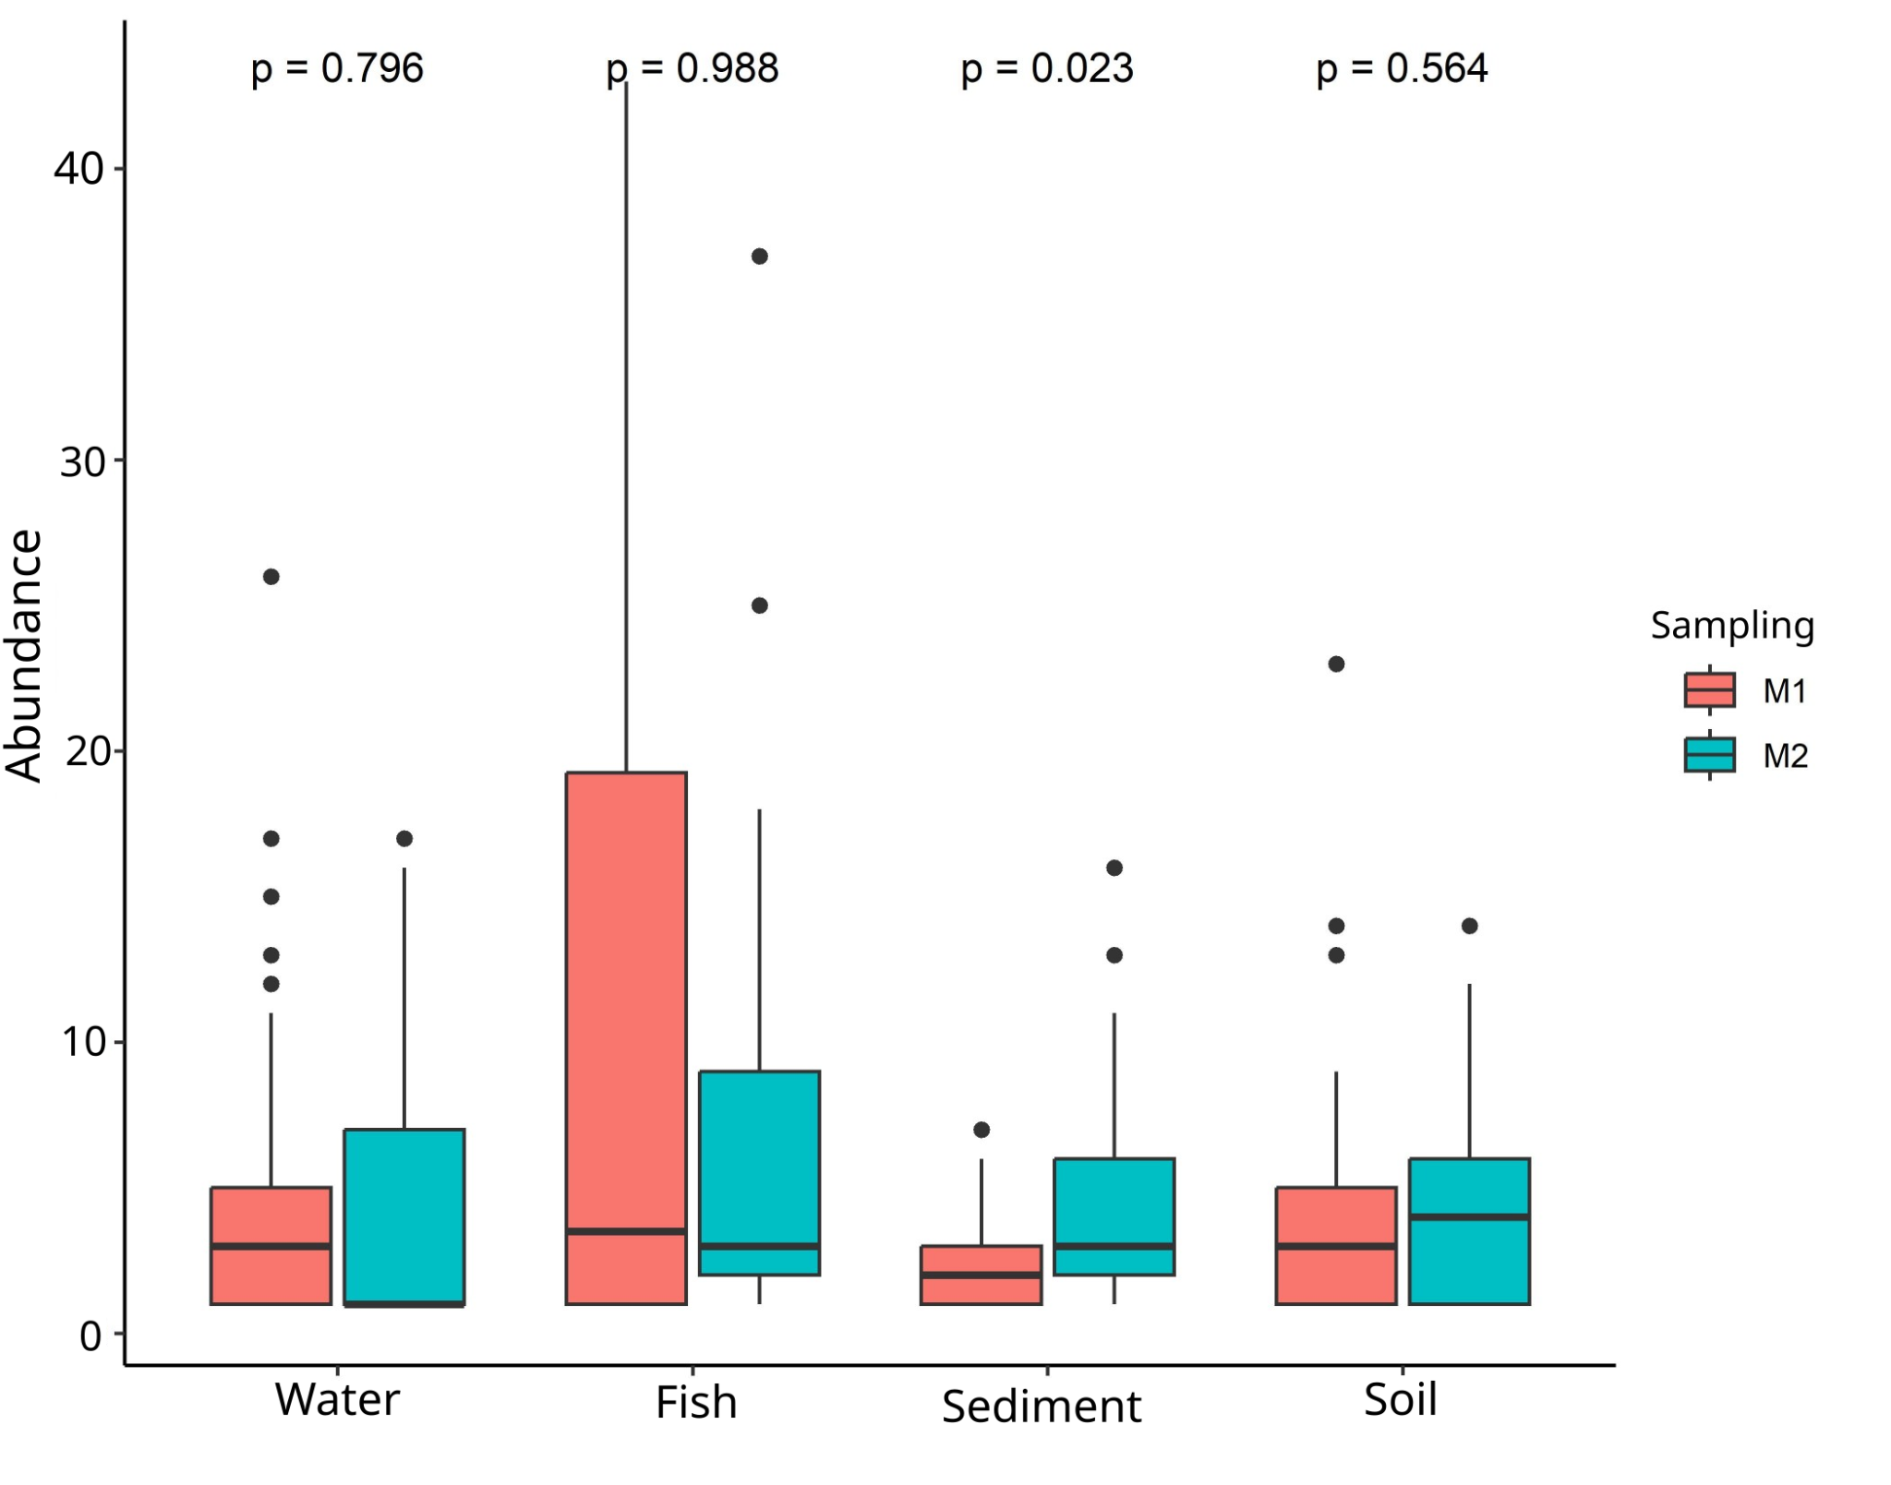
Fig IS1. Abundance of MPs analyzed by sampling and component. In all boxplots: the horizontal line represents the median; box limits indicate the interquartile range (IQR, 25th–75th percentiles); whiskers extend to 1.5 × IQR; points beyond whiskers represent outliers.

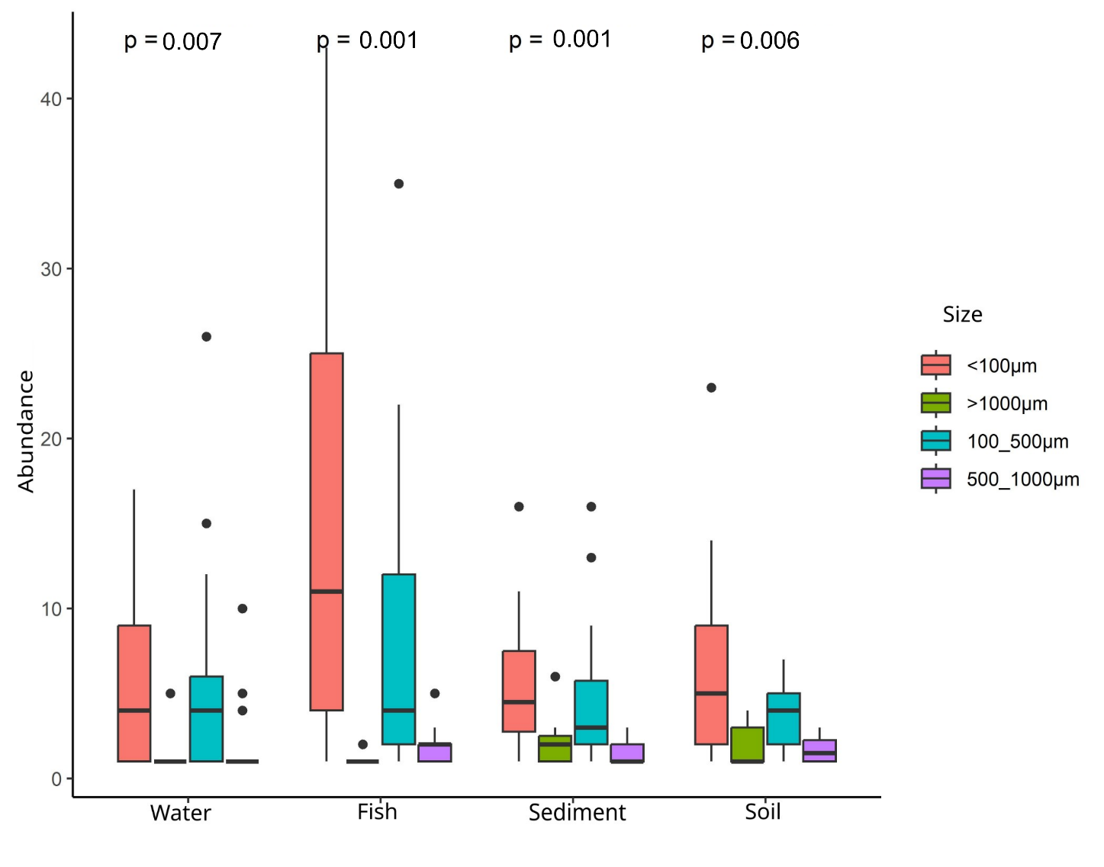

Fig IS2. Abundance of MPs by size in each studied component. In all boxplots: the horizontal line represents the median; box limits indicate the interquartile range (IQR, 25th–75th percentiles); whiskers extend to 1.5 × IQR; points beyond whiskers represent outliers.

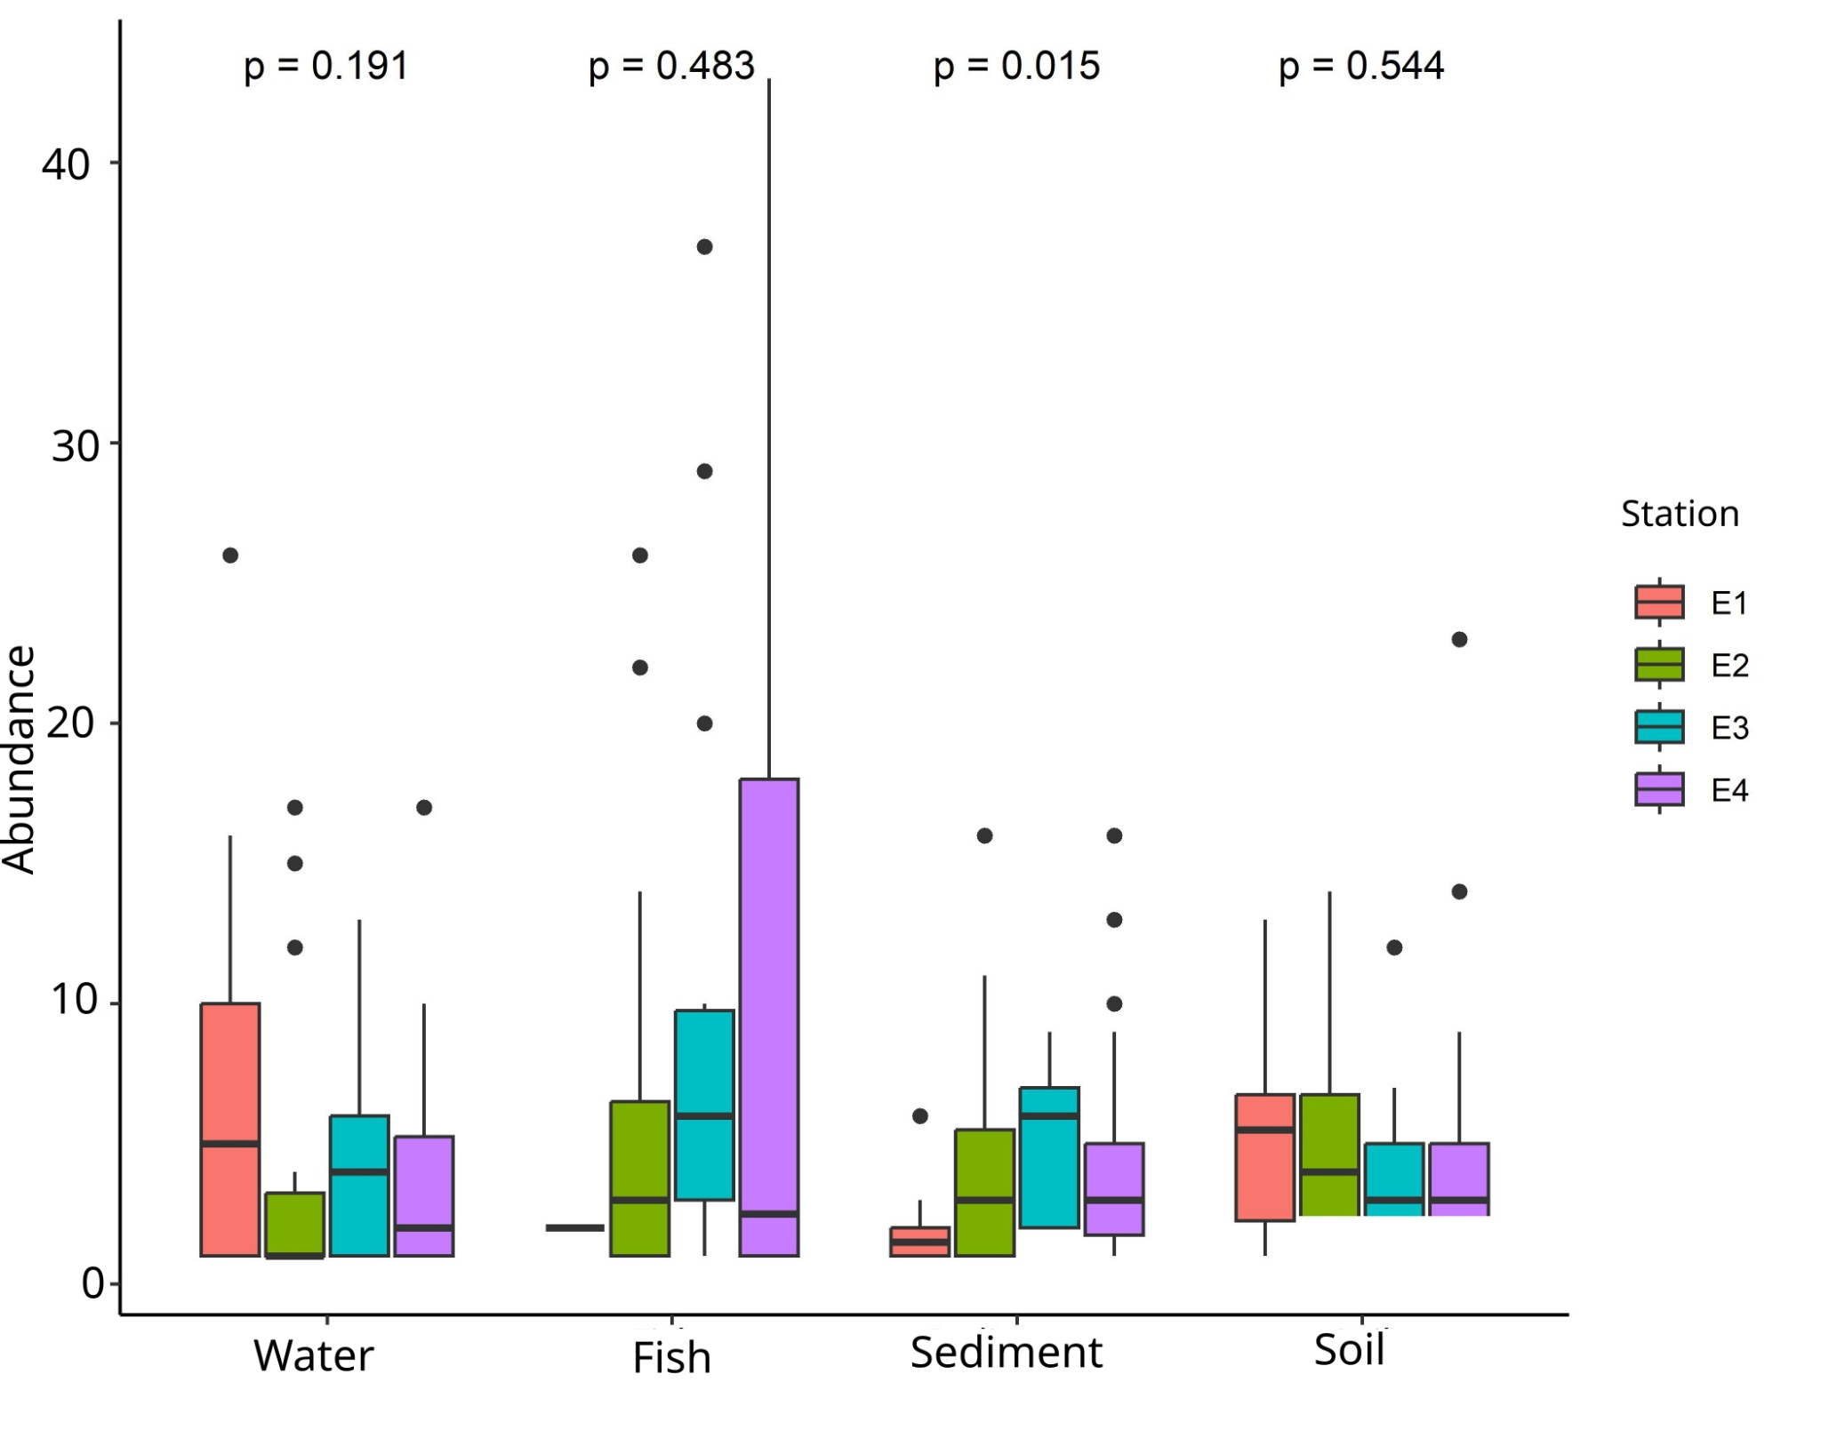
Fig IS3. Abundance of MPs by station in each of the analyzed components. In all boxplots: the horizontal line represents the median; box limits indicate the interquartile range (IQR, 25th–75th percentiles); whiskers extend to 1.5 × IQR; points beyond whiskers represent outliers.

Table IS2. Results of the envfit for the Non-Metric Multidimensional Scaling Analysis (NMDS - Bray Curtis) of MP abundance by station considering the components (water, soil, sediment, and fish) and their relationships with physical and landscape variables and macroplastics quantity in grams. Statistically significant values in bold.

Variable | NMDS1 | NMDS2 | r2 | Pr(>r)
Flow | 0.687 | 0.727 | 0.416 | 0.004
Altitude | -0.836 | -0.549 | 0.408 | 0.004
WaterArea | -0.954 | -0.301 | 0.488 | 0.004
Wide | 0.968 | 0.251 | 0.423 | 0.006
Velo | 0.529 | 0.848 | 0.340 | 0.013
AgriArea | -0.669 | 0.743 | 0.285 | 0.031
SeaCrops | 0.894 | 0.448 | 0.247 | 0.057
NoVegArea | 0.992 | 0.124 | 0.191 | 0.119
PermCrops | 0.569 | -0.822 | 0.173 | 0.120
Forest | 0.511 | -0.859 | 0.169 | 0.123
MacroPlastic | 0.767 | 0.642 | 0.175 | 0.124
Grasses | -0.529 | -0.849 | 0.165 | 0.146
ShrubsArea | 0.715 | -0.699 | 0.143 | 0.178
Depth | -0.052 | 0.999 | 0.119 | 0.278
UrbArea | 0.064 | 0.998 | 0.073 | 0.453

Table IS3. Results of the envfit for the Non-Metric Multidimensional Scaling Analysis (NMDS - Bray Curtis) of MP abundance by station considering the identified polymer types and their relationships with physical and landscape variables and macroplastics quantity in grams. Statistically significant values in bold.

Variable | NMDS1 | NMDS2 | r2 | Pr(>r)
Wide | 0.856 | 0.518 | 0.293 | 0.012
Altitude | -0.857 | -0.515 | 0.261 | 0.020
Flow | 0.850 | 0.526 | 0.214 | 0.041
SeaCrops | 0.874 | 0.485 | 0.190 | 0.058
WaterArea | -0.813 | -0.583 | 0.145 | 0.110
Velo | 0.983 | 0.181 | 0.146 | 0.120
NoVegArea | 0.880 | 0.475 | 0.118 | 0.176
Depth | -0.572 | 0.821 | 0.109 | 0.204
MacroPlastic | 0.890 | 0.457 | 0.088 | 0.283
Grasses | -0.812 | -0.584 | 0.060 | 0.416
Forest | -0.935 | -0.354 | 0.042 | 0.568
PermCrops | -0.944 | -0.330 | 0.035 | 0.629
ShrubsArea | -0.969 | -0.247 | 0.022 | 0.740
UrbArea | 0.723 | 0.691 | 0.007 | 0.909
AgriArea | 0.997 | -0.073 | 0.001 | 0.991

