Electronic Supplementary Material
Response of a Shallow Water Reservoir to Anthropogenic Stressors: Implications for the Water Supply of Lake Velence, a Major Recreational Lake in Hungary
Eszter Tombor¹, János László Korponai^{1,2}, Andrea-Rebeka Zsigmond³, Abigail Amponsaah Ofosu-Brakoh¹, Zoltán Szalai^{1,4}, Ákos Bede-Fazekas^{1,5}, Enikő Katalin Magyari^{1,6}

¹Department of Environmental and Landscape Geography, Eötvös Loránd University, Pázmány Péter sétány 1/C, Budapest H-1117, Hungary
²University of Public Service, Faculty of Water Sciences, Department of Aquatic Environmental Sciences, Bajcsy-Zsilinszky út 12–14., Baja H-6500, Hungary
³Department of Environmental Science, Sapientia Hungarian University of Transylvania, Calea Turzii 4, 400193, Cluj-Napoca, Romania
⁴Geographical Institute, HUN-REN Research Centre for Astronomy and Earth Sciences, Budaörsi út 45., Budapest H-1112, Hungary
⁵HUN-REN Centre for Ecological Research, Institute of Ecology and Botany, Vácrátót, Alkotmány út 2–4., H-2163, Hungary
⁶HUN-REN-MTM-ELTE Research group for Paleontology, Pázmány Péter sétány 1/C, Budapest H-1117, Hungary

Corresponding authors: Eszter Tombor (eszter.tombor@ttk.elte.hu), Enikő K. Magyari (eniko.magyari@ttk.elte.hu)

Supplementary tables

ESM Table 1 Spearman's rank correlation coefficient values for the geochemical elements analysed from the Pátkai-t-2 gravity core (Pátka Reservoir, Hungary) calculated by cor() with R; for visualisation R corrplot package (corrplot::corrplot()) was used

Supplementary figures

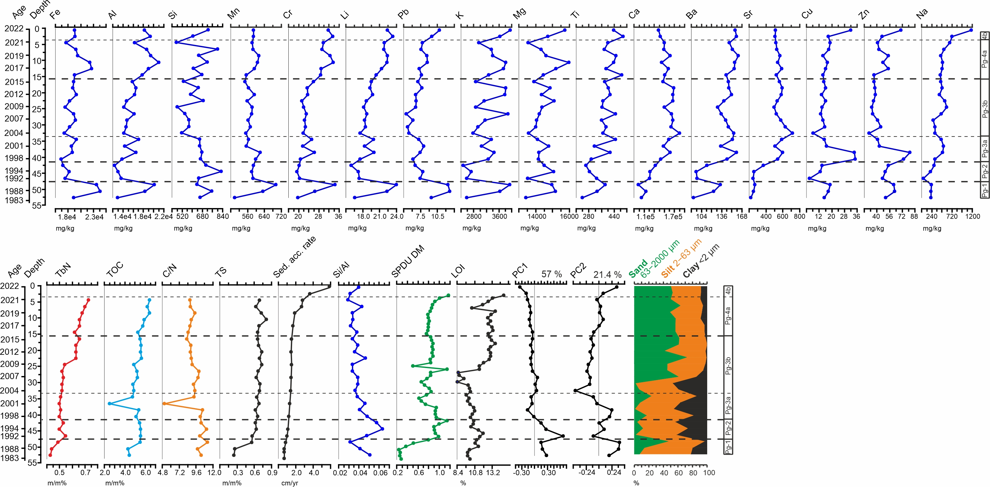

ESM Fig. 1 Measured geochemical element concentrations, PC1-PC2 stratigraphic plots, total bound nitrogen content (TbN), total organic carbon content (TOC), C/N ratio, total sulphur content (TS), sediment accumulation rate, Si/Al ratio, ratio of chlorophyll-derivatives relative to dry weight (SPDU DM), organic matter (LOI – loss on ignition) and the result of the grain size analysis from the sediment of the Pátkai-t-2 gravity core (Pátka Reservoir, Hungary)

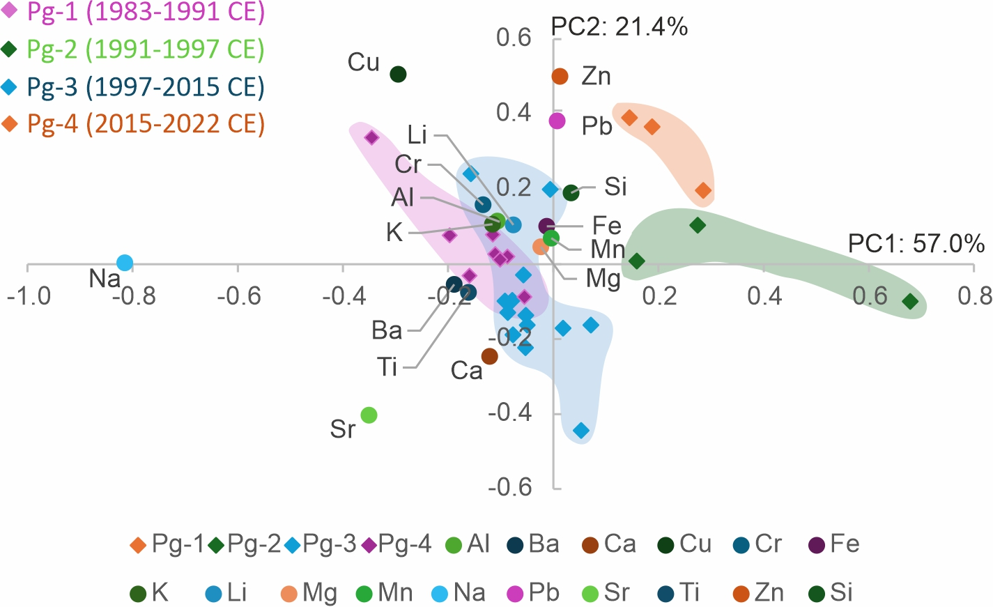
ESM Fig. 2 Principal component analysis (PCA) biplot for geochemical samples from the sediment of Pátkai-t-2 gravity core (Pátka Reservoir, Hungary); z-transformation was applied, PCA is based on a correlation matrix; Pg-1–Pg-4 represent the significant zones identified in the record

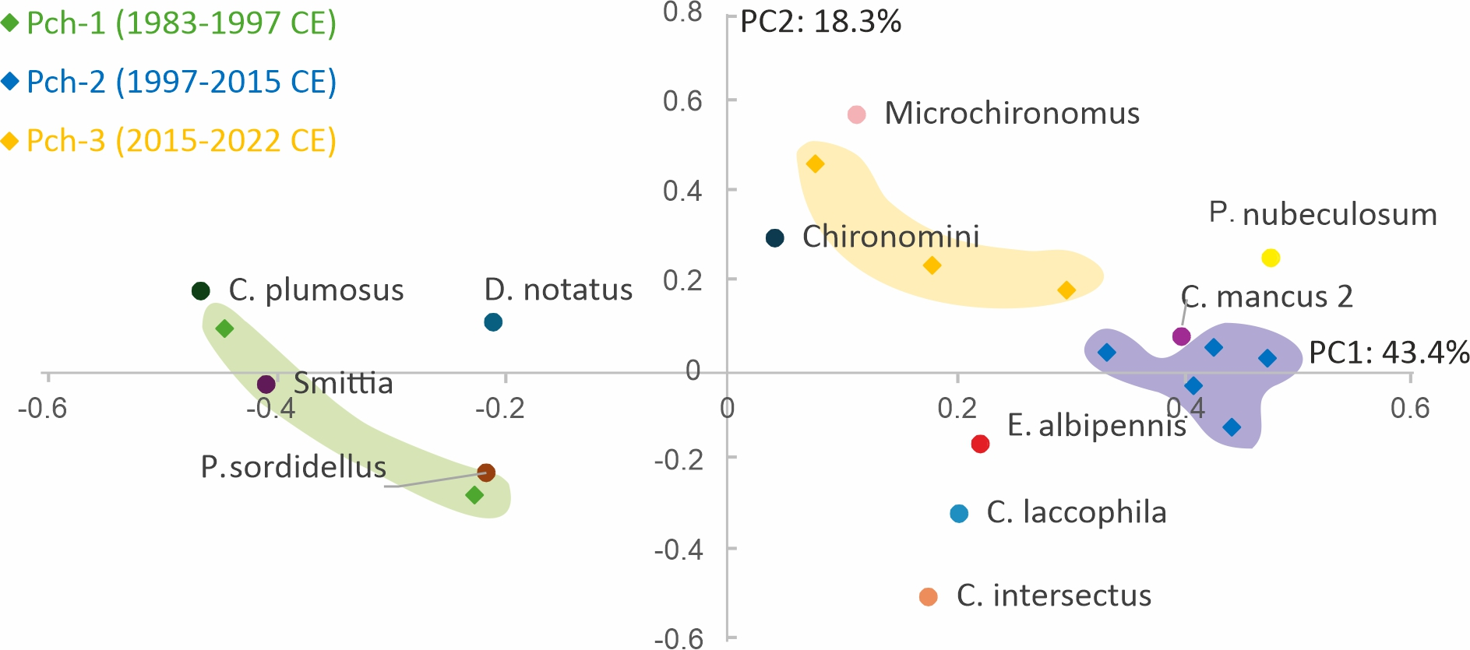

ESM Fig. 3 Principal component analysis (PCA) biplot for chironomid samples from the sediment of Pátkai-t-2 gravity core (Pátka Reservoir, Hungary); square root transformation transformation was applied, PCA is based on a covariance matrix; abbreviations: C. plumosus: Chironomus plumosus-type, D. notatus: Dicrotendipes notatus-type, Smittia: Smittia/Parasmittia, P. sordidellus: Psectrocladius sordidellus-type; P. nubeculosum: Polypedilum nubeculosum-type, C. mancus 2: Cladotanytarsus mancus type 2, E. albipennis: Endochironomus albipennis-type, C. laccophila: Cladopelma laccophila-type, C. intersectus: Cricotopus intersectus-type; Pch-1–Pch-3 represent the significant zones identified in the record

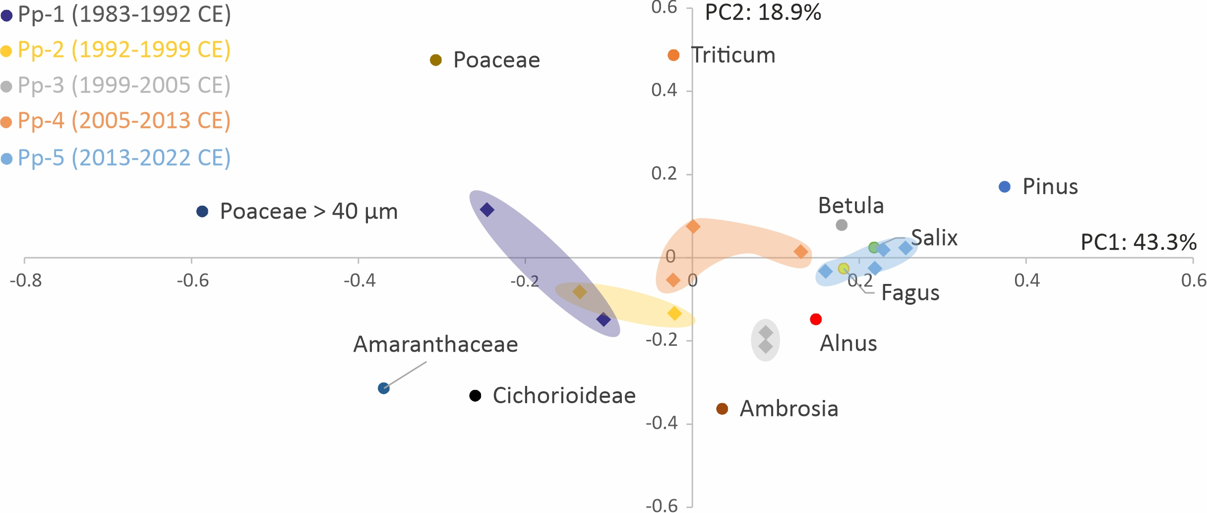
ESM Fig. 4 Principal component analysis (PCA) biplot for pollen samples from the sediment of Pátkai-t-2 gravity core (Pátka Reservoir, Hungary); square-root transformation was applied, PCA is based on a covariance matrix; Pp-1–Pp-5 represent the significant zones identified in the record

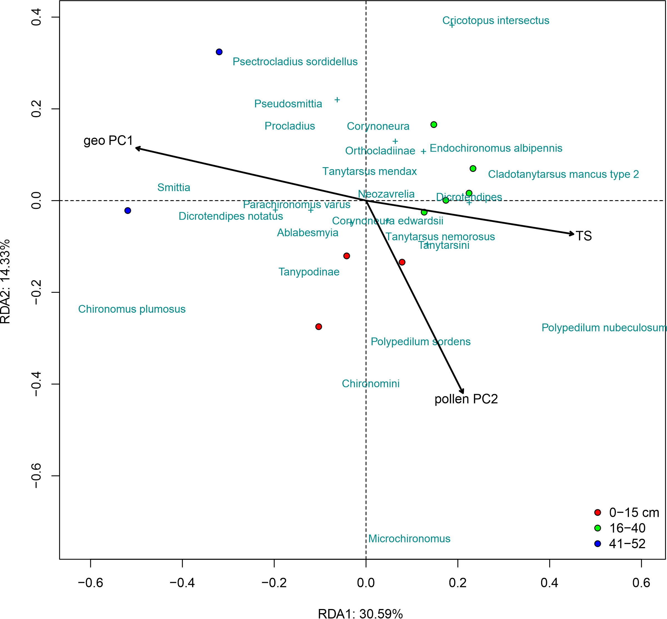
ESM Fig. 5 Results of the redundancy analysis (RDA) on the Pátkai-t-2 chironomid record (Pátka Reservoir, Hungary); explanatory variables were PC1 and PC2 of the geochemical and pollen record, particle size proportions and TOC, TbN and TS; only significant variables remained after stepwise selection (only relationships with p < 0.05 were considered significant); red dot: 0–15 cm (Pch-3 zone), 2015–2022; green dot: 16–40 cm, 1997–2015 (Pch-2 zone); blue dot: 41–52 cm, 1983–1997 (Pch-1 zone)

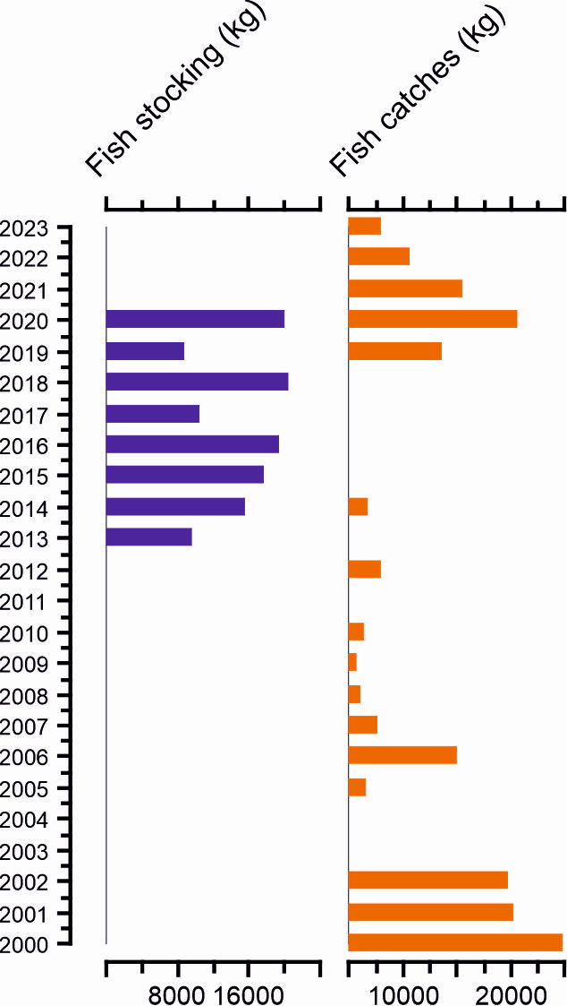

ESM Fig. 6 Fish stocking and fish catches data from the HOFESZ (Federation of Fishing Associations in Fejér County), Pátka Reservoir, Hungary

Supplementary Texts

ESM Text 1
Ponds in the catchment area of the Pátka Reservoir installed for different water uses
Based on personal communication with Mihály Temesi (regional lake inspector, KDTVIZIG), the appearing ponds along the Császár water and Rovájka water might contribute to the eutrophication process since they reserve the water of the streams, consequently reduce the water runoff and concentrate nutrients.
Upon our request, KDTVIZIG has provided us with the data on the small ponds in their register, which are located in the catchment area of the Pátka Reservoir, and which are installed for different water uses. According to the data available, there were 14 small ponds in the catchment area of the Pátkai Reservoir at the time of our sampling. Of these, 5 were classified as fish ponds, 4 as irrigation ponds, 2 as ornamental ponds, 1 as ecological, 1 as welfare and 1 as fishing pond. Their total area is almost 100 ha, of which 37.7 ha are used for irrigation. One of them was created in 1957 (Szűzvár Reservoir, welfare lake, Rovájka stream), while the others were created between 2002 and 2020 CE. Unfortunately, several of the lakes were not operated according to the requirements of the water management license.

