Article Title: Anthropogenic Microparticles Ingestion Patterns in Fish Across Trophic Guilds in Mangrove Estuaries
Journal Name: Hydrobiologia
Gleyce Aquino^{a,b,*}, Rory Oliveiraª , David Chelazzi^{c} , Laura Sforzi^{c} , Tania Martellini^{c} , Alessandra Cincinelli^{c} , Marcelo O. Soares^{d} , Tommaso Giarrizzo^{b,d} , José E. Martinelli Filho^{e} , Marcelo Ândrade^{a,b,f}

ª Núcleo de Ecologia Aquática e Pesca da Amazônia, Universidade Federal do Pará (UFPA), Belém, PA, Brazil;
^{b} Programa de Pós-Graduação em Ecologia Aquática e Pesca, Universidade Federal do Pará (UFPA), Belém, PA, Brazil;
^{c} Department of Chemistry “Ugo Schiff” and CSGI, University of Florence, Florence, Italy.
^{d} Instituto de Ciências do Mar (LABOMAR), Universidade Federal do Ceará (UFC), Fortaleza, Ceará, Brazil
^{e} Laboratório de Oceanografia Biológica, and Centro de Estudos Avançados da Biodiversidade, Universidade Federal do Pará (UFPA), Belém, PA, Brazil
^{f} Centro de Ciências Humanas, Naturais, Saúde e Tecnologia, Universidade Federal do Maranhão (UFMA), Pinheiro, MA, Brazil.

*Corresponding author: gleycegabrielle72@gmail.com (G. Aquino)

Table S1 – Food importance index according to categories, trophic guilds, location and hydrological period.
 | Algae | Crustaceans | Animal debris | Plant debris | Terrestrial invertebrates | Aquatic  invertebrates | Mollusks | Fish | Plant | Seeds
PARÁ - RAINY
Carnivorous | 0.008 | 0.153 | 0.167 | 0.001 | < 0.001 | < 0.001 | 0.230 | 0.295 | 0.121 | -
Omnivore | 0.199 | 0.340 | < 0.001 | 0.080 | < 0.001 | 0.001 | 0.021 | 0.199 | 0.003 | -
Planktivorous | 0.096 | 0.049 | < 0.001 | 0.007 | 0.106 | 0.628 | < 0.001 | 0.030 | < 0.001 | -
PARÁ – DRY
Carnivorous | 0.021 | 0.482 | 0.004 | < 0.001 | < 0.001 | < 0.001 | 0.171 | 0.280 | 0.018 | 0.008
Omnivore | 0.181 | 0.095 | 0.095 | 0.075 | 0.038 | 0.078 | 0.002 | 0.244 | 0.011 | 0.018
Planktivorous | 0.185 | 0.013 | 0.123 | 0.001 | < 0.001 | 0.049 | < 0.001 | < 0.001 | 0.009 | < 0.001
CAETÉ - RAINY
Carnivorous | 0.011 | 0.155 | 0.028 | 0.006 | - | < 0.001 | 0.027 | 0.646 | < 0.001 | < 0.001
Omnivore | 0.185 | 0.421 | < 0.001 | 0.114 | - | 0.001 | 0.001 | 0.073 | 0.053 | 0.026
Planktivorous | 0.070 | 0.052 | < 0.001 | 0.023 | - | 0.760 | < 0.001 | 0.001 | < 0.001 | < 0.001
CAETÉ - DRY
Carnivorous | 0.071 | 0.448 | 0.030 | 0.014 | 0.029 | 0.013 | 0.079 | 0.231 | 0.045 | < 0.001
Omnivore | 0.148 | 0.164 | 0.072 | 0.048 | < 0.001 | 0.032 | 0.062 | 0.191 | 0.005 | 0.023
Planktivorous | 0.476 | 0.002 | 0.092 | < 0.001 | < 0.001 | 0.269 | < 0.001 | 0.030 | < 0.001 | < 0.001
DELTA - RAINY
Carnivorous | 0.002 | 0.149 | 0.116 | 0.009 | < 0.001 | 0.050 | 0.032 | 0.620 | < 0.001 | -
Omnivore | 0.325 | 0.257 | < 0.001 | 0.047 | 0.048 | 0.003 | 0.055 | 0.149 | 0.012 | -
Planktivorous | 0.005 | 0.008 | < 0.001 | < 0.001 | 0.004 | 0.222 | < 0.001 | 0.022 | 0.001 | -

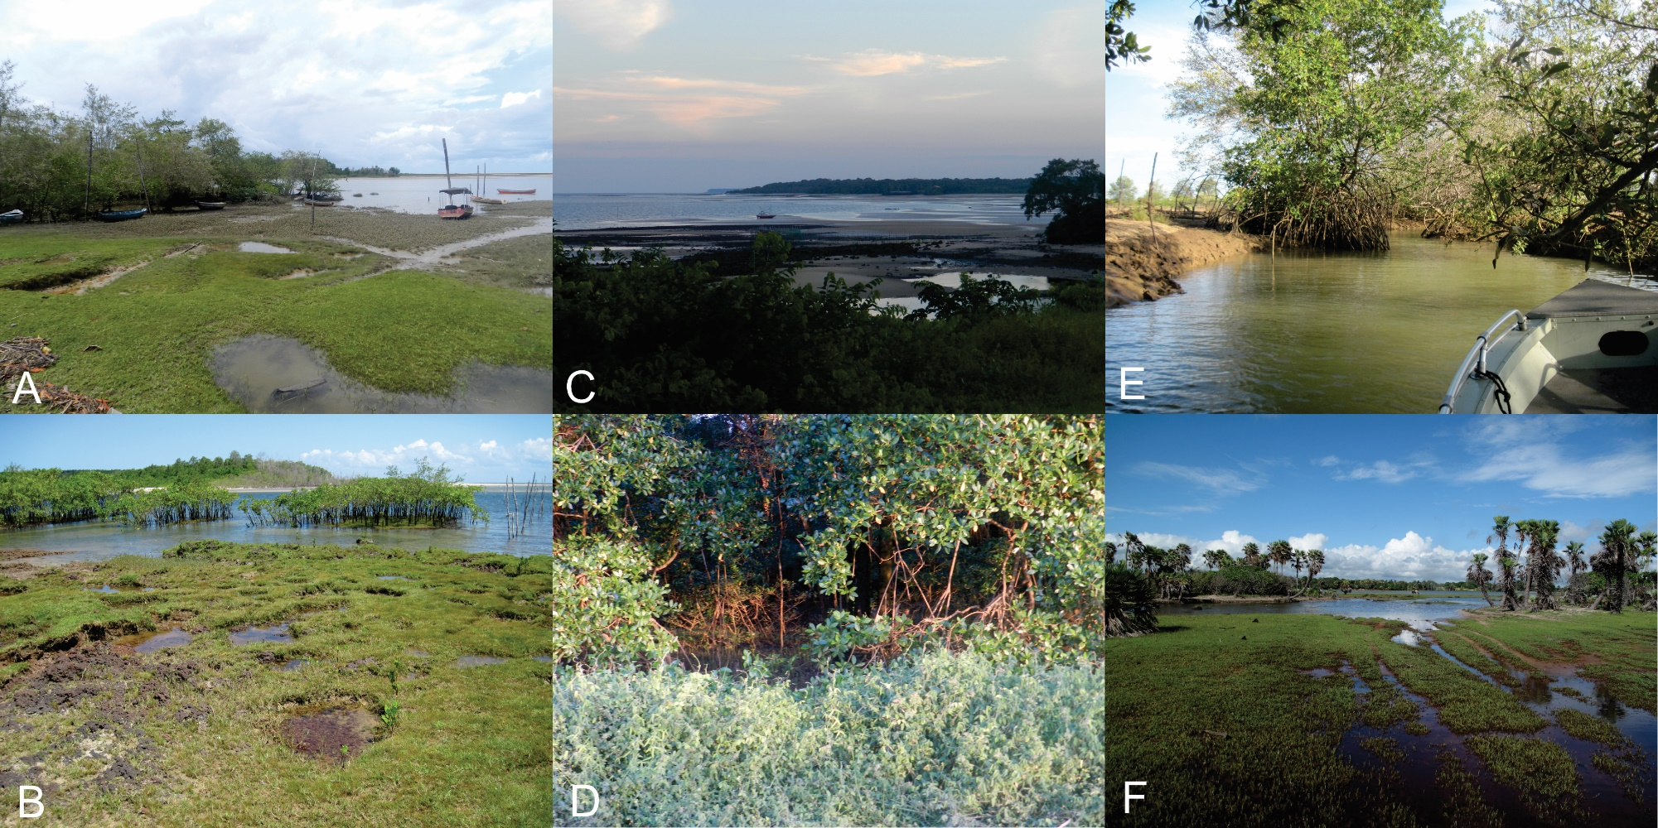

Figure S1 - Landscapes of the estuarine environments at the sampling sites. (A–B) Pará River Estuary; (C–D) Caeté River Estuary; (E–F) Parnaíba Delta.

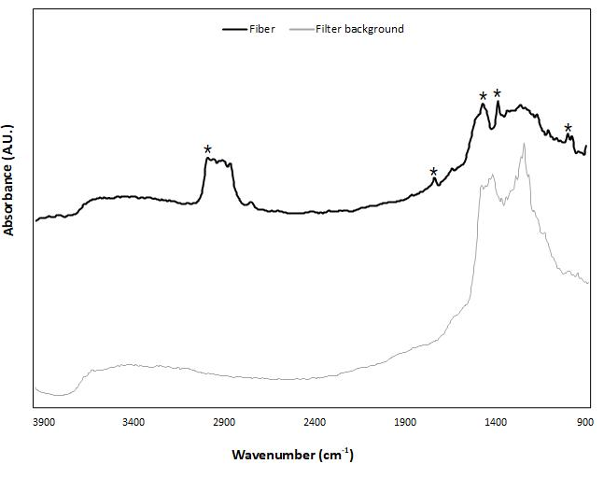
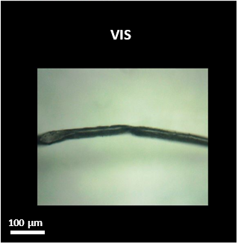
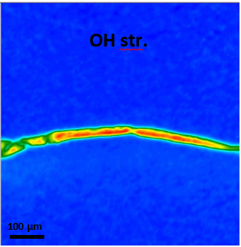
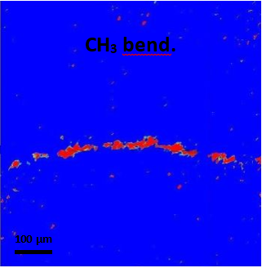
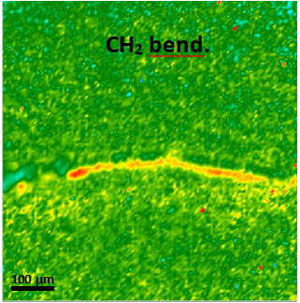
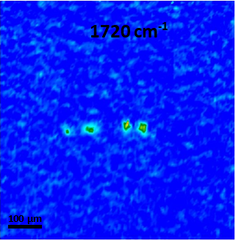

Figure S2- Visible light map and 2D FTIR Imaging maps (top and centre panels), and FTIR spectra (bottom panel) of a fiber identified as polypropylene owing to absorptions at 3000-2800 cm⁻¹ (CH stretching), 1720 cm⁻¹ (C=O stretching probably due to oxidation), 1455 cm⁻¹ (CH₂ bending), 1370 cm⁻¹ (CH₃ bending), and 979 cm⁻¹ (CH bending). The main absorption bands of the fiber have been marked with a “*”. Each spectrum relates to a single pixel (5.5 x 5.5 µm²) of the 2D Imaging maps.

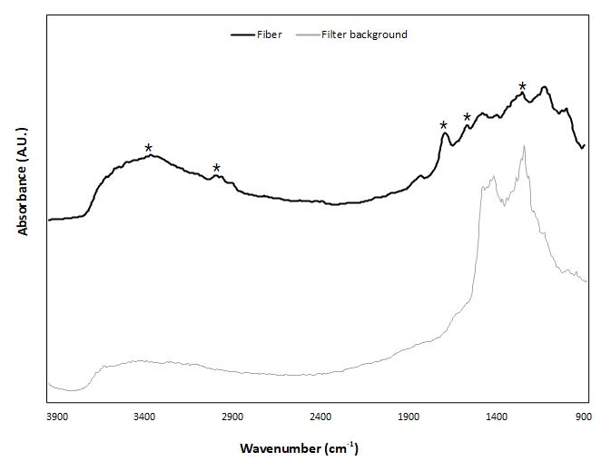
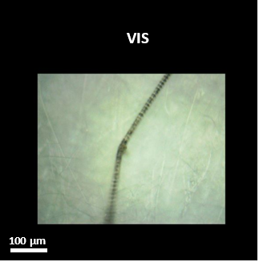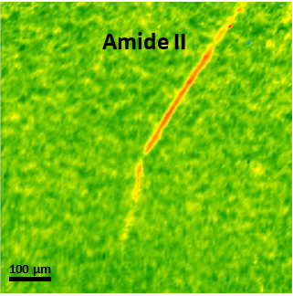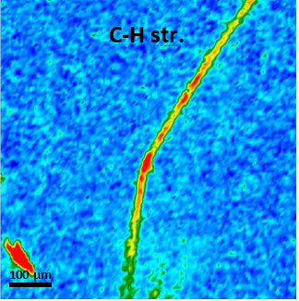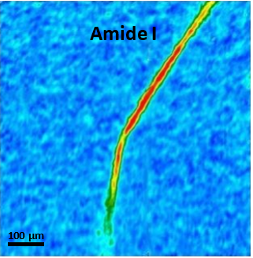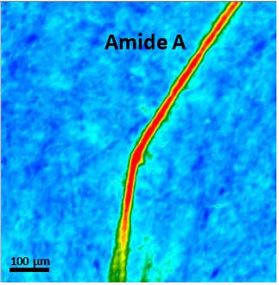

Figure S3 - Visible light map and 2D FTIR Imaging maps (top and centre panels), and FTIR spectra (bottom panel) of a fiber identified as polyamide owing to absorptions at 3401 cm⁻¹ (Amide A), 2930-2850 cm⁻¹ (CH stretching), 1633 cm⁻¹ (Amide I), 1570 cm⁻¹ (Amide II), and 1238 cm⁻¹ (C-N stretching). The main absorption bands of the fiber have been marked with a “*”. Each spectrum relates to a single pixel (5.5 x 5.5 µm²) of the 2D Imaging maps.

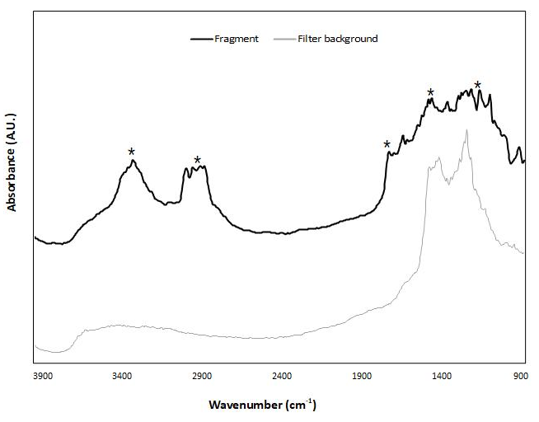
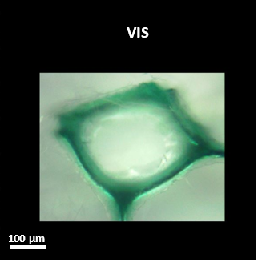
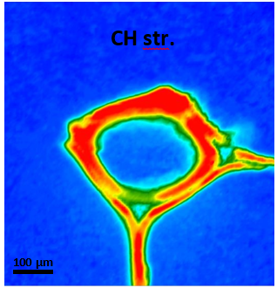
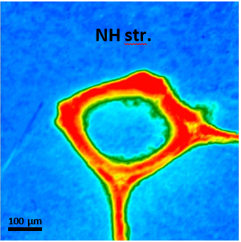

Figure S4- Visible light map and 2D FTIR Imaging maps (top and centre panels), and FTIR spectra (bottom panel) of a fragment identified as polyurethane owing to absorptions at 3290 cm⁻¹ (NH stretching), 2930-2850 cm⁻¹ (CH stretching), 1747 cm⁻¹ (C=O stretching), 1456 cm⁻¹ (CH₃ bending), and 1218 cm⁻¹ (C(=O)O stretching). The main absorption bands of the fragment have been marked with a “*”. Each spectrum relates to a single pixel (5.5 x 5.5 µm²) of the 2D Imaging maps.

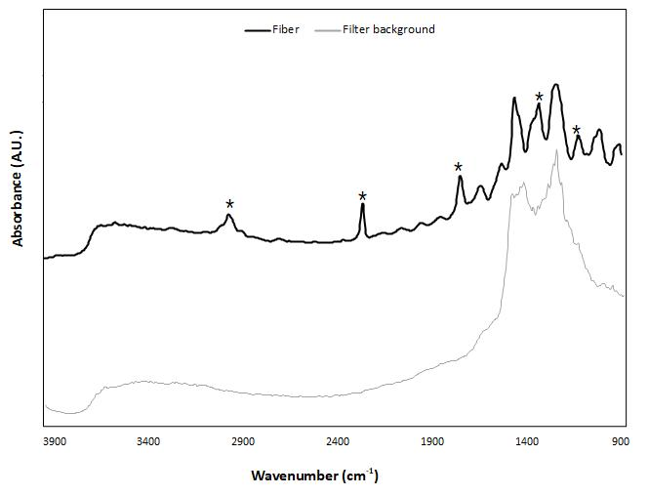
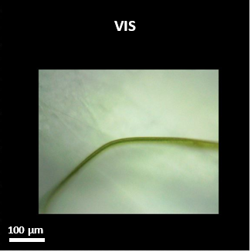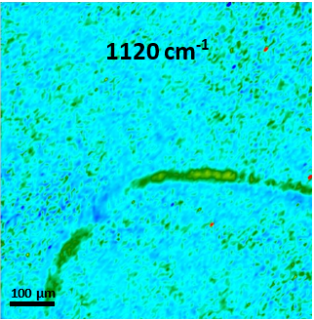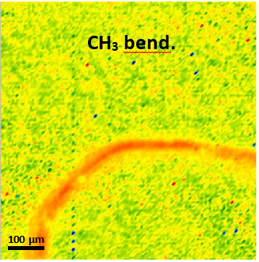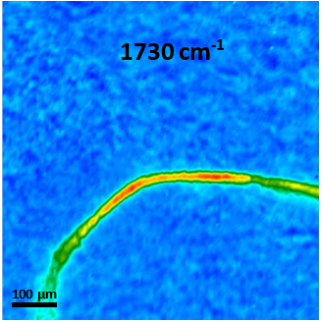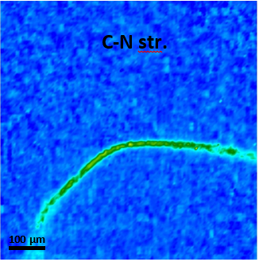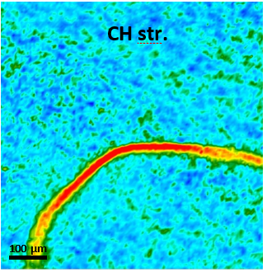

Figure S5- Visible light map and 2D FTIR Imaging maps (top and centre panels), and FTIR spectra (bottom panel) of a fiber identified as polyacrylonitrile owing to absorptions at 2940-2850 cm⁻¹ (CH stretching), 2241 cm⁻¹ (CN stretching), 1730 cm⁻¹ (C=C stretching), 1380 (CH₃ bending), and 1120 cm⁻¹ (C-O stretching). The main absorption bands of the fiber have been marked with a “*”. Each spectrum relates to a single pixel (5.5 x 5.5 µm²) of the 2D Imaging maps.

Table S2– Shape, size and colour distribution of anthropogenic microparticles by fish species and site.
SITE/SPECIES | DRY |  |  |  |  |  |  |  |  | RAINY
SITE/SPECIES | FIBRE |  |  |  |  |  |  |  | FRAGMENT | FIBRE |  |  |  |  |  | FRAGMENT
SITE/SPECIES | BLACK |  |  | BLUE |  | BROWN | RED | TRANS-  PARENT | GREEN | BLACK |  | BLUE |  | BROWN | TRANS-  PARENT | BLUE | GREEN
SITE/SPECIES | MACRO | MESO | MICRO | MESO | MICRO | MICRO | MICRO | MICRO | MICRO | MESO | MICRO | MESO | MICRO | MICRO | MESO | MICRO | MICRO
CAETE
Atherinella brasiliensis (Quoy & Gaimard 1825) |  |  |  | 1 | 1
Batrachoides surinamensis (Bloch & Schneider 1801) |  |  |  |  | 3 |  |  |  |  |  |  |  | 1 |  |  |  | 1
Cathorops spixii (Agassiz 1829) |  |  |  |  | 4 |  |  |  |  | 1 | 3 |  | 4 |  |  |  | 1
Sphoeroides psittacus (Bloch & Schneider 1801) |  |  |  |  |  |  |  |  |  |  |  | 1 | 1
Cynoscion acoupa (Lacepède 1801) |  |  |  |  | 5 |  | 2
Diapterus auratus (Ranzani 1842) |  |  |  |  | 2
Genyatremus luteus (Bloch 1790) |  |  |  |  | 1 |  |  |  |  |  |  |  | 2
Lutjanus jocu (Bloch & Schneider 1801) |  |  |  |  | 2 |  |  |  |  |  | 2 |  | 1
Lycengraulis grossidens (Spix & Agassiz 1829) |  |  |  |  |  | 2
Macrodon ancylodon (Bloch & Schneider 1801) |  |  | 2 |  | 2
Mugil sp. |  |  |  |  |  |  |  |  |  |  |  |  | 1
Pterengraulis atherinoides (Linnaeus 1766) |  |  |  |  |  |  |  |  |  | 1 | 1
Rhinosardinia amazonica (Steindachner 1879) |  |  |  |  |  |  |  |  |  |  | 1 | 2
Sciades herzbergii (Bloch 1794) |  |  |  |  | 1 |  |  |  |  | 2 | 2 | 1 | 1
Strongylura timucu (Walbaum 1792) |  |  | 1 |  |  |  |  | 1
DELTA
Anableps anableps (Linnaeus 1758) |  |  |  |  |  |  |  |  |  |  |  | 1
Atherinella brasiliensis (Quoy & Gaimard 1825) |  |  |  |  |  |  |  |  |  |  |  |  | 1
Batrachoides surinamensis (Bloch & Schneider 1801) |  |  |  |  |  |  |  |  |  |  |  |  | 3
Centropomus undecimalis (Bloch 1792) |  |  |  |  |  |  |  |  |  |  | 2
Sphoeroides psittacus (Bloch & Schneider 1801) |  |  |  |  |  |  |  |  |  |  | 1 |  | 2
Diapterus auratus (Ranzani 1842) |  |  |  |  |  |  |  |  |  | 1 | 4
Genyatremus luteus (Bloch 1790) |  |  |  |  |  |  |  |  |  |  | 1 |  |  | 1
Lutjanus jocu (Bloch & Schneider 1801) |  |  |  |  |  |  |  |  |  |  |  |  | 1
Lycengraulis grossidens (Spix & Agassiz 1829) |  |  |  |  |  |  |  |  |  |  | 2
Mugil sp. |  |  |  |  |  |  |  |  |  |  |  |  | 1
Pterengraulis atherinoides (Linnaeus 1766) |  |  |  |  |  |  |  |  |  | 1 | 2
PARÁ
Achirus achirus (Linnaeus 1758) |  |  |  |  |  |  |  |  |  |  |  |  | 1
Anableps anableps (Linnaeus 1758) |  |  |  |  |  |  |  | 1
Anchovia clupeoides |  |  |  |  |  |  |  |  |  |  |  |  | 1
Batrachoides surinamensis (Bloch & Schneider 1801) |  |  |  |  | 3
Cathorops spixii |  |  |  | 1 |  |  |  |  |  |  |  |  | 2 |  | 1
Centropomus undecimalis (Bloch 1792) |  |  |  |  |  |  |  |  |  |  | 1
Sphoeroides psittacus (Bloch & Schneider 1801) | 1 | 1 | 2 |  | 2 | 1
Diapterus auratus (Ranzani 1842) |  |  |  |  |  |  |  |  |  |  | 1 |  | 7
Genyatremus luteus (Bloch 1790) |  |  |  |  |  |  |  |  |  | 1 | 1
Lutjanus jocu (Bloch & Schneider 1801) |  |  |  |  |  |  |  |  | 2 |  |  |  | 4
Lycengraulis grossidens (Spix & Agassiz 1829) |  |  |  |  |  |  |  |  |  |  |  |  | 1 |  |  | 1
Macrodon ancylodon (Bloch & Schneider 1801) |  |  |  |  | 3 |  |  |  |  |  |  |  | 1
Pterengraulis atherinoides (Linnaeus 1766) |  |  |  |  |  |  |  |  |  |  |  |  |  |  |  |  | 1
Sciades herzbergii (Bloch 1794) |  |  |  |  |  |  |  |  | 1
Stellifer naso (Jordan 1889) |  |  |  |  |  |  |  |  |  | 1 |  | 1
Total Geral | 1 | 1 | 5 | 2 | 29 | 3 | 2 | 2 | 3 | 8 | 24 | 6 | 36 | 1 | 1 | 1 | 3

