Supplementary Fig. 1. Graphic representation of the hatching experiment regarding zooplankton dormant communities from sediments of temporary ponds under different anthropogenic pressures: Livestock = L, Preserved = P, Agriculture = C and Control = C
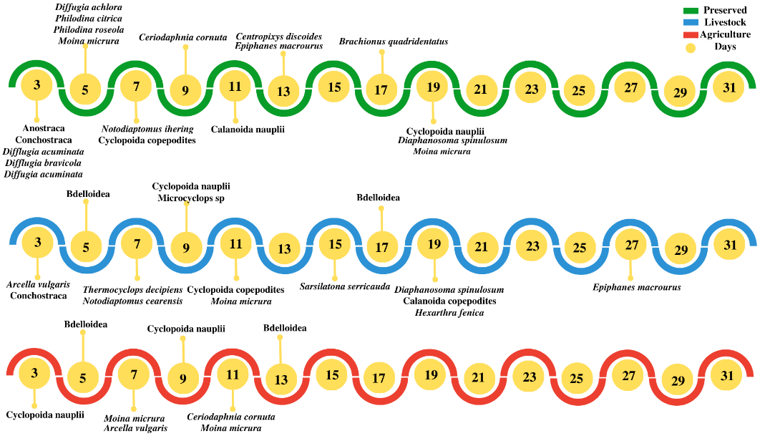
Supplementary Fig. 2. Timeline of emerging species from sediment samples of ponds influenced by various anthropogenic activities
Supplementary Table 1 Geographic coordinates (latitude and longitude in decimal degrees) of the sampled temporary ponds and their respective land use categories.
Latitude | Longitude | Site | Land use category
-8.9326787 | -36.6817182 | Saloá Pond 1 | Agriculture
-8.9369646 | -36.6805837 | Saloá Pond 2 | Agriculture
-8.9441289 | -36.6780673 | Saloá Pond 3 | Agriculture
-8.9505599 | -36.6737276 | Saloá Pond 4 | Agriculture
-8.9575548 | -36.6730392 | Saloá Pond 5 | Agriculture
-8.7993816 | -36.7344391 | Caetés Pond 1 | Livestock
-8.8124049 | -36.7500305 | Caetés Pond 2 | Livestock
-8.8164230 | -36.7608490 | Caetés Pond 3 | Livestock
-8.8199813 | -36.7671214 | Caetés Pond 4 | Livestock
-8.8069024 | -36.7239306 | Caetés Pond 5 | Livestock
-8.5021103 | -37.2541893 | Catimbau Pond 1 | Preserved
-8.5018066 | -37.2543625 | Catimbau Pond 2 | Preserved
-8.5019542 | -37.2547867 | Catimbau Pond 3 | Preserved
-8.4941279 | -37.2517678 | Catimbau Pond 4 | Preserved
-8.5016676 | -37.2545529 | Catimbau Pond 5 | Preserved

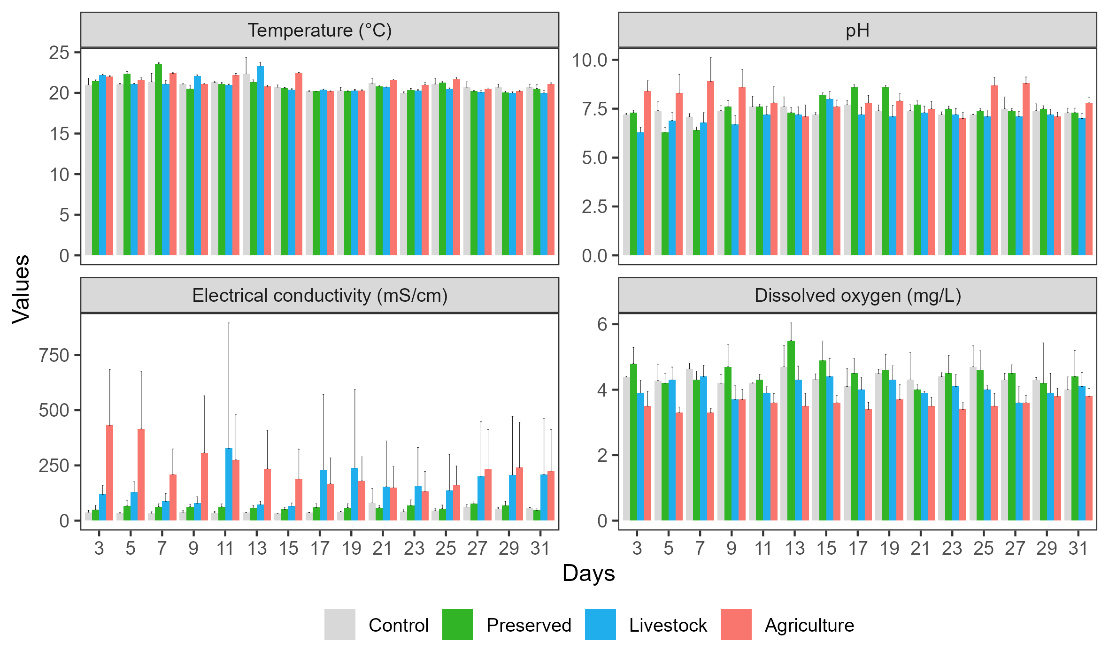
Supplementary Fig. 3. Temporal variation in environmental parameters during the resting egg hatching experiment. Mean (± SD) values of temperature (°C), pH, electrical conductivity (mS cm⁻¹), and dissolved oxygen (mg L⁻¹) are shown for the Control, Preserved, Livestock, and Agriculture treatments

Supplementary Table 6 Hatched and environmentally collected zooplankton species and copepod developmental early stages in the fifteen ponds across an anthropization gradient.
 | Hatching Experiment |  |  |  | Environment
 | Livestock | Preserved | Agriculture |  | Livestock | Preserved | Agriculture
Anuraeopsis fissa Gosse, 1851 |  | X |  |  |  | X
Anuraeopsis navicula Rousselet, 1911 |  | X
Bdelloidea | X | X | X |  | X | X | X
Brachionus angularis Gosse, 1851 |  | X
Brachionus bidentata Anderson, 1889 | X | X
Brachionus calyciflorus Pallas, 1766 | X |  |  |  | X
Brachionus caudatus Barrois & Daday, 1894 |  |  |  |  | X
Brachionus quadridentatus Hermann, 1783 |  | X
Brachionus variabilis Hempel, 1896 |  |  |  |  | X
Euchlanis dilatata Ehrenberg, 1830 |  |  |  |  |  |  | X
Epiphanes macrourus (Barrois & Daday, 1894) |  | X |  |  | X
Filinia opoliensis (Zacharias, 1898) |  |  |  |  | X
Filinia terminalis (Plate, 1886) |  |  |  |  | X
Habrotrocha leitgebii Zelinka, 1886 |  | X
Hexarthra intermedia brasiliensis Hauer, 1953 |  | X
Hexarthra fennica (Levander, 1892) | X |  |  |  | X | X
Hexarthra mira (Hudson, 1871) |  | X
Keratella americana Carlin, 1943 |  |  |  |  | X |  | X
Keratella tropica (Apstein, 1907) |  | X | X
Lecane bulla (Gosse, 1851) | X | X | X |  | X |  | X
Lecane inbricata (Carlin, 1939) |  |  |  |  | X | X
Lecane luna (Müller, 1776) | X
Lecane monostila (Daday, 1897) |  | X |  |  |  |  | X
Lecane papuana (Murray, 1913) |  |  |  |  |  | X | X
Lecane pusilla Harring, 1914 |  |  |  |  |  |  | X
Lecane ungulata (Gosse, 1887) |  |  |  |  |  |  | X
Lepadella patella Müller, 1773 | X | X |  |  | X | X | X
Liliferotrocha subtilis (Rodewald, 1940) |  |  |  |  | X
Philodina citrina Ehrenberg, 1830 |  | X
Philodina roseola Ehrenberg, 1832 |  | X
Polyarthra vulgaris Carlin, 1943 |  | X |  |  | X | X
Trichocerca pusilla (Jennings, 1903) | X | X |  |  | X | X
Testudinela patina Hermann, 1783 |  |  |  |  |  |  | X
Arcella hemisferica Perty, 1852 | X | X
Arcella vulgaris Ehrenberg,1832 | X | X | X
Arcella mitrata Leidy, 1879 | X
Difflugia oblonga Ehrenberg 1832 |  | X |  |  |  | X
Difflugia brevicola Cash & Hopkinson, 1909 | X
Difflugia acuminata Ehrenberg,1838 | X | X
Difflugia corona Wallich, 1864 |  | X |  |  | X | X
Difflugia achlora (Penard, 1902) | X | X |  |  | X | X
Centropyxis constricta (Ehrenberg, 1841) | X
Centropyxis discoides (Penard, 1890) |  | X | X
Centropyxis aculeata (Ehrenberg, 1832) |  | X | X |  |  | X
Hyalosphenia sp. Stein, 1857 |  |  |  |  | X
Lesquereusia spiralis (Ehrenberg, 1840) |  |  |  |  |  | X
Netzelia sp. |  |  |  |  | X
Ostracoda |  | X
Nauplius Conchostraca |  | X |  |  | X
Nauplius Anostraca |  | X
Copepodite Calanoida | X | X
Copepodite Cyclopoida |  | X | X
Mesocyclops sp. |  | X
Microcyclops sp. | X | X |  |  | X | X | X
Thermocyclops sp. |  | X |  |  |  |  | X
Thermocyclops decipiens (Kiefer, 1929) | X | X |  |  | X | X | X
Thermocyclops minutus (Lowndes, 1934) |  |  |  |  | X
Nauplius Calanoida | X | X |  |  | X | X | X
Nauplius Cyclopoida | X | X | X |  | X | X | X
Nauplius Harpacticoida |  | X
Notodiaptomus cearensis (Wright S., 1936) | X |  |  |  | X |  | X
Notodiaptomus iheringi (Wright, 1935) | X | X |  |  |  | X
Argyrodiaptomus furcatus (Sars G.O., 1901) |  | X
Ovalona glabra (Van Damme et al, 2010) |  |  |  |  |  | X
Prendalona julietae (Sinev, Sousa & Elmoor-Loureiro, 2023) |  |  |  |  | X | X
Biapertura ossiani Sinev (2020) |  |  |  |  | X
Ceriodaphnia laticaudata P.E. Müller, 1867 |  | X
Ceriodaphnia cornuta Sars 1885 | X | X | X |  | X | X | X
Chydorus pubescens G.O. Sars 1901 | X |  |  |  |  | X
Diaphanosoma spinulosum Herbst, 1975 | X | X |  |  |  |  | X
Ilyocryptus spinifer Herrick, 1882 |  |  |  |  |  |  | X
Moina micrura Kurtz 1875 | X | X | X |  | X | X | X
Moina minuta Hansen (1899) |  |  |  |  | X
Macrothrix elegans G.O. Sars, 1901 |  |  |  |  |  | X
Macrothrix laticornis (Jurine, 1820) |  | X |  |  |  | X
Macrothrix superaculeata (Smirnov, 1982) |  |  |  |  |  | X
Latonopsis australis G.O. Sars, 1888 |  | X | X
Sarsilatona serricauda G.O. Sars, 1901 | X

Supplementary Table 7 Resting eggs removed during sample filtration in the preserved treatment, by taxonomic group and experimental days

 |  | Preserved
Days | Rotifers | Cladocerans | Copepods | Anostracans | Conchostracans
3 | 26 | 24 | 0 | 299 | 4
5 | 0 | 0 | 0 | 905 | 1
7 | 0 | 10 | 7 | 0 | 0
9 | 0 | 0 | 0 | 4 | 558
11 | 0 | 0 | 79 | 0 | 6
13 | 0 | 0 | 0 | 0 | 160
15 | 0 | 0 | 0 | 0 | 0
17 | 0 | 0 | 0 | 0 | 0
19 | 0 | 0 | 0 | 0 | 0
21 | 0 | 0 | 0 | 0 | 0
23 | 0 | 0 | 0 | 0 | 0
25 | 0 | 0 | 0 | 0 | 0
27 | 0 | 0 | 0 | 0 | 0
29 | 0 | 0 | 0 | 0 | 0
31 | 0 | 0 | 0 | 0 | 0

Supplementary Table 8 Resting eggs removed during sample filtration in the livestock treatment, by taxonomic group and experimental days
 |  | Livestock
Days | Rotifers | Cladocerans | Copepods | Anostracans | Conchostracans
3 | 151 | 17 | 0 | 1 | 18
5 | 0 | 0 | 0 | 0 | 0
7 | 3 | 38 | 0 | 0 | 3
9 | 5 | 8 | 0 | 0 | 5
11 | 6 | 10 | 0 | 0 | 6
13 | 0 | 0 | 0 | 0 | 0
15 | 0 | 0 | 0 | 0 | 0
17 | 0 | 0 | 0 | 0 | 0
19 | 44 | 0 | 0 | 0 | 44
21 | 0 | 0 | 0 | 0 | 0
23 | 0 | 0 | 0 | 0 | 0
25 | 0 | 0 | 0 | 0 | 0
27 | 0 | 0 | 0 | 0 | 0
29 | 0 | 0 | 0 | 0 | 0
31 | 0 | 0 | 0 | 0 | 0

Supplementary Table 9 Resting eggs removed during sample filtration in the agriculture treatment, by taxonomic group and experimental days
 |  | Agriculture
Days | Rotifers | Cladocerans | Copepods | Anostracans | Conchostracans
3 | 4 | 14 | 7 | 24 | 6
5 | 12 | 0 | 9 | 0 | 0
7 | 6 | 9 | 15 | 0 | 10
9 | 14 | 0 | 1 | 0 | 3
11 | 0 | 6 | 0 | 1 | 0
13 | 5 | 3 | 6 | 0 | 0
15 | 0 | 1 | 0 | 6 | 0
17 | 0 | 0 | 4 | 0 | 0
19 | 0 | 0 | 0 | 0 | 0
21 | 0 | 0 | 0 | 0 | 0
23 | 0 | 0 | 0 | 0 | 0
25 | 0 | 0 | 0 | 0 | 0
27 | 0 | 0 | 0 | 0 | 0
29 | 0 | 0 | 0 | 0 | 0
31 | 0 | 0 | 0 | 0 | 0

