Supplementary material - Photoacclimation strategies of non-native Vaucheria-turfs (Xanthophyceae) in a temperate soft bottom coastal system
Corresponding author: Ronny Steinberg, University of Bremen, Marine Botany, James-Watt-Str. 1, 28359 Bremen, Germany, ronny.steinberg@uni-bremen.de, OrcID: 0009-0002-1797-1391
Christian Buschbaum, Alfred-Wegener Institute, Helmholtz Centre for Polar and Marine Research, Wadden Sea Station Sylt, Hafenstraße 43, 25992 List/Sylt, Germany, christian.buschbaum@awi.de
Kai Bischof, University of Bremen, Marine Botany & MARUM, James-Watt-Str. 1, 28359 Bremen, Germany, kai.bischof@uni-bremen.de, OrcID: 0000-0002-4497-1920
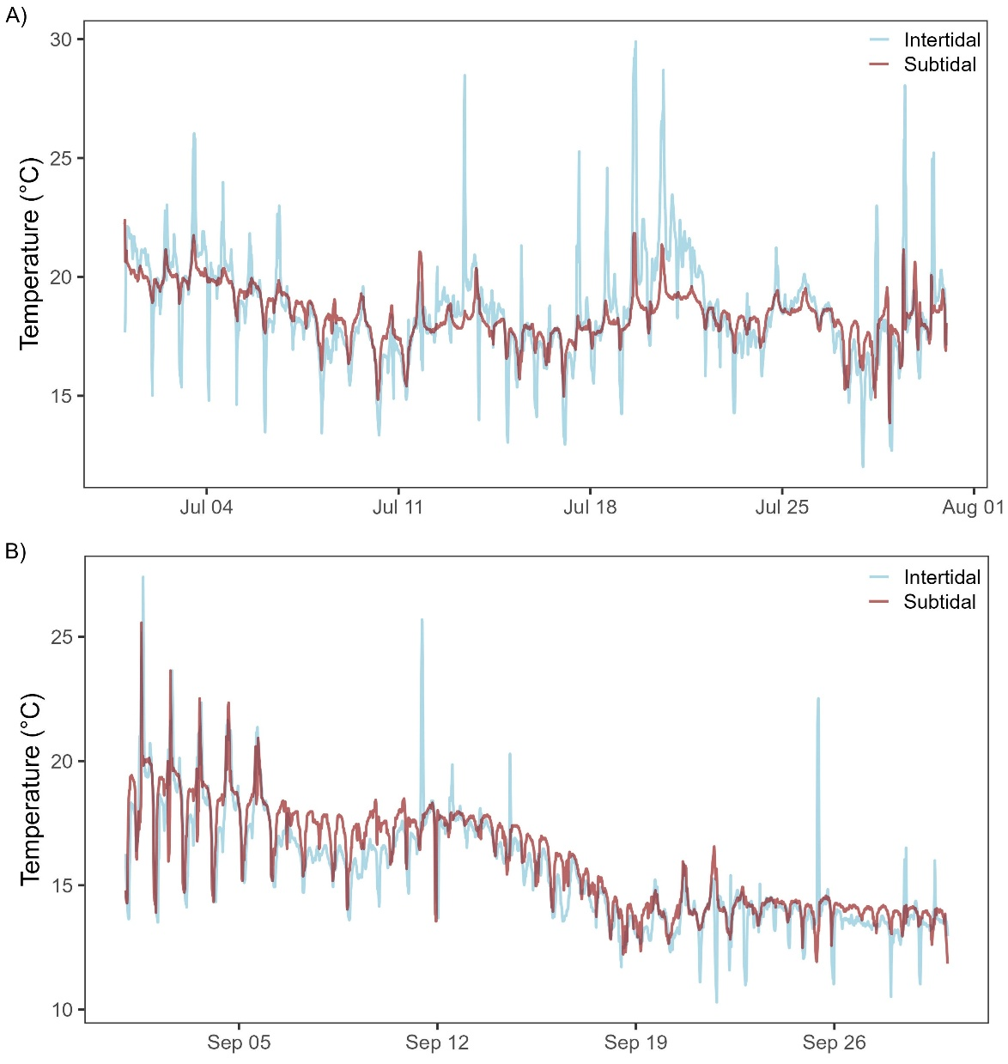
Fig. S1: Monthly surface temperature trend in intertidal (site 1, blue) and subtidal (site 2, red) sampling site. A) for July. B) for September. Temperature was measured every 15 min. on the surface of Vaucheria sp. turfs. Displayed are 2400 data points for each site and season.
Table S1: Surface temperature in both sampling sites for July and September. Mean ± standard deviation, Median, Maximum and Minimum (n_{July} = 2400, n_{September} = 2400). Temperature was measured every 15 min. on the surface of Vaucheria turfs
Month | Site | Mean Temperature (°C) | Median  Temperature  (°C) | Max. Temperature (°C) | Min. Temperature (°C)
July | Site 1 | 18.5 ± 2.17 | 18.4 | 29.9 | 12.7
 | Site 2 | 18.3 ± 1.03 | 18.3 | 22.4 | 13.8
September | Site 1 | 15.0 ± 2.03 | 14.3 | 25.6 | 10.3
 | Site 2 | 15.4 ± 1.90 | 14.4 | 22.7 | 11.8

Statistical Report
Table S2: Two-Way ANOVA: Site × Month effects for measured light response curve parameter. F-value and p-value for the parameters F_{V}/F_{M}, NPQ, Φ_{PSII} and rETR
Parameter | Effect | df | F Value | p-value
F_{V}/F_{M} | month | 1 | 547.97 | < 0.001
 | site | 1 | 437.80 | < 0.001
 | month:site | 1 | 212.42 | < 0.001
 | Residuals | 206
NPQ | month | 1 | 20.01 | < 0.001
 | site | 1 | 1.72 | 0.192
 | month:site | 1 | 0.61 | 0.436
 | Residuals | 206
Φ_{PSII} | month | 1 | 38.78 | < 0.001
 | site | 1 | 54.17 | < 0.001
 | month:site | 1 | 12.97 | < 0.001
 | Residuals | 206
rETR | month | 1 | 2.09 | 0.150
 | site | 1 | 463 | 0.032
 | month:site | 1 | 0.23 | 0.632
 | Residuals | 206

Table S3: Post-hoc: Site comparisons by month for light response curve parameter
Parameter | Site | Comparison | Difference | p-value
F_{V}/F_{M} | Site 1 | July - September | 0.24 | < 0.001
 | Site 2 | July - September | 0.06 | < 0.001
NPQ | Site 1 | July - September | 0.13 | < 0.001
 | Site 2 | July - September | 0.10 | 0.009
Φ_{PSII} | Site 1 | July - September | 0.17 | < 0.001
 | Site 2 | July - September | 0.04 | 0.08
rETR | Site 1 | July - September | 28.34 | 0.203
 | Site 2 | July - September | 13.59 | 0.523

Table S4: Two-Way ANOVA: Site × Month Effects for calculated lightcurve parameters I_{k}, α and rETR_{max}
Parameter | Effect | df | F Value | p-value
I_{k} | Site | 1 | 0.01 | 0.920
 | Month | 1 | 0.53 | 0.476
 | Site:Month | 1 | 2.21 | 0.155
 | Residuals | 17
α | Site | 1 | 6.29 | 0.022
 | Month | 1 | 5.03 | 0.038
 | Site:Month | 1 | 3.19 | 0.092
 | Residuals | 17
rETR_{max} | Site | 1 | 14.36 | 0.001
 | Month | 1 | 2.10 | 0.166
 | Site:Month | 1 | 1.38 | 0.256
 | Residuals | 17

Table S5: Post-hoc: Site comparisons by month for calculated light response curve parameters I_{k}, α and rETR_{max}
Parameter | Site | Comparison | Difference | p-value
α | Site 1 | July - September | 0.08 | 0.011
 | Site 2 | July - September | 0.01 | 0.705
rETR_{max} | Site 1 | July - September | 6.57 | 0.881
 | Site 2 | July - September | 76.93 | 0.080
I_{k} | Site 1 | July - September | -728.41 | 0.133
 | Site 2 | July - September | 221.56 | 0.622

Table S6: Results of two-way ANOVA for Chlorophyll a concentration at site 1 and site 2 in July and September 2022.
Effect | df | F Value | p-value
Month | 1 | 93.25 | 0.000
Site | 1 | 0.16 | 0.698
month:site | 1 | 49.77 | 0.000
Residuals | 16

Table S7: Results of the Tukey post-hoc test for the Chlorophyll a concentratrion.
Comparison | Difference | p-value
Site1 July - Site2 July | 56.39 | 0.001
Site1 July - Site1 September | 141.50 | 0.000
Site1 July - Site2 September | 78.42 | 0.000
Site2 July - Site1 September | 85.11 | 0.000
Site2 July - Site2 September | 22.03 | 0.292
Site1 September - Site2 September | -63.08 | 0.000

Table S8: Results of two-way ANOVA for Diadinoxanthin concentration at site 1 and site 2 in July and September 2022.
Effect | df | F Value | p-value
month | 1 | 261.60 | 0.000
site | 1 | 14.79 | 0.001
month:site | 1 | 117.25 | 0.000
Residuals | 16

Table S9: Results of the Tukey post-hoc test for the Diadinoxanthin concentratrion.
Comparison | Difference | p-value
Site1 July - Site2 July | 38.67 | 0.000
Site1 July - Site1 September | 71.16 | 0.000
Site1 July - Site2 September | 52.76 | 0.000
Site2 July - Site1 September | 32.49 | 0.000
Site2 July - Site2 September | 14.09 | 0.008
Site1 September - Site2 September | -18.40 | 0.001

Table S10: Results of two-way ANOVA for Diatoxanthin concentration at site 1 and site 2 in July and September 2022.
Effect | df | F Value | p-value
month | 1 | 700.92 | 0
site | 1 | 776.71 | 0
month:site | 1 | 493.99 | 0
Residuals | 16

Table S11: Results of the Tukey post-hoc test for the Diatoxanthin concentratrion.
Comparison | Difference | p-value
Site1 July - Site2 July | 18.39 | 0.000
Site1 July - Site1 September | 17.88 | 0.000
Site1 July - Site2 September | 19.95 | 0.000
Site2 July - Site1 September | -0.51 | 0.759
Site2 July - Site2 September | 1.56 | 0.038
Site1 September - Site2 September | 2.07 | 0.005

Table S12: Results of two-way ANOVA for the pigment ratio Chlorophyll a/ (Diadinoxanthin + Diatoxanthin) at site 1 and site 2 in July and September 2022.
Effect | df | F Value | p-value
month | 1 | 170.93 | 0.000
site | 1 | 12.39 | 0.003
month:site | 1 | 57.05 | 0.000
Residuals | 16

Table S13: Results of the Tukey post-hoc test for the pigment ratio Chlorophyll a/ (Diadinoxanthin + Diatoxanthin).
Comparison | Difference | p-value
Site1 July - Site2 July | -1.49 | 0.000
Site1 July - Site1 September | -2.78 | 0.000
Site1 July - Site2 September | -2.23 | 0.000
Site2 July - Site1 September | -1.29 | 0.000
Site2 July - Site2 September | -0.74 | 0.006
Site1 September - Site2 September | 0.54 | 0.051

Table S14: Results of two-way ANOVA for the pigment ratio Diadinoxanthin / Diatoxanthin at site 1 and site 2 in July and September 2022.
Effect | df | F Value | p-value
month | 1 | 49.25 | 0.000
site | 1 | 416.58 | 0.000
month:site | 1 | 0.46 | 0.506
Residuals | 16

Table S15: Results of the Tukey post-hoc test for the pigment ratio Diadinoxanthin / Diatoxanthin.
Comparison | Difference | p-value
Site1 July - Site2 July | -11.37 | 0.000
Site1 July - Site1 September | -4.15 | 0.000
Site1 July - Site2 September | -14.79 | 0.000
Site2 July - Site1 September | 7.22 | 0.000
Site2 July - Site2 September | -3.42 | 0.002
Site1 September - Site2 September | -10.64 | 0.000

