Supplementary information

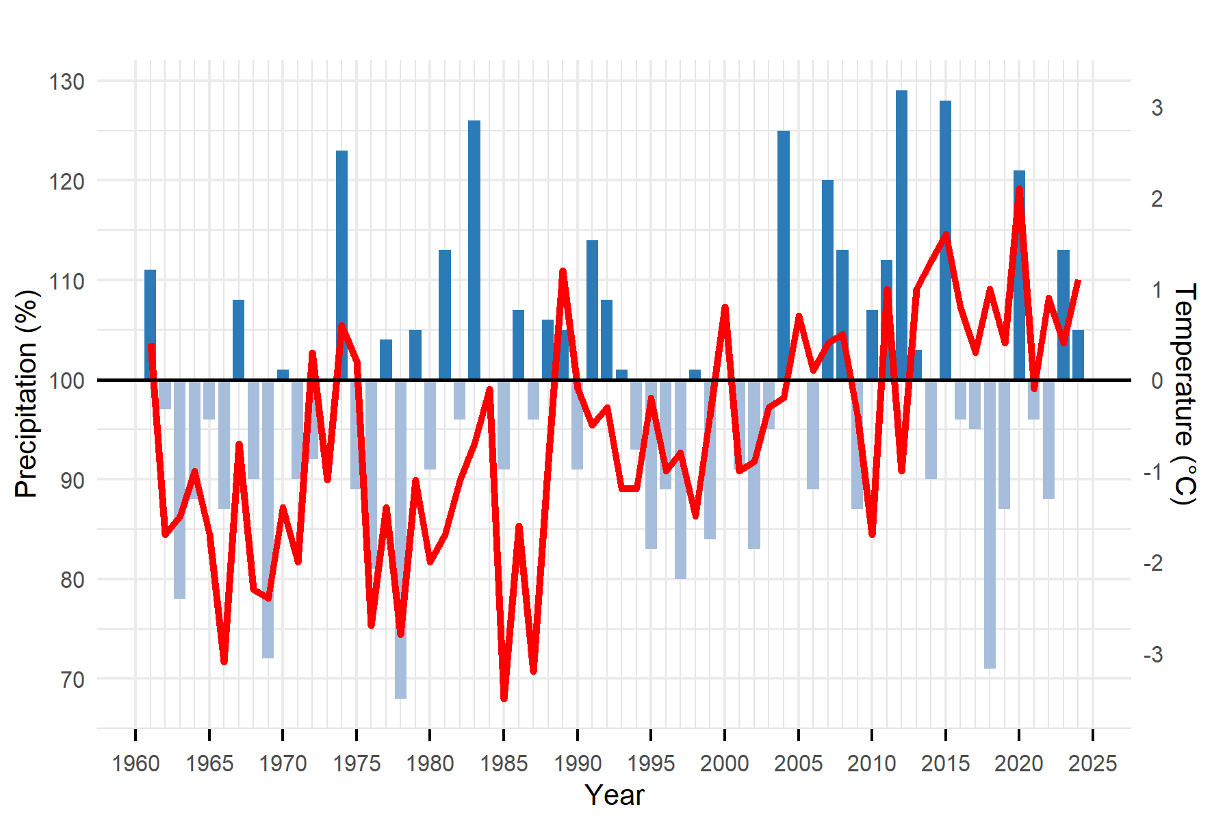
Supplementary Fig. 1 Annual anomalies of precipitation (blue bars) and temperature (red line) in Kajaani. Precipitation is expressed as a percentage deviation of the 1991–2020 long-term average (620 mm), while temperature shows the deviation from the 1991–2020 long-term mean (-9.4 °C). Data source: Finnish Meteorological Institute.

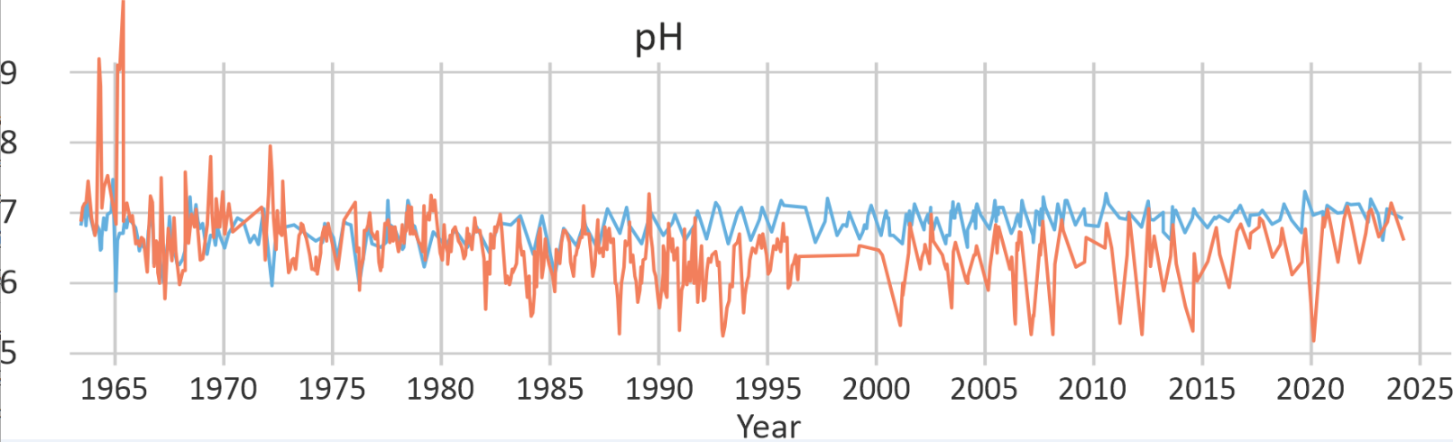

Supplementary Fig. 2 Monthly mean pH in Junttiselkä (red) and Munasaarensekä (blue) water column.
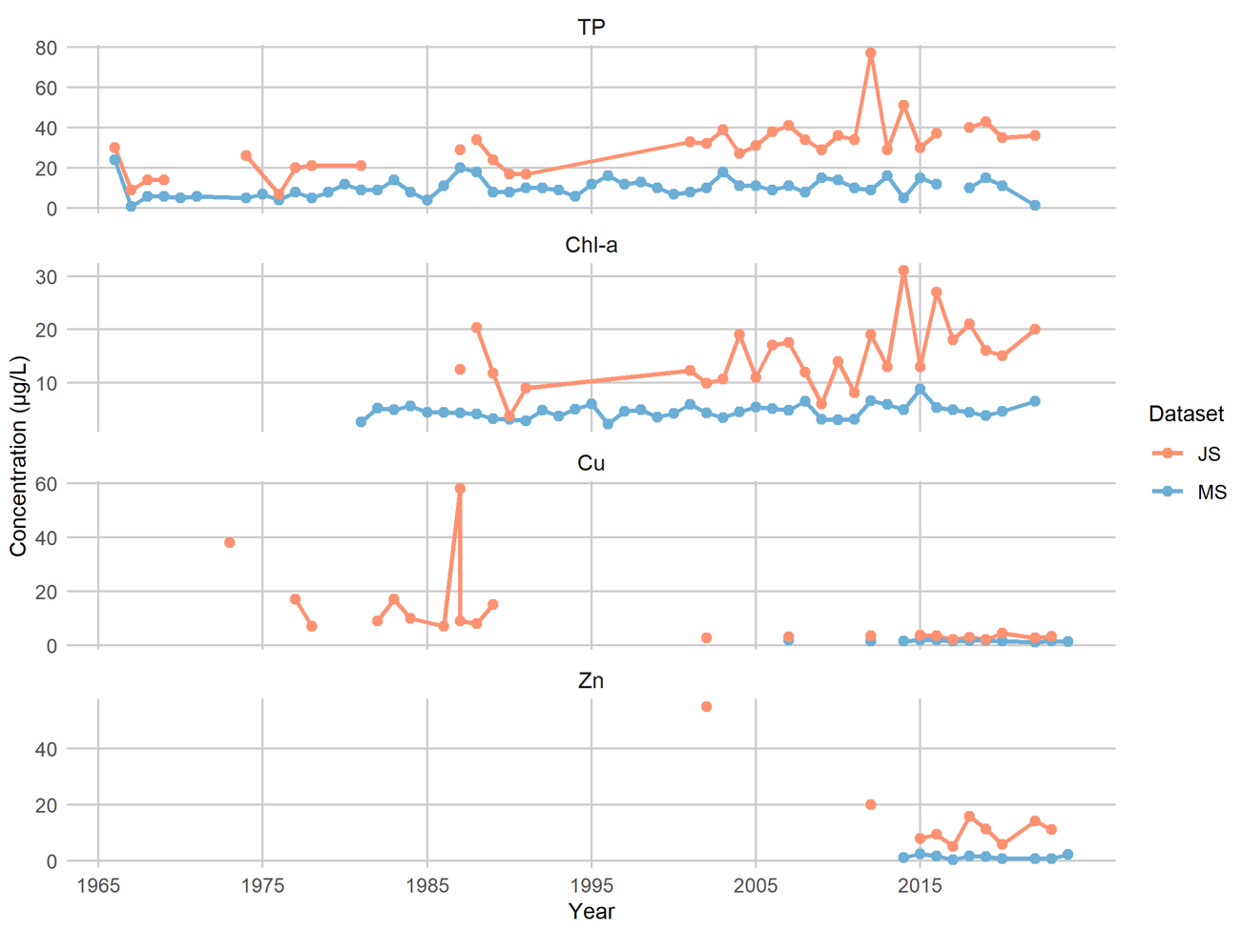

Supplementary Fig. 3. Measured lake water chlorophyll-a (Chl-a), total phosphorus (TP), unfiltered copper (Cu) and unfiltered zinc (Zn) concentrations. Data were obtained from the Hertta database maintained by the Finnish Environment Institute (Syke).

