Appendix S1: Detailed community structure and species-level dynamics
Title: Compositional resilience despite dynamical instability in stream fish communities following highway construction.
Overview
This appendix provides detailed species-level information to support the aggregate community stability and synchrony metrics presented in the main text. Given the low species richness typical of these headwater streams, these analyses clarify the individual population drivers of community-level patterns.
Section 1: Species Dominance and Temporal Variability
As community stability (Stab) is the ratio of mean abundance (μ) to standard deviation (σ) (Stab = μ/ σ), Table S1 quantifies these parameters for each species before and after the highway construction.
Table S1. Summary of species-specific abundance and variability. Mean abundance (μ), temporal variability (σ) and Coefficients of Variation (CV) by species and Period.
Species | code | Period | μ | σ | CV (%)
Deuterodon janeiroensis (Eigenmann, 1908) | Djan | Before | 0.75 | 1.29 | 172.1
 |  | After | 0.44 | 1.56 | 357.6
Hollandichthys multifasciatus (Eigenmann &Norris, 1900) | Hmul | Before | 0.88 | 1.59 | 181.3
Hollandichthys multifasciatus (Eigenmann &Norris, 1900) |  | After | 0.72 | 2.37 | 330.1
Hoplias malabaricus (Bloch, 1794) | Hmal | Before | 0.31 | 0.7 | 225.3
 |  | After | 0.06 | 0.25 | 393.5
Scleromystax barbatus (Quoy & Gaimard, 1824) | Sbar | Before | 1.25 | 1.61 | 129.0
 |  | After | 0.47 | 1.08 | 229.8
Rhamdia aff. quelen (Quoy & Gaimard, 1824) | Rque | Before | 0.88 | 0.89 | 101.1
 |  | After | 0.31 | 0.78 | 249.7
Pseudotothyris obtusa (Miranda Ribeiro, 1911) | Pobt | Before | 0.81 | 1.11 | 136.5
 |  | After | 0.06 | 0.25 | 393.5
Isbrueckerichthys duseni (Miranda Ribeiro, 1907) | Idus | Before | 1.88 | 2.19 | 116.6
 |  | After | 1.38 | 3.27 | 237.8
Cambeva zonata (Eigenmann, 1918) | Czon | Before | 0.88 | 0.81 | 92.1
 |  | After | 3.25 | 3.92 | 120.6
Phalloceros lucenorum Lucinda, 2008 | Pluc | Before | 5.56 | 8.58 | 154.2
 |  | After | 11.53 | 18.7 | 162.1
Geophagus iporangensis Haseman, 1911 | Gipo | Before | 0.62 | 0.96 | 153.2
 |  | After | 0.19 | 0.54 | 285.4
Note: CV (Coefficient of Variation) = σ/μ * 100. A general increase in CV across species indicates widespread population destabilization following the impact.
Section 2: Multivariate Ordination of Community Structure
Principal Component Analysis (PCA) was used to visualize species associations and multivariate dispersion. The ordination reveals an expansion in multivariate dispersion during the 'After' period (red ellipse) compared to the 'Before' period (blue ellipse). This expansion is a visual hallmark of dynamical instability. Vectors for Pluc and Czon identify these species as primary drivers of the compositional shift and increased community-wide variability.
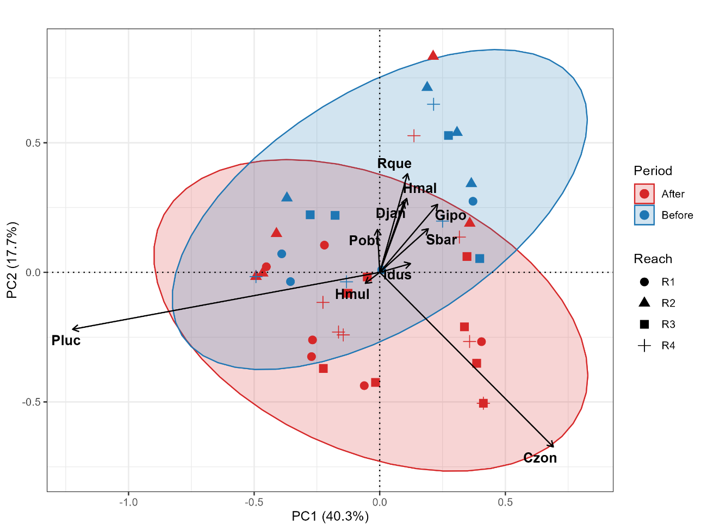
Figure S1.1: PCA biplot of fish community structure (Hellinger-transformed).

Appendix S2: Detailed turnover rates across the 'Before' and 'After' periods
Title: Reach-specific temporal trajectories of richness-based species turnover in the stream fish community across Before and After highway duplication periods.
Overview
This figure provides a detailed visualization of the temporal dynamics of the stream fish community across four reaches (R1–R4). The connected points reveal the inherent stochasticity of species replacement rates over time. The dashed vertical line indicates the onset of highway construction (Interval 3); the lack of a consistent upward or downward trend across all reaches following this event supports the finding of high taxonomic reliability (p = 0.938). Our findings reveal that while the highway duplication reduced aggregate community stability, the disturbance did not reach the threshold required to trigger a directional shift in turnover.
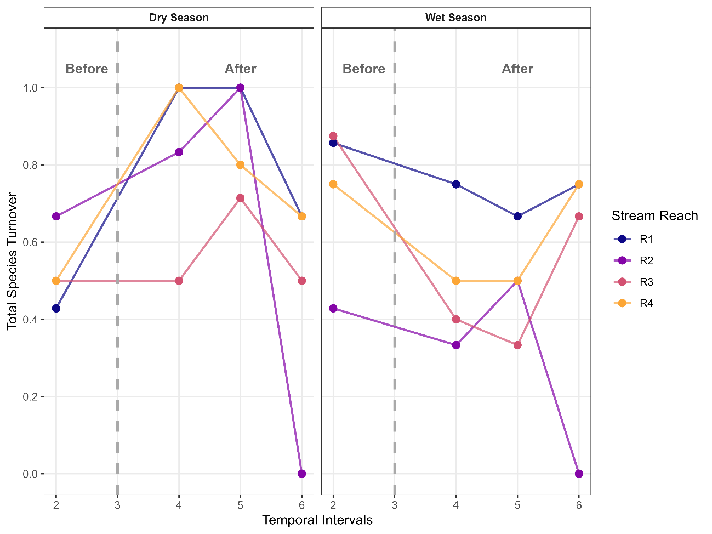
Figure S2.1. Reach-specific temporal trajectories of species turnover in the stream fish community. Lines represent independent time series for each combination of reach (R1–R4) and hydrological season (Dry and Wet). The vertical dashed line indicates the onset of highway construction (Interval 3). These trajectories reveal high taxonomic reliability over time, with the rate of species gains and losses remaining stable across both the 'Before' (n = 8 intervals) and 'After' (n = 24 intervals) periods.

