Supplementary Materials - Divergent drivers of fish habitat suitability in the Yangtze River Estuary: Environmental filtering versus prey availability

Hailang Yang¹, Wei Tang^{1#}, Xuefang Wang^{1,2*}

1. College of Marine Living Resources and Management, Shanghai Ocean University, Shanghai, 201306, China
2. Joint Laboratory for Monitoring and Conservation of Aquatic Living Resources in the Yangtze Estuary, Shanghai 202162, China

* Corresponding Author: Xuefang Wang
Email: xfwang@shou.edu.cn
Phone: +86-13764146654
Correspondence Address: College of Marine Living Resources and Management, Shanghai Ocean University, 999 Hucheng Huan Road, Shanghai, 201306, China

# Hailang Yang and Wei Tang contributed equally to this work and should be considered co-first authors

Table S1 Summary of species occurrence data for Collichthys lucidus and Leiocassis longirostris in the Yangtze River Estuary from 2021-2024
Species | Year | Season | Total samples | Presence | Absence | Proportion of Presence
Collichthys lucidus | 2021 | Spring | 12 | 0 | 12 | 0.00%
Collichthys lucidus | 2021 | Summer | 16 | 6 | 10 | 37.50%
Collichthys lucidus | 2021 | Autumn | 16 | 8 | 8 | 50.00%
Collichthys lucidus | 2021 | Winter | 14 | 1 | 13 | 7.14%
Collichthys lucidus | 2022 | Summer | 18 | 2 | 16 | 11.11%
Collichthys lucidus | 2022 | Autumn | 18 | 13 | 5 | 72.22%
Collichthys lucidus | 2023 | Spring | 18 | 11 | 7 | 61.11%
Collichthys lucidus | 2023 | Summer | 19 | 10 | 9 | 52.63%
Collichthys lucidus | 2023 | Autumn | 17 | 10 | 7 | 58.82%
Collichthys lucidus | 2023 | Winter | 17 | 13 | 4 | 76.47%
Collichthys lucidus | 2024 | Spring | 17 | 4 | 13 | 23.53%
Collichthys lucidus | 2024 | Summer | 17 | 12 | 5 | 70.59%
Collichthys lucidus | 2024 | Autumn | 17 | 17 | 0 | 100.00%
Collichthys lucidus | 2024 | Winter | 17 | 10 | 7 | 58.82%
Leiocassis longirostris | 2021 | Spring | 12 | 3 | 9 | 25.00%
Leiocassis longirostris | 2021 | Summer | 16 | 10 | 6 | 62.50%
Leiocassis longirostris | 2021 | Autumn | 16 | 6 | 10 | 37.50%
Leiocassis longirostris | 2021 | Winter | 14 | 0 | 14 | 0.00%
Leiocassis longirostris | 2022 | Summer | 18 | 5 | 13 | 27.78%
Leiocassis longirostris | 2022 | Autumn | 18 | 3 | 15 | 16.67%
Leiocassis longirostris | 2023 | Spring | 18 | 7 | 10 | 38.89%
Leiocassis longirostris | 2023 | Summer | 19 | 9 | 10 | 47.37%
Leiocassis longirostris | 2023 | Autumn | 17 | 8 | 9 | 47.06%
Leiocassis longirostris | 2023 | Winter | 17 | 0 | 17 | 0.00%
Leiocassis longirostris | 2024 | Spring | 17 | 3 | 14 | 17.65%
Leiocassis longirostris | 2024 | Summer | 17 | 5 | 12 | 29.41%
Leiocassis longirostris | 2024 | Autumn | 17 | 8 | 9 | 47.06%
Leiocassis longirostris | 2024 | Winter | 17 | 1 | 16 | 5.88%

Table S2 Rationale for model parameter selection and their potential implications
Model | Parameter | Value | Rationale for Selection | Potential Implications
GBM | n.trees | 2000 | A relatively large number of trees enhances model stability | Reduces the influence of individual trees and smooths predictions; increases computational cost
GBM | interaction.depth | 7 | Allows moderate nonlinear interactions | Captures complex responses; excessive depth may increase overfitting risk, mitigated by low learning rate
GBM | shrinkage | 0.005 | Small learning rate for gradual boosting | Reduces overfitting risk but requires more trees
RF | ntree | 500 | Commonly used value ensuring stable performance | Predictions stabilize when tree number is sufficient; acceptable computational cost
RF | mtry | 2 | Determined via candidate comparison and OOB error; close to $\sqrt{p}$ heuristic | Smaller mtry increases tree diversity and reduces correlation; too small may underfit, but OOB evaluation selects optimal value
RF | nodesize | 5 | Restricts minimum terminal node size | Prevents over-partitioning; improves generalization ability
ANN | size | 10 | Controls network complexity | Smaller hidden layer reduces overfitting risk
ANN | decay | 0.001 | Weight decay regularization | Prevents excessive weight magnitude; enhances stability
ANN | maxit | 200 | Ensures convergence | Insufficient iterations may underfit; excessive iterations may increase noise fitting
FDA | method | mars | Common non-parametric classification method | Captures nonlinear responses with controlled complexity
FDA | add_args | NULL | No additional tuning | Maintains comparability among algorithms
GAM | algo | GAM_mgcv | Mature implementation framework ensuring stability | Relies on automatic smoothing parameter selection; over- or under-smoothing may affect interpretability but is detectable via cross-validation
GAM | k | -1 | Default upper limit for basis dimension in mgcv, allowing data-driven smoothing | Larger k increases flexibility; effective degrees of freedom (EDF) are automatically estimated via penalized regression (GCV/REML) and typically remain below theoretical maximum; five-fold cross-validation further controls overfitting
GAM | interaction.level | 0 | No higher-order interactions | Reduces model complexity; avoids high-order nonlinear overfitting
GLM | type | Quadratic | Allows quadratic terms | Captures unimodal responses; higher-order polynomials may overfit, but no high-order interactions included
GLM | interaction.level | 0 | No interaction terms | Maintains interpretability
GLM | mustart | 0.5 | Default initial value | Minimal influence on final results

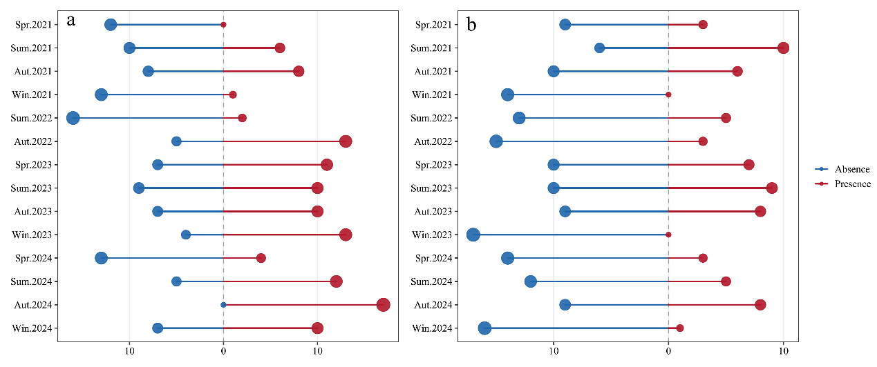
Fig. S1 Summary of species occurrence data for Collichthys lucidus and Leiocassis longirostris in the Yangtze River Estuary from 2021-2024 (a: C. lucidus; b: L. longirostris; blue dots indicate absences; red dots indicate presences).

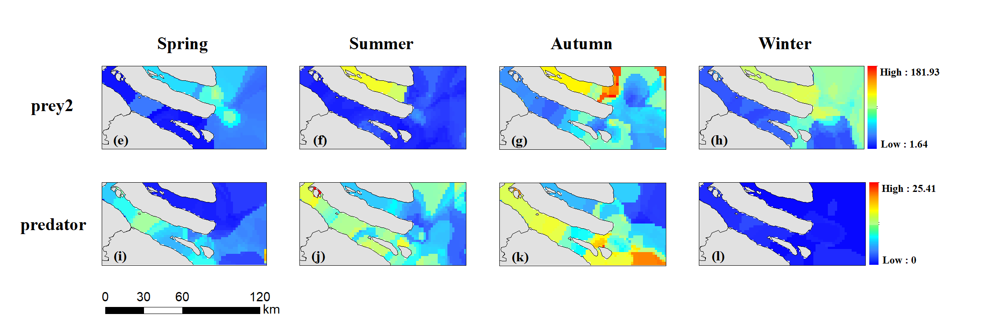
Fig. S2 Spatial distribution of the predicted abundance of prey2 and predator in 2023 based on RF (predicted abundance increases gradually from blue to red)

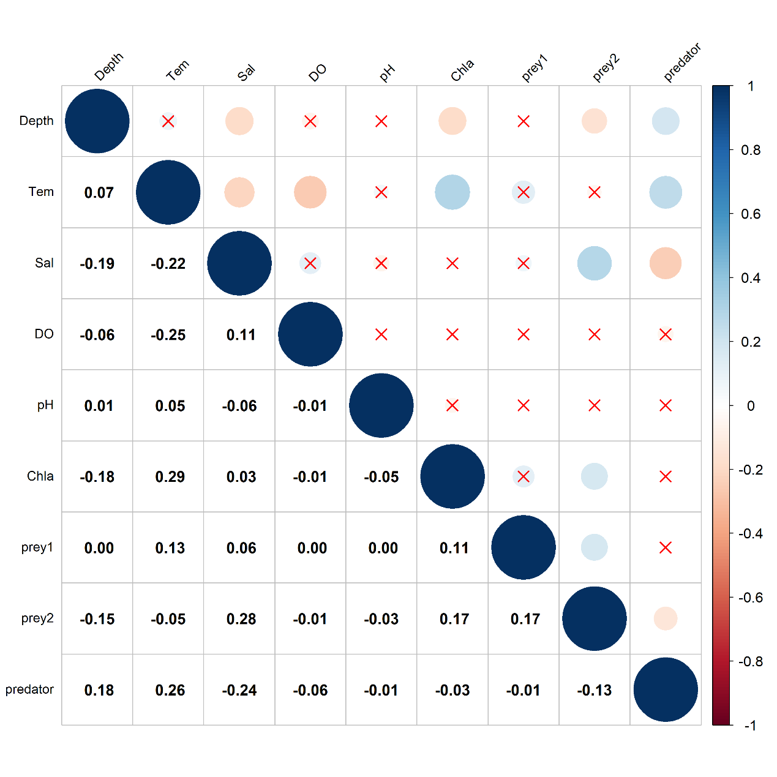
Fig. S3 Pearson correlation matrix among all predictor variables. (Numerical values in the lower triangle represent the Pearson correlation coefficients between each pair of variables, while the color gradient from red to blue indicates the strength and direction of the correlation, ranging from -1 to 1)

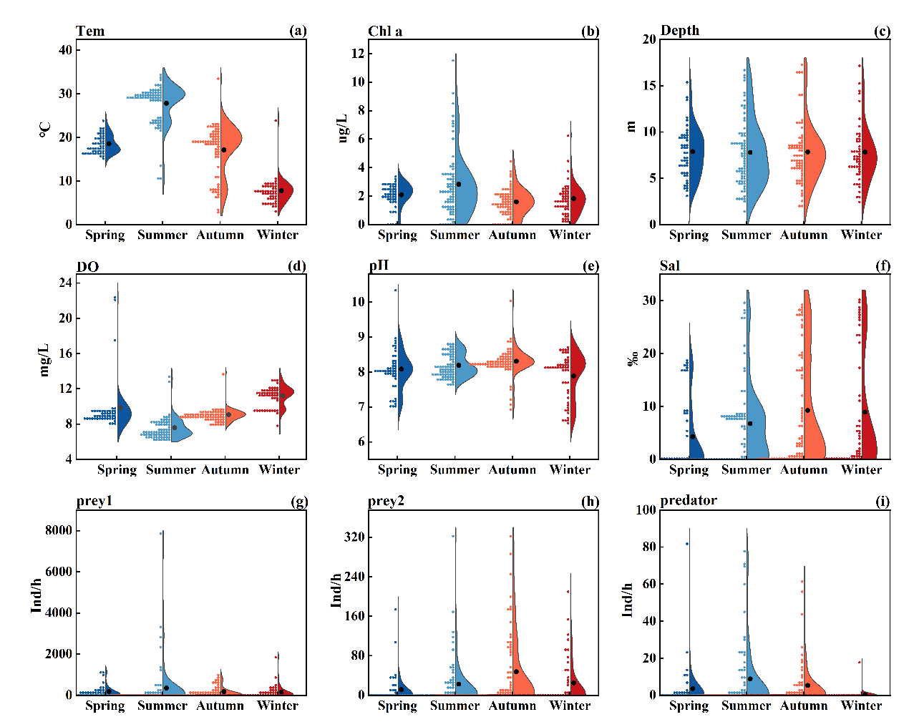
Fig. S4 Seasonal variation ranges of abiotic and biotic variables in the study area of the Yangtze River estuary (Tem: temperature; Chl a: chlorophyll a; depth; DO: dissolved oxygen; pH; Sal: salinity; prey1; prey2; predator)

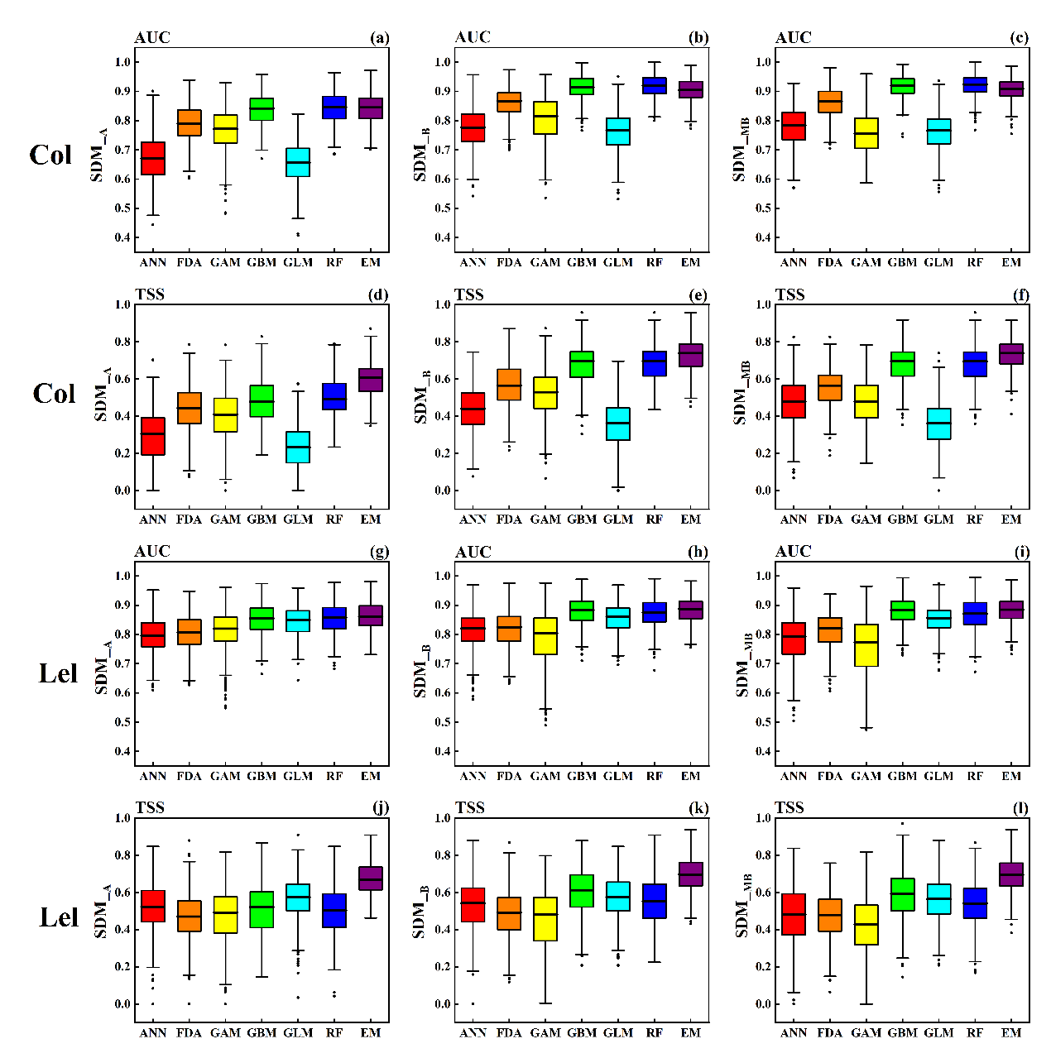
Fig. S5 Accuracy assessment results of six single models and the ensemble model (EM) based on 100 runs of five-fold cross-validations ((a–l) represent boxplots of AUC and TSS scores for Collichthys lucidus and Leiocassis longirostris; the horizontal line at the centre of the box indicates the median, and solid circles denote outliers).

