Online Resource 2: Supplementary Methods and Data Sources
Author Information:
Anna Söderman
Division of Water Resources Engineering, Lund University, Lund, Sweden.
Email: anna.soderman@tvrl.lth.se.
ORCID: https://orcid.org/0009-0002-1958-7107
Christian Alsterberg
Division of Water Resources Engineering, Lund University, Lund, Sweden.
Division of Research and Development, Sydvatten AB, Malmö, Sweden.
Magnus Larson
Division of Water Resources Engineering, Lund University, Lund, Sweden.
Kenneth M. Persson
Division of Water Resources Engineering, Lund University, Lund, Sweden.
Division of Research and Development, Sydvatten AB, Malmö, Sweden.
Magnus Persson
Division of Water Resources Engineering, Lund University, Lund, Sweden.
This online resource aims to gain a better understanding of the data collection of the dataset compiled for Lake Vombsjön and its surrounding tributaries for the paper “Five Decades of Phosphorus Trends in a Eutrophic Lake: Insights from Lake Vombsjön, Sweden” (Hydrobiologia). The data compilation process was conducted in the R software environment (version 4.4.1; R Core Team, 2024). The measurement sites and their corresponding IDs are shown in Fig. S1 and consist of Vombsjöns utlopp (ID 17), Torpsbäcken (ID 19), Borstbäcken (ID 21), Björkaån (ID 20), and Lake Vombsjön (ID 18). In addition, six monitoring points within Lake Vombsjön, labelled Lake IDs 1-6, are associated with Site ID 18.
The dataset was compiled from various datasets, reports, and published studies spanning the 1940s to the present, all of which are presented in this online resource. The final dataset is presented in an Excel file that includes a metadata sheet, a source sheet, and, lastly, a sheet for each measurement site and its corresponding measurements. All data used, and the R code are available upon request from the corresponding author.
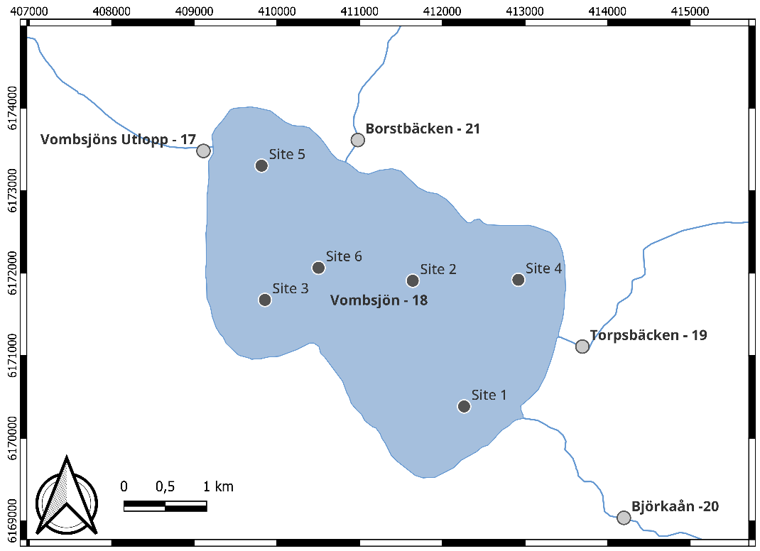
Fig. S1 Overview of monitoring sites in Lake Vombsjön and its tributaries. Sites include Vombsjöns utlopp (ID 17), Torpsbäcken (ID 19), Borstbäcken (ID 21), Björkaån (ID 20), Lake Vombsjön (ID 18), and six in-lake sites (Lake IDs 1-6).
Data Sources
Various data sources were used to compile the dataset of Lake Vombsjön and its tributaries. Each source will hereby be presented. The full references for the data sources are presented in the reference section of this online resource, in the same manner as they are cited in this section.
Annual Reports from the monitoring program
Monitoring of water quality and pollution sources in the Kävlingeå Catchment began in the 1950s under Kävlingeåns Vattenvårdsförbund, later Kävlingeåns Vattenråd. Annual summaries of measurements were published in reports, however, reports before 2001 were not digitally available and required manual digitisation.
These reports were digitised into an Excel file, with each annual report stored in a separate sheet corresponding to the year. A metadata sheet was created to document abbreviations, units, and parameters. During digitisation, all parameters were converted to standardised units as defined in the metadata sheet. Additionally, a source sheet was included to track all references, which are also listed in the References section. In total, 33 annual reports (1958-2001) were digitised. One additional 2020 report that was not previously digitised was also included.
Reports from 2001 onward were already available in digital Excel format. However, spreadsheet structures varied across years, so each file was imported into R individually, standardised, and renamed to ensure consistency across the dataset.
Compilation Reports
Four compilation reports for Lake Vombsjön were conducted during the 60s to 80s (Almestrand, 1968; Malmö Kommun, 1978; Almestrand & Lundkvist, 1983; Kävlingeåns Vattenvårdsförbund, 1970). These all had to be digitised before analysis, which was done individually into Excel sheets named the same way as the source. In addition, a metadata sheet was created with the abbreviation, unit and parameter name, as well as a source sheet with the source name and the complete reference.
Papers
Lund University is situated not too far from Lake Vombsjön, and several researchers have therefore used the lake as their case study for their research. In total, 12 of these articles were included in the dataset, which spanned from 1937 to the 1990s (Andersson, 1948; Andersson et al., 1968; Cronberg, 1996; Cronberg et al., 1997; Cronberg et al., 1998; Cronberg et al., 1999; Gelin, 1970; Gelin, 1971; Gelin, 1972; Gelin, 1973; Gelin, 1974).
These all had to be digitised before analysis, which was done individually into Excel sheets named the same way as the source. In addition, a metadata sheet was created with the abbreviation, unit and parameter name, as well as a source sheet with the source name and the complete reference.
Miljödata-MVM Database
Data from the SLU-MVM (Swedish University of Agricultural Sciences - Environmental Monitoring and Assessment Program) were downloaded from the official database (Miljödata-MVM, 2025). These contained water chemistry measurements from multiple monitoring sites. Thus, the file was filtered for the assigned monitoring sites (Fig. S1), standardised, and units renamed to ensure consistency across the dataset.
Data Processing
Standardization
Since all data sources varied in structure, they first had to be standardised before merging. The goal was that each data source would consist of three data frames: one metadata data frame, one source data frame, and one data frame with the measurement data, as seen in Figure 1.
Each metadata data frame consists of three columns: Abbreviation, Unit and Parameter. The source file includes both the in-text source reference and the complete reference. Lastly, the measurement data should all have a site column with site names (SITE), their corresponding ID (SITE_ID), date (DATE), data source (SOURCE), and all the measurement data. The source data frame is linked to the measurement data through the source column, and the metadata related to the measurement data through the abbreviations, which are the column names in the measurement data (see Fig. S2).
This was done for all measurement sites (Vombsjöns utlopp, Björkaån, Torpsbäcken, Borstbäcken, and Vombsjön). However, in Lake Vombsjön, six additional measurement sites are present (Sites 1 to 6), which were added through a column named “LAKE ID”. As most measurements were conducted at the deepest part of the lake (“Djuphålan”), this was translated into the LAKE ID “Site 2”.
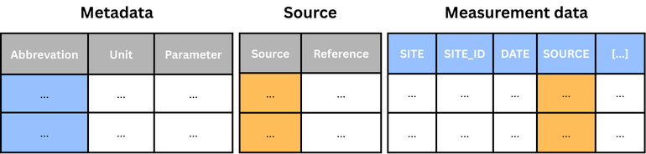
Fig. S2 Standardisation structure for the individual, and the last data frame for Lake Vombsjön.
The data sources, which had to be digitised, were already in this format, with each sheet in the Excel file corresponding to each data frame seen in Figure 1. Thus, these could be imported directly into R; however, for the data from Kävlingeåns Vattenråd and SLU MVM, which were in another structure in the Excel sheets, adjustments were required. These were therefore inserted into R, where the additional metadata and source files were created from the original file. Additionally, the measurement data frames were updated to the specified abbreviations, and the site names corresponding IDs were updated. Moreover, a source column indicating the data source was added.
Once all data sources had a consistent format, all concentration values were converted to mg/L, and the corresponding metadata units were updated accordingly. After these conversions, all variables were stored as character type to enable uniform handling across datasets. At the end of the standardisation process, all sources consisted of three data frames: metadata, source, and measurement.
Merging and Homogenization
When all data frames were standardised, they were combined into complete datasets. This was done in a similar structure to the standardisation process, seen in Figure 1. Thus, all the measurement data frames were merged into one dataset, the source files into one, and lastly, the metadata were merged into one.
In the complete measurement dataset, observations reported below detection limits were excluded due to inconsistent thresholds across laboratories and time periods and were thereafter converted to numeric values. All measurements were thereafter rounded to three significant numbers for consistency.
Sorting by Site
The dataset was sorted by site, and a list of measurement sites was created. Thereafter, the coordinates for each measurement site were added to each measurement site along with the coordinate system. For the sites Vombsjöns utlopp, Björkaån, Torpsbäcken, and Bortbäcken, which are all streams, these were added in a SWEREFF 99 (North/East) style. For Lake Vombsjön and its six additional measurement sites, the locations were added in WGS-84 (Long/Lat) coordinates. The metadata dataset was updated with the new column names and corresponding unit and parameter names.
Removing duplicates
Duplicates in the full updated measurement data dataset were thereafter removed, ensuring each entry was represented only once. This was conducted measurement site by measurement site, where observations were grouped by sampling date. If multiple sources were reported for the same date, the source names were combined into a single column. For water chemistry parameters, values from Miljödata-MVM (2025) were prioritised if available, otherwise, the first non-missing value was retained. For Lake Vombsjön, there were often multiple observations per day because measurements were conducted at different depths. The depth dimensions were therefore preserved in the duplicates as well.
For the metadata data frame, the same matter was conducted. First, a manual inspection of the merged metadata was conducted to ensure all units were consistent across the merged data. When all units were the same, each data frame was merged into a single data frame.
Final Dataset
Using the final three data frames, the complete dataset could be generated in an Excel file. It consists of one sheet of metadata, one sheet of sources, and one sheet per site with data from the monitoring sites.
References
Annual Reports from the monitoring program
Not digitised
Ekologigruppen Ekoplan AB, 2020. Kävlingeån – vattenkontroll 2019. Report produced for Kävlingeåns Vattenråd.
Kävlingeåns Vattenvårdsförbund, 1958. Redogörelse för företagna undersökningar i Kävlingeån under år 1958 jämte bedömning av de vattenhygieniska förhållandena. SE/M004/19. Eslövs kommunarkiv.
Kävlingeåns Vattenvårdsförbund, 1959. Redogörelse för företagna undersökningar i Kävlingeån under år 1959 jämte bedömning av de vattenhygieniska förhållandena. SE/M004/19. Eslövs kommunarkiv.
Kävlingeåns Vattenvårdsförbund, 1960. Redogörelse för företagna undersökningar i Kävlingeån under år 1960 jämte bedömning av de vattenhygieniska förhållandena. SE/M004/19. Eslövs kommunarkiv.
Kävlingeåns Vattenvårdsförbund, 1965. Förvaltningsberättelse för Kävlingeåns Vattenvårdsförbund år 1965.
Kävlingeåns Vattenvårdsförbund, 1966. Förvaltningsberättelse för Kävlingeåns Vattenvårdsförbund år 1966.
Kävlingeåns Vattenvårdsförbund, 1975. Handlingar för samlingspärm 1975. SE/M004/19. Eslövs kommunarkiv.
Kävlingeåns Vattenvårdsförbund, 1976. Samlingspärm 1976. SE/M004/19. Eslövs kommunarkiv.
Kävlingeåns Vattenvårdsförbund, 1978. Samlingspärm 1978. SE/M004/19. Eslövs kommunarkiv.
Kävlingeåns Vattenvårdsförbund, 1979. Samlingspärm 1979. SE/M004/19. Eslövs kommunarkiv.
Kävlingeåns Vattenvårdsförbund, 1980. Samlingspärm 1980. SE/M004/19. Eslövs kommunarkiv.
Kävlingeåns Vattenvårdsförbund, 1981. Samlingspärm 1981. SE/M004/19. Eslövs kommunarkiv.
Scandiaconsult, 1983. Sammanfattning av rapporter 1982 (Report No. 52.4185-01). Report produced for Kävlingeåns Vattenvårdsförbund.
Scandiaconsult, 1984. Sammanfattning av rapporter 1983 (Report No. 52.4570-01). Report produced for Kävlingeåns Vattenvårdsförbund.
Scandiaconsult, 1985. Sammanfattning av rapporter 1984 (Report No. 8154-01). Report produced for Kävlingeåns Vattenvårdsförbund.
Scandiaconsult, 1986. Sammanfattning av rapporter 1985 (Report No. 8154-01). Report produced for Kävlingeåns Vattenvårdsförbund.
Scandiaconsult, 1987. Sammanfattning av rapporter 1986 (Report No. 11069-01). Report produced for Kävlingeåns Vattenvårdsförbund.
Scandiaconsult, 1988. Sammanfattning av rapporter 1987. Report produced for Kävlingeåns Vattenvårdsförbund.
Scandiaconsult, 1989. Sammanfattning av rapporter 1988. Report produced for Kävlingeåns Vattenvårdsförbund.
Kävlingeåns Vattenvårdsförbund, 1989. Sammanfattning av rapporter 1989.
Kävlingeåns Vattenvårdsförbund, 1990. Sammanfattning av rapporter 1990.
Kävlingeåns Vattenvårdsförbund, 1991. Sammanfattning av rapporter 1991.
Kävlingeåns Vattenvårdsförbund, 1992. Samlingspärm för 1992. SE/M004/19. Eslövs kommunarkiv.
Kävlingeåns Vattenvårdsförbund, 1993. Samlingspärm för 1993. SE/M004/19. Eslövs kommunarkiv.
Kävlingeåns Vattenvårdsförbund, 1994. Samlingspärm för 1994. SE/M004/19. Eslövs kommunarkiv.
Svelab Miljölaboratorier AB, 1996. Samordnad recipientkontroll Kävlingeån 1995. Report produced for Kävlingeåns Vattenvårdsförbund.
Svelab Miljölaboratorier AB, 1997. Samordnad recipientkontroll Kävlingeån 1996. Report produced for Kävlingeåns Vattenvårdsförbund.
Svelab Miljölaboratorier AB, 1998. Kävlingeån 1997 – årsrapport över recipientkontrollen. Report produced for Kävlingeåns Vattenvårdsförbund.
Scandiaconsult Sverige AB, 1999. Samordnad recipientkontroll 1998. Report produced for Kävlingeåns Vattenvårdsförbund.
Scandiaconsult Miljöteknik, 2000. Samordnad recipientkontroll 1999. Report produced for Kävlingeåns Vattenvårdsförbund.
Kävlingeåns Vattenvårdsförbund, 2000. Vattendragskontroller samt handlingar som berör Kävlingeån. SE/M004/19. Eslövs kommunarkiv.
Scandiaconsult Sverige AB, 2002. Samordnad recipientkontroll – Årsrapport 2001 (p. 24). Report produced for Kävlingeåns Vattenvårdsförbund.
Digitised:
ALcontrol AB, 2013. Kävlingeån – vattenkontroll 2012. Report produced for Kävlingeåns Vattenvårdsförbund.
ALcontrol AB, 2014. Kävlingeån – vattenkontroll 2013. Report produced for Kävlingeåns Vattenvårdsförbund.
ALcontrol AB, 2015. Kävlingeån – vattenkontroll 2014. Report produced for Kävlingeåns Vattenråd.
ALcontrol AB, 2016. Kävlingeån – vattenkontroll 2015. Report produced for Kävlingeåns Vattenråd.
ALcontrol AB, 2017. Kävlingeån – vattenkontroll 2016. Report produced for Kävlingeåns Vattenråd.
Ekologgruppen i Landskrona AB, 2003. Kävlingeån – vattenkontroll 2002. Report produced for Kävlingeåns Vattenvårdsförbund.
Ekologgruppen i Landskrona AB, 2004. Kävlingeån – vattenkontroll 2003. Report produced for Kävlingeåns Vattenvårdsförbund.
Ekologgruppen i Landskrona AB, 2005. Kävlingeån – vattenkontroll 2004. Report produced for Kävlingeåns Vattenvårdsförbund.
Ekologgruppen i Landskrona AB, 2006. Kävlingeån – vattenkontroll 2005. Report produced for Kävlingeåns Vattenvårdsförbund.
Ekologgruppen i Landskrona AB, 2007. Kävlingeån – vattenkontroll 2006. Report produced for Kävlingeåns Vattenvårdsförbund.
Ekologgruppen i Landskrona AB, 2008. Kävlingeån – vattenkontroll 2007. Report produced for Kävlingeåns Vattenvårdsförbund.
Ekologgruppen i Landskrona AB, 2009. Kävlingeån – vattenkontroll 2008. Report produced for Kävlingeåns Vattenvårdsförbund.
Ekologgruppen i Landskrona AB, 2010. Kävlingeån – vattenkontroll 2009. Report produced for Kävlingeåns Vattenvårdsförbund.
Ekologgruppen i Landskrona AB, 2011. Kävlingeån – vattenkontroll 2010. Report produced for Kävlingeåns Vattenvårdsförbund.
Ekologgruppen i Landskrona AB, 2012. Kävlingeån – vattenkontroll 2011. Report produced for Kävlingeåns Vattenvårdsförbund.
Ekologigruppen Ekoplan AB, 2019. Kävlingeån – vattenkontroll 2018. Report produced for Kävlingeåns Vattenråd.
Ekologigruppen Ekoplan AB, 2021. Kävlingeån – vattenkontroll 2020. Report produced for Kävlingeåns Vattenråd.
Ekologigruppen Ekoplan AB, 2025. Kävlingeån – vattenkontroll 2024. Report produced for Kävlingeåns Vattenråd.
SGS Analytics Sweden AB, 2022. Kävlingeån vattenkontroll 2021. Report produced for Kävlingeåns Vattenråd.
SGS Analytics Sweden AB, 2023. Kävlingeån vattenkontroll 2022. Report produced for Kävlingeåns Vattenråd.
SGS Analytics Sweden AB, 2024. Kävlingeån vattenkontroll 2023. Report produced for Kävlingeåns Vattenråd.
SYNLAB, 2018. Kävlingeån – vattenkontroll 2017. Report produced for Kävlingeåns Vattenråd.
Kävlingeåns Vattenvårdsförbund, 2002-2024. Recipientkontroll Kävlingeån [Excel spreadsheets]. Provided by Kävlingeåns Vattenråd.

Compilation reports
Arthur Almestrand, 1968. Biologisk Statusundersökning av Vombsjön utförd 1967-1968. SE/MSA/00643/F/F 4/F 4 B/F 4 BEB/2. Malmö stadsarkiv.
Malmö Kommun, 1978. Biologisk statusundersökning av Vombsjön 1969-1977. SE/MSA/01455/F 11 C/2. Malmö stadsarkiv.
Almestrand, A. & C. Lundkvist, 1983. Vombsjön faktasammanställning 1983. Länsstyrelsen i Malmöhus län, Naturvårdsenheten, Meddelande nr 1983:1. Available at: https://fokusvombsjon.se/wp-content/uploads/2024/01/Almestrand-Lundkvist-1983.pdf
Kävlingeåns Vattenvårdsförbund, 1970. Vattenvårdsplan för Kävlingeån. Available at: https://fokusvombsjon.se/wp-content/uploads/2024/01/Weijman-Hane-1970.pdf

Papers
Cronberg, G., H. Annadotter, M. Lindberg & V. Lirås, 1999. Undersökning av Vombsjön 1998. Lund University, Limnology, Department of Ecology, Lund, Sweden.
Cronberg, G., H. Annadotter, M. Lindberg & V. Lirås, 1998. Undersökning av Vombsjön 1997. Lund University, Limnology, Department of Ecology, Lund, Sweden.
Cronberg, G., H. Annadotter, M. Lindberg & V. Lirås, 1997. Undersökning av Vombsjön 1996. Lund University, Limnology, Department of Ecology, Lund, Sweden.
Cronberg, G., 1996. Blågröna alger i Skånska Sjöar, Förekomst och utveckling under 1900-talet. Lund University, Limnology, Department of Ecology, Lund, Sweden.
Gelin, C., 1970. Fytoplanktons primärproduktion i Vombsjön 1969. Lund University, Limnologiska institutionen, Lund, Sweden.
Gelin, C., 1971. Fytoplanktons primärproduktion i Vombsjön 1970. Lund University, Limnologiska institutionen, Lund, Sweden.
Gelin, C., 1972. Fytoplanktons primärproduktion i Vombsjön 1971. Lund University, Limnologiska institutionen, Lund, Sweden.
Gelin, C., 1973. Fytoplanktons primärproduktion i Vombsjön 1972. Lund University, Limnologiska institutionen, Lund, Sweden.
Gelin, C., 1974. Fytoplanktons primärproduktion i Vombsjön 1973. Lund University, Limnologiska institutionen, Lund, Sweden.
Andersson, A., 1948. Näringstillgång och planktonutveckling i några skånska sjöar. Vattenhygien, no. 1.
Åberg, B., & W. Rodhe, 1942. Über die Milieufaktoren in einigen südschwedischen Seen. Symbolae botanicae upsalienses, 5(3).
Andersson, G., B.Berzins, S. Björk & C. Gelin, 1968. Vombsjöns sommargröna vatten. Skånes Natur, 55.

Miljödata-MVM
Miljödata-MVM, 2025. Swedish University of Agricultural Sciences (SLU). National data host lakes and watercourses, and national data host agricultural land, https://miljodata.slu.se/mvm/ [2025-08-18].

