Supplementary material
The supplementary tables are available at https://doi.org/10.5281/zenodo.19385739
Table S1. Ranges of variation, mean, and standard error of the mean (SEM) for egg traits (length, width, area and primary extraembryonic space angle) estimated for the diapausing eggs of the clones from the two species studied, B. plicatilis (Bp) and B. rotundiformis (Br).
Table S2. Ranges of variation, mean, and standard error of the mean (SEM) for embryo traits (length, width, area and embryo area without extraembryonic space surround) estimated for the diapausing eggs of the clones from the two species studied, B. plicatilis (Bp) and B. rotundiformis (Br).
Table S3. Ranges of variation, mean, and standard error of the mean (SEM) for extraembryonic space traits (area and percentage of primary and secondary extraembryonic spaces) estimated in diapausing eggs of clones from the two studied species, B. plicatilis (Bp) and B. rotundiformis (Br).
Table S4. Ranges of variation, mean, and standard error of the mean (SEM) for embryo colour traits (pixel intensity and variation) estimated in diapausing eggs of clones from the two studied species, B. plicatilis (Bp) and B. rotundiformis (Br).
Table S5. Ranges of variation, mean, and standard error of the mean (SEM) for diapausing egg weight estimated in clones from the two studied species, B. plicatilis (Bp) and B. rotundiformis (Br).
Table S6. Ranges of variation, mean, and standard error of the mean (SEM) for lipid traits (area and pixel intensity) estimated in diapausing eggs of clones from the two studied species, B. plicatilis (Bp) and B. rotundiformis (Br).
Table S7. SNP annotation results showing associated traits, SNP positions, nearby gene information, functional annotation, and Gene Ontology (GO) terms. Adjusted p values are reported in their original (non-transformed) scale.

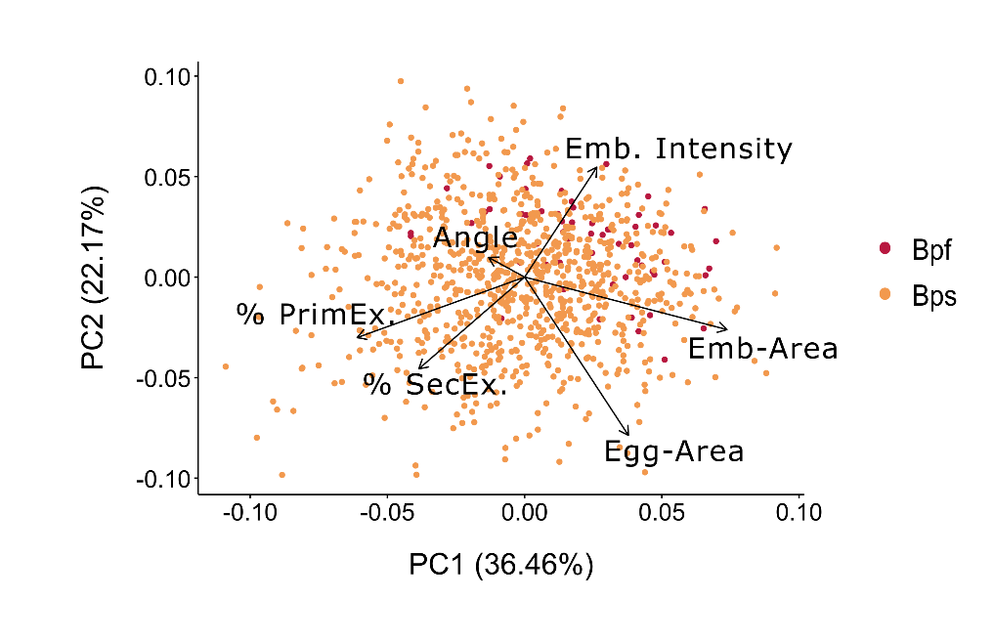
Figure S1. Principal component analysis (PCA) of the six selected biometrical traits: egg area (Egg-Area), embryo area (Emb-Area), mean pixel intensity of the embryo (Emb. Intensity), angle of the main extraembryonic space (Angle), percentage of the primary extraembryonic space (% PrimEx.), and percentage of the secondary extraembryonic space (% SecEx.) for B. plicatilis eggs.
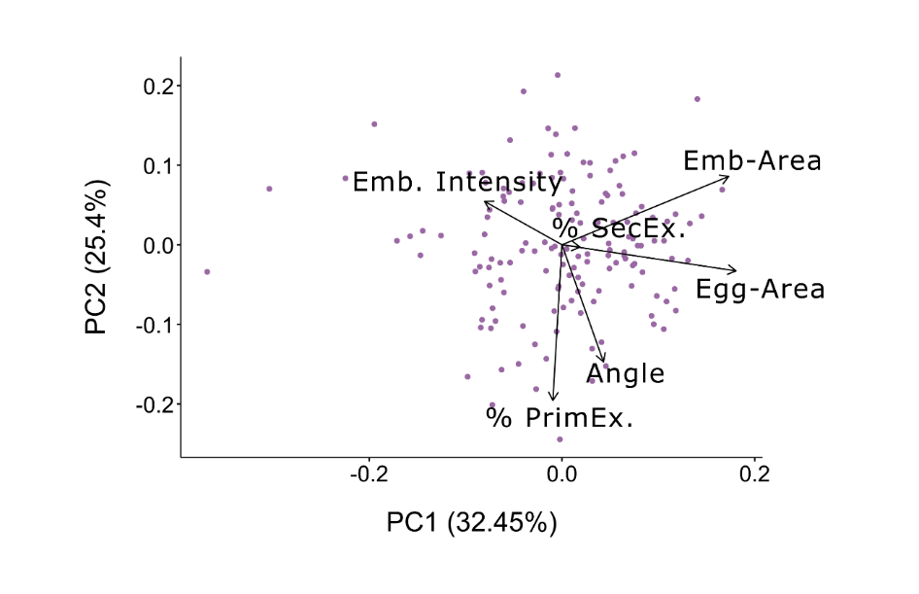
Figure S2. Principal component analysis (PCA) of the six selected biometrical traits: egg area (Egg-Area), embryo area (Emb-Area), mean pixel intensity of the embryo (Emb. Intensity), angle of the main extraembryonic space (Angle), percentage of the primary extraembryonic space (% PrimEx.), and percentage of the secondary extraembryonic space (% SecEx.) for B. rotundiformis eggs.

