Supplementary information
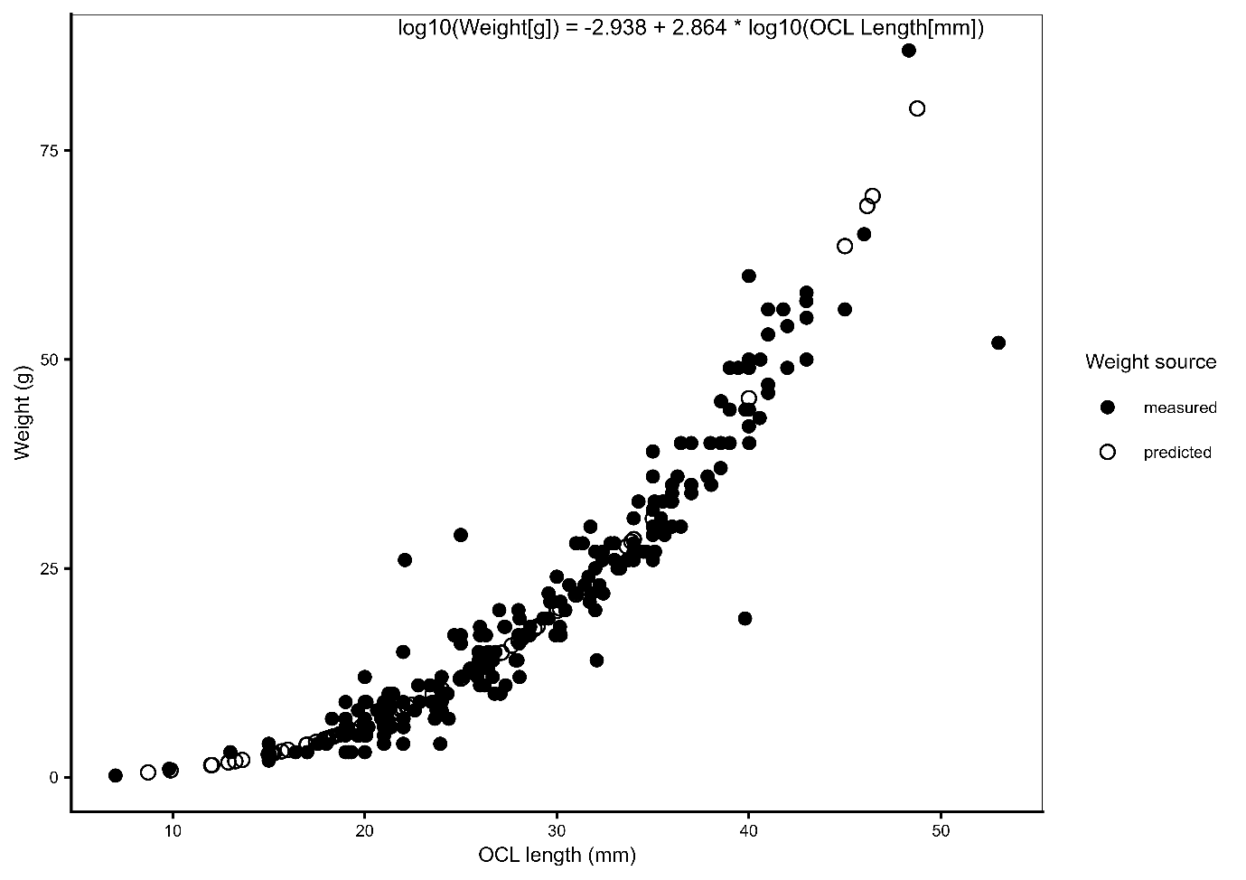
Fig. S1 Length–weight relationship used to estimate missing kōura weights. Observed (measured) and model-predicted body weights are shown in relation to orbital carapace length (OCL). The log₁₀–log₁₀ regression was fitted to individuals with both length and weight measurements (n = 240) and used to estimate missing weights (n = 81). Predicted values were back-transformed using a lognormal bias correction factor. The fitted regression equation is shown on the plot.
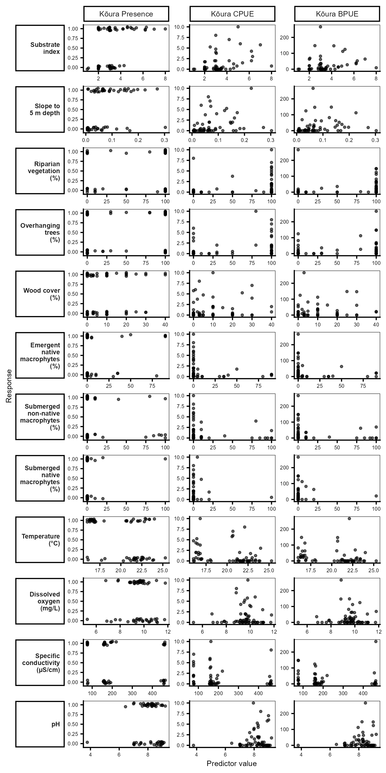
Fig. S2 Raw relationships between all environmental predictors examined and kōura occurrence, CPUE, and BPUE across all 60 surveyed littoral sites. Each panel shows observed values at individual sites (n = 60 for occurrence; n = 33 for CPUE and BPUE). Points are jittered slightly for occurrence data to reduce overplotting. Predictors highlighted in bold were retained in final GAM models.
Table S1 Distribution of environmental and biotic variables measured at littoral sampling sites across five Te Arawa lakes in the Rotorua region of Aotearoa New Zealand.
Lake | Variable | Unit | n | Mean | Median | Min | Max | CI low | CI high
Rotorua | Substrate index |  | 12 | 3.66 | 3.30 | 2.80 | 6.30 | 3.01 | 4.31
Rotoiti | Substrate index |  | 12 | 3.92 | 3.20 | 2.00 | 8.00 | 2.73 | 5.11
Rotoehu | Substrate index |  | 12 | 2.77 | 2.45 | 2.00 | 4.90 | 2.15 | 3.39
Rotomā | Substrate index |  | 12 | 3.50 | 3.03 | 2.00 | 6.20 | 2.64 | 4.36
Ōkāreka | Substrate index |  | 12 | 2.86 | 2.70 | 1.00 | 6.20 | 1.92 | 3.79
All lakes | Substrate index |  | 60 | 3.34 | 3.00 | 1.00 | 8.00 | 2.98 | 3.71
Rotorua | Slope 5m |  | 12 | 0.02 | 0.01 | 0.01 | 0.16 | 0.00 | 0.05
Rotoiti | Slope 5m |  | 12 | 0.09 | 0.07 | 0.04 | 0.30 | 0.04 | 0.14
Rotoehu | Slope 5m |  | 12 | 0.08 | 0.06 | 0.02 | 0.27 | 0.03 | 0.12
Rotomā | Slope 5m |  | 12 | 0.07 | 0.06 | 0.01 | 0.23 | 0.03 | 0.11
Ōkāreka | Slope 5m |  | 12 | 0.11 | 0.13 | 0.01 | 0.20 | 0.07 | 0.15
All lakes | Slope 5m |  | 60 | 0.08 | 0.06 | 0.01 | 0.30 | 0.06 | 0.09
Rotorua | Riparian vegetation | % | 12 | 67.50 | 100.00 | 0.00 | 100.00 | 40.12 | 94.88
Rotoiti | Riparian vegetation | % | 12 | 92.50 | 100.00 | 20.00 | 100.00 | 77.88 | 107.12
Rotoehu | Riparian vegetation | % | 12 | 67.50 | 100.00 | 0.00 | 100.00 | 36.95 | 98.05
Rotomā | Riparian vegetation | % | 12 | 63.33 | 90.00 | 0.00 | 100.00 | 35.13 | 91.53
Ōkāreka | Riparian vegetation | % | 12 | 75.83 | 100.00 | 0.00 | 100.00 | 48.01 | 103.66
All lakes | Riparian vegetation | % | 60 | 73.33 | 100.00 | 0.00 | 100.00 | 62.65 | 84.02
Rotorua | Overhanging trees | % | 12 | 46.67 | 30.00 | 0.00 | 100.00 | 15.50 | 77.83
Rotoiti | Overhanging trees | % | 12 | 54.17 | 65.00 | 0.00 | 100.00 | 23.22 | 85.11
Rotoehu | Overhanging trees | % | 12 | 35.83 | 0.00 | 0.00 | 100.00 | 5.25 | 66.42
Rotomā | Overhanging trees | % | 12 | 52.50 | 55.00 | 0.00 | 100.00 | 22.44 | 82.56
Ōkāreka | Overhanging trees | % | 12 | 52.50 | 65.00 | 0.00 | 100.00 | 21.71 | 83.29
All lakes | Overhanging trees | % | 60 | 48.33 | 30.00 | 0.00 | 100.00 | 36.15 | 60.52
Rotorua | Wood cover | % | 12 | 8.33 | 3.50 | 0.00 | 30.00 | 1.98 | 14.69
Rotoiti | Wood cover | % | 12 | 4.25 | 1.50 | 0.00 | 20.00 | 0.31 | 8.19
Rotoehu | Wood cover | % | 12 | 14.92 | 10.00 | 3.00 | 40.00 | 7.24 | 22.60
Rotomā | Wood cover | % | 12 | 10.00 | 10.00 | 0.00 | 30.00 | 4.13 | 15.87
Ōkāreka | Wood cover | % | 12 | 11.25 | 7.50 | 0.00 | 40.00 | 2.56 | 19.94
All lakes | Wood cover | % | 60 | 9.75 | 5.00 | 0.00 | 40.00 | 6.96 | 12.54
Rotorua | Emergent macrophytes | % | 12 | 0.00 | 0.00 | 0.00 | 0.00 | 0.00 | 0.00
Rotoiti | Emergent macrophytes | % | 12 | 9.50 | 0.00 | 0.00 | 100.00 | -8.71 | 27.71
Rotoehu | Emergent macrophytes | % | 12 | 8.75 | 0.00 | 0.00 | 35.00 | -0.74 | 18.24
Rotomā | Emergent macrophytes | % | 12 | 10.83 | 0.00 | 0.00 | 80.00 | -4.78 | 26.45
Ōkāreka | Emergent macrophytes | % | 12 | 22.50 | 0.00 | 0.00 | 90.00 | -0.35 | 45.35
All lakes | Emergent macrophytes | % | 60 | 10.32 | 0.00 | 0.00 | 100.00 | 3.98 | 16.65
Rotorua | Submerged macrophytes | % | 12 | 0.83 | 0.00 | 0.00 | 10.00 | -1.00 | 2.67
Rotoiti | Submerged macrophytes | % | 12 | 0.83 | 0.00 | 0.00 | 10.00 | -1.00 | 2.67
Rotoehu | Submerged macrophytes | % | 12 | 51.42 | 52.50 | 0.00 | 100.00 | 20.51 | 82.33
Rotomā | Submerged macrophytes | % | 12 | 21.67 | 10.00 | 0.00 | 85.00 | 2.21 | 41.12
Ōkāreka | Submerged macrophytes | % | 12 | 10.83 | 0.00 | 0.00 | 100.00 | -7.43 | 29.10
All lakes | Submerged macrophytes | % | 60 | 17.12 | 0.00 | 0.00 | 100.00 | 8.42 | 25.81
Rotorua | Temperature | °C | 12 | 23.15 | 23.25 | 21.80 | 25.30 | 22.52 | 23.78
Rotoiti | Temperature | °C | 12 | 21.63 | 21.50 | 20.60 | 23.80 | 21.03 | 22.22
Rotoehu | Temperature | °C | 12 | 22.11 | 22.05 | 21.20 | 23.00 | 21.72 | 22.49
Rotomā | Temperature | °C | 12 | 17.02 | 16.85 | 16.30 | 18.10 | 16.64 | 17.39
Ōkāreka | Temperature | °C | 12 | 16.98 | 16.30 | 16.00 | 20.70 | 15.93 | 18.04
All lakes | Temperature | °C | 60 | 20.18 | 21.25 | 16.00 | 25.30 | 19.44 | 20.91
Rotorua | Dissolved oxygen | mg L⁻¹ | 12 | 8.49 | 7.93 | 5.25 | 11.05 | 7.39 | 9.59
Rotoiti | Dissolved oxygen | mg L⁻¹ | 12 | 9.59 | 9.76 | 6.80 | 10.64 | 8.92 | 10.25
Rotoehu | Dissolved oxygen | mg L⁻¹ | 12 | 10.36 | 10.77 | 8.85 | 11.79 | 9.67 | 11.05
Rotomā | Dissolved oxygen | mg L⁻¹ | 12 | 9.72 | 9.76 | 8.66 | 10.31 | 9.45 | 9.98
Ōkāreka | Dissolved oxygen | mg L⁻¹ | 12 | 9.37 | 9.38 | 8.83 | 9.74 | 9.20 | 9.53
All lakes | Dissolved oxygen | mg L⁻¹ | 60 | 9.50 | 9.63 | 5.25 | 11.79 | 9.20 | 9.81
Rotorua | Specific conductivity | µS cm⁻¹ | 12 | 205.36 | 188.27 | 156.20 | 443.01 | 156.39 | 254.33
Rotoiti | Specific conductivity | µS cm⁻¹ | 12 | 163.11 | 158.70 | 155.79 | 196.01 | 156.22 | 170.00
Rotoehu | Specific conductivity | µS cm⁻¹ | 12 | 458.89 | 458.22 | 455.44 | 464.72 | 456.91 | 460.87
Rotomā | Specific conductivity | µS cm⁻¹ | 12 | 162.90 | 161.79 | 156.73 | 174.96 | 159.94 | 165.85
Ōkāreka | Specific conductivity | µS cm⁻¹ | 12 | 76.34 | 76.15 | 75.62 | 78.59 | 75.82 | 76.86
All lakes | Specific conductivity | µS cm⁻¹ | 60 | 213.32 | 162.55 | 75.62 | 464.72 | 178.41 | 248.23
Rotorua | pH |  | 12 | 6.94 | 7.04 | 3.78 | 7.69 | 6.29 | 7.60
Rotoiti | pH |  | 12 | 8.67 | 8.73 | 8.08 | 9.02 | 8.46 | 8.87
Rotoehu | pH |  | 12 | 8.83 | 8.91 | 8.46 | 9.21 | 8.68 | 8.99
Rotomā | pH |  | 12 | 7.80 | 7.92 | 6.44 | 8.56 | 7.47 | 8.13
Ōkāreka | pH |  | 12 | 8.33 | 8.29 | 7.77 | 9.00 | 8.15 | 8.50
All lakes | pH |  | 60 | 8.11 | 8.28 | 3.78 | 9.21 | 7.89 | 8.34
Rotorua | Presence Catfish |  | 12 | 0.08 | 0.00 | 0.00 | 1.00 | -0.10 | 0.27
Rotoiti | Presence Catfish |  | 12 | 0.42 | 0.00 | 0.00 | 1.00 | 0.09 | 0.74
Rotoehu | Presence Catfish |  | 12 | 0.00 | 0.00 | 0.00 | 0.00 | 0.00 | 0.00
Rotomā | Presence Catfish |  | 12 | 0.00 | 0.00 | 0.00 | 0.00 | 0.00 | 0.00
Ōkāreka | Presence Catfish |  | 12 | 0.00 | 0.00 | 0.00 | 0.00 | 0.00 | 0.00
All lakes | Presence Catfish |  | 60 | 0.10 | NA | NA | NA | 0.02 | 0.18
Rotorua | Presence Eel |  | 12 | 0.33 | 0.00 | 0.00 | 1.00 | 0.02 | 0.65
Rotoiti | Presence Eel |  | 12 | 0.08 | 0.00 | 0.00 | 1.00 | -0.10 | 0.27
Rotoehu | Presence Eel |  | 12 | 0.00 | 0.00 | 0.00 | 0.00 | 0.00 | 0.00
Rotomā | Presence Eel |  | 12 | 0.25 | 0.00 | 0.00 | 1.00 | -0.04 | 0.54
Ōkāreka | Presence Eel |  | 12 | 0.00 | 0.00 | 0.00 | 0.00 | 0.00 | 0.00
All lakes | Presence Eel |  | 60 | 0.13 | NA | NA | NA | 0.04 | 0.22
Rotorua | Presence Goldfish |  | 12 | 0.08 | 0.00 | 0.00 | 1.00 | -0.10 | 0.27
Rotoiti | Presence Goldfish |  | 12 | 0.67 | 1.00 | 0.00 | 1.00 | 0.35 | 0.98
Rotoehu | Presence Goldfish |  | 12 | 1.00 | 1.00 | 1.00 | 1.00 | 1.00 | 1.00
Rotomā | Presence Goldfish |  | 12 | 0.50 | 0.50 | 0.00 | 1.00 | 0.17 | 0.83
Ōkāreka | Presence Goldfish |  | 12 | 0.25 | 0.00 | 0.00 | 1.00 | -0.04 | 0.54
All lakes | Presence Goldfish |  | 60 | 0.50 | NA | NA | NA | 0.37 | 0.63
Rotorua | Presence Common smelt |  | 12 | 0.25 | 0.00 | 0.00 | 1.00 | -0.04 | 0.54
Rotoiti | Presence Common smelt |  | 12 | 0.67 | 1.00 | 0.00 | 1.00 | 0.35 | 0.98
Rotoehu | Presence Common smelt |  | 12 | 0.50 | 0.50 | 0.00 | 1.00 | 0.17 | 0.83
Rotomā | Presence Common smelt |  | 12 | 0.42 | 0.00 | 0.00 | 1.00 | 0.09 | 0.74
Ōkāreka | Presence Common smelt |  | 12 | 0.58 | 1.00 | 0.00 | 1.00 | 0.26 | 0.91
All lakes | Presence Common smelt |  | 60 | 0.48 | NA | NA | NA | 0.35 | 0.61
Rotorua | Presence Kōaro |  | 12 | 0.00 | 0.00 | 0.00 | 0.00 | 0.00 | 0.00
Rotoiti | Presence Kōaro |  | 12 | 0.00 | 0.00 | 0.00 | 0.00 | 0.00 | 0.00
Rotoehu | Presence Kōaro |  | 12 | 0.00 | 0.00 | 0.00 | 0.00 | 0.00 | 0.00
Rotomā | Presence Kōaro |  | 12 | 0.00 | 0.00 | 0.00 | 0.00 | 0.00 | 0.00
Ōkāreka | Presence Kōaro |  | 12 | 0.67 | 1.00 | 0.00 | 1.00 | 0.35 | 0.98
All lakes | Presence Kōaro |  | 60 | 0.13 | NA | NA | NA | 0.04 | 0.22
Rotorua | Presence Trout |  | 12 | 0.17 | 0.00 | 0.00 | 1.00 | -0.08 | 0.41
Rotoiti | Presence Trout |  | 12 | 0.17 | 0.00 | 0.00 | 1.00 | -0.08 | 0.41
Rotoehu | Presence Trout |  | 12 | 0.00 | 0.00 | 0.00 | 0.00 | 0.00 | 0.00
Rotomā | Presence Trout |  | 12 | 0.00 | 0.00 | 0.00 | 0.00 | 0.00 | 0.00
Ōkāreka | Presence Trout |  | 12 | 0.17 | 0.00 | 0.00 | 1.00 | -0.08 | 0.41
All lakes | Presence Trout |  | 60 | 0.10 | NA | NA | NA | 0.02 | 0.18

