Supplemental Fig 4:
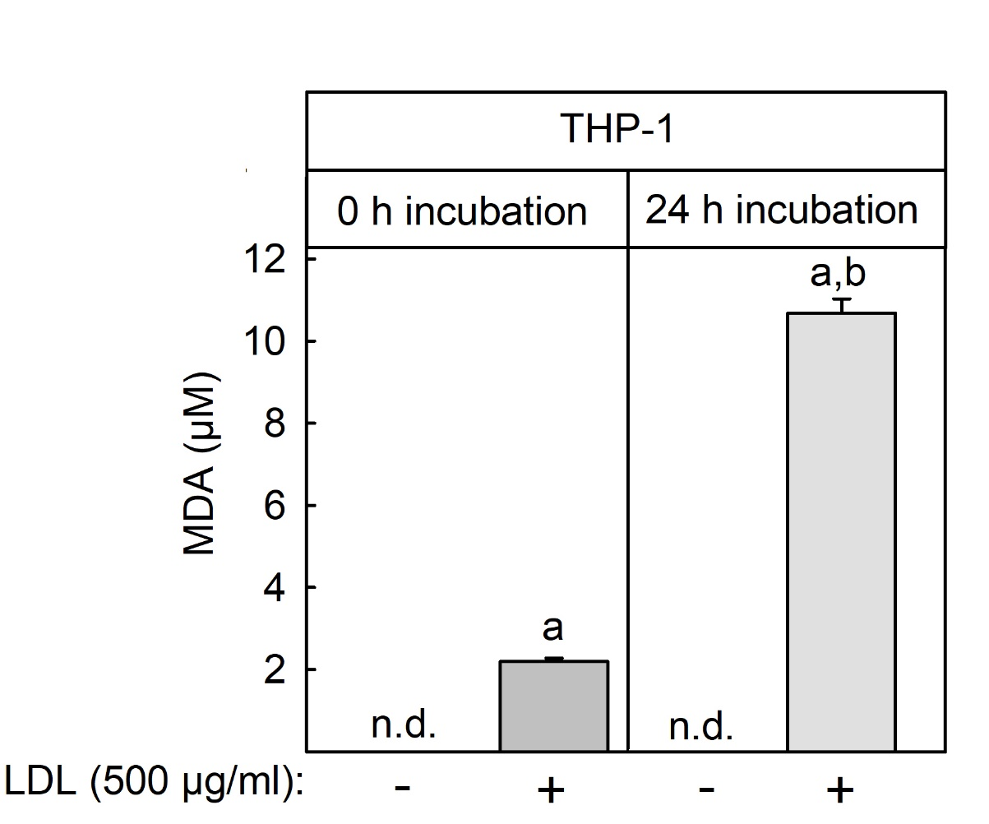
Supplemental Fig. 4: Lipid peroxidation of LDL by THP-1 macrophages. Differentiated THP-1 cells were incubated in culture medium (RPMI 16040 + 0,5% (v/v) FCS) with or without 500 µg/ml native LDL for 0 h or 24 h at 37°C. Malondialdehyde (MDA), as a product of lipid peroxidation, was measured in cell culture supernatants using a commercial TBARS assay kit (Cayman chemicals) according to the manufacturer’s instructions. Data shown are means + S.E.M. of three independent experiments performed in triplicate. Statistics: 2-way ANOVA with Tuckey’s multicomparison test. a: significant > than without LDL, b: significant > 0 h incubation (p < 0.05)

