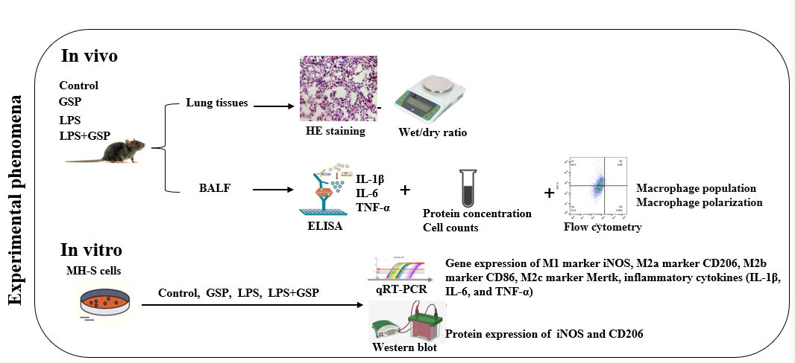

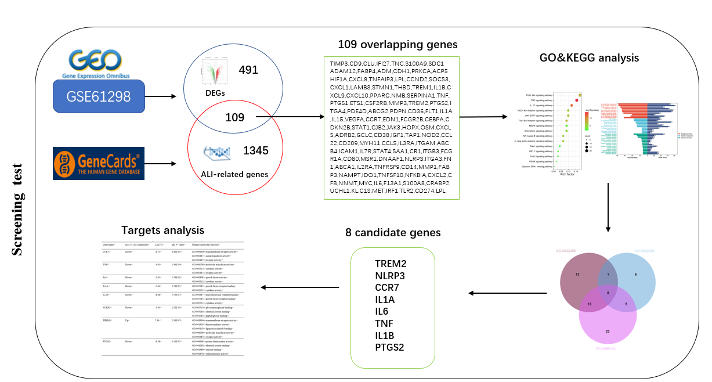

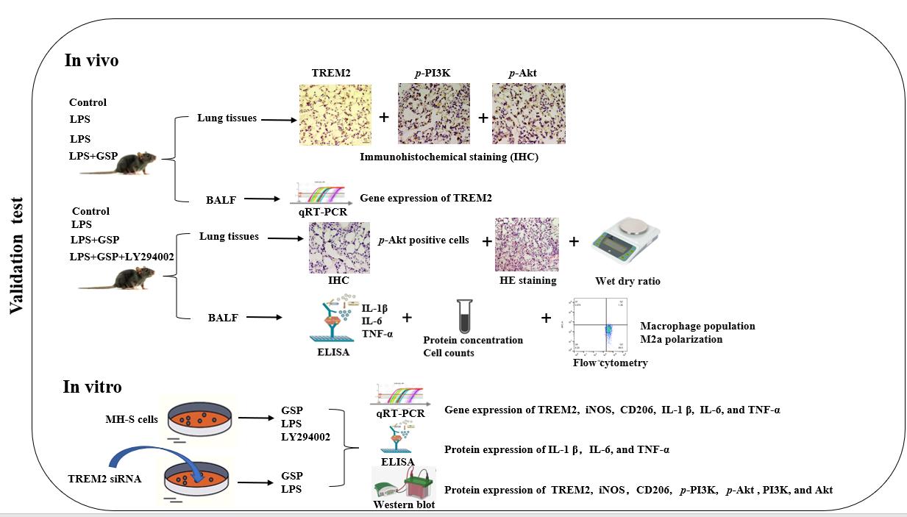

Figure 1. The work-flow of this study.

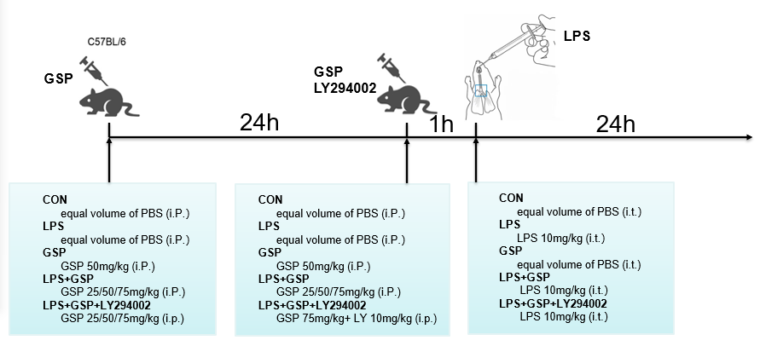
Figure 2. Murine model of LPS‑induced ALI and drug treatment.

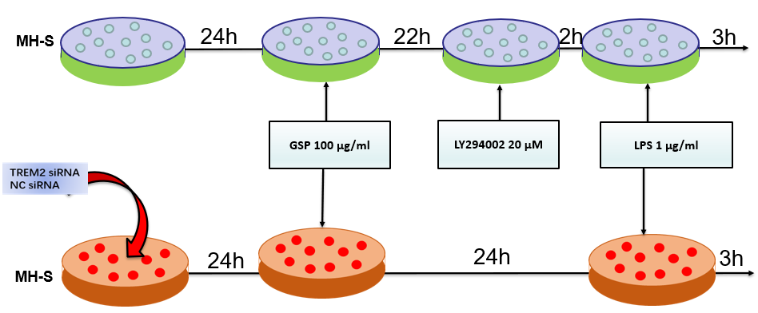
Figure 3. The cell culture and interfering conditions.

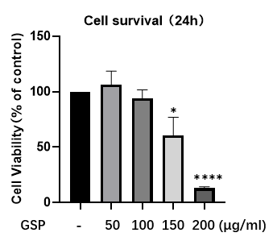
Figure 4. CCK-8 measurement of cell vitality. Cells were treated with different concentrations of GSP for 24 h.
C
B

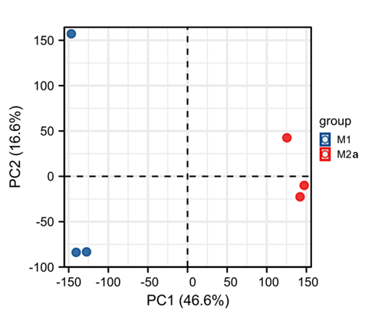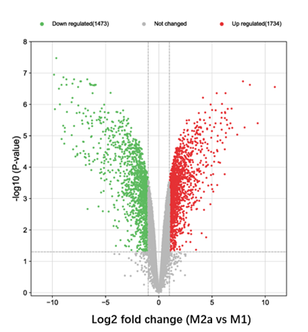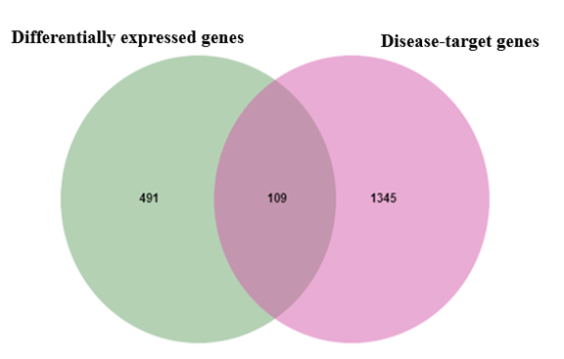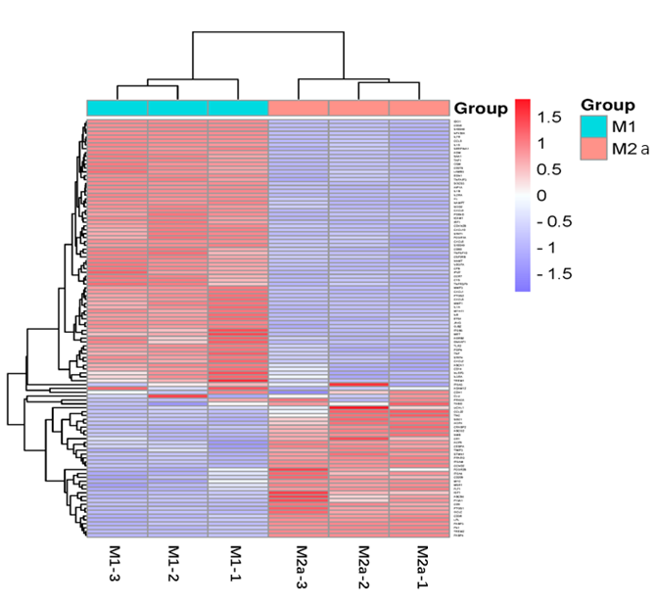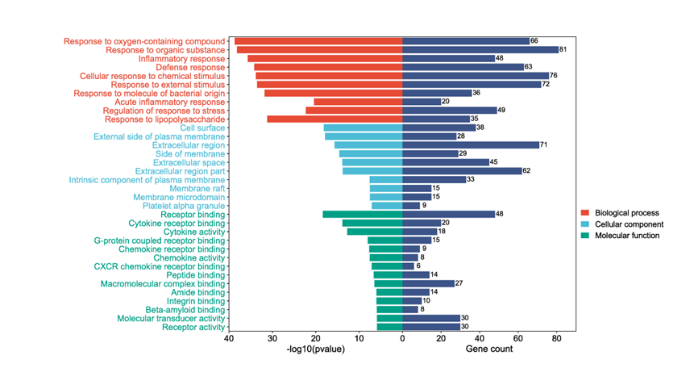
E
D
A

Figure 5. Differentially expressed genes in M2a- and M1-polarized macrophages. (A) Principal component analysis for GSE61298. (B) Volcano map of differential genes. Upregulated genes with significant difference are in red, genes that were not significantly different are in grey, and significant downregulated genes are in green. (C) Venn plot of intersection genes. (D) The heat map of the expression of 109 intersection genes. (E) GO enrichment analysis. GO= Gene Ontology.
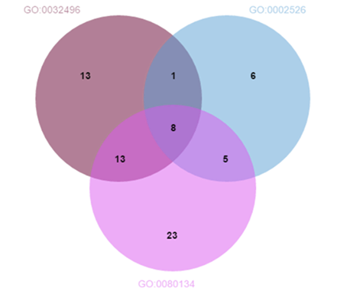
Figure 6. Venn diagram of intersection among ALI-related biological process (A) GO:0032496: response to lipopolysaccharide. (B) GO:0080134：regulation of response to stress. (C) GO:0002526: acute inflammatory response.

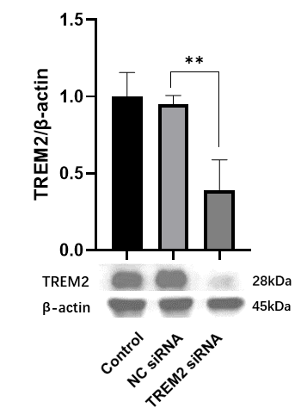
Figure 7. Expression of the TREM2 protein in MH-S cells transfected with 50 nM TREM2 siRNA or negative control (NC) siRNA for 24 h.

A B
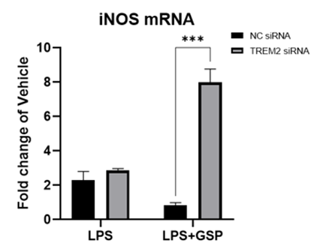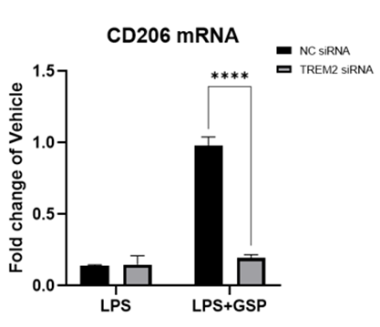

Figure 8. The mRNA expression levels of (A) M1 marker iNOS and (B) M2a marker CD206 after TREM2 knockdown by a siRNA. 24h after siRNA transfection, cells were pretreated with 100 μg/ml GSP for 24 h and then stimulated with 1μg/mL LPS for another 3 h. The results were the means ± SD. ***p < 0.001; ****p<0.0001.
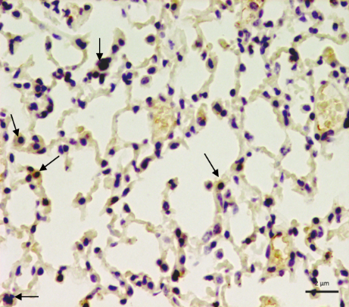
LPS
Control
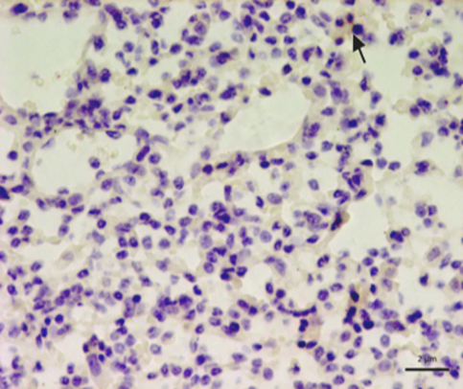
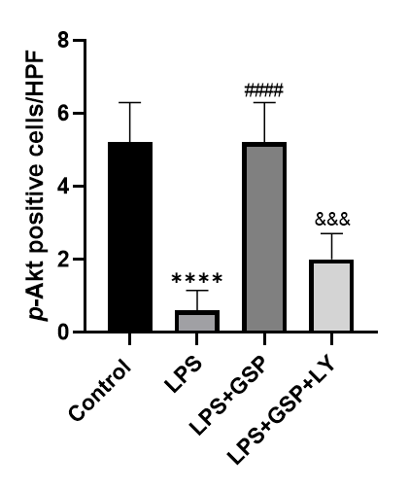

LPS+GSP (75)
LPS+GSP (75) + LY

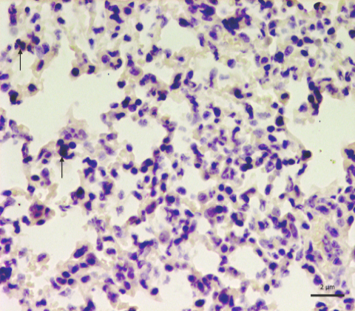
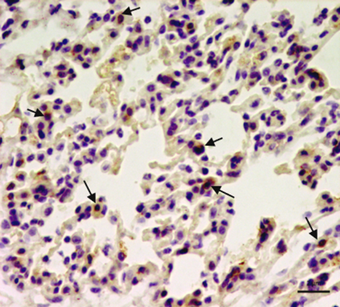

Figure 9. Representative images of p-Akt protein level in lung macrophages determined by immunohistochemistry (magnification 400×, as indicated by the black arrows). n=5.The values represent the means ± SD, ****p < 0.0001 vs. the Control group; ####p < 0.0001 vs. the LPS group; &&&&p < 0.0001 vs. the LPS+GSP group.

Table 1. ALI/ARDS‐related GO terms enriched by the 109 intersection genes.
Ontology | ID | Description | Gene ratio | P‐value | Count
BP | GO:0032496 | response to lipopolysaccharide | 35/109 | 6.30E-32 | 35
BP | GO:0080134 | regulation of response to stress | 49/109 | 4.99E-23 | 49
BP | GO:0002526 | acute inflammatory response | 20/109 | 4.05E-21 | 20

Table 2. The information on intersection genes involved in ALI-related biological process.
Gene name | M2a vs. M1 Expression | Log FC | adj. P. Value | Primary molecular function
CCR7 | Down | -6.55 | 4.48E-05 | GO:0099600~transmembrane receptor activity  GO:0004871~signal transducer activity  GO:0004872~receptor activity
TNF | Down | -4.91 | 2.44E-04 | GO:0060089~molecular transducer activity  GO:0005125~cytokine activity  GO:0004872~receptor activity
IL6 | Down | -2.65 | 1.74E-02 | GO:0008083~growth factor activity  GO:0005125~cytokine activity
IL1A | Down | -7.64 | 3.78E-05 | GO:0070851~growth factor receptor binding  GO:0005125~cytokine activity
IL1B | Down | -8.68 | 1.59E-07 | GO:0044877~macromolecular complex binding  GO:0070851~growth factor receptor binding  GO:0005125~cytokine activity
NLRP3 | Down | -3.84 | 2.28E-03 | GO:0005539~glycosaminoglycan binding  GO:0042802~identical protein binding  GO:0042834~peptidoglycan binding
TREM2 | Up | 7.91 | 2.38E-07 | GO:0099600~transmembrane receptor activity  GO:0019207~kinase regulator activity  GO:0001530~lipopolysaccharide binding  GO:0060089~molecular transducer activity  GO:0004872~receptor activity
PTGS2 | Down | -9.38 | 3.16E-07 | GO:0046983~protein dimerization activity  GO:0042802~identical protein binding  GO:0019899~enzyme binding  GO:0016702~oxidoreductase activity

