Table S1. RT-qPCR Primer Sequences
Gene | Sequence (5’-3’)
TRAF6(human) | Forward: TTGGCCCAGGCTGTTCATAG
 | Reverse: CAAGGCGACCCTCTAACTGG
TAK1(human) | Forward: AGTCATCCATGGACCCCTGA
 | Reverse: ATCCTGGTCCAGTTCTGCAA
GAPDH(human) | Forward: GGCTGTTGTCATACTTCTCATGG
 | Reverse: GGAGCGAGATCCCTCCAAAAT
Caspase-1(human) | Forward: CATCCCACAATGGGCTCTGT
 | Reverse: GCATCTGCGCTCTACCATCT
GSDMD（human） | Forward: GGCCCAGCTGGTTATTGACT
 | Reverse: TCAGGAAGTTGTGGAGGCAC
GSDMD(Rat) | Forward: GCTCGACTCTGGAGAACTGG
 | Reverse: CCAAGACGTGCTTCACCAAC
TAK1(Rat) | Forward: AACCGCTTCATTTGGCAACA
 | Reverse: GGCTTCTCTGAGGTTGGTCC
GAPDH(Rat) | Forward: GCGAGATCCCGCTAACATCA
 | Reverse: CTCGTGGTTCACACCCATCA
Caspase-1(Rat) | Forward: GACCGAGTGGTTCCCTCAAG
 | Reverse: GACGTGTACGAGTGGGTGTT
TRAF6 (Rat) | Forward: TGCTTGATGGCTTTACGGGA
 | Reverse: TTGGACACTTTACCGTCAGGG
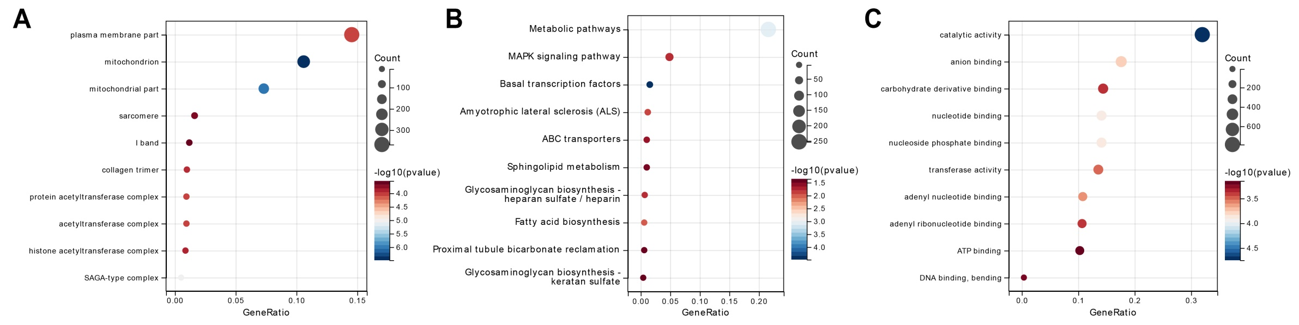
Figure S1. GO Enrichment Analysis of Differentially Expressed Genes in PMN
Note: (A) BP results of GO enrichment analysis of differentially expressed genes; (B) CC results of GO enrichment analysis of differentially expressed genes; (C) MF results of GO enrichment analysis of differentially expressed genes.

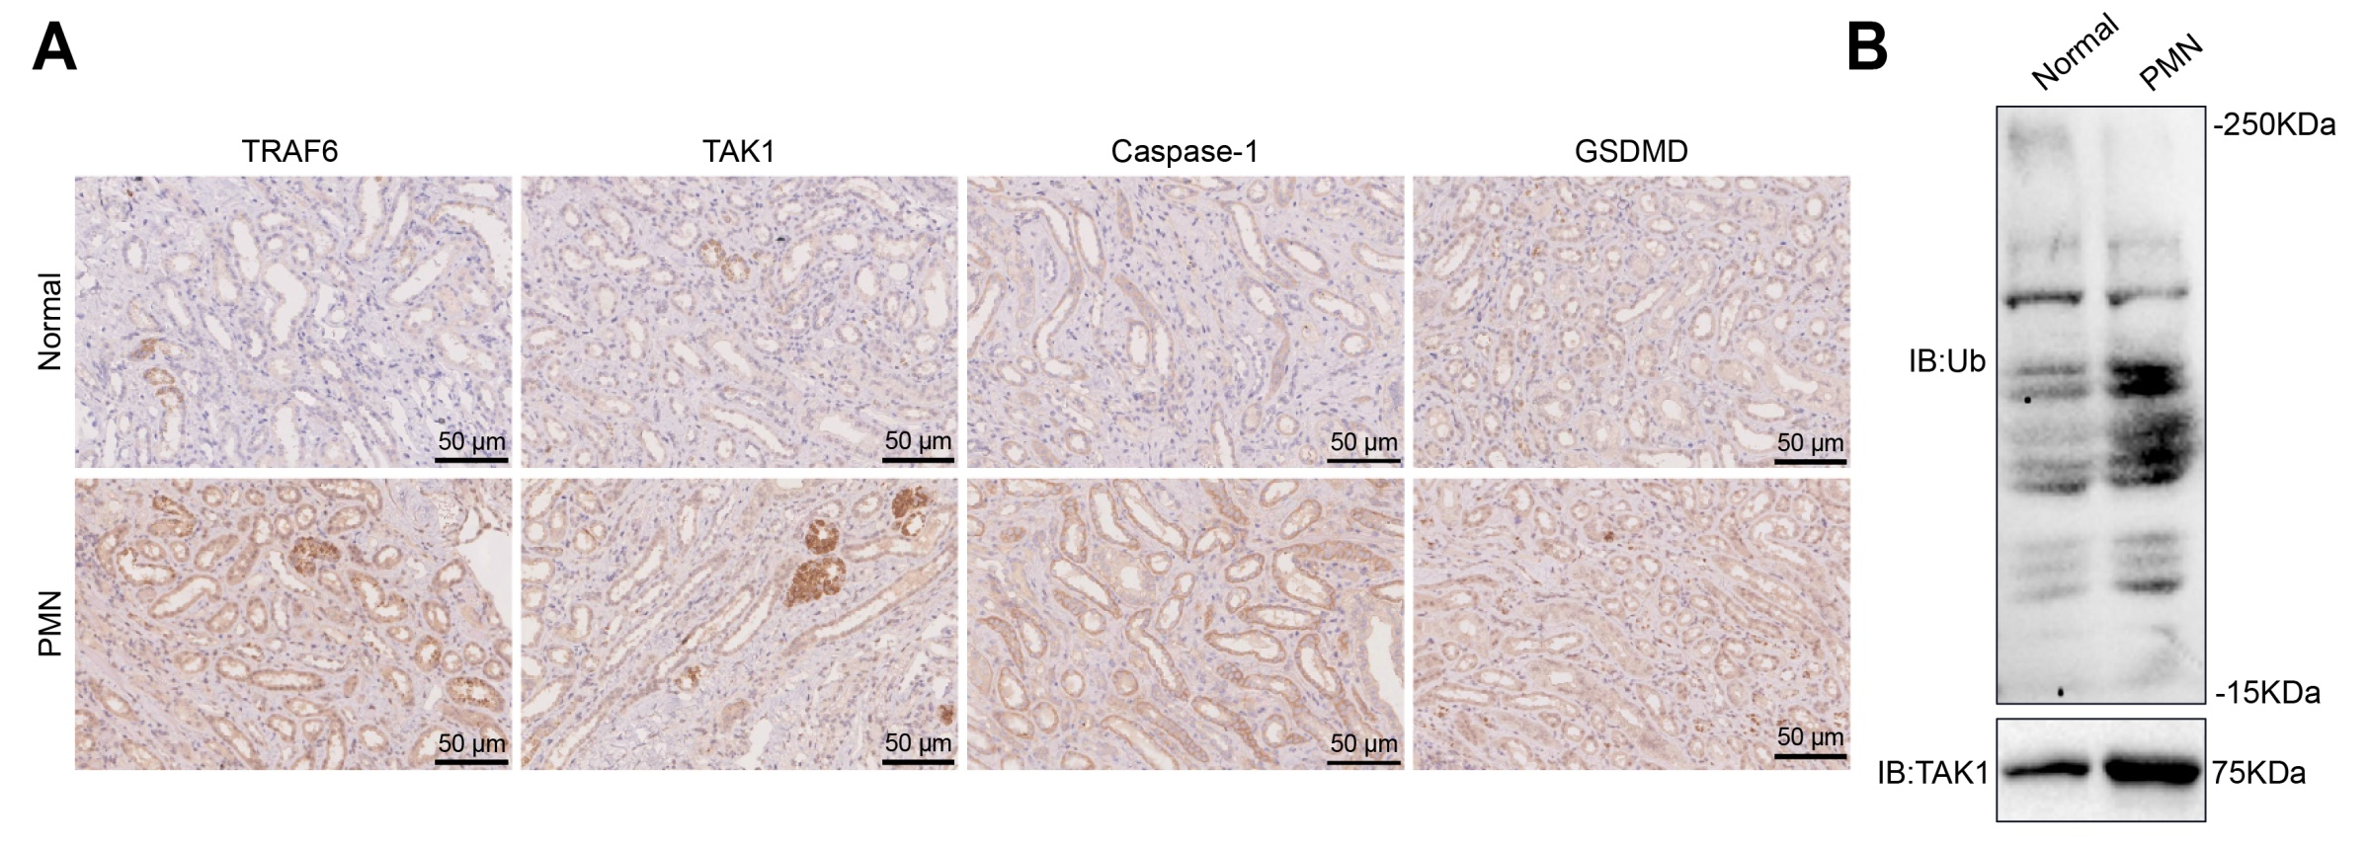
Figure S2. Expression Analysis of the TRAF6/TAK1 Signaling Axis and Associated Pyroptosis in PMN Patients
Note: (A) Immunohistochemistry analysis of TRAF6, TAK1, Caspase-1, and GSDMD protein expression in kidney tissues from PMN patients and healthy controls. (B) Western blot analysis of TRAF6 ubiquitination in kidney tissues from PMN patients and healthy controls. Scale bar = 50 μm. Experiments were repeated three times.

