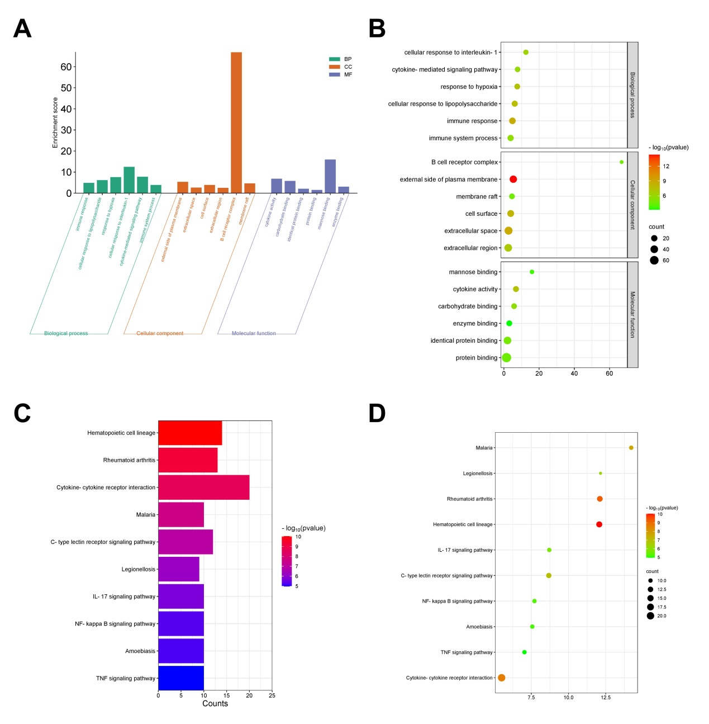
Supplementary figure 1 The top six of the Gene Ontology (GO) annotations and top ten Kyoto Encyclopedia of Genes and Genomes (KEGG) significant results for common DEGs. A-B. Bar and bubble plots for GO annotation analysis, including biological process (BP), cellular component (CC), and molecular function (MF). C-D. Bar and bubble plots for KEGG pathway enrichment analysis.
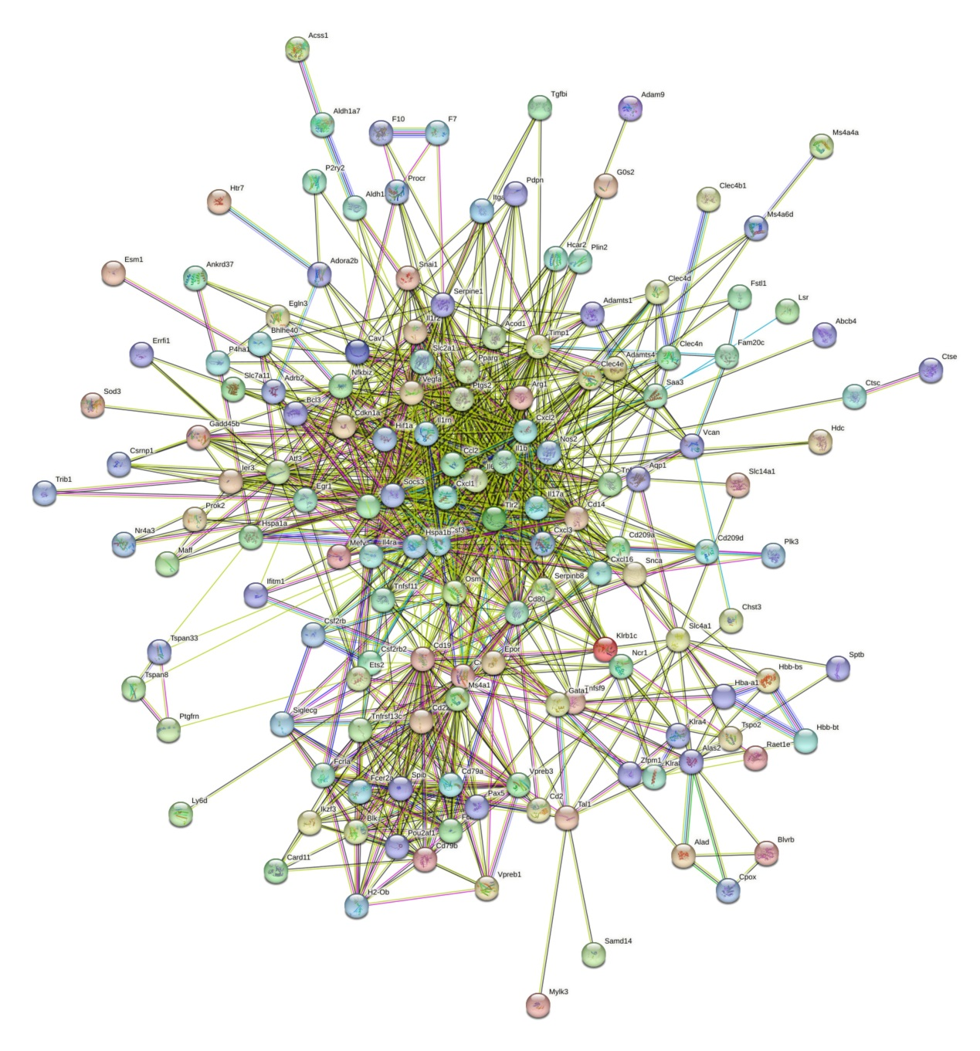
Supplementary figure 2 The PPI network showed the interactions among the common DEGs.
Supplementary figure 3 Receiver operating characteristic (ROC) curves for hub genes based on the GSE166522 and GSE227521 datasets.
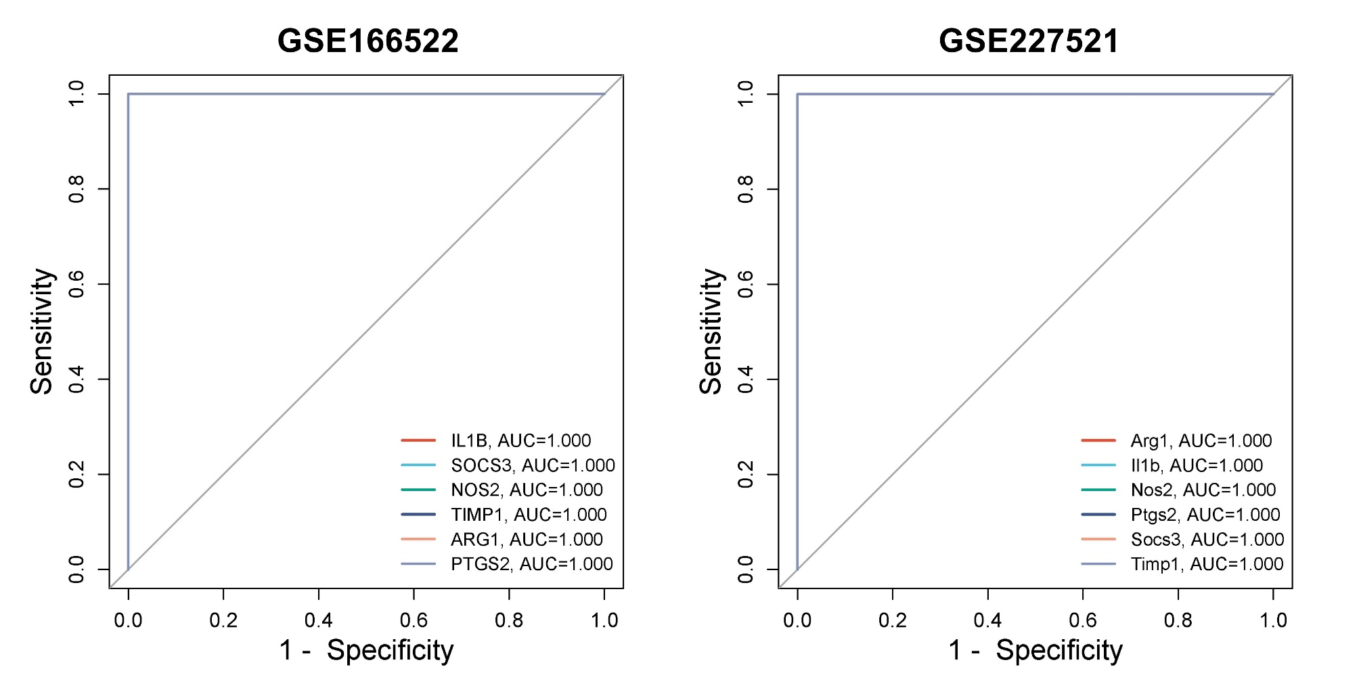

Supplementary table 1 Sequences of RT-qPCR primers
Primer name | Sequence (5'-3')
GAPDH-F | TTGCAGTGGCAAAGTGGAGA
GAPDH-R | ACTGTGCCGTTGAATTTGCC
ARG1-F | CTGGGAGCCACCTGTTACTG
ARG1-R | CGGCTGTGCATCATACAACG
TIMP1-F | TTGCAGTGGCAAAGTGGAGA
TIMP1-R | ACTGTGCCGTTGAATTTGCC
NOS2-F | GTAGCTGAGGAGCCCAACTC
NOS2-R | ACACACAACCACCCCTTCAG
PTGS2-F | CTGGGAGCCACCTGTTACTG
PTGS2-R | CGGCTGTGCATCATACAACG
SOCS3-F | AGGGACCCCCTCCTTTTCTT
SOCS3 -R | ACTGATCCAGGAACTCCCGA
IL1B -F | AGAGCCCATCCTCTGTGACT
IL1B -R | GCTTGGGATCCACACTCTCC

