Activation of human FPR2 with AT-RvD1 Resolves Acute Sialadenitis in Vivo Kihoon Nam^{1,3}, Harim Tavares dos Santos⁸, Frank M. Maslow^{1,3}, Daniel J. Davis⁴,
Tabitha LI. Galloway¹, Laura M. Dooley¹, Patrick T. Tassone¹, Robert P. Zitsch III¹, Bryan G. Trump⁵, Venkata Yellepeddi^{6,7} and Olga J. Baker^{1,2,3*}
¹Department of Otolaryngology-Head and Neck Surgery, University of Missouri, Columbia, MO, USA, ²Department of Biochemistry, University of Missouri, Columbia, MO, USA, ³Christopher S. Bond Life Sciences Center, University of Missouri, Columbia, MO, USA, ⁴Animal Modeling Core, University of Missouri, Columbia, MO, USA, ⁵School of Dentistry University of Utah, Salt Lake City UT, USA, ⁶Division of Clinical Pharmacology, Department of Pediatrics, School of Medicine University of Utah, Salt Lake City UT, United States, ⁷Department of Molecular Pharmaceutics, College of Pharmacy, University of Utah, Salt Lake City, UT, USA, ⁸School of Dental Medicine, Department of Oral Biology, University at Buffalo, The State University of New York, Buffalo NY, USA.

*To whom correspondence should be addressed:
Olga J. Baker DDS., PhD.
Department of Otolaryngology-Head and Neck Surgery
Department of Biochemistry
University of Missouri
540B Christopher S. Bond Life Sciences Center
1201 Rollins Street
Columbia, Missouri 65211-7310
Email: bakero@health.missouri.edu
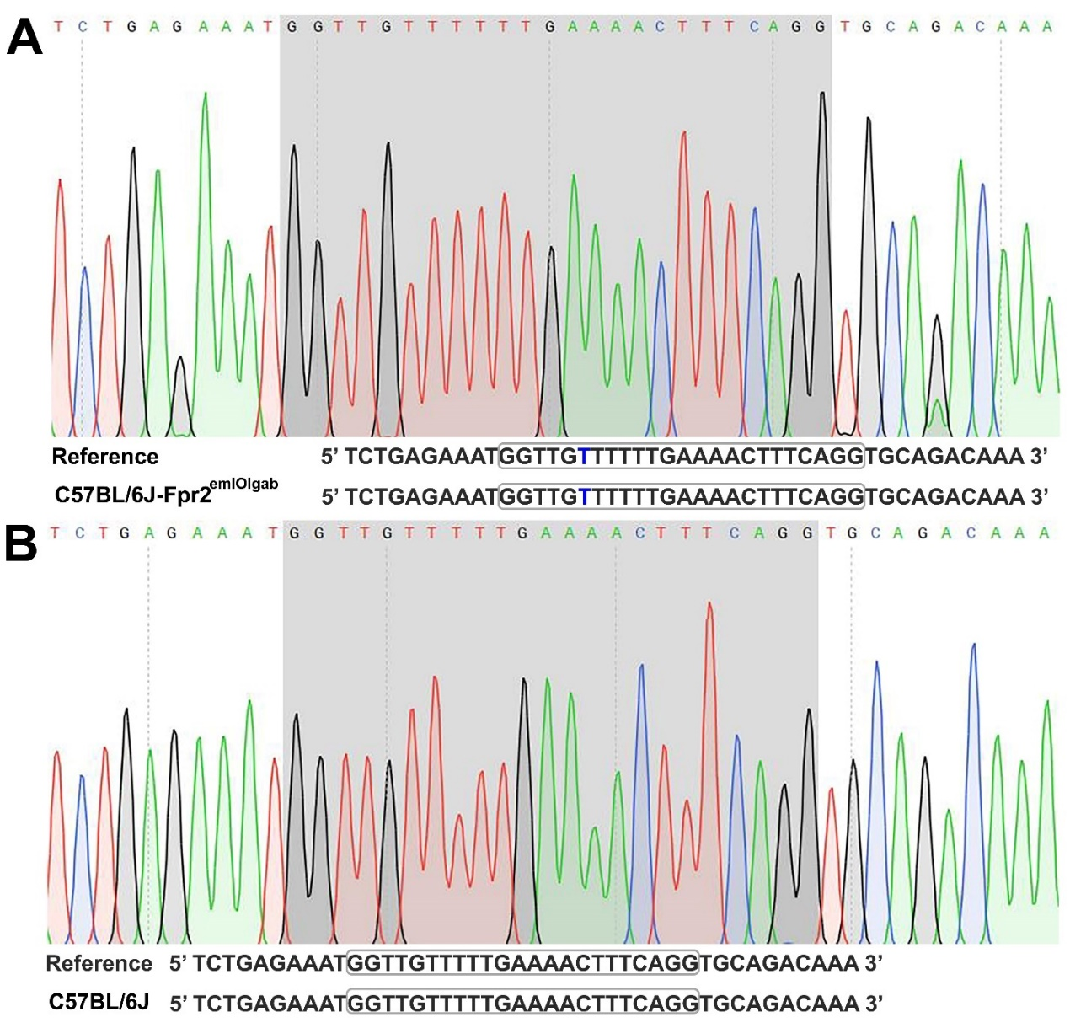
Supplementary Figure 1. Sanger sequencing confirms no off-target mutations in the human FPR2 mouse model. The chromatogram shows the Sanger sequencing results of the predicted off-target site located at Chr17:17920234 in the hFPR2 mouse model (A). This analysis was conducted to verify the presence of any unintended mutations at this off-target site. The boxed region indicates the predicted sgRNA binding site, and the reference sequence is indicated as C57BL/6J genomic DNA. Blue highlights bulging base pairs compared to the sgRNA sequence (DNA bulge). Alignment shows no sequence mutations when compared to the C57BL/6 reference genome. For comparison, the chromatogram shows on-target sequencing results from a wild-type C57BL/6J sample. The sequence is aligned to the same region, and no mutations are observed (B).

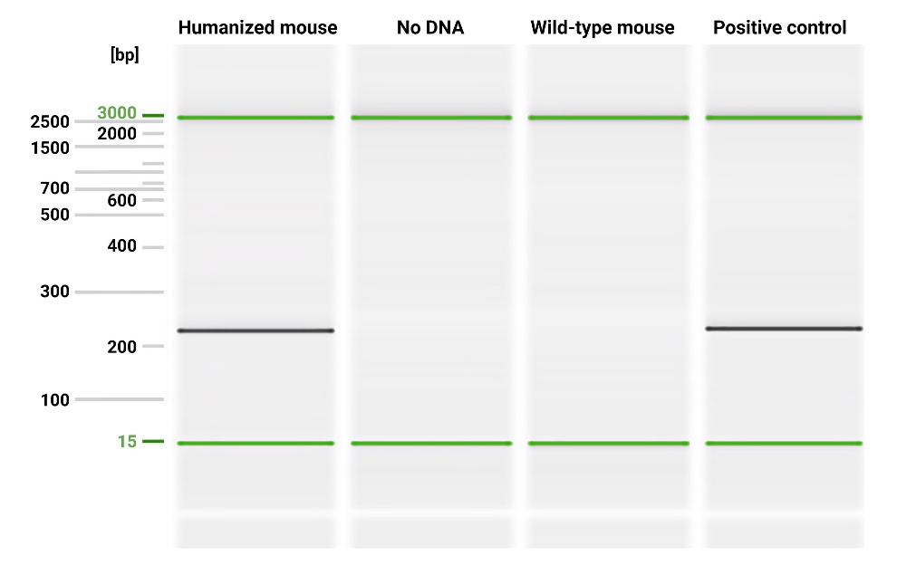
Supplementary Figure 2. PCR genotyping of humanized hFPR2 knock-in mice. The insertion of the hFPR2 gene in humanized mice was verified by PCR using genomic DNA isolated from tail biopsy samples collected at 3 weeks of age. PCR was performed using the following primers: forward primer 5’-GCTATGCTACCCCAGAAAGG-3’ and reverse primer 5’-GCAGAACAGTGTAGCCAGCA-3’. Note that the positive control is DNA from the sequence-verified founder animal carrying the correct knock-in allele.

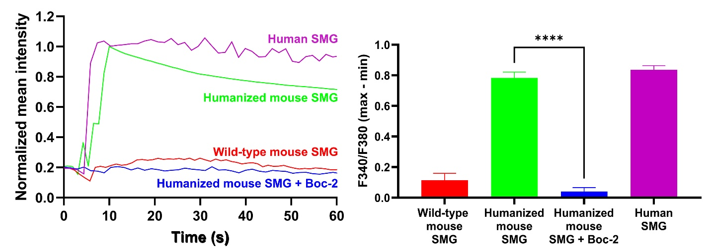
Supplementary Figure 3. MMK-1-induced calcium signaling confirms functional hFPR2 expression in humanized mice. To determine hFPR2 activity, freshly isolated SMG cells were stimulated with MMK-1 and changes in intracellular [Ca²⁺]_{i} were measured using a Leica STELLARIS 5 confocal microscope. Note that the FPR2-selective agonist MMK-1 effectively increased [Ca²⁺]_{i} in SMG cells from humanized mouse (green) and human SMG cells (purple), whereas no response to MMK-1 was observed in SMG cells from C57BL/6J mice (red) or in SMG cells from hFPR2 mice treated with the FPR2 antagonist Boc-2 (blue). Data are presented as the mean ± SD from a total of four experiments. Statistical significance was assessed by one-way ANOVA (where *p ≤ 0.05 was considered statistically significant) followed by Tukey’s post-hoc test.

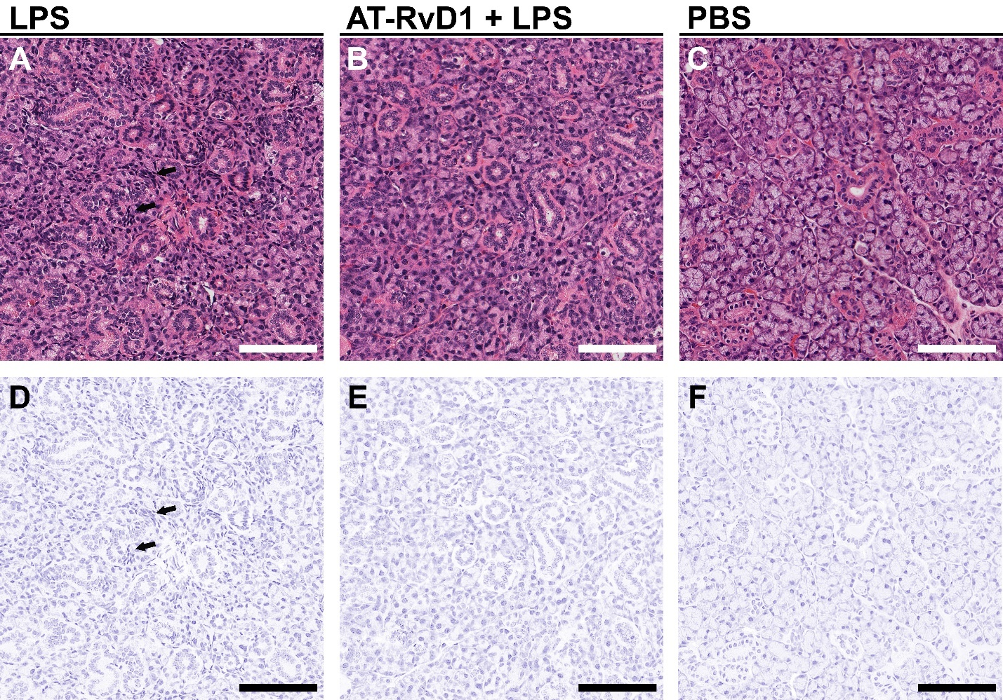
Supplementary Figure 4. AT-RvD1 restores morphology in SMG from mFpr2 mice treated with LPS. Rehydrated SMG tissue sections from wild-type mice treated with LPS (A, D), AT-RvD1 + LPS (B, E) and PBS (C, F) were stained with hematoxylin-eosin and images captured using a Leica DMI6000B and analyzed using QuPath 0.4.3. Results showed that SMG treated with LPS displayed loss of epithelial integrity with areas of acinar shrinkage (black arrows). In contrast, SMG that were treated with AT-RvD1 + LPS showed restoration of tissue architecture and a decrease of acinar shrinkage comparable to PBS-treated healthy controls. Samples were examined using a Leica STELLARIS 5 confocal microscope and analyzed using QuPath 0.4.3. Representative image from a total of 4 mice per group. Scale bars are 100 μm.
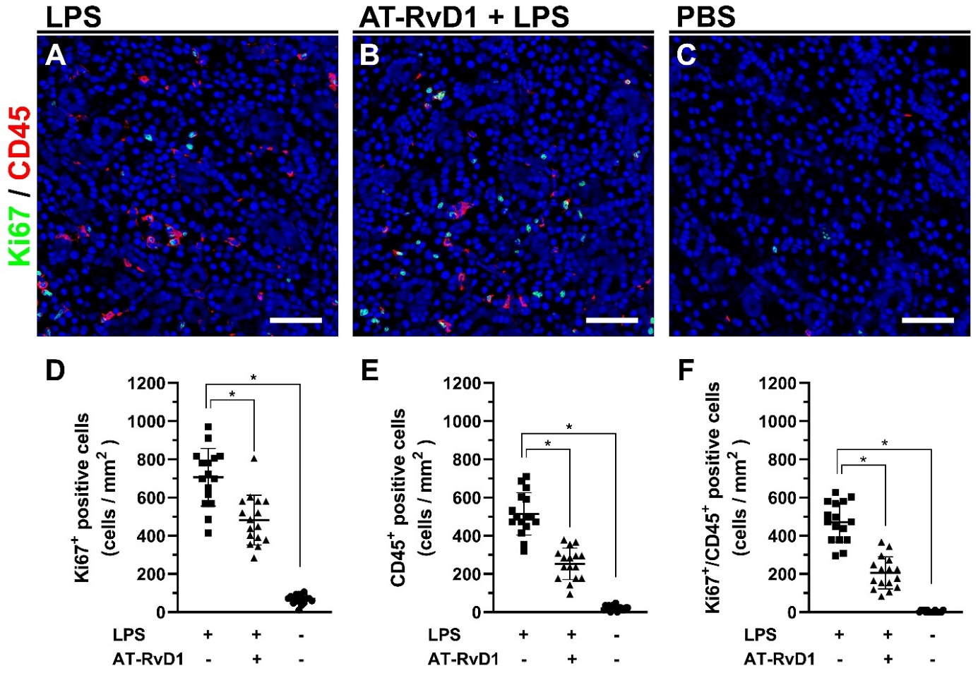
Supplementary Figure 5. AT-RvD1 reduces proliferating inflammatory cells in SMG from mFpr2 mice treated with LPS. SMG tissue sections from C57BL/6J mice treated with LPS (A), AT-RvD1 + LPS (B) and PBS (C) were analyzed using confocal microscopy with rabbit anti-Ki67 (green) and mouse anti-CD45 (red) antibodies, and counterstained with DAPI (blue). Our results show that SMG treated with LPS displayed an increased number of proliferating cells (D), CD45⁺ cells (E), and proliferating CD45⁺ cells (F). In contrast, SMG treated with AT-RvD1 + LPS showed a significant reduction in proliferating cells (D), CD45⁺ cells (E), and proliferating CD45⁺ cells (F). Samples were examined using a Leica STELLARIS 5 confocal microscope equipped with an artificial intelligence-guided image analysis software (AIVIA). Representative image from a total of 4 mice per group in quadruples. Statistical significance was assessed by one-way ANOVA (where *p ≤ 0.05 is considered statistically significant) followed by Dunnett's post-hoc test for multiple comparisons (D-F). Scale bars represent 50 μm.
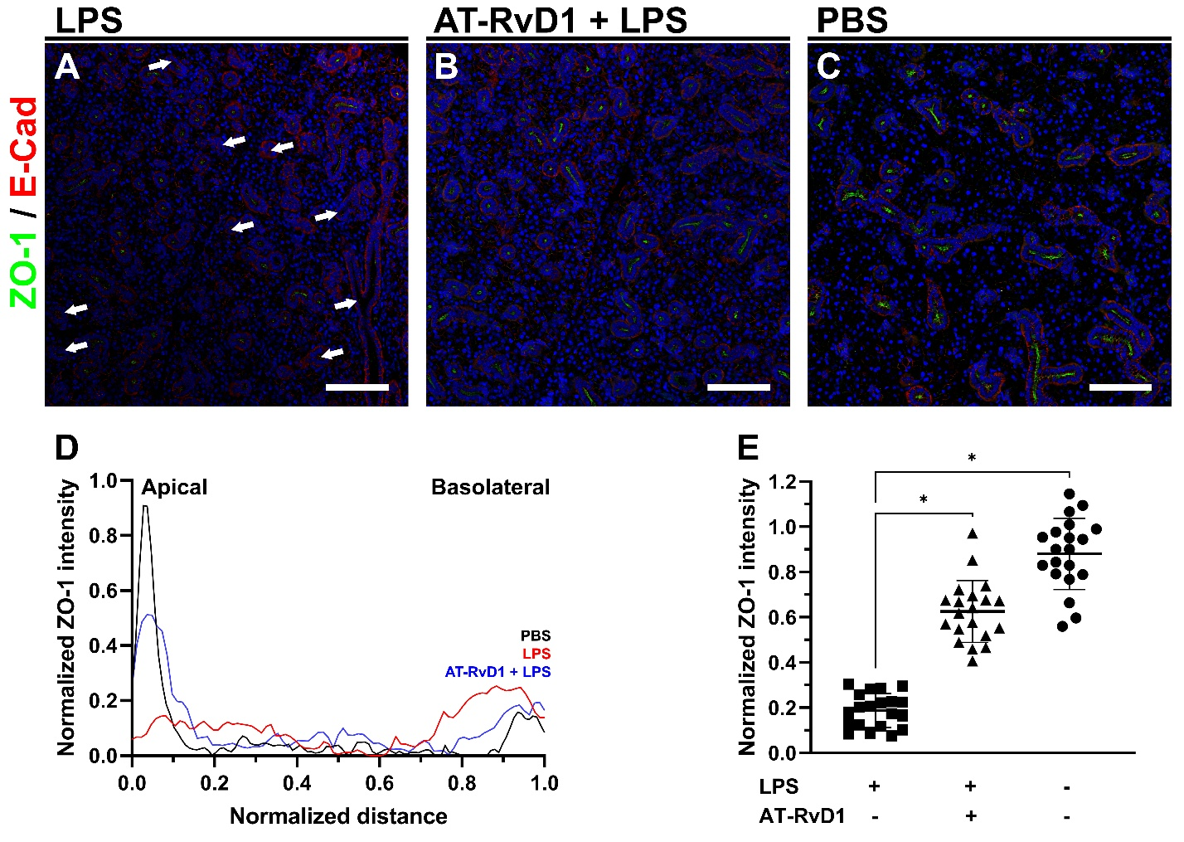
Supplementary Figure 6. AT-RvD1 restores epithelial polarization in SMG from mFpr2 mice treated with LPS. SMG tissue sections from wild-type mice treated with LPS (A, D; red line), AT-RvD1 + LPS (B, D; blue line) and PBS (C, D; black line) were analyzed using confocal microscopy with rabbit anti-ZO-1 (green) and mouse anti-E-cadherin (red) antibodies, and counterstained with DAPI (blue). Our results show that SMG that were treated with LPS displayed a local reduction in ZO-1 expression as indicated by decreased intensity in some areas (white arrows). (D) In contrast, SMG treated with AT-RvD1 + LPS showed a significant increase in ZO-1 expression and restored epithelial polarization comparable to PBS-treated healthy controls. Samples were examined using a Leica STELLARIS 5 confocal microscope and analyzed using image J. Representative image from a total of 4 mice per group in quadruples. Scale bars are 100 μm.
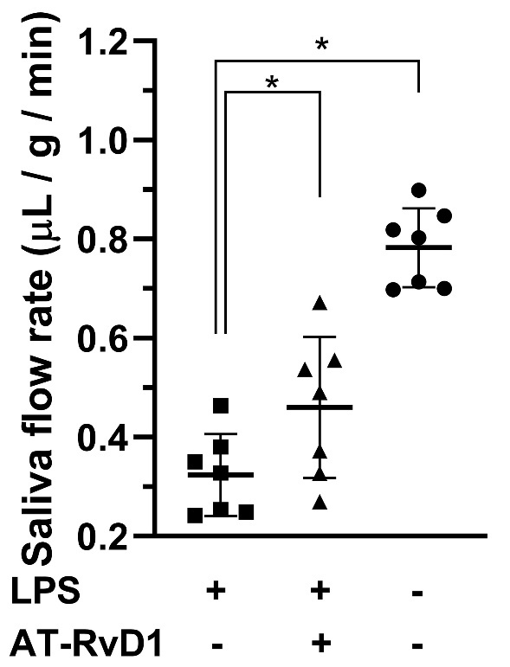
Supplementary Figure 7. AT-RvD1 restores saliva secretion in mFpr2 mice treated with LPS. Mice were anesthetized and stimulated with pilocarpine. Then, saliva was collected for 20 minutes. Data represent the means ± SD of n = 7 mice per condition and statistical significance was assessed by one-way ANOVA (where *p ≤ 0.05 is considered statistically significant) followed by Dunnett's post-hoc test for multiple comparisons. The saliva flow rate from C57BL/6J mice treated with LPS was significantly reduced. In contrast, mice treated with AT-RvD1 + LPS showed a significant increase in saliva flow rate compared to those treated with LPS alone.
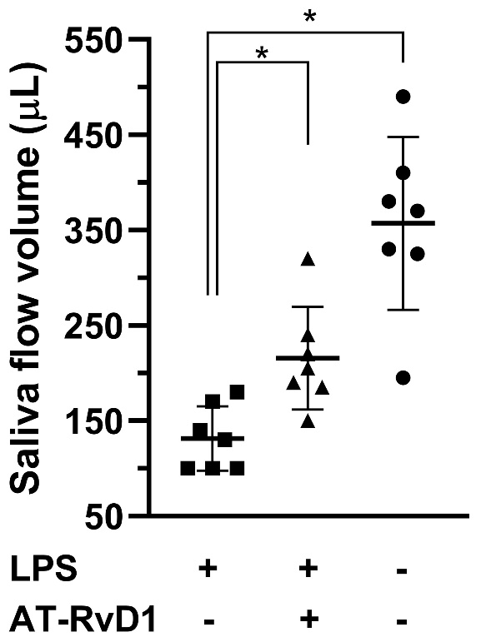
Supplementary Figure 8. AT-RvD1 restores saliva secretion in hFPR2 mice treated with LPS. Mice were anesthetized and stimulated with pilocarpine. Then, saliva was collected for 20 minutes. Data represent the means ± SD of n = 7 mice per condition and statistical significance was assessed by one-way ANOVA (where *p ≤ 0.05 is considered statistically significant) followed by Dunnett's post-hoc test for multiple comparisons. The saliva volume from hFPR2 mice treated with LPS was significantly reduced. In contrast, mice treated with AT-RvD1 + LPS showed a significant increase in saliva volume compared to those treated with LPS alone.
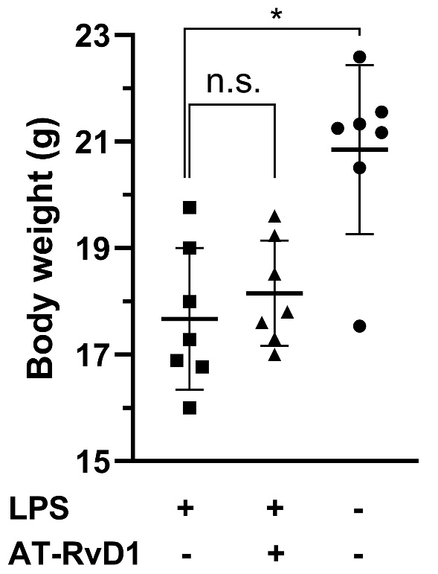
Supplementary Figure 9. Body weight of hFPR2 mice. Data represent the means ± SD of n = 7 mice per condition and statistical significance was assessed by one-way ANOVA (where *p ≤ 0.05 is considered statistically significant) followed by Dunnett's post-hoc test for multiple comparisons to the LPS treated group. * = significant difference from the LPS treated group; n.s. = no significant difference from the LPS treated group. The weight from hFPR2 mice treated with LPS was significantly reduced when compared to PBS-treated healthy controls.

