Fig1 B GPR40 β-actin

Fig 4 A NLRP3 Fig 4 A GAPDH

Fig 4 A Caspase-1 Fig 4 A GAPDH
Fig 5 B GPR40 β-actin

Fig 6 A Caspase-1 GAPDH

Fig 6 A NLRP3 GAPDH

Fig8 -A p-ERK GAPDH

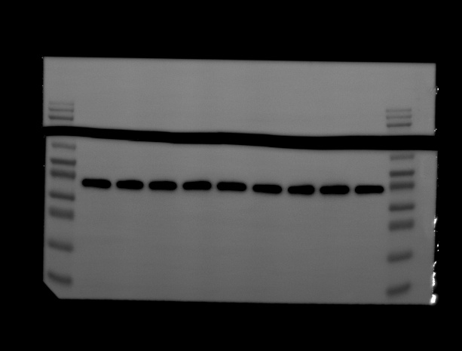
Fig8 -A ERK GAPDH

Fig8 -D p-ERK GAPDH

Fig8 -D ERK GAPDH

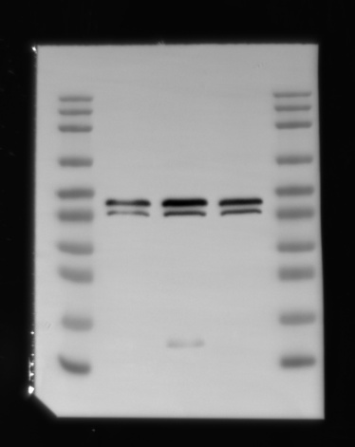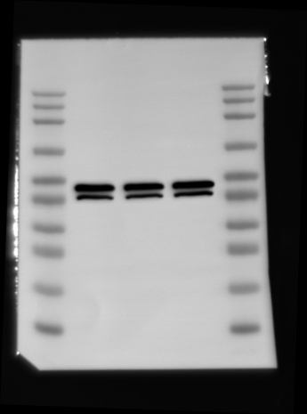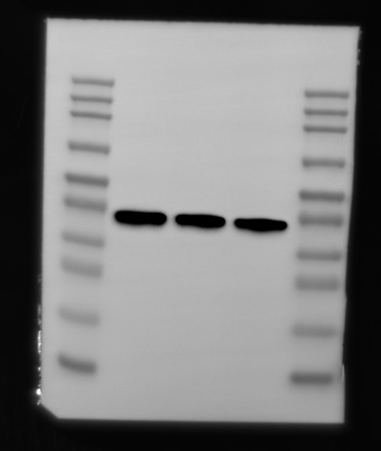
Fig8 -H p-ERK ERK GAPDH

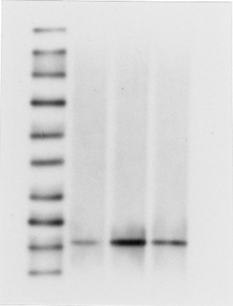
Fig 4 D Cleaved Casepace-1 Fig 4 D GAPDH

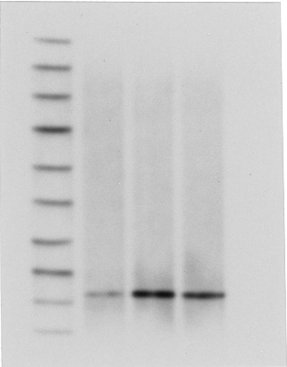
Fig 6 D Cleaved Caspace-1 GAPDH

