Supplementary Fig.1 Expression levels of MIF pathway-related proteins in different cells of CKD and control kidneys. The expression of MIF(a), CD74(b), CXCR4 (c) in T cell populations within CKD kidneys was significantly elevated.
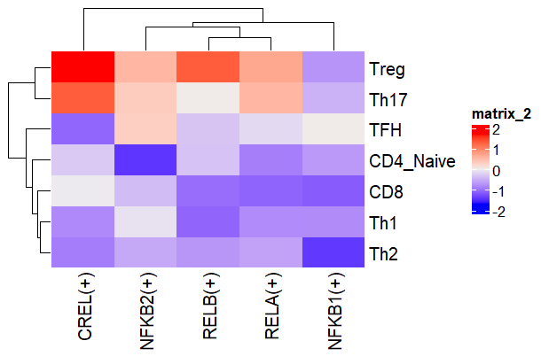
Supplementary Fig.2 Heatmap of upstream transcription factors regulating immune cell alterations in CKD.

Supplementary Fig.3 Integrated single-cell RNA sequencing analysis of renal tissues from unilateral ureteral obstruction (UUO) model mice. (a, d) Cell clustering and annotation; (b, e) Refined subclustering and cell type identification. (c, f) Schematic workflow of iterative clustering and annotation. (g) KEGG pathway enrichment of highly variable genes across distinct cell populations. (h) Reactome-based signaling pathway association analysis. (i) Intercellular communication network via ligand-receptor interactions. (j) Pseudotime trajectory reconstruction depicting cellular state transitions during UUO progression.

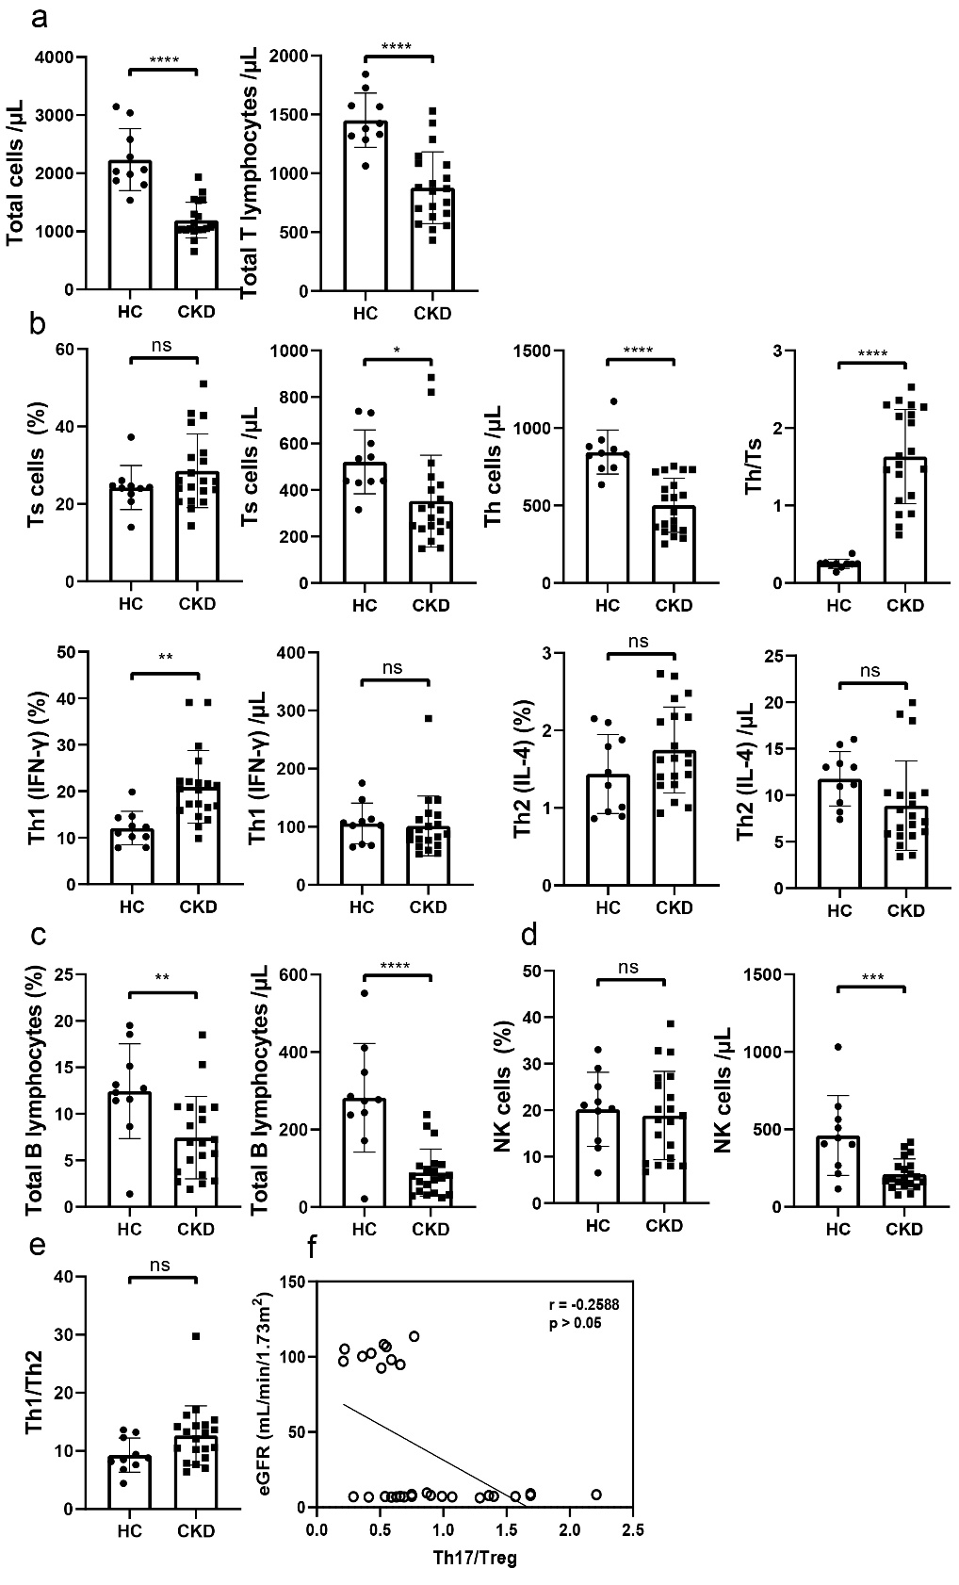
Supplementary Fig.4: Differences in T cells subsets between PBMC from CKD patients (n=20) and healthy controls (n=10) and their correlation with renal function. (a) Differences in Total cells (including T lymphocytes, B lymphocytes, and NK cells) between CKD patients and healthy individuals; (b) Differences in T cell-subsets, B cells (c), NK cells (d), and Th1/Th2 (e) between CKD patients and healthy individuals; (f) The correlation of eGFR and Th17/Treg.
Ts cells: suppressor T cell; Th cells: Helper T cells. *P < 0.05, **P < 0.01, ****P < 0.0001, indicating statistically significant data between groups.

Supplementary Fig.5: Western blot analysis confirmed that AAV-MIF injection effectively knocked down MIF expression levels in the kidney.

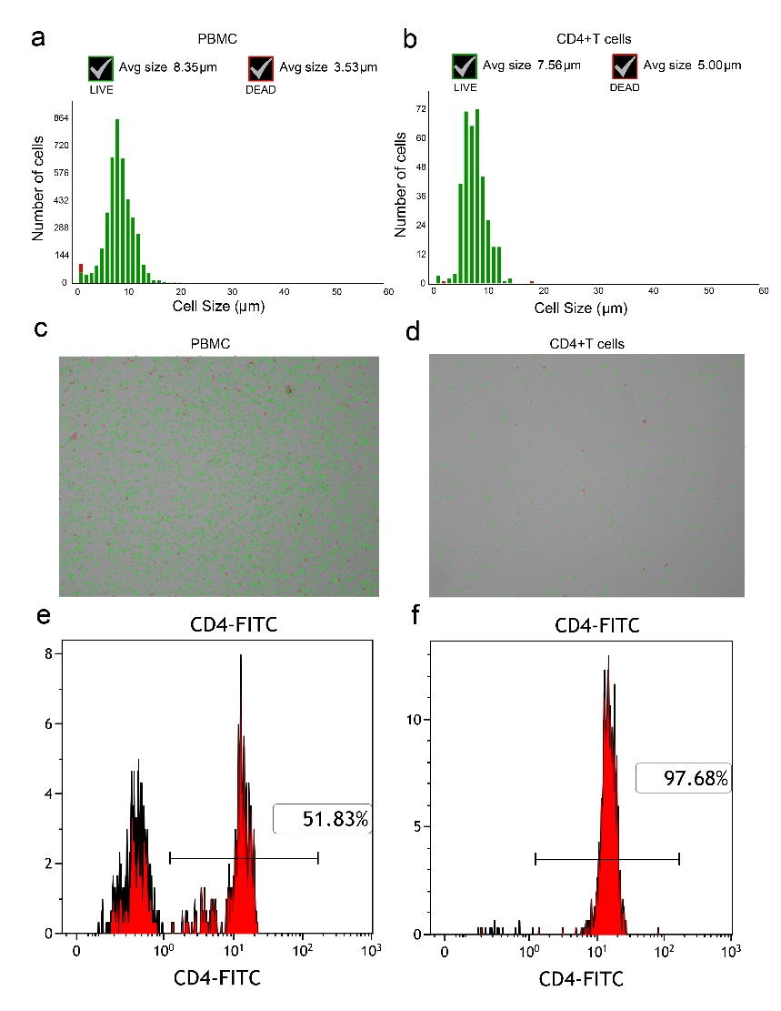
Supplementary Fig.6: Activity of extracted cells and purity of CD4+T cells. (a-b) Number and size distribution of live and dead cells in PBMC and CD4+ T cells. (c-d) Trypan blue staining of PBMC and CD4+T cells. (e-f) Purity of CD4+T cells after two cell separations.

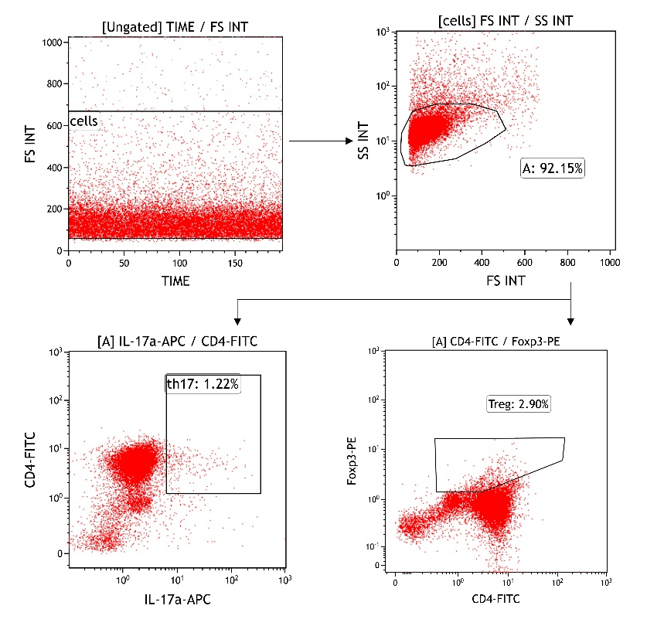
Supplementary Fig.7: Gating strategies for flow cytometry.

