Table S1. Primer sequences for the mRNA of the target genes
Gene | Primer sequences | Length
IL-6 | Forward: 5'-TGAGGAGACTTGCCTGGT -3'  Reverse: 5'-GGGTCAGGGGTGGTTATT -3' | 186bp
IL-17 | Forward: 5'-TACAACCGATCCACCTCAC-3'  Reverse: 5'-GTAGTCCACGTTCCCATCA-3' | 126bp
TNF-α | Forward: 5'-CCCTCCTTCAGACACCCT -3'  Reverse: 5'-GGTTGCCAGCACTTCACT -3' | 153 bp
VEGF | Forward: 5'-CAGGGAAGAGGAGGAGATG-3'  Reverse: 5'-CTGGGTTTGTCGGTGTTC -3' | 148bp
PDGF | Forward: 5'-CTGATGAAAGCACACGGA -3'  Reverse: 5'-TGATCTCTGGATGTCGGAA-3' | 143bp
GAPDH | Forward: 5'-CAAGTTCAACGGCACAGTCAAG-3’  Reverse: 5'-ACATACTCAGCACCAGCATCAC-3’ | 123 bp

Table S2. Qualitative arthritis scoring.
Score | Condition
0 | Normal
1 | Mild, but definite redness and swelling of the ankle or wrist, or apparent redness and swelling limited to individual digits, regardless of the number of affected digits
2 | Moderate redness and swelling of ankle or wrist
3 | Severe redness and swelling of the entire paw including digits
4 | Maximally inflamed limb with involvement of multiple joints

Figure S1. Proteomics analysis of Metrnl stimulation on RA-FLS cells.
(A) DEPs of comparable group between Metrnl and control group. (B) GSEA map of positively regulated TNF Signaling Pathway. (C) GSEA map of positively regulated Cytokine-Cytokine Receptor Interaction. (D) GSEA map of positively regulated T Cell Receptor Signaling Pathway. (E) GSEA map of positively regulated Toll-like Receptor Signaling Pathway. (F) GSEA map of positively regulated Th17 Cell Differentiation. (G) GSEA map of positively regulated VEGF Signaling Pathway. (H) GSEA map of negatively regulated Complement and Coagulation Cascades. (I) GSEA map of negatively regulated Rheumatoid Arthritis.

Figure S2. The bone-related parameters without statistical differences of TS, BS/BV, and TV in CIA mice.

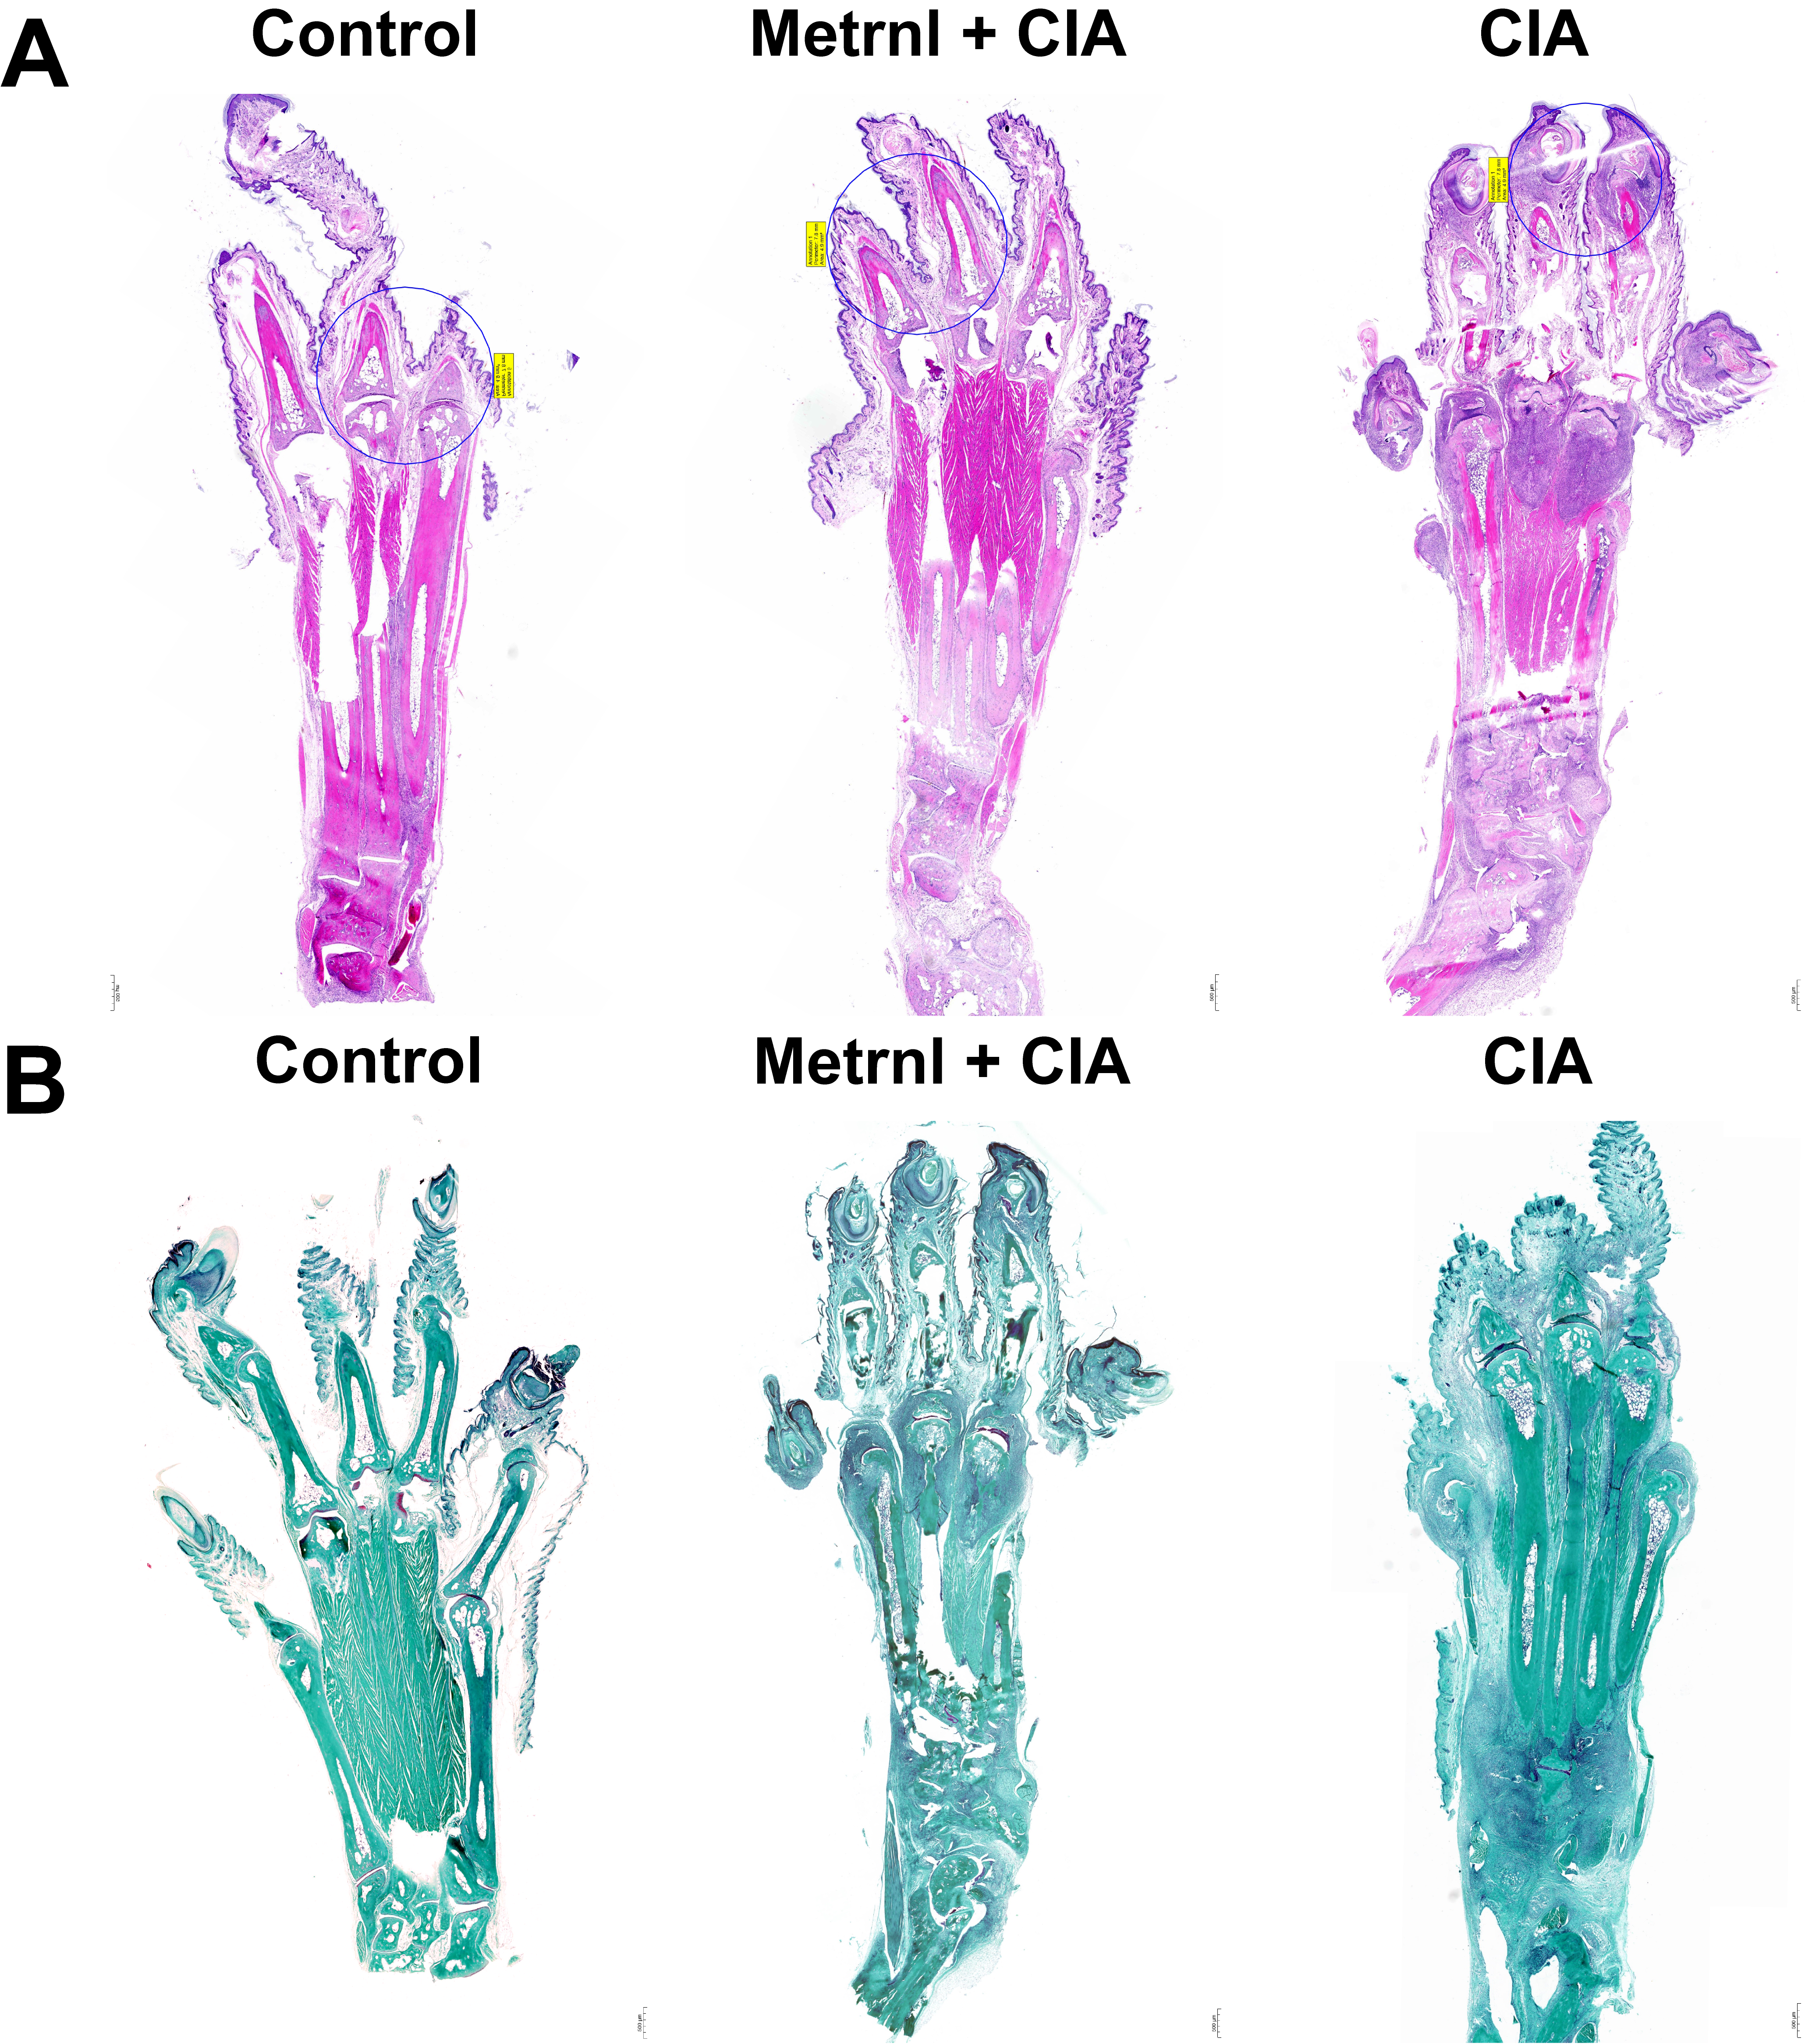

Figure S3. HE and Safranin O-Fast green staining of limbs.

