Supplementary Materials for

Caveolin-1 regulates ultrastructural alterations of astrocytes in chronic cerebral hypoperfusion

Min Wu†, Xiaohao Zhang†, Di Wang, Xiuli Shu, Dongyue Chen, Ying Zhao, Qiushi Lv, Yunzi Li, Zhenqian Huang, Jie Gao, Wusheng Zhu, Zibin Wang*, Xinfeng Liu*, Yi Xie*

†Contributed equally.
*Corresponding author. E-mail: xieyi@njmu.edu.cn (Y.X.); xfliu2@vip.163.com (X.L.); wangzibin@njmu.edu.cn (Z.W.)

The file includes:
Supplementary Fig. 1. Chronic hypoperfusion-induced alterations in astrocytic organelles.
Supplementary Fig. 2. Ultrastructural Characteristics of astrocytes, oligodendrocytes, and microglia.
Supplementary Fig. 3. The expression of LAMP1 within astrocytes under chronic hypoperfusion.
Supplementary Fig. 4. The adaptive cellular remodeling after conditional knockout of astrocytic Cav-1.
Supplementary Fig. 5. Astrocytic activation and corpus callosum demyelination in WT and Cav-1-cKO mice under chronic hypoperfusion.
Supplementary Fig. 1. Chronic hypoperfusion-induced alterations in astrocytic organelles.
(A, B) Immunofluorescent images and quantifications for the mitochondria abundance. (C, D) Representative images and quantifications for the Golgi apparatus. (E, F) Immunofluorescent images and quantifications for the ER stress. (n=5 in each group; mean ± SD; **P < 0.01; unpaired t-test). Scale bar, 20µm. Abbreviations: BCAS, bilateral carotid artery stenosis; GFAP, glial fibrillary acidic protein; ER, endoplasmic reticulum; SD, standard deviation.
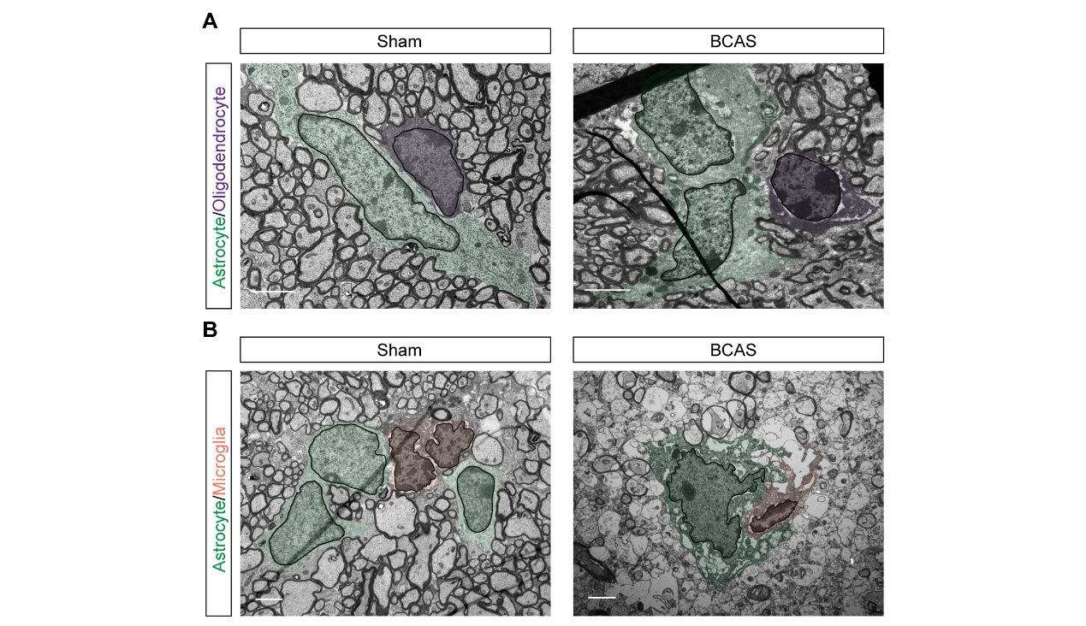
Supplementary Fig. 2. Ultrastructural Characteristics of astrocytes, oligodendrocytes, and microglia.
(A) Electron micrographs of astrocytes and oligodendrocytes in the sham and BCAS groups. (B) Electron micrographs of astrocytes and microglia in the sham and BCAS groups. Astrocytes were identified by electron-lucent cytoplasm, granular chromatin, and angular processes contacting myelinated axons and neighboring glial cells. Oligodendrocytes exhibited small, compact cell bodies with round, heterochromatic nuclei and sparse cytoplasm. Microglia, the smallest glial cells, displayed electron-dense cytoplasm, irregular nuclei with peripheral heterochromatin, and highly branched processes. Green pseudo-coloring, astrocytes; Purple pseudo-coloring, oligodendrocytes; Orange pseudo-coloring, microglia; Black outline, nucleus. Scale bar, 2µm. Abbreviations: BCAS, bilateral carotid artery stenosis.
Supplementary Fig. 3. The expression of LAMP1 within astrocytes under chronic hypoperfusion.
(A, B) Representative images and quantifications of lysosomes. (n=5 in each group; mean ± SD; **P < 0.01; unpaired t-test). Scale bar, 20µm. Abbreviations: BCAS, bilateral carotid artery stenosis; GFAP, glial fibrillary acidic protein; SD, standard deviation.

Supplementary Fig. 4. The adaptive cellular remodeling after conditional knockout of astrocytic Cav-1.
(A, B) Immunofluorescent images and quantifications for the Cav-1 expression in astrocytes. (n=5 in each group; mean ± SD; **P < 0.01; unpaired t-test). Scale bar, 20µm. (C) The TEM image of astrocytes in the intact corpus callosum in the WT and Cav-1-cKO mice. Scale bar, 2µm. (D–J) Quantitative analysis of the ultrastructural cellular contents within astrocytes. (n=5, 40 astrocytes in each group; mean ± SD; **P < 0.01; unpaired t-test). Red outline, cytoplasmic membrane; Green pseudo-coloring, nucleus; Yellow outline, mitochondria; Blue pseudo-coloring, Golgi apparatus; Purple pseudo-coloring, ER; Orange pseudo-coloring, lysosome. Abbreviations: WT, wildtype; Cav-1, caveolin-1; TEM, transmission electron microscope; ER, endoplasmic reticulum; SD, standard deviation.
Supplementary Fig. 5. Astrocytic activation and corpus callosum demyelination in WT and Cav-1-cKO mice under chronic hypoperfusion.
(A) Immunofluorescent images showing the activation and phagocytic transformation of astrocytes between the WT and Cav-1-cKO BCAS group. Scale bar, 20µm for fluorescence; 50µm for 3D reconstruction images. (B) Quantitative analysis of the activated astrocytes between the two groups (n=5 in each group; mean ± SD; unpaired t-test). (C) Percentage of the GFAP⁺ astrocytes with phagocytosis between the two groups (n=5 in each group; mean ± SD; unpaired t-test). (D, E) Immunofluorescence images and quantification of MBP staining between the two groups. Scale bar, 100µm. (n=5 in each group; mean ± SD; **P < 0.01; unpaired t-test). Abbreviations: WT: wildtype; BCAS, bilateral carotid artery stenosis; Cav-1: caveolin-1; GFAP, glial fibrillary acidic protein; SD, standard deviation.

