Supplementary Information
Tenascin-C promotes rheumatoid arthritis progression by regulating fibroblast survival and immune activation
First Authors: Mingyue Hu
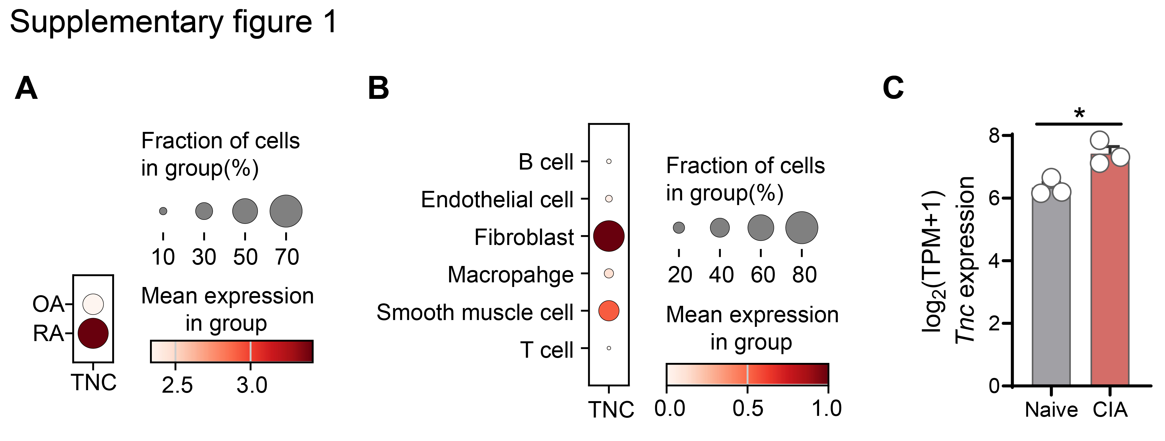
Corresponding Authors: Xiong Cai, and Liang Liu
Supplementary figures 1-4
Supplementary tables 2
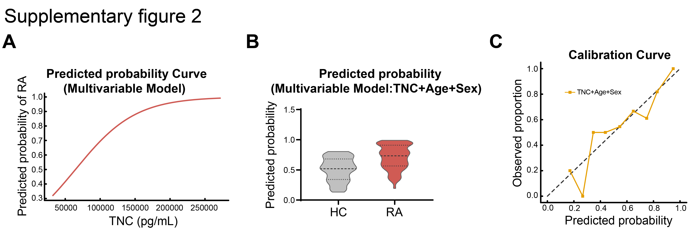
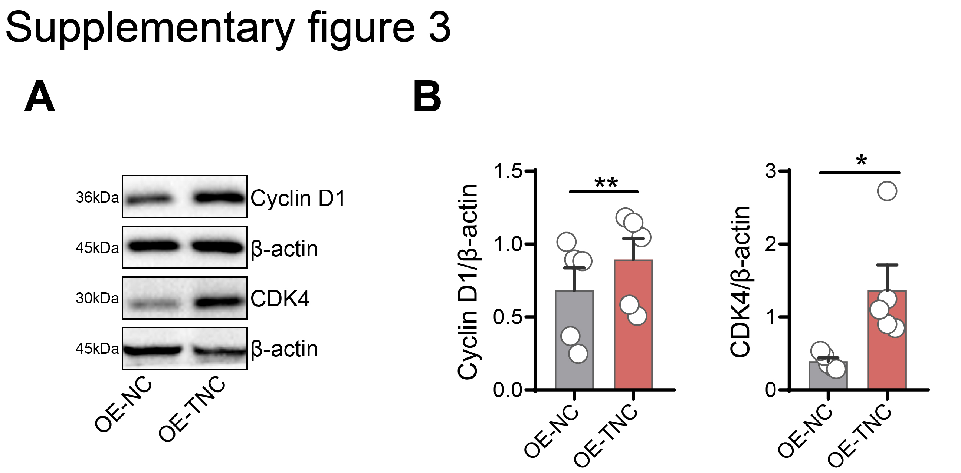
Supplementary figure 1. TNC expression patterns in human and murine synovial tissues at single-cell and bulk transcriptomic levels. (A) Pseudobulk comparison of TNC expression between RA and OA synovial tissues derived from integrated scRNA-seq datasets (GSE200815 and GSE152805). Expression values were aggregated at the patient level to account for inter-individual variability. (B) Cell type-specific distribution of TNC expression across major synovial cell types, including B cells, endothelial cells, fibroblasts, macrophages, smooth muscle cells, and T cells, identifying fibroblasts as the predominant cellular source. (C) Tnc expression in primary FLS isolated from naive and CIA mice (GSE162306). Expression values were log₂-transformed [log₂(TPM+1)] and are presented as mean±SEM (n=3 per group). *P<0.05 by unpaired two-tailed Student’s t-test.
Supplementary figure 2. (A) Predicted probability of RA by TNC level (multivariable logistic regression). Higher TNC levels are associated with an increased predicted probability of RA, independent of age and sex. (B) Predicted probabilities from the multivariable model (TNC+Age+Sex) are shown for RA and HC groups. Distributions are visualized using violin plots to illustrate group separation. (C) Logistic regression model including TNC, Age, and Sex was fitted to distinguish RA from HC. The predicted probability of RA is plotted against TNC expression, holding other covariates constant, illustrating the nonlinear (sigmoidal) relationship between TNC levels and RA risk.
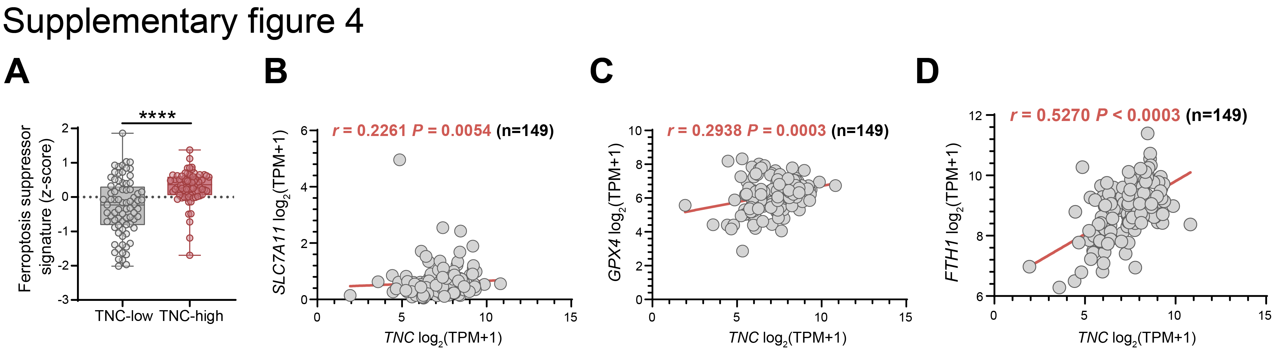
Supplementary figure 3. (A-B) RA-FLS were infected with a TNC-overexpressing adenoviral vector at a multiplicity of infection (MOI) of 300 for 48 h. Western blot analysis was performed to assess the expression of Cyclin D1 and CDK4 (n=5).
Supplementary figure 4. Association between elevated TNC expression and a ferroptosis-suppressing molecular program in RA synovial samples (GSE89408). (A) Ferroptosis suppressor signature scores in TNC-high and TNC-low groups, showing a significant enrichment of anti-ferroptotic markers in TNC-overexpressing synovia. Data are presented as the mean±SEM. ****P<0.0001 by unpaired two-tailed Student’s t-test. (B-D) Correlation analyses between TNC expression and the expression of key ferroptosis-related genes, including SLC7A11 (B), GPX4 (C), and FTH1 (D), in RA synovial samples. Correlations were assessed using Spearman’s rank correlation, with correlation coefficients (r) and P values indicated.

Supplementary Table 1 Clinical and laboratory characteristics of patients with RA and HCs (peripheral blood cohort)
 | HCs (n=40) | Patients with RA (n=70)
 | HCs (n=40) | Total  (n=70) | DAS28-ESR≤3.2  (n=11) | 3.2＜DAS28-ESR≤5.1  (n=31) | DAS28-ESR>5.1  (n=28)
Female, n (%) | 22 (55.0%) | 47 (67.1%) | 9 (81.8%) | 22 (71.0%) | 16 (57.1%)
Age (year) | 51±14.7 | 55.5±12.1 | 44.0±9.9 | 55±11.9 | 60.5±10.96
Duration of disease (month) | - | 12.0 (1.0-360.0) | 12.0 (1.0-24.0) | 12.0 (2.0-360.0) | 24.0 (1.0-240.0)
RF (U/mL) | - | 102.1 (9.2-545.7) | 48.5 (11.9-198.9) | 115.3 (9.2-545.7) | 131.1 (12.9-477.2)
Anti-CCP (U/mL) | - | 191.8 (83.7-202.8) | 187.5 (92.0-199.7) | 192.0 (92.0-202.8) | 191.3 (83.7-200.1)
CRP (mg/L) | - | 17.3 (0.2-152.5) | 2.5 (0.2-29.0) | 10.0 (0.49-76.0) | 41.5 (0.72-152.5)
ESR (mm/h) | - | 51.5 (2-153) | 20 (2.0-23.0) | 38.0 (15.0-103.0) | 93.5 (43.0-153.0)
DAS28-ESR | - | 4.55 (1.66-7.39) | 2.92 (1.68-3.10) | 4.06 (3.31-4.96) | 6.16 (5.12-7.39)

Supplementary Table 2 Clinical and laboratory characteristics of RA and OA synovial tissue donors
 | Patients with OA (n=9) | Patients with RA (n=8)
Female, n (%) | 6 (66.7%) | 7 (87.5%)
Age (year) | 66.3±5.8 | 60.3±12.4
Duration of disease (month) | 72 (5-120) | 60 (6-360)
RF (U/mL) | - | 110.5 (11.3-645.1)
Anti-CCP (U/mL) | - | 187.0 (8.8-204.6)
CRP (mg/L) | 4.32 (0.25-16.69) | 9.24 (2.19-127.55)
ESR (mm/h) | 12 (3-28) | 62 (42-129)

