Appendix with Means, SDs, and Descriptive Plots for Measures by Group, Time and Birthplace

Appendix Table

Means and SDs by group, birthplace and time
 |  | Intervention Group |  |  |  | Comparison Group
 |  | U.S-born |  | Foreign -born |  | U.S.-born |  | Foreign-born
notice bias | Time | M | (SD) | M | (SD) | M | (SD) | M | (SD)
 | Pretest | 5.79ª | 1.12 | 5.07^{b} | 1.65 | 5.95ª | 1.26 | 4.83^{b} | 1.64
 | post-test | 6.04ª | 1.03 | 5.84ª | 1.05 | 6.17ª | 0.99 | 4.97^{b} | 1.76
self-efficacy | pretest | 5.39 | 1.25 | 5.39 | 1.10 | 5.63 | 1.09 | 5.33 | 0.93
 | postest | 6.21 | 0.72 | 5.77 | 1.02 | 5.68 | 1.34 | 5.32 | 1.10
benefit | pretest | 5.26 | 1.34 | 4.53 | 1.37 | 4.71 | 1.76 | 4.38 | 1.42
 | postest | 5.57 | 1.35 | 4.81 | 1.50 | 4.47 | 1.65 | 4.35 | 1.38
risk* | pretest | 3.82 | 1.64 | 3.22 | 1.51 | 3.82 | 1.64 | 3.50 | 1.45
 | postest | 3.49 | 1.67 | 3.46 | 1.62 | 3.78 | 2.00 | 3.66 | 1.31
take action | pretest | 4.01 | 1.34 | 3.83 | 1.48 | 4.13 | 1.31 | 3.70 | 1.35
 | postest | 4.64 | 1.31 | 4.35 | 1.36 | 4.04 | 1.44 | 3.56 | 1.22
reverse scored.
^{ab} Means with different superscripts differ significantly, Tukey's test, p < .005.

Descriptive Plots for the Five Measures by Group, Time & Birthplace
Figure 1 Figure 2 Figure 3

noticing bias | self-efficacy | take action to reduce bias
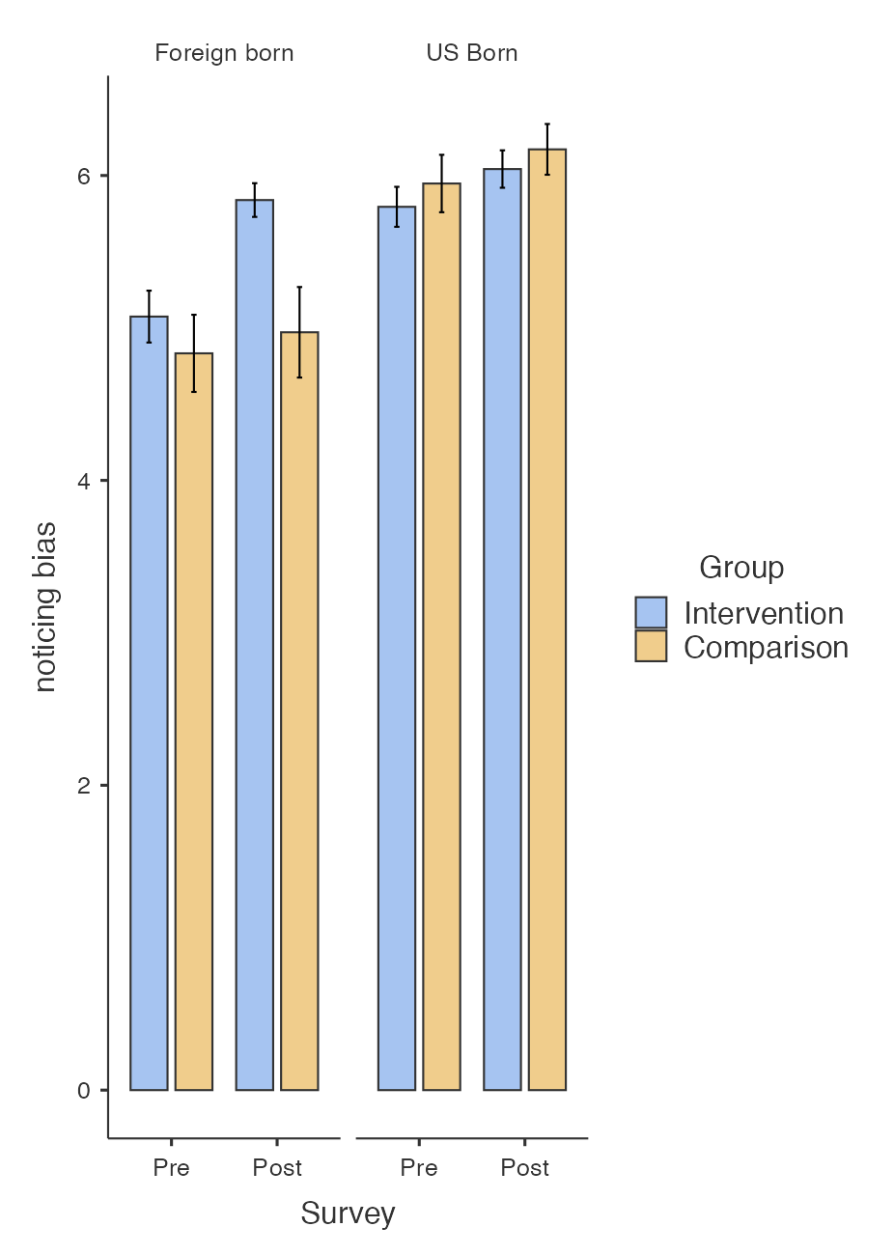 | 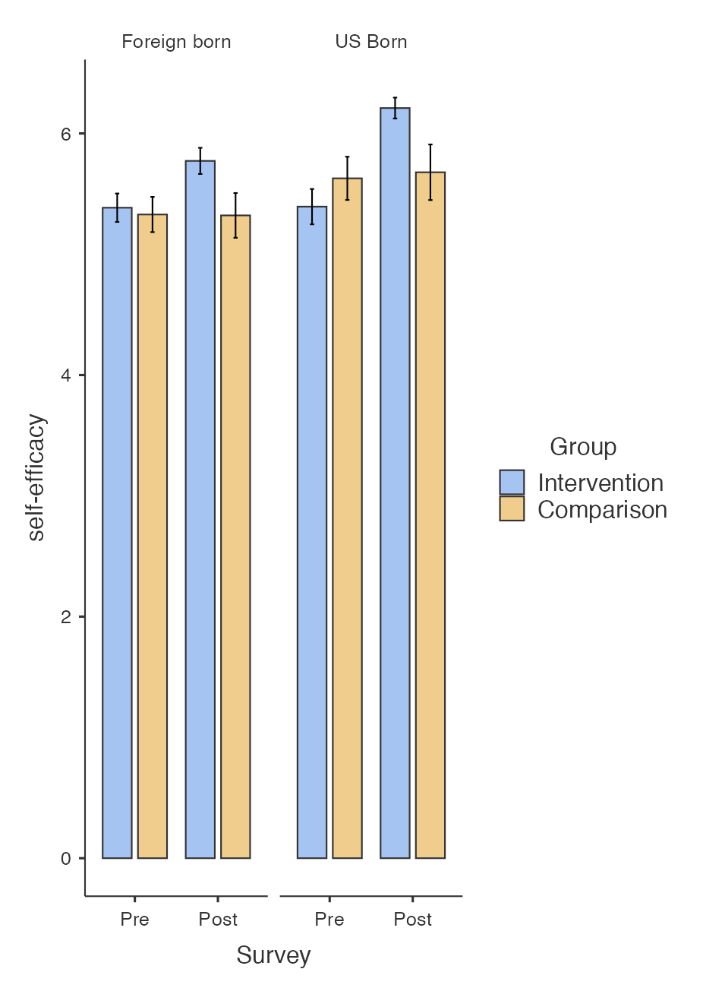 | 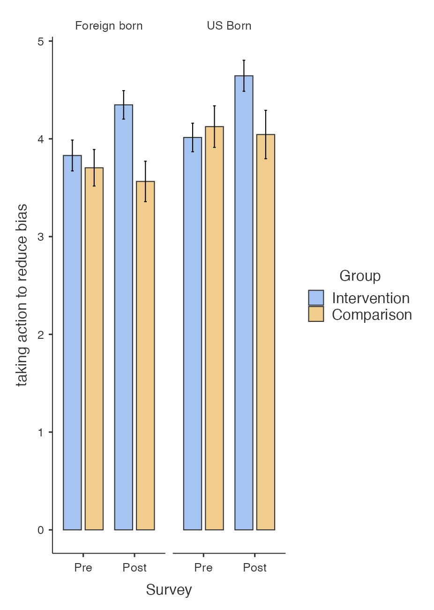
For Notice bias. Group x Birthplace differed significantly. See further details in Figure 4.
Self-efficacy and Take Action differed significantly for Group x Time, with the Intervention group improving on both after the workshop. See also Table 7. No interaction effect was observed for self-effficacy or take action.
Figure 4 Figure 5
perception of benefit | perception of risk
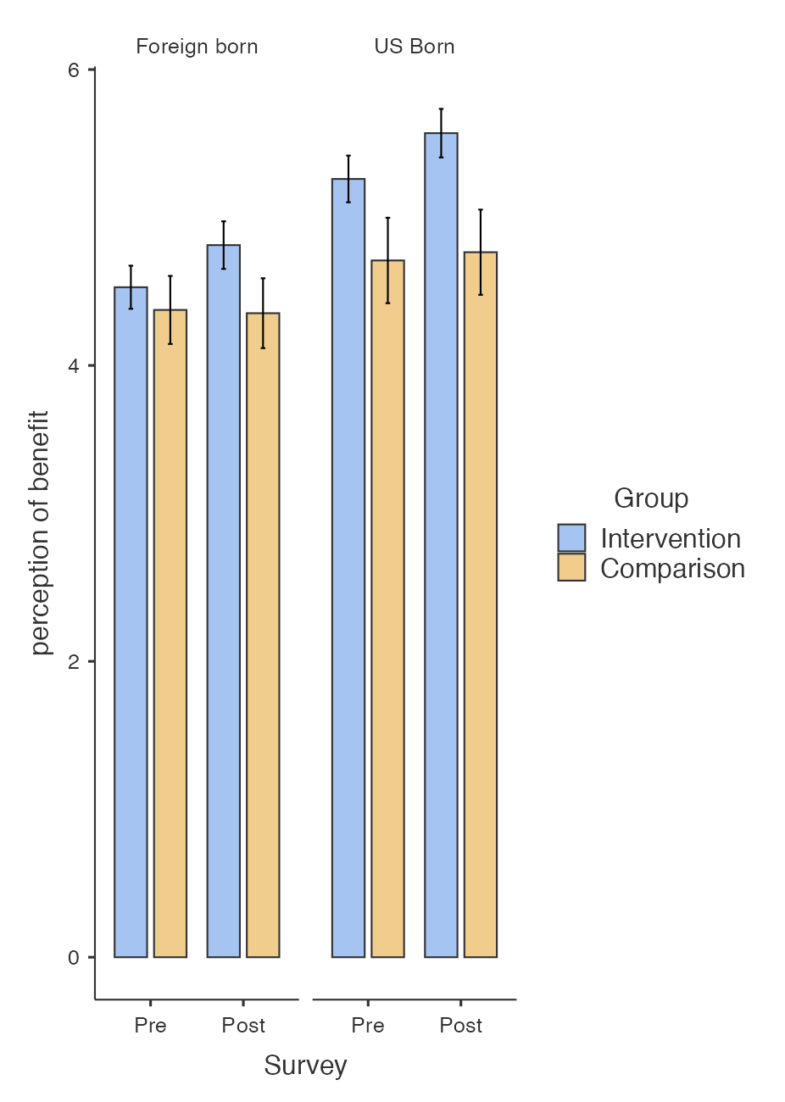 | 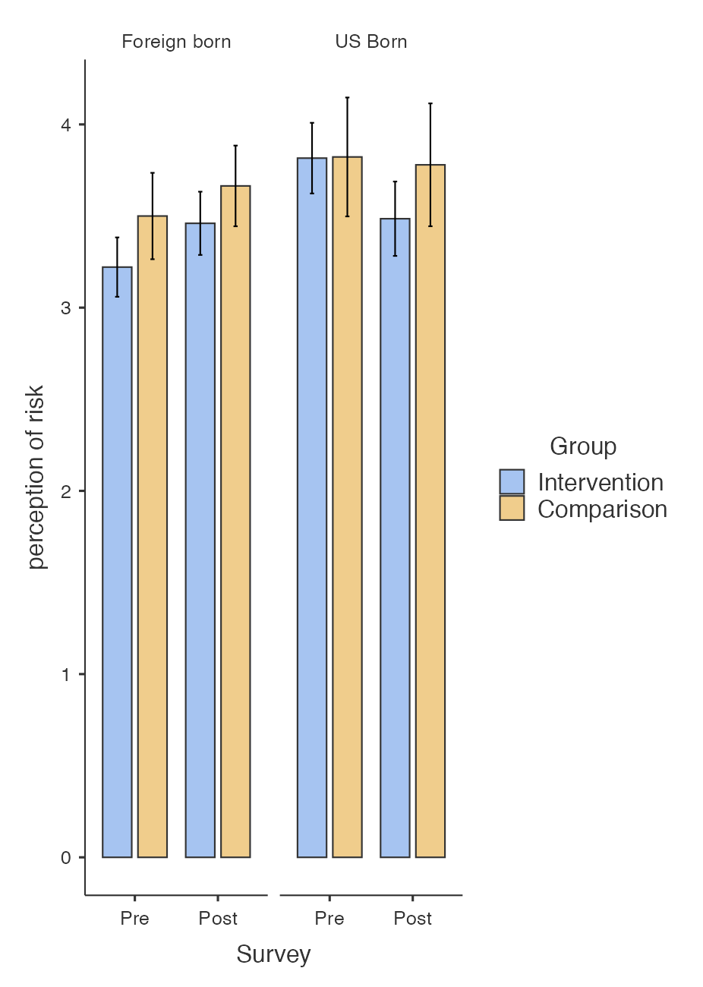

No significant main effects or interaction effects were found for benefit or risk.

