Electronic Supplementary material
Appendix 1
Table 1 Interview protocol
No | Theme | Sample questions
1 | Teachers’ Background | How long have you taught? What modes do you use? What subjects do you teach?
2 | Course design practices | How do you design your courses?  What strategies do you use to make changes in your courses?  What challenges do you face in this process?
3 | Awareness, feelings, and concerns about LA | What is your general view/understanding of LA?  Do you have any concerns about LA?  What pre-conditions do you have ahead of using LA?  What kind of LA would you prefer?
4 | How LA can support course design | What do you perceive as the potential of LA as a tool to support LD?

Appendix 2
LA visualizations displayed to teachers during interviews
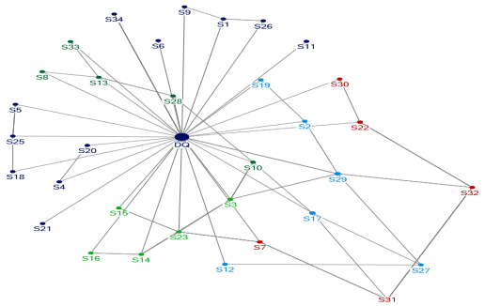
Student interaction dynamics
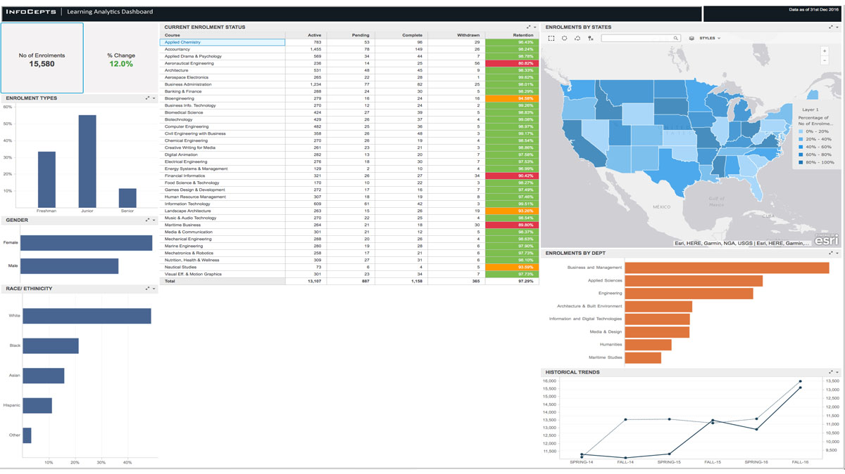
Learning Analytics dashboards
Appendix 3: Codebook
Theory-Driven Codes & Definitions
Code-add after revision | Description
LA perception-based referencing | Teachers highlights the possible benefits of LA but not based on their own experience of using LA
LA concerns referencing | Teachers makes reference to the possible challenges of using LA (eg., emotional and cognitive attitudes
Future use and intentions | Teacher describes or gives examples of how they intend to use LA in the future or not

Research Question-Driven Codes & Definitions
Code | Description
LA understanding | Teacher describes or gives examples of what he/she thinks LA is about
LD practices/strategies | Teacher describes how they are currently designing courses
LD challenges | Teacher describes the challenges associated with LD

