SUPPLEMENTARY FIGURE

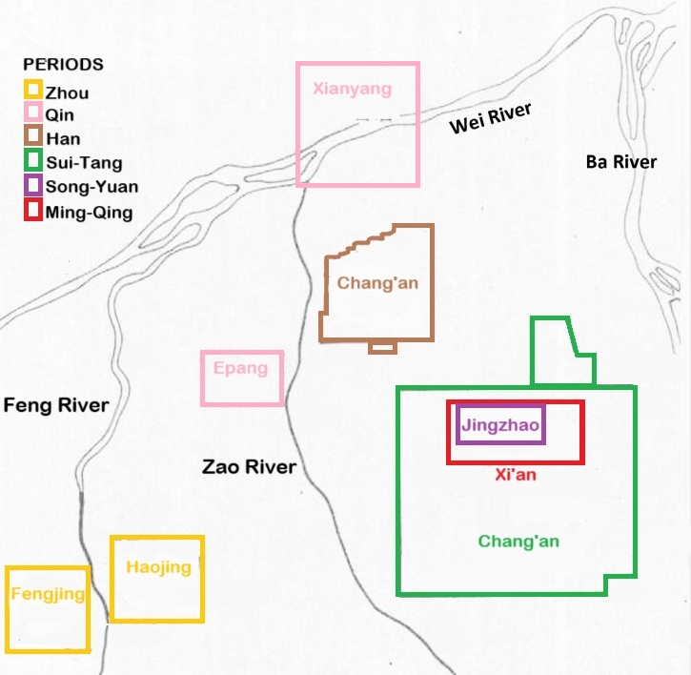
Figure S1. Capital and seats sites of various dynasties in and around Xi’an (Adapted from Ng et al. 2016)

