Supplemental Information for “Terahertz Spectroscopy for Characterization of Hydrogen Bonding and Cross-Linked Structure Dynamics in Polyurethane”
Hiromichi Hoshina¹, Yuichi Saito¹, Takumi Furuhashi², Tomomi Shimazaki²,
Manabu Sawada², Yasunori Hioki² and Chiko Otani¹

1.Smoothing

Smoothing is applied all of the absorption spectra to remove spike noise originated in the absorption of the residual water vapor in the sample chamber. The spectra were averaged by OriginTM software with adjacent average option with 100 points. Also, smoothing was applied when the second derivative spectra was calculated. Figure S1 shows an example of the absorption spectra of sample-A and its smoothed spectra (a), and its second derivative spectra (b), with the smoothing points of 50, 100 and 150 points, respectively.
When spectrum is smoothed by 50 points, the 2nd derivative spectrum become too noisy to find the peak position. On the other hand, when spectrum is smoothed by 150 points, the spectral shape is “oversmoothed”. The peak position of the second derivative spectra smoothed by 150 pts shifts about 0.1 THz higher frequency than that by 100 pts. Therefore, we applied smoothing with 100 points for all of the spectra. With the soothing points of 100, the absorption spectra is slightly “oversmoothed” in (a), which cause slight (< 0.1 THz) blue-shifting of peak position in the second derivative spectra.
Figure S1. (a) An example of the THz absorption spectrum (Sanple-A, 30°C) and its smoothed spectra with 50, 100 and 150 points, respectively. (b) Second derivative spectra obtained with smoothing of 50, 100 and 150 points, respectively.

2. Additional information for THz spectrum calculations on samples A and B

This supplemental paper gives comparisons between spectra obtained from different size models. Our organic materials are in the amorphous state, and therefore it is difficult to determine a unique simulation model suitable to THz calculations, unlike organic crystal materials. So, we examined several models for THz simulations. In Figures S2, we demonstrated THz spectra calculated from different size models. Figure S2a and S2b are for samples A and B, respectively. The blue solid-lines indicate calculation results from the material models used in our manuscript. On the other hand, red dashed-lines are obtained from the small size models. In the small model, several atomic groups in main chains are removed. We show the molecular geometry (structure) of these models in Figures S3 and S4 for samples A and B, respectively.

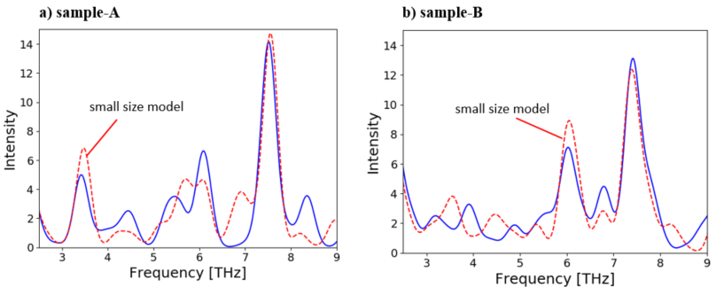
Figure S2. THz spectrum calculation results for (a) sample-A and (b) sample-B. The blue solid-lines are the same spectra discussed in our paper. Conversely, the red dashed-lines are obtained from small size models. We can confirm that different size models can give similar simulation results; especially they reproduce a large peak around 7.5 THz.

In Tables S1, we summarize the data of THz spectrum calculated for sample-A. The values in parentheses are scaled frequencies to compensate the anharmonic effect. Conversely, Table S2 is for sample-B. The data of the small size model for sample-B material are summarized in Table S2b. The more detailed information for the molecular structure can be found in other supplemental files.
From calculation results, we can easily confirm that similar THz spectra are obtained. Especially, we observe a large peak around 7.5 THz in those calculations, because vibrations of MDI bridge in the cross-linked materials mainly contribute to the peak.

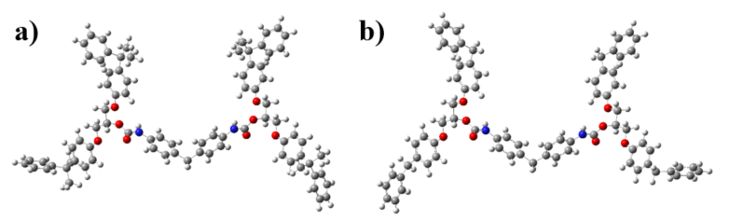
Figure S3. Different size models for sample-A. The model (a) is used to obtain the THz spectrum of sample-A in our paper. In the small size model (b), methyl groups are removed. Precise molecular coordinates of these modes can be found in other supplemental files. (Sample_A_molecular_geometry.pdf, Sample_A_small_size_molecular_geometry.pdf)

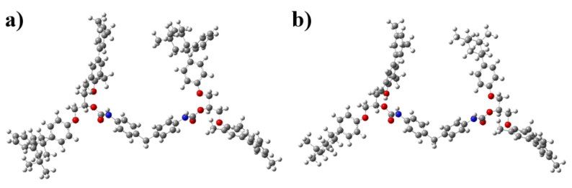
Figure S4. Different size models for sample-B. The model (a) is used to obtain the THz spectrum of sample-B in our paper. In the small size model (b), phenyl groups are removed. Precise molecular coordinates of these modes can be found in other supplemental files (Sample_B_molecular_geometry.pdf, Sample_B_small_size_molecular_geometry.pdf)

Table S1a. Calculated THz spectrum of sample-A. The molecular geometry shown in Figure S3a is used for the calculation. The values in parentheses are scaled frequencies to compensate the anharmonic effect in the IR (THz) calculation.
THz | Intensity |  | THz | Intensity
1.1 (1.07) | 1.18 |  | 5.02 (4.85) | 0.01
1.19 (1.15) | 0.13 |  | 5.46 (5.27) | 1.65
1.22 (1.18) | 0.09 |  | 5.53 (5.35) | 0.77
1.33 (1.28) | 0.07 |  | 5.75 (5.55) | 2.27
1.34 (1.29) | 0.26 |  | 5.9 (5.7) | 0.58
1.39 (1.34) | 0.21 |  | 6.25 (6.04) | 0.64
1.51 (1.46) | 0.01 |  | 6.28 (6.06) | 2.1
1.56 (1.51) | 0.1 |  | 6.28 (6.07) | 1.99
1.66 (1.6) | 0.06 |  | 6.38 (6.16) | 1.64
1.69 (1.63) | 0.18 |  | 6.41 (6.19) | 0.59
1.76 (1.7) | 0.27 |  | 7.08 (6.84) | 0.04
1.77 (1.71) | 0.15 |  | 7.29 (7.04) | 0.24
2.01 (1.94) | 0.39 |  | 7.59 (7.33) | 1.45
2.1 (2.03) | 1.26 |  | 7.76 (7.49) | 0.22
2.13 (2.06) | 1.59 |  | 7.79 (7.53) | 13.19
2.18 (2.11) | 2.28 |  | 8.16 (7.88) | 0.45
2.28 (2.2) | 2.83 |  | 8.22 (7.94) | 0.86
2.45 (2.37) | 1.82 |  | 8.59 (8.3) | 0.72
2.61 (2.52) | 0.49 |  | 8.64 (8.35) | 1.14
2.92 (2.82) | 0.12 |  | 8.65 (8.35) | 0.62
3.0 (2.89) | 0.15 |  | 8.7 (8.41) | 1.14
3.29 (3.18) | 0.01
3.54 (3.42) | 4.93
3.82 (3.69) | 0.04
3.87 (3.74) | 0.38
4.07 (3.93) | 0.7
4.24 (4.1) | 0.38
4.37 (4.22) | 0.44
4.54 (4.39) | 0.96
4.67 (4.52) | 1.57

Table S1b. Calculated THz spectrum of sample-A (small size model). The molecular geometry shown in Figure S3b is used for the calculation. The values in parentheses are scaled frequencies to compensate the anharmonic effect in the IR (THz) calculation.
THz | Intensity |  | THz | Intensity
1.09 (1.05) | 1.06 |  | 6.13 (5.92) | 0.42
1.15 (1.11) | 0.13 |  | 6.33 (6.11) | 4.19
1.22 (1.18) | 0.04 |  | 6.97 (6.73) | 1.37
1.24 (1.2) | 0.17 |  | 7.17 (6.93) | 2.76
1.31 (1.26) | 0.02 |  | 7.36 (7.11) | 0.58
1.33 (1.28) | 0.54 |  | 7.52 (7.26) | 1.12
1.37 (1.33) | 0.34 |  | 7.83 (7.56) | 14.55
1.5 (1.45) | 0.02 |  | 8.49 (8.2) | 0.95
1.75 (1.69) | 0.08 |  | 8.73 (8.44) | 0.03
2.03 (1.96) | 0.32
2.07 (2.0) | 1.13
2.19 (2.12) | 3.08
2.26 (2.19) | 3.96
2.49 (2.4) | 1.62
2.75 (2.65) | 0.73
3.24 (3.13) | 0.18
3.39 (3.28) | 0.29
3.44 (3.32) | 0.13
3.6 (3.48) | 6.61
4.32 (4.17) | 0.44
4.38 (4.23) | 0.52
4.67 (4.51) | 0.84
4.86 (4.7) | 0.05
5.06 (4.89) | 0.03
5.17 (5.0) | 0.07
5.34 (5.16) | 1.25
5.37 (5.19) | 0.26
5.72 (5.52) | 1.83
5.76 (5.57) | 0.2
5.93 (5.73) | 3.33

Table S2a. Calculated THz spectrum of Sample-B. The molecular geometry shown in Figure S4a is used for the calculation. The values in parentheses are scaled frequencies to compensate the anharmonic effect in the IR (THz) calculation.
THz | Intensity |  | THz | Intensity
1.05 (1.01) | 0.1 |  | 5.1 (4.93) | 1.28
1.11 (1.07) | 0.46 |  | 5.51 (5.33) | 1.28
1.15 (1.11) | 0.44 |  | 5.66 (5.47) | 0.38
1.19 (1.15) | 0.36 |  | 5.79 (5.59) | 0.71
1.24 (1.19) | 0.14 |  | 5.82 (5.63) | 1.2
1.25 (1.21) | 0.01 |  | 6.18 (5.97) | 3.21
1.3 (1.25) | 0.39 |  | 6.27 (6.05) | 3.22
1.42 (1.38) | 0.06 |  | 6.29 (6.07) | 0.57
1.51 (1.46) | 0.1 |  | 6.56 (6.33) | 2
1.56 (1.51) | 0.03 |  | 6.63 (6.41) | 0.24
1.65 (1.6) | 0.66 |  | 6.99 (6.75) | 2.15
1.7 (1.64) | 0.33 |  | 7.05 (6.81) | 1.63
1.75 (1.69) | 0.32 |  | 7.1 (6.86) | 0.51
1.85 (1.79) | 0.09 |  | 7.17 (6.93) | 0.36
1.88 (1.82) | 0.1 |  | 7.52 (7.26) | 1.13
1.96 (1.9) | 0.13 |  | 7.54 (7.28) | 0.07
2.03 (1.96) | 0.53 |  | 7.58 (7.32) | 0.38
2.12 (2.05) | 0.28 |  | 7.67 (7.41) | 11.2
2.34 (2.26) | 2.88 |  | 7.75 (7.49) | 0.31
2.37 (2.29) | 3.39 |  | 7.78 (7.51) | 0.08
2.4 (2.31) | 2.18 |  | 7.95 (7.68) | 0.13
2.44 (2.36) | 0.22 |  | 7.97 (7.7) | 1.39
2.52 (2.43) | 0.23 |  | 8.03 (7.76) | 1.18
2.68 (2.59) | 0.76 |  | 8.07 (7.8) | 0.64
2.7 (2.61) | 1.31 |  | 8.08 (7.81) | 0.59
2.73 (2.64) | 0.23 |  | 8.1 (7.83) | 0.18
2.88 (2.79) | 0.33 |  | 8.2 (7.92) | 0.31
2.9 (2.8) | 0.38 |  | 8.23 (7.95) | 0.51
3.01 (2.91) | 0.07 |  | 8.36 (8.07) | 0.41
3.21 (3.1) | 0.09 |  | 8.81 (8.51) | 0.19
3.26 (3.15) | 1.89 |  | 8.83 (8.53) | 0.13
3.4 (3.29) | 0.22 |  | 8.9 (8.6) | 0.09
3.48 (3.36) | 0.22
3.54 (3.42) | 0.48
3.65 (3.53) | 0.74
3.89 (3.76) | 0.21
4.05 (3.91) | 2.96
4.29 (4.15) | 0.44
4.54 (4.39) | 0.7
4.8 (4.64) | 0.18
4.82 (4.66) | 0
4.95 (4.79) | 0.17
4.97 (4.8) | 0.49

Table S2b. Calculated THz spectrum of sample-B (small size model). The molecular geometry shown in Figure S4b is used for the calculation. The values in parentheses are scaled frequencies to compensate the anharmonic effect in the IR (THz) calculation.
THz | Intensity |  | THz | Intensity
1.02 (0.98) | 0.33 |  | 5.06 (4.89) | 1.02
1.07 (1.03) | 0.09 |  | 5.27 (5.09) | 0.07
1.08 (1.04) | 0.89 |  | 5.46 (5.27) | 0.22
1.12 (1.08) | 0.08 |  | 5.54 (5.36) | 1.56
1.22 (1.18) | 0.01 |  | 5.7 (5.5) | 0.21
1.23 (1.19) | 0.06 |  | 6.17 (5.96) | 1.98
1.27 (1.23) | 0.25 |  | 6.21 (6.0) | 1.33
1.35 (1.3) | 0.13 |  | 6.23 (6.02) | 3.14
1.46 (1.41) | 0.38 |  | 6.28 (6.07) | 1.39
1.52 (1.47) | 0.09 |  | 6.31 (6.09) | 0.14
1.58 (1.53) | 0.31 |  | 6.47 (6.25) | 2.58
1.6 (1.55) | 0.05 |  | 6.52 (6.29) | 0.56
1.79 (1.73) | 0.17 |  | 6.98 (6.75) | 1.1
1.88 (1.82) | 0.3 |  | 7.03 (6.79) | 1.72
2.05 (1.98) | 0.33 |  | 7.45 (7.19) | 0.28
2.12 (2.05) | 0.51 |  | 7.49 (7.24) | 0.51
2.14 (2.07) | 0.99 |  | 7.53 (7.28) | 1.41
2.31 (2.23) | 3.97 |  | 7.65 (7.39) | 10.02
2.36 (2.28) | 4.09 |  | 7.81 (7.54) | 0.39
2.46 (2.38) | 0.19 |  | 7.9 (7.63) | 0.7
2.61 (2.52) | 1.07 |  | 7.91 (7.64) | 0.27
2.7 (2.61) | 0.94 |  | 7.95 (7.68) | 0.86
2.71 (2.61) | 0.28 |  | 8.02 (7.75) | 0.63
2.81 (2.72) | 0.19 |  | 8.05 (7.78) | 0.88
3.1 (2.99) | 0.19 |  | 8.06 (7.79) | 0.38
3.13 (3.03) | 0.88 |  | 8.15 (7.88) | 0.02
3.16 (3.05) | 0.3 |  | 8.18 (7.9) | 0.37
3.36 (3.24) | 0.12 |  | 8.41 (8.13) | 0.29
3.37 (3.25) | 0.26 |  | 8.5 (8.21) | 1.26
3.44 (3.32) | 1.18 |  | 8.63 (8.33) | 0.17
3.71 (3.59) | 3.4 |  | 8.68 (8.38) | 0.32
4.07 (3.93) | 0.27 |  | 8.82 (8.52) | 0.06
4.18 (4.04) | 0.68 |  | 8.85 (8.55) | 0.16
4.51 (4.35) | 1.31
4.59 (4.44) | 0.34
4.72 (4.55) | 1.28
4.87 (4.7) | 0.31
4.9 (4.73) | 0.03

